THE BOOK OF THOTH

***(Egyptian Tarot)***

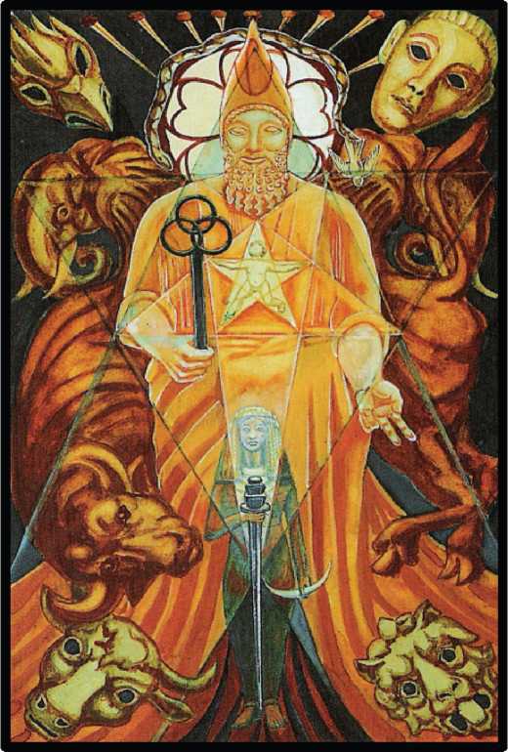

*by*

THE MASTER THERION

***(Aleister Crowley)***

**THE BOOK OF THOTH**

A SHORT ESSAY ON THE TAROT OF THE EGYPTIANS

BEING

THE EQUINOX VOL. III No. V

by

THE MASTER THERION

(Aleister Crowley)

Artist Executant: Frieda Harris

An Ixviii Sol in O° O’ O” Aries March 21, 1944 e. v. 5:29 p.m.

**N O C T PRESS 2 0 10**

First published 1944 e.v. in a limited edition of 200 copies.

This electronic edition by the Noct Press first issued 2010 e.v.

Release 0.9—9/June/2010

Further proofing is needed; no hyperlinks yet; footnotes not at bottom of page.

Pl[ease report errors](mailto:bifrons@live.com) to [bifrons@live.com](mailto:bifrons@live.com)

citing release number.

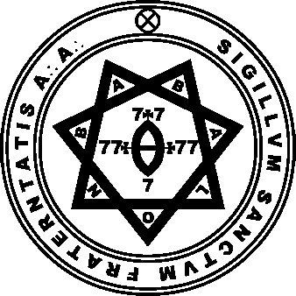

A л A л Publication in Class B. Imprimatur N. Fra: A л A л O. M. 7°=4n R.R. et A.C. I.A. 5°=6n R.R. et A.C.

WHEEL AND—WHOA!

The Great Wheel of Samsara.

The Wheel of the Law. (Dhamma.)

The Wheel of the Taro.

The Wheel of the Heavens.

The Wheel of Life.

All these Wheels be one; yet of all these the Wheel of the TARO alone avails thee consciously.

Meditate long and broad and deep, O man, upon this Wheel, revolving it in thy mind!

Be this thy task, to see how each card springs necessarily from each other card, even in due order from The Fool unto The Ten of Coins.

Then, when thou know’st the Wheel of Destiny complete, may’st thou perceive THAT Will which moved it first. [There is no first or last.]

And lo! thou art past through the Abyss.

The Book of Lies КЕФ.О^

CONTENTS

PART ONE: THE THEORY OF THE TAROT

1. The Contents of the Tarot; The Origin of the Tarot; The Theory of the correspondences of the Tarot; The Evidence for the Initiated Tradition of the Tarot; I. Eliphaz Levi and the Tarot; 2. The Tarot in the Cipher Manuscripts; 3. The Tarot and the “Hermetic Order of the Golden Dawn”; 4. The Nature of the Evidence; Summary of the Questions Hitherto Discussed.
2. The Tarot and the Holy Qabalah; The Naples Arrangement; The Tarot and the Formula of Tetragrammaton; The Tarot and the Elements; The Twenty-two Keys, Atu, or Trumps of the Tarot.
3. The Tarot and the Universe; Theories of the Ancients; The Tree of Life; The Naples Ar­rangement; The Tarot and the Tree of Life; The Atu of Tahuti; The Roman Numbers of the Trumps; The Tarot and Magick; The Shemhamphorasch and the Tarot; The Tarot and Ceremo­nial Magick; The Tarot and Animism; The Cards of the Tarot as Living Beings.

PART TWO: THE ATU (KEYS OR TRUMPS)

1. The Fool. The Formula of Tetragrammaton; The “Green Man” of the Spring Festival. “April Fool”; The Holy Ghost; The “Great Fool” of the Celts (Dalua); “The Rich Fisherman”; Percivale; The Crocodile (Mako, Son of Set, or Sebek); Hoor-Pa-Kraat; Zeus Arrhenotheleus; Dionysus Zagreus; Bacchus Diphues; Baphomet; Summary.
2. to XXI. The Juggler; The High Priestess; The Empress; The Emperor; The Hierophant; The Lovers (or, The Brothers); The Chariot; Adjustment; The Hermit; Fortune; Lust; The Hanged Man; Death; Art; The Devil; The Tower (or, War); The Star; The Moon; The Sun; The Aeon; The Universe.

APPENDIX. The Fool—i. Silence; ii. De Sapientia et Stultitia; De Oraculo Summo; iii. De Herba Sanctissima Arabia; De Quibusdam Mysteriis, Quae Vidi; De Quodam Modo Meditationis; Se- quitur De Hac Re; Conclusio De Hoc Modo Sanctitatis; De Via Sola Solis. The Magus— i. De Mercuno; ii. The Lord of Illusion; Fortune, R.O.T.A. —The Wheel; Lust, Babalon; Art, The Ar­row; The Universe. The Virgin Universe.

PART THREE: THE COURT CARDS

General Remarks; General Characteristics of the Four Dignitaries; Summarized description of the Sixteen Court Cards; Knight 0f Wands; Queen of Wands; Prince of Wands; Princess of Wands; Knight of Cups; Queen of Cups; Prince of Cups; Princess of Cups; Knight of Swords; Queen of Swords; Prince of Swords; Princess of Swords; Knight of Disks; Queen of Disks; Prince of Disks; Princess of Disks.

PART IV. THE SMALL CARDS

The Four Aces; The Four Twos; The Four Threes; The Four Fours; The Four Fives; The Four Sixes; The Four Sevens; The Four Eights; The Four Nines; The Four Tens. The Root of the Pow­ers of Fire Ace of Wands; Dominion—Two of Wands; Virtue—Three of Wands; Completion— Four of Wands; Strife—Five of Wands; Victory—Six of Wands; Valour—Seven of Wands; Swiftness—Eight of Wands; Strength—Nine of Wands; Oppression—Ten of Wands. The Root of the Powers of Water—Ace of Cups; Love—Two of Cups; Abundance—Three of Cups; Lux­ury—Four of Cups; Disappointment—Five of Cups; Pleasure—Six of Cups; Debauch—Seven of Cups; Indolence—Eight of Cups; Happiness—Nine of Cups; Satiety—Ten of Cups. Ace of Swords; Peace—Two of Swords; Sorrow—Three of Swords; Truce—Four of Swords; Defeat— Five of Swords; Science—Six of Swords; Futility—Seven of Swords; Interference—Eight of Swords; Cruelty—Nine of Swords; Ruin—Ten of Swords. Ace of Disks; Change —Two of Disks; Work—Three of Disks; Power—Four of Disks; Worry —Five of Disks; Success—Six of Disks; Failure—Seven of Disks; Prudence—Eight of Disks; Gain—Nine of Disks; Wealth—Ten of Disks.

INVOCATION AND MNEMONICS

APPENDIX A—THE BEHAVIOUR OF THE TAROT: ITS USE IN THE ART OF DIVINATION

The Behaviour of the Tarot; The Significator; First Operation; Second Operation— Development of the Question; Third Operation—Further Development of the Question; Fourth Operation—Penultimate Aspects of the Question; Fifth Operation—Final Result. Gen­eral Characters of the Trumps as they appear in Use.

APPENDIX B—CORRESPONDENCES

Correspondences; The Key Scale; The General Attributions of the Tarot; The Chinese Cosmos; The Caduceus; The Numbers of the Planets; The Elements and their Symbols; The Sphinx; Ta­bles of Correspondence; The Four Scales of Colour; Attributions of the Court Cards; Attribu­tions of the Small Cards; The Essential Dignities of the Planets; The Triple Trinity of the Plan­ets; The Triplicities of the Zodiac; The Vital Triads.

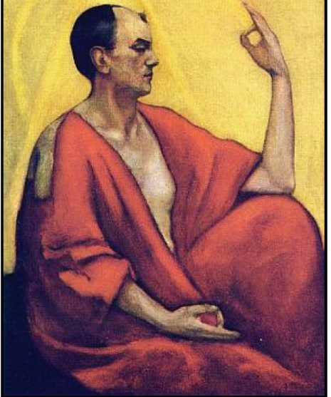

BIBLIOGRAPHICAL NOTE

On 18th November, 1898 e.v., Aleister Crowley was initiated into the Hermetic Order of the Golden Dawn; he took the motto “Perdurabo”—”I shall endure to the end”1

In February of the year following, he attained the grade of Practicus, and was accord­ingly entrusted with the secret attributions of the Tarot, especially those of the Atu. (See pp. 5­10).

He worked daily on these MSS., for the most part under the personal instruction of G.H. Frater 7°=4°, D.D.C.F. (S. Liddell Matters) and V.H. Fratres 5°=6° Iehi Aour (Allan Bennett, later Sayadaw Ananda Metteya) and Volo Noscere (George Cecil Jones) as host or guest of one of these Adepts.

He continued these studies alone during his first Voyage around the earth in search of the Hidden Wisdom.

On 8th, 9th and 10th April, 1904 e.v., he received the Book of the Law. Chosen bv the Masters to carry out Their sublime plan, he began to prepare the way for the establishment of the New Aeon, as They instructed him. (See The Equinox of the Gods for a very full and de­tailed account of this, the most important event in his career). He accordingly published the previously secret attributions of the Tarot in the Book 777

vel

Prolegomena symbolica ad systemam Sceptico-mysticae viae explicandae, fundamentum hieroglyphicum sanctissimorum scientiae summae.

Following the tradition of Eliphaz Levi, much of his magical writing is modelled on, or adorned by references to, the Tarot. Notable in this connexion are:

Ambrosii Magi Hortus Rosarum (The Sword of Song, 1904 e.v.).

The Wake-World (Konx Om Pax, 1907 e.v.).

Liber XXX Aerum vel Saeculi sub figura CCCCXVIII: being of the Angels of the 30

Aethyrs the Vision and the Voice (1911 e.v.).

The Book of Lies (1913 e.v.).

Magick in Theory and Practice (Book 4, Part III) 1929 e.v.

He published a full account of the Tarot, according to the MSS. of the Hermetic Order of the Golden Dawn in The Equinox, Vol.1, Nos. 7 and 8 (1912 e.v.).

*To trace his progress in the Order will assist the reader to follow his work. He attained the grade of Adeptus Minor 5°=6° (Fra: R.R. et A.C.) in January, 1900 e.v. That of Adeptus Major 6°=5°, taking the motto “OL SONUF VAORESAJI”, in April, 1904 e.v. That of Adeptus Exemptus 7°=4°, taking the motto OY MH, in 1909 e.v. (Fra:

A-'- A-'-) That of Magister Templi 8°=3° on 3rd December, 1910 e.v. accepting the motto previously (Oct., 1906 e.v.) bestowed upon him, Vi Veri Vniversum Vivus Vici. See Liber 418 pp. 73-76 et al. That of Magus 9°=2° taking the motto TO МЕГА 0HPION (ПТП) on October 12, 1915 e.v.

During all this time the Tarot was his daily companion, guide, and object of research.

He succeeded in uniting under the Schema of the Holy Qabalah, of which the Tarot is the greatest single element, all philosophical and magical systems soever, including that of the Chinese. This, and his “Naples Arrangement” are with little doubt his greatest achievements in scholarship.

For many years he had deplored the absence of any authentic Text of the Tarot. The mediaeval packs are hopelessly corrupt, compiled by partisans of existing political systems, or otherwise far from presenting the Ancient Truth of the Book in a coherent system, or a shape of lucid beauty.

It had from the beginning of his study been his fervent wish to construct a worthy Text.

Eliphaz Levi had himself wished to execute a similar task, but succeeded only in leav­ing us two of the Atu, “The Chariot” and “The Devil”. Many others have attempted the work, but without even the knowledge of the true Attributions. Their attempts have been gross, senseless, pitifully grotesque.

But the Masters who had watched, guided, and chastised the author of this present volume, had in store the reward of his labours. They introduced to him a skilled artist, Frieda Harris, who, though she had little or no previous knowledge of the Tarot, possessed in her own right the Essential Spirit of the book.

Together they bent their energies to the formidable task of preparing the 78 cards of the Book of Thoth.

His original idea had been to execute a pack after the tradition of the Mediaeval Edi­tors, corrected in the light of the descriptions given in The Equinox I, vii and viii. But she found technical difficulties, such as introducing “10rayed Angelic hands” all over the place, producing a grotesque effect; and she also observed that his teaching, in the course of his ex­planations went far higher and deeper than any-thing in any accessible models. She accord­ingly forced him—the laziest man in three continents!—to undertake what is to all intent an original work, including the latest discoveries in modern science, mathematics, philosophy, and anthropology; in a word, to reproduce the whole of his Magical Mind pictorially on the skeleton of the ancient Qabalistic tradition. He accepted this colossal burden; it renewed his energy and his enthusiasm.

Yet the burden was sore: the anticipated three months’ work extended to five years. Her success as his interpreter surpasses belief. She had to work from his very rough sketches, often from mere descriptions, or from reading between the lines of the old packs. She devoted her genius to the Work. With incredible rapidity she picked up the rhythm, and with inex­haustible patience submitted to the corrections of the fanatical slave-driver that she had in­voked, often painting the same card as many as eight times until it measured up to his Vana­dium Steel yardstick!

May the passionate “love under will” which she has stored in this Treasury of Truth and Beauty flow forth from the Splendour and Strength of her work to enlighten the world; may this Tarot serve as a chart for the bold seamen of the New Aeon, to guide them across the Great Sea of Understanding to the City of the Pyramids!

The accompanying booklet was dashed off by Aleister Crowley, without help from par­ents. Its perusal may be omitted with advantage.

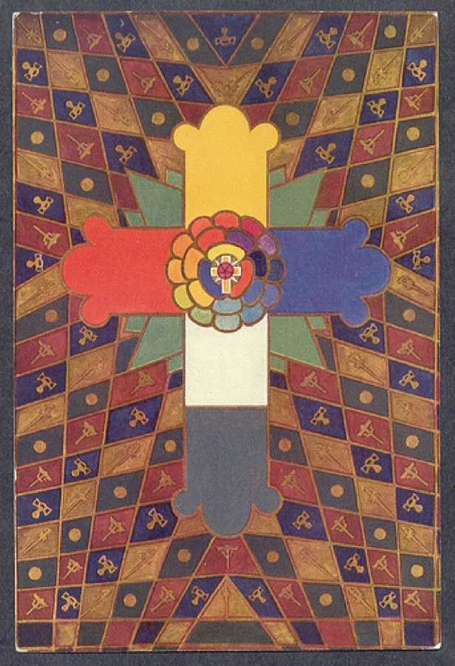

PART ONE

THE THEORY OF THE TAROT

1. The Contents of the Tarot; The Origin of the Tarot; The Theory of the correspondences of the Tarot; The Evidence for the Initiated Tradition of the Tarot; I. Eliphaz Levi and the Tarot; 2. The Tarot in the Cipher Manuscripts; 3. The Tarot and the "Hermetic Order of the Golden Dawn"; 4. The Nature of the Evidence; Summary of the Questions Hitherto Discussed.
2. The Tarot and the Holy Qabalah; The Naples Arrangement; The Tarot and the Formula of Tetragrammaton; The Tarot and the Elements; The Twenty-two Keys, Atu, or Trumps of the Tarot.
3. The Tarot and the Universe; Theories of the Ancients; The Tree of Life; The Naples Arrangement; The Tarot and the Tree of Life; The Atu of Tahuti; The Roman Numbers of the Trumps; The Tarot and Magick; The Shemhamphorasch and the Tarot; The Tarot and Ceremonial Magick; The Tarot and Animism; The Cards of the Tarot as Living Beings.

THE CONTENTS OF THE TAROT

THE TAROT is a pack of seventy-eight cards. There are four suits, as in modern playing cards, which are derived from it. But the Court cards number four instead of three. In addi­tion, there are twenty-two cards called “Trumps”, each of which is a symbolic picture with a title itself. At first sight one would suppose this arrangement to be arbitrary, but it is not. It is necessitated, as will appear later, by the structure of the universe, and in particular of the So­lar System, as symbolized by the Holy Qabalah. This will be explained in due course.

THE ORIGIN OF THE TAROT

The origin of this pack of cards is very obscure. Some authorities seek to put it back as far as the ancient Egyptian Mysteries; others try to bring it forward as late as the fifteenth or even the sixteenth century. But the Tarot certainly existed, in what may be called the classical form, as early as the fourteenth century; for packs of that date are extant, and the form has not varied in any notable respect since that time. In the Middle Ages, these cards were much used for fortune telling, especially by gypsies, so that it was customary to speak of the “Tarot of the Bohemians”, or “Egyptians”. When it was found that the gypsies, despite the etymology, were of Asiatic origin, some people tried to find its source in Indian art and literature. There is here no need to enter into any discussion of these disputed points.1

THE THEORY OF THE CORRESPONDENCES OF THE TAROT

Unimportant to the present purpose are tradition and authority. Einstein's Theory of Relativity does not rest on the fact that, when

1It is supposed by some scholars that the R.O.T.A. (Rota, a wheel) consulted in the Collegium ad Spiritum Sanctum—see the Manifesto “Fama Fraternitatis” of the Brothers of the Rosy Cross—was the Tarot.

his theory was put to the test, it was confirmed. The only theory of ultimate interest about the Tarot is that it is an admirable symbolic picture of the Universe, based on the data of the Holy Qabalah. It will be proper, later in this essay, to describe the Holy Qabalah somewhat fully, and to discuss relevant details. The part of it which is here relevant is called Gematria, a science in which the numerical value of a Hebrew word, each letter being also a number, links that word with others of the same value, or a multiple thereof. For example, AChD unity (1+8 +4) =13; and AHBH love (1+5+2+5)=13. This fact is held to indicate “The nature of Unity is Love”. Then IHVH Jehovah (10 +5+6+5) =26=2 X 13. Therefore: “Jehovah is Unity manifested in Duality.” And so forth. One important interpretation of Tarot is that it is a Notariqon of the Hebrew To­rah, the Law; also of ThROA, the Gate. Now, by the Yetziratic attributions—see table at end— this word may be read The Universe—the new-born Sun—Zero. This is the true Magical Doc­trine of Thelema: Zero equals Two. Also, by Gematria, the numerical value of ThROA is 671 =61 x 11. Now 61 is AIN, Nothing or Zero; and 11is the number of Magical Expansion; in this

way also, therefore, ThROA announces that same dogma, the only satisfactory philosophical explanation of the Cosmos, its origin, mode, and object. Complete mystery surrounds the question of the origin of this system; any theory which satisfies the facts demands assump­tions which are completely absurd. To explain it at all, one has to postulate in the obscure past a fantastic assembly of learned rabbins, who solemnly calculated all sorts of combinations of letters and numbers, and created the Hebrew language on this series of manipulations. This theory is plainly contrary, not only to common sense, but to the facts of history, and to all that we know about the formation of language. Nevertheless, the evidence is equally strong that there is something, not a little of something but a great deal of something, a something which excludes all reasonable theories of coincidence, in the correspondence between words and numbers.

It is an undeniable fact that any given number is not merely one more than the previ­ous number and one less than the subsequent number, but is an independent individual idea, a thing in itself; a spiritual, moral and intellectual substance, not only as much as, but a great deal more than, any human being. Its merely mathematical relations are indeed the laws of its being, but they do not constitute the number, any more than the chemical and physical laws of reaction in the human anatomy give a complete picture of a man.

THE EVIDENCE FOR THE INITIATED TRADITION OF THE TAROT

1. Eliphaz Levi and the Taro.

Although the origins of the Tarot are perfectly obscure, there is a very interesting piece of quite modern history, history well within the memory of living man, which is extremely significant, and will be found, as the thesis develops, to sustain it in a very remarkable wav. In the middle of the nineteenth century, there arose a very great Qabalist and scholar, who still annoys dull people by his habit of diverting himself at their expense by making fools of them posthumously. His name was Alphonse Louis Constant, and he was an Abbe of the Roman Church. For his “nom-de-guerre” he translated his name into Hebrew—Eliphas Levi Zahed, and he is very generally known as Eliphas Levi. Eliphas Levi was a philosopher and an artist, besides being a supreme literary stylist and a practical joker of the variety called “Pince sans rire”; and, being an artist and a profound symbolist, he was immensely attracted by the Tarot. While in England, he proposed to Kenneth Mackenzie, a famous occult scholar and high-grade Freemason, to reconstitute and issue a scientifically-designed pack. In his works are new presentations by him of the trumps called Tile Chariot and The Devil. He seems to have un­derstood that the Tarot was actually a pictorial form of the Qabalistic Tree of Life, which is the basis of the whole Qabalah, so much so that he composed his works on this basis. He wished to write a complete treatise on Magick. He divided his subject into two parts—Theory and Practice which he called Dogma and Ritual. Each part has twenty-two chapters, one for each of the twenty-two trumps; and each chapter deals with the subject represented by the picture displayed by the trump. The importance of the accuracy of the correspondence will appear in due course. Here we come to a slight complication. The chapters correspond, but they corre­spond wrongly; and this is only to be explained by the fact that Levi felt himself bound by his original oath of secrecy to the Order of Initiates which had given him the secrets of the Tarot.

1. The Tarot in the Cipher Manuscripts

At the time of the French Renaissance of the eighteen-fifties, a similar movement took place in England. Its interest centred in ancient religions, and their traditions of initiation and thaumaturgy. Learned societies, some secret or semi-secret, were founded or revived. Among the members of one such group, the Quatuor Coronati Lodge of Freemasonry, were three men: one, Dr. Wynn Westcott, a London coroner; a Dr. Woodford, and a Dr. Woodman. There is a lit­tle dispute as to which of these men went to the Farringdon Road, or whether it was the Far- ringdon Road to which they went; but there is no doubt whatever that one of them bought an old book, either from an obscure bookseller, or off a barrow, or found it in a library. This hap­pened about 1884 or 1885. There is no dispute that in this book were some loose papers; that these papers turned out to be written in cipher; that these cipher manuscripts contained the material for the foundation of a secret society purporting to confer initiation by means of rit­ual; and that among these manuscripts was an attribution of the trumps of the Tarot to the letters of the Hebrew alphabet. When this matter is examined, it becomes quite clear that Levi’s wrong attribution of the letters was deliberate; that he knew the right attribution, and considered it his duty to conceal it. (It made much trouble for him to camouflage his chap­ters!)

The cipher manuscripts were alleged to date from the earliest years of the nineteenth century; and there is a note to one page which seems to be in the writing of Eliphas Levi. It appears extremely probable that he had access to this manuscript on his visit to Bulwer Lyt- ton, in England. In any case, as previously observed, Levi shows constantly that he knew the correct attributions (with the exception, of course, of Tzaddi—why, will be seen later) and tried to use them, without improperly revealing any secrets which he was sworn not to dis­close.

As soon as one possesses the true attributions of these trumps, the Tarot leaps into life. One is intellectually knocked down by the rightness of it. All the difficulties created by the tra­ditional attributions as understood by the ordinary scholar, disappear in a flash. For this rea­son, one is inclined to credit the claim for the promulgators of the cipher manuscript, that they were guardians of a tradition of Truth.

“this correspondence must now cease”, but that if they wanted more advanced knowledge they could perfectly well get it by using in the proper

xAn impudent mushroom swindle, calling itself “Order of Hidden Masters”, has recently appeared—and disappeared.

manner the knowledge which they already possessed. In other words, they must utilize their magical powers to make contact with the Secret Chiefs of the Order. (This, incidentally, is a quite normal and traditional mode of procedure.)

Shortly afterwards, Mathers, who had manoeuvred himself into the practical Headship of the Order, announced that he had made this link; that the Secret Chiefs had authorized him to continue the work of the Order, as its sole head. There is, however, no evidence that he was here a witness of truth, because no new knowledge of any particular importance came to the Order; such as did appear proved to be no more than Mathers could have acquired by normal means from quite accessible sources, such as the British Museum. These circumstances, and a great deal of petty intrigue, led to serious dissatisfaction among the members of the Order. Frl. Sprengel’s judgment, that group-working in an Order of this sort is possible, was shown in this case to be wrong. In 1900, the Order in its existing form was destroyed.

The point of these data is simply to show that, at that time, the main preoccupation of all the serious members of the Order was to get in touch with the Secret Chiefs themselves. In 1904 success was attained by one of the youngest members, Frater Perdurabo. The very full­est details of this occurrence are given in The Equinox of the Gods.1 It is not here useful to dis­cuss the evidence which goes to establish the truth of this claim. But it is to be observed that it is internal evidence. It exists in the manuscript itself. It would make no difference if the statement of any of the persons concerned turned out to be false.

1. The Nature of the Evidence

These historical digressions have been essential to the under-standing of the condi­tions of this enquiry. It is now proper to con-

1Consult especially pp. 61 to 119. The message of the Secret Chiefs is even in the **Book of the Law** which has been published privately for initiates, and publicly in The Equinox, Vol. I, No.7 and No.10; also, with full de­tails, in **The Equinox of the Gods,** pp. 13 to 38. In a pocket at the end of that volume is a photolithographic repro­duction of the manuscript. There is also a cheap pocket edition of the text of the Book by itself. There are also American Editions of the text.

sider the peculiar numbering of the Trumps. It appears natural to a mathematician to begin the series of natural numbers with Zero; but it is very disturbing to the non-mathematically trained mind. In the traditional essays and books on the Tarot, the card numbered “0” was supposed to lie between the cards XX and XXI. The secret of the initiated interpretation, which makes the whole meaning of the Trumps luminous, is simply to put this card marked “0” in its natural place, where any mathematician would have put it, in front of the number One. But there is still one peculiarity, one disturbance in the natural sequence. This is that the cards VIII and XI have to be counterchanged, in order to preserve the attribution. For the card XI is called “Strength”; on it appears a Lion, and it quite evidently refers to the zodiaca1 sign Leo, whereas the card VIII is called “Justice”, and represents the conventional symbolic figure, throned, with sword and balances, thus obviously referring to tile zodiacal sign of Libra, the Balance.

Frater Perdurabo had made a very profound study of the Tarot since his initiation to the Order on 18th November, 1898; for, three months later, he had attained the grade of Prac- ticus; as such, he became entitled to know the Secret Attribution. He constantly studied this and the accompanying explanatory manuscripts. He checked up on all these attributes of the numbers to the forms of nature, and found nothing incongruous. But when (8th April, 1904 e.v.) he was writing down the Book of the Law from the dictation of the messenger of the Se­cret Chiefs, he seems to have put a mental question, suggested by the words in Chapter I, verse 57: “the law of the Fortress, and the great mystery of the House of God” (“The House of God” is one name of the Tarot Trump numbered XVI) to this effect: “Have I got these attribu­tions right?” For there came an interpolated answer, ‘All these old letters of my book are aright; but x is not the Star. This also is secret; my prophet shall reveal it to the wise”. This was exceedingly annoying. If Tzaddi was not “the Star”, what was? And what was Tzaddi? He tried for years to counter-change this card, “The Star”, which is numbered XVII, with some other. He had no success. It was many years later that the solution came to him. Tzaddi is “The Em­peror”; and therefore the positions of XVII and IV must be counterchanged. This attribution is very satisfactory.

Yes, but it is something a great deal more than satisfactory; it is, to clear thought, the most convincing evidence possible that the Book of ‘he Law is a genuine message from the Se­cret Chiefs.

For “The Star” is referred to Aquarius in the Zodiac, and “The Emperor’ to Aries. Now Aries and Aquarius are on each side of Pisces, just as Leo and Libra are on each side of Virgo; that is to say, the correction in the Book of the Law gives a perfect symmetry in the zodiacal attribution, just as if a loop were formed at one end of the ellipse to correspond exactly with the existing loop at the other end. These matters sound rather technical; in fact, they are; but the more one studies the Tarot, the more one perceives the admirable symmetry and perfec­tion of the symbolism. Yet, even to the layman, it ought to be evident that balance and fitness are essential to any perfection, and the elucidation of these two tangles in the last 150 years is undoubtedly a very remarkable phenomenon.

SUMMARY OF THE QUESTIONS HITHERTO DISCUSSED

1. The origin of the Tarot is quite irrelevant, even if it were certain, It must stand or fall as a system on its own merits.
2. It is beyond doubt a deliberate attempt to represent, in pictorial form, the doctrines of the Qabalah.
3. The evidence for this is very much like the evidence brought forward by a person doing a crossword puzzle. He knows from the “Across” clues that his word is “SCRUN blank H”; so it is certain, beyond error, that the blank must be a “C”
4. These attributions are in one sense a conventional, symbolic map; such could be in­vented by some person or persons of great artistic imagination and ingenuity combined with almost unthinkably great scholarship and philosophical clarity.
5. Such persons, however eminent we may suppose them to have been, are not quite capable of making a system so abstruse in its entirety without the assistance of superiors whose mental processes were) or are, pertaining to a higher Dimension.

One might take, by way of an analogy, the game of chess. Chess has developed from very simple beginnings. It was a mimic battle for tired warriors; but the subtleties of the mod­ern game—which have now, thanks to Richard Reti, gone quite beyond calculation into the world of aesthetic creation—were latent in the original design. The originators of the game were “building better than they knew” It is of course possible to argue that these subtleties have arisen in the course of the development of the game; and indeed it is quite clear, histori­cally, that the early players whose games are on record had no conscious conception of any­thing beyond a variety of rather crude and elementary stratagems. It is quite possible to argue that the game of chess is merely one of a number of games which has developed while other games died out, because of some accident. One can argue that it is merely by chance that modern chess was latent in the original game.

The theory of inspiration is really very much simpler, and it accounts for the facts without violation of the law of parsimony.

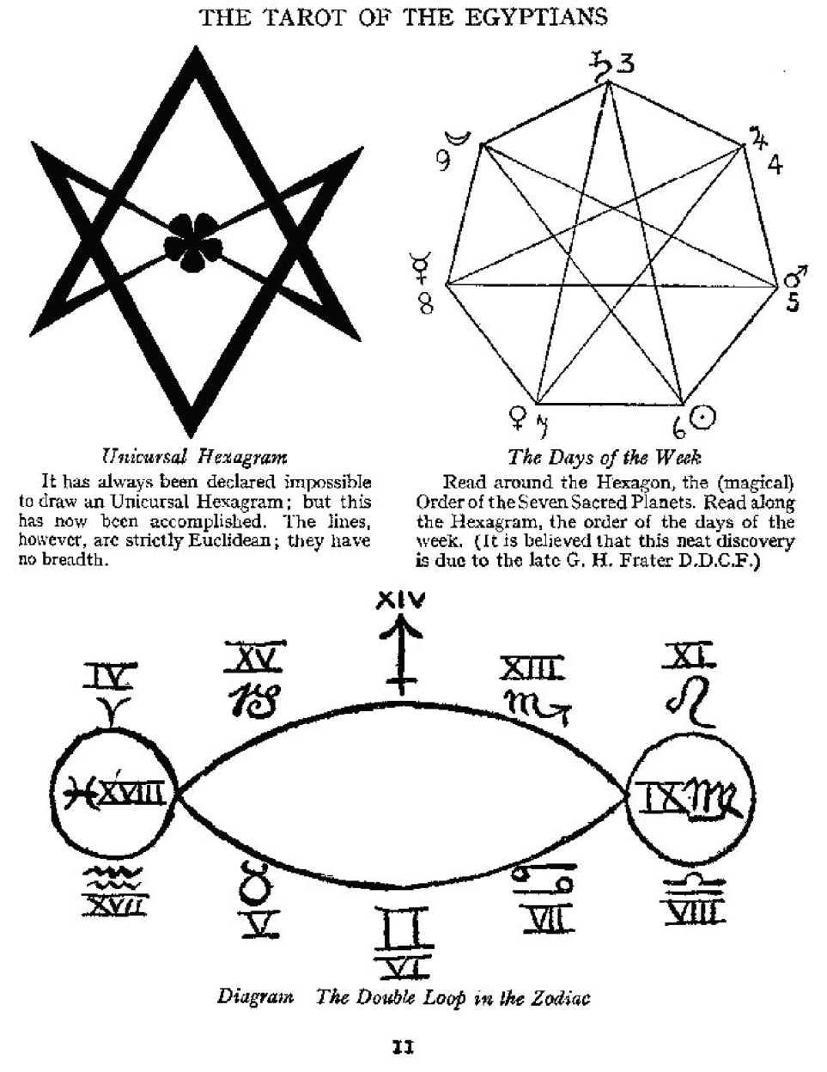

THE TAROT AND THE HOLY QABALAH

THE NEXT issue is the Holy Qabalah. This is a very simple subject, and presents no dif­ficulties to the ordinary intelligent mind. There are ten numbers in the decimal system; and there is a genuine reason why there should be ten numbers, and only ten, in a numerical sys­tem which is not merely mathematical, but philosophical. It is necessary, at this point, to in­troduce the “Naples Arrangement”. But first of all, one must understand the pictorial repre­sentation of the Universe given by the Holy Qabalah. (See diagram.)

This picture represents the Tree of Life, which is a map of the Universe. One must be­gin, as a mathematician would, with the idea of Zero, Absolute Zero, which turns out on ex­amination to mean any quantity that one may choose, but not, as the layman may at first sup­pose, Nothing, in the “absence-of-anything” vulgar sense of the word. (See “Berashith”, Paris, 1902).

“THE NAPLES ARRANGEMENT”

The Qabalists expanded this idea of N othing, and got a second kind of Nothing which they called ‘Ain Soph”—’’Without Limit”. (This idea seems not unlike that of Space.) They then decided that in order to interpret this mere absence of any means of definition, it was neces­sary to postulate the Ain Soph Aur—’’Limitless Light”. By this they seem to have meant very much what the late Victorian men of science meant, or thought that they meant, by the Lumi- niferous Ether. (The Space-Time Continuum?)

All this is evidently without form and void; these are abstract conditions, not positive ideas. The next step must be the idea of Position. One must formulate this thesis: If there is anything except Nothing, it must exist within this Boundless Light; within this Space; within this inconceivable Nothingness, which cannot exist as Nothingness, but has to be conceived of as a Nothingness composed of the annihilation of two imaginary opposites. Thus appears The Point, which has “neither parts nor magnitude, but only position”.

But position does not mean anything at all unless there is something else, some other position with which it can be compared. One has to describe it. The only way to do this is to have another Point, and that means that one must invent the number Two, making possible The Line.

But this Line does not really mean very much, because there is yet no measure of length. The limit of knowledge at this stage is that there are two things, in order to be able to talk about them at all. But one cannot say that they are near each other, or that they are far apart; one can only say that they are distant. In order to discriminate between them at all, there must be a third thing. We must have another point. One must invent The Surface; one must invent The Triangle. In doing this, incidentally, appears the whole of Plane Geometry. One can now say, “A is nearer to B than A is to C”.

But, so far, there is no substance in any of these ideas. In fact there are no ideas at all, except the idea of Distance and perhaps the idea of Between-ness, and of Angular Measure­

ment; so that Plane Geometry, which now exists in theory, is after all completely inchoate and incoherent. There has been no approach at all to the conception of a really existing thing. No more has been done than to make definitions, all in a purely ideal and imaginary world.

Now then comes The Abyss. One cannot go any further into the ideal. The next step must be the Actual—at least, an approach to the Actual. There are three points, but there is no idea of where any one of them. is. A fourth point is essential, and this formulates the idea of matter.

The Point, the Line, the Plane. The fourth point, unless it should happen to lie in the plane, gives The Solid. If one wants to know the position of any point, one must define it by the use of three co-ordinate axes. It is so many feet from the North wall, and so many feet from the East wall, and so many feet from the floor.

Thus there has been developed from Nothingness a Something which can be said to exist. One has arrived at the idea of Matter. But this existence is exceedingly tenuous, for the only property of any given point is its position in relation to certain other points; no change is possible; nothing can happen. One is therefore compelled, in the analysis of known Reality, to postulate a fifth positive idea, which is that of Motion.

This implies the idea of Time, for only through Motion, and in Time, can any event hap­pen. Without this change and sequence, nothing can be the object of sense. (It is to be noticed that this No.5 is the number of the letter He in the Hebrew alphabet. This is the letter tradi­tionally consecrated to the Great Mother. It is the womb in which the Great Father, who is rep­resented by the letter Yod which is pictorially the representation of an ultimate Point, moves and begets active existence).

There is now possible a concrete idea of the Point; and, at last it is a point which can be self-conscious, because it can have a Past, Present and Future. It is able to define itself in terms of the previous ideas. Here is the number Six, the centre of the system: self-conscious, capable of experience.

At this stage it is convenient to turn away for a moment from the strictly Qabalistic symbolism. The doctrine of the next three numbers (to some minds at least) is not very clearly expressed. One must look to the Vedanta system for a more lucid interpretation of the numbers 7, 8 and 9 although they correspond very closely with the Qabalistic ideas. In the Hindu analysis of existence the Rishis (sages) postulate three qualities: Sat, the Essence of Be­ing itself; Chit, Thought, or Intellection; and Ananda (usually translated Bliss), the pleasure experienced by Being in the course of events. This ecstasy is evidently the exciting cause of the mobility of existence. It explains the assumption of imperfection on the part of Perfection. The Absolute would be Nothing, would remain in the condition of Nothingness; therefore, in order to be conscious of its possibilities and to enjoy them, it must explore these possibilities. One may here insert a parallel statement of this doctrine from the document called The Book of the Great Auk to enable the student to consider the position from the standpoint of two dif­ferent minds.

“All elements must at one time have been separate.—That would be the case with great heat.—Now, when the atoms get to the Sun, we get that immense, extreme heat, and all the elements are themselves again. Imagine that each atom of each element possesses the mem­ory of all his adventures in combination. By the way, that atom, fortified with memory, would not be the same atom; yet it is, because it has gained nothing from anywhere except this memory. Therefore, by the lapse of time and by virtue of memory, a thing could become some­thing more than itself; thus, a real development is possible. One can then see a reason for any element deciding to go through this series of incarnations, because so, and only so, can he go; and he suffers the lapse of memory which he has during these incarnations, because he knows he will come through unchanged.

“Therefore you can have an infinite number of gods, individual and equal though diverse, each one supreme and utterly indestructible. This is also the only explanation of how a Being could create a world in which War, Evil, etc., exist. Evil is only an appearance, because (like “Good”) it cannot affect the substance itself, but only multiply its combinations. This is something the same as Mystic Monotheism; but the objection to that theory is that God has to create things which are all parts of himself, so that their interplay is false. If we presuppose many elements, their interplay is natural.”

These ideas of Being, Thought and Bliss constitute the minimum possible qualities which a Point must possess if it is to have a real sensible experience of itself. These corre­spond to the numbers 9, 8 and 7. The first idea of reality, as known by the mind, is therefore to conceive of the Point as built up of these previous nine successive developments from Zero. Here then at last is the number Ten.

In other words, to describe Reality in the form of Knowledge, one must postulate these ten successive ideas. In the Qabalah, they are called “Sephiroth”, which means “Numbers”. As will be seen later, each number has a significance of its own; each corresponds with all phe­nomena in such a way that their arrangement in the Tree of Life, as shown in the diagrams (pp. 266, 268, 270), is a map of the Universe. These ten numbers are represented in the Tarot by the forty small cards.

THE TAROT AND THE FORMULA OF TETRAGRAMMATON

What, then, are the Court Cards? This question involves another aspect of the system of development. What was the first mental process? Obliged to describe Nothing, the only way to do so without destroying its integrity was to represent it as the union of a Plus Something with an equivalent Minus Something. One may call these two ideas, the Active and Passive, the Father and Mother. But although the Father and Mother can make a perfect union, thereby re­turning to Zero, which is a retrogression, they can also go forward into Matter, so that their union produces a Son and a Daughter. The idea works out in practice as a method of describ­ing how the union of any two things produces a third thing which is neither of them.

The simplest illustration is in Chemistry. If we take hydrogen gas and chlorine gas, and pass an electric spark through them, an explosion takes place, and hydrochloric acid is pro­duced. Here we have a positive substance, which may be called the Son of the marriage of these elements, and is an advance into Matter. But also, in the ecstasy of the union, Light and Heat are disengaged; these phenomena are not material in the same sense as the hydrochloric acid is material; this product of the union is therefore of a spiritual nature, and corresponds to the Daughter.

In the language of the alchemists, these phenomena were classified for convenience under the figure of four “elements”. Fire, the purest and most active, corresponds to the Fa­ther; Water, still pure but passive, is the Mother; their union results in an element partaking of both natures, yet distinct from either, and this they called ‘Air”.

One must constantly remember that the terms used by ancient and medieval philoso­phers do not mean at all what they mean nowadays. “Water” does not mean to them the chemical compound H2O; it is an intensely abstract idea, and exists everywhere. The ductabil- ity of iron is a watery quality.1 The word “element” does not mean a chemical element; it means a set of ideas; it summarises certain qualities or properties.

It seems hardly possible to define these terms in such a way as to make their meaning clear to the student. He must discover for himself by constant practice what they mean to him. It does not even follow that he will arrive at the same ideas. This will not mean that one mind is right and the other wrong, because each one of us has his own universe all to himself, and it is not the same as anybody else's universe. The moon that A. sees is not the moon that B., standing by him, sees. In this case, the difference is so infinitesimal that it does not exist in practice; yet there is a difference. But if A. and B look at a picture in a gallery, it is very much not the same picture to both, because A's mind has been trained to observe it by his experi­ence of thousands of other pictures; B. has probably seen an entirely different set of pictures. Their experience will coincide only in the matter of a few well-known pictures. Besides this, their minds are essentially different in many other ways. So, if A. dislikes Van Gogh, B. pities him; if C. admires Bougereau, D. shrugs his shoulders. There is no right or wrong about any matter whatsoever.

4ts magnetic virtue (similarly) is fiery, its conductivity airy, and its weight and hardness earthy. Yet, weight is but a function of the curvature of the “space-time Continuum”: “Earth is the Throne of Spirit.”

This is true, even in matters of the strictest science. The scientific description of an object is universally true; and yet it is not completely true for any single observer. The phenomenon called the Daughter is ambiguous. It has been explained above as the spiritual ingredient in the result of the marriage of the Father and the Mother; but this is only one interpretation.

THE TAROT AND THE ELEMENTS

The Ancients conceived of Fire; Water and Air as pure elements. They were connected with the three qualities of Being, Knowledge and Bliss, previously mentioned. They also cor­respond with what the Hindus called the Three Gunas—Sattvas, Rajas and Tamas, which may be translated roughly as “Calm”, “Activity”, and “Slothful Darkness”. The alchemists had three similar principles of energy, of which all existing phenomena are composed: Sulphur, Mercury and Salt. This Sulphur is Activity, Energy, Desire; Mercury is Fluidity, Intelligence, the power of Transmission; Salt is the vehicle of these two forms of energy, but itself possesses qualities which react on them.

The student must keep in his mind all these tripartite classifications. In some cases, one set will be more useful than others. For the moment, concentrate on the Fire, Water, Air series. These elements are represented in the Hebrew alphabet by the letters Shin, Mem and Aleph. The Qabalists call them the Three Mother Letters. In this particular group, the three elements concerned are completely spiritual forms of pure energy; they can only manifest in sensible experience by impinging upon the senses, crystallising out in a fourth element which they call “Earth”, represented by the last letter of the alphabet, Tau. This, then, is another quite different interpretation of the idea of the Daughter, which is here considered as a pendant to the Triangle. It is the number Ten suspended from the 7, 8, 9 in the diagram.

These two interpretations must be kept in mind simultaneously. The Qabalists, devis­ing the Tarot, then proceeded to make pictures of these extremely abstract ideas of Father, Mother, Son and Daughter, and they called them King, Queen, Prince and Princess. It is confus­ing, but they were also called Knight, Queen, King and Princess. Sometimes, too, the Prince and Princess are called “Emperor” and “Empress”.

The reason for this confusion is connected with the doctrine of the Fool of the Tarot, the legendary Wanderer, who wins the King’s daughter, a legend which is connected with the old and exceedingly wise plan of choosing the successor to a king by his ability to win the princess from all competitors. (Frazer’s Golden Bough is the authority on this subject.)

It has been thought better, for the present pack, to adopt the term “Knight”, “Queen”, “Prince” and “Princess”, to represent the series Father, Mother, Son, Daughter, because the doctrine involved, which is extraordinarily complex and difficult, demands it. The Father is “Knight” because he is represented as riding on a horse. It may make it more clear to describe the two main systems, the Hebrew and the Pagan, as if they were (and had always been) con­crete and separate.

The Hebrew system is straightforward and irreversible; it postulates Father and Mother from whose union issue Son and Daughter. There an end. It is only later philosophical speculation to derive the Father-Mother Dyad from a Unity manifest, and later still to seek the source of that Unity in Nothing. This is a concrete and limited scheme, crude, with its cause­less Beginning and its sterile End.

The Pagan system is circular, self-generated, self-nourished, self-renewed. It is a wheel on whose rim are Father-Mother-Son-Daughter; they move about the motionless axis of Zero; they unite at will; they transform one into another; there is neither Beginning nor End to the Orbit; none is higher or lower than another. The Equation “Naught=Many=Two=One=All=Naught” is implicit in every mode of the being of the System.

Difficult as this is, at least one very desirable result has been attained: to explain why the Tarot has four Court cards, not three. It also explains why there are four suits. The four suits are named as follows: “Wands”, attributed to Fire; “Cups”, to Water; “Swords”, to Air; and “Disks” (“Coins”, or “Pantacles”), to Earth. The student will notice this interplay and counter­change of the number 4. It is also important for him to notice that even in the tenfold ar­rangement, the number 4 takes its part. The Tree of Life can be divided into four planes: the number I corresponds to Fire; numbers 2 and 3, to Water; numbers 4 to 9, to Air; and the number 10 to Earth. This division corresponds to the analysis of Man. The number I is his spiritual essence, without quality or quantity; the numbers 2 and 3 represent his creative and transmissive powers, his virility and his intelligence; the numbers 4 to 9 describe his mental and moral qualities as concentrated in his human personality; the number 6, so to speak, is a concrete elaboration of the number I; and the number 10 corresponds to Earth, which is the physical vehicle of the previous nine numbers. The names of these parts of the soul are: I, Jechidah; 2 and 3, Chiah and Neschamah; 4 to 9, Ruach; and lastly 10; Nephesch.

These four planes correspond once more to the so-called “Four Worlds”, to understand the nature of which one should refer, with all due reservations, to the Platonic system. The number I is Atziluth, the Archetypal World; but the number 2, as being the dynamic aspect of the number I, is the Practical attribution. The number 3 is Briah, the Creative World in which the Will of the Father takes shape through the Conception of the Mother, just as the spermato­zoon, by fertilizing the ovum, makes possible the production of an image of its parents. The numbers 4 to 9 include Yetzirah, the Formative World, in which an intellectual image, an ap­preciable form of the idea, is produced; and this mental image becomes real and sensible in the number 10, Assiah, the Material World.

It is by going through all these confusing (and sometimes seemingly contradictory) at­tributions, with unwearying patience and persistent energy, that one comes at the end to a lucid understanding, to an understanding which is infinitely clearer than any intellectual in­terpretation could possibly be. This is a fundamental exercise in the way to initiation. If one were a shallow rationalist, it would be quite easy to pick holes in all these attributions and semi-philosophical hypotheses, or near-hypotheses; but it is also quite simple to prove by mathematics that it is impossible to hit a golf ball.

Hitherto, the main theme of this essay has been the Tree of Life, in its essence the Se- phiroth. It is now proper to consider the relations of the Sephiroth with each other. (See dia­gram in Appendix B—Correspondences.) It will be noticed that twenty-two lines are em­ployed to complete the structure of the Tree of Life. It will be explained in due course how it is that these correspond to the letters of the Hebrew alphabet. It will be remarked that in some respects the way in which these are joined up appears arbitrary. Notably, there is an equilat­eral triangle, which one would think would be a natural basis for the Operations of Philoso­phy, consisting of the numbers 1,4 and 5. But there are no lines joining 1and 4, or 1and 5. This is not an accident. Nowhere in the figure is there an erect equilateral triangle, although there are three equilateral triangles with the apex downwards. This is because of the original for­mula “Father, Mother, Son”, which is three times repeated in a descending scale of simplicity and spirituality. The number 1is above these triangles, because it is an integration of Zero and depends from the triple veil of the Negative.

Now the Sephiroth, which are emanations of the number 1, as already shown, are things-in-themselves, in almost the Kantian sense. The lines joining them are Forces of Na­ture, of a much less complete type; they are less abstruse, less abstract.

THE TWENTY-TWO KEYS, ATU, OR TRUMPS OF THE TAROT

Here now is an excellent example of the all-pervading doctrine of Equilibrium. The equation always reads ax2+bx +x=0. If it does not equal 0, it is not an equation. And so, when­ever any symbol loses importance in one place in the Qabalah, it gains in another. The Court cards and small cards form the skeletal structure of the Tarot in its principal function as a map of the Universe. But, for the special significance of the pack as a Key to magical formula, the twenty-two trumps acquire a peculiar importance.

To what symbols are they attributed? They cannot be related identically with any of the essential ideas, because that place is taken by the cards from 1 to 10. They cannot repre­sent primarily the Father, Mother, Son, Daughter complex in its fulness, because the Court cards have already taken that position. They are attributed as follows: the three Mother let­ters, Shin, Mem and Aleph, represent the three active elements; the seven so-called double let­ters, Beth, Gimel, Daleth, Kapli, Pe, Resh and Tau, represent the seven sacred planets. The re­maining twelve letters He, Van, Zain, Cheth, Teth, Yod, Lamed, Nun, Samekh, A’ain, Tzaddi and Qoph represent the Signs of the Zodiac.

There is a slight clotting or overlapping in this arrangement. The letter Shin has to do duty for both Fire and Spirit, in very much the same way as the number 2 partakes of the na­ture of the number 1; and the letter Tau represents both Saturn and the element of Earth. In these difficulties there is a doctrine.

But one cannot dismiss these twenty-two letters thus casually. The stone that the builders rejected becomes the head of the corner. These twenty-two cards acquire a personal­ity of their own: a very curious personality. It would be quite wrong to say that they represent a complete universe. They seem to represent certain rather curious phases of the universe. They do not seem essential factors in the structure of the universe. They change from time to time in their relation to current events. A glance at the list of their titles seems to show no longer the strictly philosophical and scientific spirit of austere classification that is found in the other cards. There leaps at us the language of the Artist. These names are, the Fool, the Juggler, the High Priestess, the Empress, the Emperor, the Hierophant, the Lovers, the Chariot, Lust, the Wheel of Fortune, Adjustment, the Hanged Man, Death, Art, the Devil, the House of God, the Star, the Moon, the Sun, the Aeon, the Universe. Obviously these are not plain, straightforward symbolic representations of the signs, elements and planets concerned. They are rather hieroglyphs of peculiar mysteries connected with each. One may begin to suspect that the Tarot is not a mere straightforward representation of the Universe in the impersonal way of the system of the Yi King. The Tarot is beginning to look like Propaganda. It is as if the Secret Chiefs of the Great Order, which is the guardian of the destinies of the human race, had wished to put forward certain particular aspects of the Universe; to establish certain especial doctrines; to declare certain modes of working, proper to the existing political situations. They differ; somewhat as a literary composition differs from a dictionary.

It has been very unfortunate, but quite unavoidable, to be obliged to go so far into ar­gument, and that this argument has involved so many digressions as a preliminary to a straightforward description of the pack. It may make it simpler to proceed to summarize the above statements.

Here is a simple statement of the plan of the Tree of Life. The numbers, or Things-in- Themselves, are ten, successive emanations from the triple veil of the Negative. The small cards numbered I to 10 correspond to the Sephiroth. These cards are shown in fourfold form, because they are not the pure abstract numbers, but particular symbols of those numbers in the universe of manifestation, which is, for convenience, classified under the figure of four elements.

The Court cards represent the elements themselves, each element divided into four sub-elements. For convenience, here follows a list of these cards:

Knight of Wands, Queen of Wands, Prince of Wands, Princess of Wands,

Fire of Fire Water of Fire Air of Fire Earth of Fire

Knight of Cups, Queen of Cups, Prince of Cups, Princess of Cups,

Knight of Swords, Queen of Swords, Prince of Swords, Princess of Swords,

Fire of Water Water of Water Air of Water Earth of Water

Fire of Air Water of Air Air of Air Earth of Air

Fire of Earth

Knight of Disks,

Queen of Disks, Water of Earth

Prince of Disks, Air of Earth

Princess of Disks, Earth of Earth

The Tarot trumps are twenty-two in number; they represent the elements between the Sephiroth or Things-in-Themselves, so that their position on the Tree of Life is significant. Here are one or two examples. The card called “The Lovers”, whose secret title is “The Chil­dren of the Voice, the Oracle of the Mighty Gods”, leads from the number 3 to the number 6. The number 6 is the human personality of a man; the number 3 is his spiritual intuition. Therefore, it is natural and significant that the influence of the 3 upon the 6 is that of the intu­itional or inspirational voice. It is the illumination of the mind and the heart by the Great Mother.

Consider again the card joining the number I to the number 6. This card is called “The High Priestess”, and is attributed to the Moon. The card represents the Heavenly Isis. It is a symbol of complete spiritual purity; it is initiation in its most secret and intimate form, de­scending upon the human consciousness from the ultimate divine consciousness. Looked at from below, it is the pure and unwavering aspiration of the man to the Godhead, his source. It will be proper to enter more fully into these matters when dealing separately with the cards in turn.

From the foregoing it will be clear that the Tarot illustrates, first of all, the Tree of Life in its universal aspect, and secondly, the particular comment illustrating that phase of the Tree of Life which is of peculiar interest to those persons charged with the guardianship of the human race at the particular moment of the production of any given authorised pack. It is therefore proper for those guardians to modify the aspect of the pack when it seems to them good to do so. The traditional pack has itself been subjected to numerous modifications, adopted for convenience. For instance: the Emperor and the Empress, in the medieval packs, were referred quite definitely to the Holy Roman Emperor and his Consort. The card origi­nally called “The Hierophant”, representing Osiris (as is shown by the shape of the tiara) be­came, in the Renaissance period, the Pope. The High Priestess came to be called “Pope Joan”, representing a certain symbolic legend which circulated among initiates, and became vulgar­ised in the fable of a Female Pope. More important still, “The Angel”, or “The Last Judgment”, represented the destruction of the world by fire. Its hieroglyph is, in a way, prophetic, for when the world was destroyed by fire on 21st March, 1904,1 one’s attention was inevitably called to the similarity of this card to the Stele of Revealing. This being the beginning of the New Aeon, it has seemed

**\*See The** Equinox of the Gods, **loc. cit.**

more fitting to show the beginning of the Aeon; for all that is known about the next Aeon, due in 2,000 years’ time, is that its symbol is the double-wanded one.1 But the new Aeon has pro­duced such fantastic changes in the settled order of things that it would be evidently absurd to attempt to carry on the outworn traditions, “the rituals of the old time are black.” It has consequently been the endeavour of the present Scribe to preserve those essential features of the Tarot which are independent of the periodic changes of Aeon, while bringing up to date those dogmatic and artistic features of the Tarot which have become unintelligible. The art of progress is to keep intact the Eternal; yet to adopt an advance-guard, perhaps m some cases almost revolutionary, position in respect of such accidents as are subject to the empire of Time.

xSee AL III, 34. The reference is to Maat, Themis, Lady of the Balance.

THE TAROT AND THE UNIVERSE

THE TAROT is a Pictorial representation of the Forces of Nature as conceived by the Ancients according to a conventional symbolism.

The Sun is a star. Around him revolve a number of bodies called planets, including the Moon, a satellite of the Earth.

These bodies revolve in one direction only. The Solar system is not a sphere, but a wheel. The planets do not remain in exact alignment but swing to a certain (comparatively small) extent from one side of the true plane to the other. Their orbits are elliptical.

The Ancients imagined this wheel very much more clearly than modern minds are wont to do. They paid particular attention to the imaginary rim. Within the limits of this rim, they conceived that the Fixed Stars beyond were in a special way connected with the apparent motion of the Sun. This rim or belt of the wheel they called the Zodiac. The constellations out­side this belt did not seem to them to matter so much to mankind, because they were not in the direct line of the great whirling force of the wheel. (T.A.R.O. = R.O.T.A. = wheel.)

THEORIES OF THE ANCIENTS

1. In old times, it was supposed that the Earth was the centre of the Universe. The Heavens being above the Earth—they did not realise them as being equally below it—they were accounted as of the Divine Nature. And as they recognised imperfections and irregular­ity in mundane affairs, they thought that the movements of the Heavenly Bodies, which they observed to be regular, must be perfect.

They then started some a priori thinking. Their mathematicians had the idea that a Cir­cle was a perfect figure; therefore (they said, with characteristic theological reasoning) all heavenly bodies must move in circles.1 This religious assumption caused great trouble to the astronomers. As their measurements became more extended and accurate, they found it in­creasingly difficult to reconcile observation with theory, at least to do so without putting themselves to vast inconvenience in their calculations. So they invented “cycles” and “epicy­cles” to explain the observed movements. Ultimately Copernicus was goaded by this annoy­ance to suggest that it would really be very much more convenient (if only the idea were not so wicked) to imagine that the Sun, and not the Earth, was the

1rThey did not understand that the Circle is only one case of the Ellipse: that in which the foci coincide. centre of the System.

In mathematics there are no fixed facts. Bertrand Russell says that in this subject “no­body knows what he is talking about, and it matters to nobody whether he is right or wrong”.

For example: Begin with the assumption that the Moon is the immovable centre of the Universe. Nobody can contradict it; one simply switches the calculations over to suit. The practical objection to this is that it would not facilitate the work of navigators.

It is important to have this idea in one’s mind, because otherwise one fails to grasp the whole spirit of modern Science-Philosophy. It does not aim at Truth; it does not conceive of Truth (in any ordinary sense of the word) as possible; it aims at maximum convenience.

1. To return to the picture of the Solar System. The Sun is the Hub of the Wheel; the outermost Planet is on its rim; and beyond, but laterally within that rim, are the Twelve Con­stellations of the Zodiac. Why twelve? The first rough division of the circle is into four, accord­ing to the observed seasons. This choice may also have been influenced by the division of the Elements into Four—Fire, Air, Water, Earth. (These do not mean the objects now understood by these words, as explained above.)

Perhaps because they thought it necessary to introduce so sacred a number as Three into everything heavenly, or else because the observed constellations happened to be natu­rally divided into twelve groups, they divided the Zodiac into twelve signs, three to each Sea­son.

The Influence of the Sun upon the Earth was observed to change as He passed through the Signs. So did quite simple things like the measure of time between Sunrise and Sunset.

When one says that the Sun enters the Sign of Aries, one means that if a straight line were drawn from the Earth to the Sun and pro-longed to the Stars, that line would pass through the beginning of that Constellation. Suppose, for instance, that one observes the Full Moon on the first day of Spring, one will be able to see, behind her, the stars of the beginning of Libra, the sign opposite to Aries.

It was observed that the Moon took approximately twenty-eight days to pass from Full to Full; and to each day was assigned what was called a Mansion. Her mysterious influence was supposed to change in each Mansion. This theory does not enter directly into the Tarot, but it must be mentioned to help to clear up a certain confusion which is about to complicate the question.

A short digression. One of the most important doctrines of the Ancients was that of the Macrocosm and the Microcosm. Man is himself a little Universe; he is a minute copy of the big Universe. This argument was, of course, worked backwards; so the characteristics above given of the qualities of the Three Decans in the sign were probably due to an analogy with the course of a man’s life.

1. The above remarks constitute a fairly complete idea of the arbitrary, or mostly arbi­trary, presentation of the Cosmos by the Ancients. First of all, the division into Four Elements. These Elements pervade everything. They would argue something like this about the Sun. They would say that he was principally Fire, for obvious reasons; but he would have also in him the Airy quality of Mobility. The Watery part would be shown by his power to create Im­ages; and the Earthy part, his immense Stability.

Similarly, of a Serpent, they would call his power of Death fiery; his Swiftness, airy; his undulatory motion, Watery; and his habit of life, Earthy.

These descriptions are obviously quite inadequate; they have to be filled up by attrib­uting planetary qualities and zodiacal qualities to all objects. Thus, the Bull in the Zodiac is an Earthy sign, and this is the central sign of the three through which the Sun passes during Spring. But the bovine nature is also gentle; wherefore they said that Venus rules the Sign of Taurus. The Cow, moreover, is the principal milk-giving animal, so they made her the Great Mother-Goddess, thus identifying her with the Moon, the Mother of Heaven as the Sun is the Father. They represented this idea by saying that the Moon is “exalted” in Taurus—that is, that she exerts the most beneficent aspect of her influence when she is in that sign.

fect balance, the Sun and the Moon in imperfect balance, and the Four Elements in unbalanced form. (See diagram: The Chinese Cosmos.) This Chinese arrangement is thus tenfold, and has been shown to be admirably equivalent to the System which has been here examined.

1. The ancient scheme of the Elements, Planets and Zodiacal Signs, was summarised by the Qabalists in their Tree of Life.

This identity between the two systems was masked, until quite recently1, by the fact that the Chinese continued with their doubling-up system, and so turned their eight trigrams into sixty-four hexagrams, while the scholars of Western Asia joined together their ten num­bers on the Tree of Life by twenty-two Paths.

The Chinese have thus sixty-four principal symbols as against the thirty-two of the Tree; but the Qabalists have a concatenation of symbols which is capable of very subtle inter­pretation and handling. It is also better fitted to describe the internal relations of its Elements. Moreover, each can be multiplied or subdivided at will. as convenience may require.

THE TREE OF LIFE

1. This figure must be studied very carefully, for it is the basis of the whole system on which the Tarot is based. It is quite impossible to give a complete explanation of this figure, because (for one thing) it is quite universal. Therefore it cannot mean the same to any one person as to any other. A’s universe is not B’s universe. If A and B are sitting opposite each other at table, A sees the right side of the lobster, and B the left. If they stand side by side and look at a star, the angle is different; although this difference is infinitesimal, it exists. But the Tarot is the same for all in the same way in which any scientific fact or formula is the same for all. It is most important to remember that the facts of science, though universally true in the abstract, are still not precisely true for any one observer, because even if the observation of any common object is made by two people

1rThe present author discovered this fact during his study—still incomplete—of the Yi King.

of identical sensory reactions from the same spot, it cannot be done directly at the same time; and even the smallest fraction of a second is sufficient to move both object and observer in space.

This fact is to be emphasised, because one must not take the Tree of Life as a dead fixed formula. It is in a sense an eternal pattern of the Universe, just because it is infinitely elastic; and it is to be used as an instrument in one’s researches into Nature and her forces. It is not to be made an excuse for Dogmatism. The Tarot should be learnt as early in life as possible; a ful­crum for memory and a schema for mind. It should be studied constantly, a daily exercise; for it is universally elastic and grows in proportion to the use intelligently made of it. Thus it be­comes a most ingenious and excellent method of appreciating the whole of Existence.

Further, the attempt to describe Reality by a single definite term has been abandoned. Modern thought conceives Reality under the image of a ring of ten ideas, such as Potential, Matter, and so on. Each term has no meaning in itself; it can only be understood in terms of the others. This is exactly the conclusion which appears earlier in this essay, with regard to the way in which the planets, elements and signs were all dependent on each other, and composed of each other.

But the further attempt to reach Reality led the Qabalists to sum up the qualities of these rather vague and literary ideas by referring them all to the numbers of the decimal scale.

Numbers, then, are the nearest approach to Reality which is shown in this system. The number 4, for instance, is not so specially the result of adding one to three, or squaring two, or halving eight. It is a thing in itself, with all sorts of moral, sensible, and intellectual qualities. It symbolises such ideas as Law, Restraint, Power, Protection and Stability.

In the Qabalistic system the original idea is Zero,1 which appears under three forms, rather as (in Chinese philosophy) the Tao becomes manifested little by little through the Teh, or as (in the best of the Hindu systems) the god of Destruction and Annihilation, Shiva, be­comes manifested through the Infinite Energy, Sakti. The system begins therefore with Ain— Nothing, Ain Soph—Without Limit, and Ain Soph Aur—the Limitless Light.

One may now proceed to imagine any point in this “light”, to select it for observation; the fact of doing so makes it Positive. This gives the number 1, which is called Kether, the Crown. The other numbers arise by reason of the necessity of thought, as explained in the fol­lowing table:

THE NAPLES ARRANGEMENT[1]

61=0.

61+146=0 as Undefined (Space).

61+146+207=0 as basis of Possible Vibration.

1. The Point: Positive yet indefinable,
2. ,, ,, Distinguishable from 1 other.
3. ,, ,, Defined by relation to 2 others.

The Abyss—between Ideal and Actual.

1. The Point: Defined by 3 co-ordinates: Matter.
2. Motion (time)—He, the Womb; for only through Motion and in Time can events oc­cur.
3. The Point: now self-conscious, because able to define itself in terms of above.
4. The Point’s Idea of Bliss (Ananda).
5. ,, ,, ,, ,, Thought (Chit).
6. ,, ,, ,, ,, Being (Sat).
7. ,, ,, ,, ,, Itself fulfilled in its complement, as determined by 7, 8

and 9.

It will be seen from the above that by means of these ten positive

4t is intentional to repeat here, in other language, the ideas explained already in this essay. 2So called because first worked out in that city.

numbers, but not by any lesser number, one can arrive at a positive description of any given object or idea.

So far, the argument has been erected on a rigid, mathematical basis, with only the slightest tincture of philosophy to give it form. But it is at this point that, for the purpose of describing the objects Thought and Sense, one is compelled to join hands with the astrologers. The problem now is: to assign to Pure Number the moral ideas which go with it. This is partly a matter of experience, partly tradition derived from older experience. It would be unwise to discard tradition with complete contempt, because all thinking is bound by the laws of the mind itself, and Mind has been formed rough thousands of years of evolution in each man by the thoughts of his ancestors. The cells of all living brains are just as much the children of the great thinkers of the past as the development of the organs and limbs.

There are very few people today who have heard of Plato and Aristotle. Not one in a thousand, perhaps ten thousand, of those have ever read either of them, even in translations. But there are also very few people whose thinking, such as it is, is not conditioned by the ideas of those two men.

In the Tree of Life, therefore, is found the first attempt to connect the Ideal with the Ac­tual. The Qabalists say, for example, that the number 7 contains the idea of Venus, and the number 8 that of Mercury, that the connecting path between I and 6 refers to the moon, and that between 3 and 6 to the Sign of Gemini.

Then what is the true meaning, in the category of the Real, of these planets and signs? Here again one is faced with the impossibility exact definition, because the possibilities of re­search are infinite; also, at any moment in any research, the one idea merges into the her and clouds the exact definition of the images. But this, of course, is the objective. These are all blind steps on the way to the Great Light: when the Universe is perceived as one, yet with all its parts, each necessary and each distinct.

The beginning of this work is, however, easy enough. One requires no more than ele­mentary classical knowledge. Roughly taking, for a start, the natures of the planets are de­scribed by those of the gods after whom the actual bodies in heaven were named, according to the old astrological ideas of their influence on the affairs of men. The same is true, to a less extent, of the Signs of the Zodiac. There is not so much information available about their na­tures; but it is helpful to note which planet rules which sign, and in which sign which planets are exalted. The individual Fixed Stars do not enter into the system of the Tarot.

THE TAROT AND THE TREE OF LIFE

The Tarot, while based on these theoretical attributions, was designed as a practical instrument for Qabalistic calculations and for divination. In it is little place for abstract ideas. The subject of the book—the Tarot is called The Book of Thoth or Tahuti—is the influence of the Ten Numbers and the Twenty-two Letters on man, and his best methods of manipulating their forces. There is therefore no mention of the Three Veils of the Negative, which was dis­cussed in the description of the Tree of Life. The description begins with the “small cards”, numbered I to 10. These are divided into four suits according to the four elements.

Thus the Ace of Wands is called the Root of the Forces of Fire. It pertains to Kether, and purports to represent the first positive manifestation of the idea of Fire.

The 2 pertains to Chokmah. But here is already no more the simplicity of the idea of fire. An Idea in action or in manifestation is no more the pure Idea.

This card is attributed to the first Decan of the fiery sign Aries, which is ruled by Mars; this, then, gives the idea of a violent and aggressive force. The card is therefore called the Lord of Dominion. This progressive degradation of the idea of Fife goes on increasing through the suit. Each successive card becomes less ideal and more actual, increasingly so until, with the number 6 which corresponds to the Sun, the centre of the whole system, the fiery idea re­surges, balanced; hence pure, although complex. Beyond this, the force is beginning to expend itself, or to spiritualise itself, in the cards of the Decan of Sagittarius. But the best fixation of the fiery force is found in the 9, which number is the foundation of the structure of the Tree of life. Thus the card is called The Lord of Strength. The fire has been purified, etherealised and balanced. But in the 10, showing complete materialisation and nimiety, the effect of fire is pushed to its extreme limit. Its death is impending, but it reacts against this as best it can by appearing as the Lord of Oppression, formidable on the surface, but with the seeds of decay already sprouting. The above summary can easily be applied by the student to the other suits.

The Court cards are sixteen in number, four to each suit. There is thus a subdivision of each element into its own system. The Knights represent the element of Fire, so that the Knight of Wands represents the fiery part of Fire, the Knight of Cups, the fiery part of Water. Similarly the Princesses or Empresses represent Earth, so that the Empress of Disks (Coins, or Pantacles) represents the earthy part of Earth.

These cards have many manifestations in natural phenomena. Thus, the Knight of Wands has the attribution of Aries, and represents swift violence of onset, the lightning flash. But the airy part of Fire is sympathetic with Leo, the steady force of energy, the Sun. I,astly, in the watery part of Fire, the harmony is with Sagittarius, which shows the fading, spiritualised reflection or translucence of the image of Fire, and this suggests the Rainbow. (See table of the Triplicities of the Zodiac).

THE ATU OF TAHUTI1

*Or: The Twenty-two Houses of Wisdom,*

*Or: The Twenty-two Trumps of the Tarot.*

Twenty-two is the number of the letters of the Hebrew alphabet. It is the number of the Paths of the Sepher Yetzirah. These paths are the paths which join the ten numbers on the figure called the Tree of Life.

Why are there twenty-two of them? Because that is the number of the letters of the Hebrew alphabet, and one letter goes to each path.

Why should this be so? Why should these paths be arranged on the Tree in the way that the diagram shows? Why should there not be paths connecting the numbers 2 and 5 and the numbers 3 and 4?

One cannot answer any of these questions. Who knows “How A got leave an ox to be, No camel, quoth the Jews, like G”. (Browning)? One knows only that this was the conventional arrangement adopted by whoever it was that devised the Tarot.

What is worse, it seems very confusing, very annoying; it shakes one’s faith in these great sages. But at least there is no doubt that this is so.

The letters of the Hebrew alphabet are twenty-two. There are three “ Mother” Letters for the Elements, seven “Double Letters” for the Planets, and twelve “Single” Letters for the Signs of the Zodiac.

But there are four Elements, not three. Or, including the element of Spirit (an impor­tant matter to initiates), there are five.

There are therefore two letters of the alphabet which have to do double duty. The ele­ment of Fire is very close kin to the idea of Spirit; so the letter Shin, belonging to Fire, may be taken to mean Spirit as well. There is a special reason why this should be so, although it only applies in later ages, since the introduction of the dogma that Spirit rules the four elements, and the formation of the “Pentagram of Salvation” connected with the Hebrew word IHShVH, Yeheshuah.

With regard to Earth, it was considered adequate to make the letter Tau, belonging to Saturn, correspond also to Earth.

These additions are clear evidence that the Tarot took definite and arbitrary steps to assert the new discovery in Magick some two thousand years ago; for no system is more rigid than a Hebrew system. And the system of the Sepher Yetzirah is the deepest rooted of all the ele­ments of the Hebrew system, the most dogmatic of them all.

The Tarot is justified not by faith, but by works. The departures from the original bone- dry Qabalah have been justified by experience. The point (raised above) about the way in which the paths are selected to join certain numbers and not others, is found to express im­portant doctrines connected with the facts of initiation. It must always be

*Atu: House or Key, in Ancient Egyptian. Tahuti: Egyptian God of Wisdom, magick, Science, also Illusion. In Coptic, Thoth: in Greek, Hermes: in Latin, Mercury. The Hindu and Scandinavian Gods corresponding are de­based forms.

borne in mind that the Tarot is not only an atlas for recording facts, but a guide-book showing one how to travel through these countries previously unknown.

Travellers in China are somewhat bewildered at first when they are told that it is 100 li from Yung Chang to Pu Peng, but only 40 li from Pu Peng to Yung Chang. The answer is that the li is a measure of the time of marching, not of miles. The difference of calculation informs one that Pu Peng is a long way up the hill.

It is very much the same with the Tarot. The 6 of Wands is referred to Jupiter in Leo, and called the Lord of Victory. This dictates not only what victory is like, but also the condi­tions to be fulfilled in order to obtain victory. There is need of the fiery energy of the suit of Wands, the balance of the number 6, the stubborn courage of Leo, and also the influence of Jupiter, the little bit of luck that tips the scale.

These considerations are particularly important in dealing with the Atu, or Trumps. The Planets are already represented in the numbers or Sephiroth of the Tree of Life. But they have also attributions to certain of the Paths.

Some etymologists of a singularly idle disposition have tried to derive the French word “atout” from the ATU meaning House. It may seem simpler to suggest that “atout” is short for “bon atout”, meaning “good for anything”, because a Trump will take any card of any suit.

The Atu of Tahuti, who is the Lord of Wisdom, are also called Keys. They are guides to conduct. They give you the map of the Kingdom of Heaven, and also the best way to take it by force. A complete understanding of any magical problem is necessary before it can be solved. Study from outside, and action from outside, are ways abortive.

It is of the utmost importance to understand this extremely specialised character of the Trumps.

To say that the Trump numbered III, called The Empress, represents Venus, means something much less and also much more ‘than appears if Venus be studied from a strictly as­trological standpoint. One abandons the contemplation of the whole in order to take practical advantage of a part. J ust so Tactics differs from Strategy. A great general does not think of war in the abstract, but confines his attention to a minute part of his perhaps vast knowledge of the subject by considering the disposition of his forces at a given place and hme, and how best to employ them against his adversary. Thi5 is of course true not only of the Trumps, but of all the other cards; and it must be true of any specialised studies. If one goes into a shop and asks for a map of a certain country, one cannot get a complete map, because any such map would necessarily merge into the Universe as it approached completeness, for a country’s character is modified by the adjacent countries, and so on for ever. Nor would even any useful map be complete in the most vulgar practical way without leading to confusion. The shopman would want to know whether his customer wanted a geological map, an orographical map, a com­mercial map, a map showing the distribution of population, or a strategic map; and so on for ever.

The student of the Tarot must not therefore expect to find anything beyond a careful selection of the facts about any given card, a selection made for a quite definite magical pur­pose.

However, the Tarot does try to resume, in a single pictorial symbol, as many as possible of the useful aspects of the idea. In studying any card, one ought not to neglect any of the at­tributions, because each class of attribution does modify the form and colour of the card, and its use. This essay will endeavour, in the section describing each card in turn, to include as many of the correspondences as possible.

THE ROMAN NUMBERS OF THE TRUMPS1

The Trumps are numbered in Roman figures in order to avoid confusion with the Ara­bic numbers of the Sephiroth. It has puzzled the traditional writers on the Tarot that these numbers should run from 0 to XXI. They seem to have thought that it would be proper to as­sume that 0 was the Fool, because he was a cipher, a good-for-nothing. They made this as­sumption simply because they did not

xSome paragraphs of this section repeat, in slightly different phrases, statements already made in earlier pages. This is intended.

know the secret doctrine of the Qabalistic Zero. They did not know elementary Mathematics. They did not know that mathematicians begin the decimal scale with Zero.

To make it quite clear to initiates that they did not understand the meaning of the card called The Fool, they put him down between the cards XX and XXI, for what reason .it baffles the human imagination to conceive. They then attributed the card number I, the Juggler, to the letter Aleph. In this simple yet ingenious manner they the attribution of every card, except The Universe, XXI, wrong.

Meanwhile, the true attribution was well guarded in the Sanctuary; it only became public when the secret lection issued to members of the Grade of Practicus of the Hermetic Order of the Golden Dawn was published as a result of the catastrophe attending the English branch of the Order in 1899 and 1900, e.v., and the reconstruction of the whole Order in March and April, 1904, e.v. By putting the card marked 0 in its proper place, where any mathematician would have put it, the attributions fall into a natural order which is confirmed by every investigation.

There was, however, one kink in the rope. The card called adjustment is marked VIII. The card called Lust is marked XI. to maintain the natural sequence, Lust must be attributed to Libra, and Adjustment to Leo.1 This is evidently wrong, because the card called Adjustment actually shows a woman with sword and scales, while the card called Lust shows a woman and a lion.

It was quite impossible to understand why this reversal should have taken place until the events of March and April, 1904, which are recounted in detail in “The Equinox of the Gods”. One need here give only one quotation: ‘All these old letters of my Book are aright; but x is not the Star”. (AL. 1.57.) This was making darkness deeper. It was clear that the attribution of “The Star” to the letter Tzaddi was unsatisfactory; and the question arose, how to find an­other card which would take its place. An incredible amount of work was done on this; in vain. After nearly twenty years the solution appeared.

The Star represents Nuit, the starry heavens. “I am Infinite Space, and the Infinite Stars thereof.” (AL. 1.22.) She is represented

xThe old titles of these cards were respectively “Strength” and “Justice”: they are inadequate or misleading.

with two vases, one pouring water, a symbol of Light, upon herself, the other upon the earth. This is a glyph of the Economy of the Universe. It continually pours forth energy and continu­ally reabsorbs it. It is the realisation of Perpetual Motion, which is never true of any part) but necessarily true of the whole. For, if it were not so, there would be something disappearing into nothing, which is mathematically absurd. The principle of Carnot (the Second Law of Thermodynamics) is only true in finite Equations.

The card which must be exchanged for “The Star” is “The Emperor”, who bears the number IV, which signifies Power, Authority, Law, and is attributed to the sign Aries. This proves very satisfactory. But it became infinitely more so as soon as it was seen that this sub­stitution cleared up the other mystery about Strength and Justice. For Leo and Libra are, by this exchange, shown as revolved about Virgo, the sixth sign of the Zodiac, which balances the revolution of Aries and Aquarius about Pisces, the twelfth sign. This is a reference to a pecu­liar secret of the ancients which was very deeply studied by Godfrey Higgins and others of his school. It is useless to go far into the matter here. But the position is made clear enough by the accompanying diagram. It will be seen at a glance that now, for the first time, is a perfect symmetry established in the Tarot.

The justice of the exchange is evident when one considers Etymology. It is natural that the Great Mother should be attributed to He, which is her letter in the Tetragrammaton, while the letter Tzaddi is the natural letter of the Emperor in the original phonetic system, as shown in the words Tsar, Czar, Kaiser, C^sar, Senior, Seigueur, Senor, Signor, Sir.

THE TAROT AND MAGICK

Magick is the science and art of causing change to occur in conformity with the Will. In other words, it is Science, Pure and Applied. This thesis has been worked out at great length by Dr. Sir J. G. Frazer. But in common parlance the word Magic has been used to mean the kind of science which ordinary people do not understand. It is in this restricted sense, for the most part, that the word will be used ill this essay.

The business of Science is to explore Nature. It's first questions are, What is this? How did it come to be? What are its relations with any other object? The knowledge acquired may then be used in Applied Science, which asks: How can we best employ such-and-such a thing or idea for the purpose that, to us, seems fit? An example may make this clear.

The Greeks of old were aware that by rubbing amber (which they called Electron) upon silk, the amber acquired the power of attracting to itself light objects such as small pieces of paper. But there they stopped. Their science was hoodwinked by theological and phi­losophical theories of the a priori type. It was well over 2,000 years before this phenomenon was correlated with other electrical phenomena. The idea of Measurement was hardly known to anyone but mathematicians like Archimedes, and astronomers. The foundations of Science, as it is understood to-day, were hardly laid at all 200 years ago. There was an immense amount of knowledge; but it was nearly all qualitative. The classification of phenomena de­pended chiefly upon poetic analogies. The doctrines of “correspondences” and signatures” were based upon fanciful resemblances. Cornelius Agrippa wrote of the “antipathy” between a Dolphin and a Whirlpool. If a meretrix sat under an olive tree, it would bear no more fruit. If anything looked like something else, it partook in some mysterious way of its qualities.

This sounds to-day to many people mere superstitious ignorance and nonsense; but it is not altogether so. The old system of classification was sometimes good and sometimes bad, as far as it went. But in no case did it go very far. The natural ingenuity of their natural phi­losophers did compensate very largely for the weakness of their theory; and it did ultimately lead them (especially through Alchemy, where they were forced by the nature of the work to add real to their ideal observation) to introduce the idea of Measure. Modern Science, intoxi­cated by the practical success which attended this innovation, has simply shut the door on anything that cannot be measured. The Old Guard refuses to discuss it. But the loss is im­mense. Obsession with strictly physical qualities has blocked out all real human values.

The science of the Tarot is entirely based upon this older system. The calculations in­volved are very precise; but they never lose sight of the Incommensurable and the Imponder­able.

The theory of Animism was always present in the minds of the mediaeval masters. Any natural object possessed not only its material characteristics, but was a manifestation of a more or less tangible idea on which it depended. The Pool was a pool, true; but also there was a nymph whose home it was. In her turn, she was dependent on a superior kind of nymph, who was much less closely attached to any given pool, but more to pools in general; and so on, up to the supreme Lady of Water, who exercised a general supervision over her whole domin­ion. She, of course, was subject to the General Ruler of all the Four Elements. It was exactly the same idea as in the case of the police constable, who has his sergeant, inspector, superinten­dent, commissioner, always getting more cloudy and remote until you reach the shadowy Home Secretary, who is, himself, the servant of a completely intangible and incalculable phan­tom called The Will of the People.

We may doubt how far the personification of these entities was conceived as real by the ancients; but the theory was that while anyone with a pair of eyes could see the pool, he could not see the nymph except by some accident. But they thought that a superior type of person, by dint of searching, study and experiment, might acquire this general power. A per­son still more advanced in this science could get into real connection with the superior, be­cause subtler, forms of Life. He could perhaps cause them to manifest themselves to him in material shape.

A good deal of this rests upon the Platonic ideology, which maintained that any mate­rial object was an impure and imperfect copy of some ideal perfection. So men who wished to advance in spiritual science and philosophy strove always to formulate for themselves the pure idea. They tried to proceed from the Particular to the General; and this principle has been of the greatest service to ordinary science. The mathematics of 6+5=11, and 12+3=15, was all in bits. Advance only came when they wrote down their equations in general terms. X2- Y2=(X +Y) (X-Y) covers all possible cases of subtracting the square of one number from the square of another. So the Meaningless and Abstract, when understood, has far more meaning than the Intelligible and Concrete.

These considerations apply to the cards taken from the Tarot. What is the meaning of the Five of Wands? This card is subject to the Lord of Fire, because it is a Wand, and to the Se- phira Geburah because it is a Five. It is also subject to the sign Leo, and to the planet Saturn, because this planet and sign determine the nature of the card. This is no more than saying that a Dry Martini has got some juniper in it, and some alcohol, and some white wine and herbs, and a bit of lemon peel, and some ice. It is a harmonious composition of various ele­ments; once mixed, it forms a single compound from which it would be very difficult to sepa­rate the ingredients; yet each element is necessary to the composition.

The Five of Wands is therefore a personality; the nature of this is summed up in the Tarot by calling it “Strife”. This means that, if used passively in divination, one says, when it turns up, “There is going to be a fight”. If used actively, it means that the proper course of con­duct is to contend. But there is a further point about this card. It is governed from the angelic world by two Beings, one during the hours of Light, the other during the hours of Darkness.

Therefore, in order to use the properties of this card, one way is to get into communication with the Intelligence concerned, and to induce him to execute his function. There are thus seventy-two “Angels” set over the thirty-six small cards; these are derived from the “Great Name of God” of seventy-two letters, called Shemhamphorasch.

THE SHEMHAMPHORASCH AND THE TAROT

This word means the Divided Name. The “Name” is Tetragrammaton: I.H.V.H., com­monly called Jehovah. He is the Supreme Lord of the Four Elements which compose funda­mentally the whole Universe.

There are three verses in Exodus (xiv, 19, 20, 21) each containing seventy-two letters. By writing down the first of these, and underneath this the next verse backwards, and under this again the last verse forwards, seventy-two columns of three letters each are obtained. These are read downwards, and the terminations AL or AH according as they are male or fe­male, appended. There is also an attribution of these Intelligences, one to each of the quinar- ies or segments of five degrees of the Zodiac; but there are also innumerable other angels, demons, magical images, lords of triplicities, lesser assistant angels and so on, with demons to correspond. It is quite useless to study all these attributions. They could only be wanted in case of wishing to get into actual communication with one of these for some special purpose. These matters are here mentioned for the sake of completeness; but the Tarot will lose all its vitality for one who allows himself to be side-tracked by its pedantry.

THE TAROT AND CEREMONIAL MAGICK

The Tarot is, thus, intimately bound up with the purely magical Arts of Invocation and Evocation. By Invocation is meant the aspiration to the highest, the purest form of the part of oneself that one wishes to put into action.

Evocation is much more objective. It does not imply perfect sympathy. One’s attitude to the Being evoked may even be, at least superficially, hostile. Then, of course, the further ad­vanced one is in initiation, the less the idea of hostility enters one’s mind. “Tout comprendre, c’est tout pardonner.” Thus, in order to understand any given card, one must identify oneself with it completely for the moment; and one way of doing this is to induce or compel the Intel­ligence ruling the card to manifest to the senses. For, as explained above, the ancient theory of the Universe included the thesis that every object in Nature possessed a spiritual guardian. Roughly speaking, this did not apply so much to manufactured objects, though there are ex­ceptions to this, as in the case of the Gods of the Hearth, the Lintel, and the like; or of angels or spirits as supposed to be interested in one’s sword or one’s spear. A particularly powerful weapon was likely to get the reputation of not having been manufactured at all by human hands, but forged in volcanoes or in fairy-land, and thus imbued with preternatural powers. Some famous swords had names, and were regarded as living beings; they were liable to fly out of the window if the owner played about too much, instead of killing people as is proper.

THE TAROT AND ANIMISM

It is only natural, therefore, that at a time when pictorial or written representations of ideas were beyond the comprehension of any but a very few people, when Writing itself was considered magical, and Printing (as it is) an invention of the Devil, people should regard hi­eroglyphs (whether written or pictured) as living things having power in themselves. It may be that, even to-day, there are houses in darkest Shropshire where anyone who put another book on the top of the Family Bible would be told never to darken those doors again. Auto­matic action is everywhere ascribed to inanimate objects; for instance, Horseshoes on doors. There is an entire class of such superstitions. The problem of how any given superstition arose has not always been satisfactorily solved. One can (ignorantly) derive the Sitting-down- Thirteen-at-Table nonsense from the legend of the Last Supper. (Incidentally, it can hardly have been the first time that those thirteen sat down to table.)

But the really primitive superstitions cannot be explained so simply. It seems more probable that they arose from the unscientific habit (extremely common among men of sci­ence) of generalising from too few facts. It might happen by chance that on half a dozen occa­sions within a short period, a hunter, setting out at Full Moon, was killed. The old fallacy of Post hoc propter hoc would come in; and the village would say, “It is unlucky to go out hunting at Full Moon”. This would gather force, as it was repeated through the generations, by virtue of mental indolence; and it would not be disturbed, because Tabu would render the original co­incidence unlikely to recur. If, however, something similar came off at the New Moon, there would be a new superstition; and presently there would be a complete nexus of Tabu about the Moon. A recent case. The late Mr. S. L. Mathers published, in 1898-9, the translation of a manuscript called The Sacred Magic of Abramelin the Mage in a small private edition. Some hundreds of people bought it. One special group of purchasers under his personal observation were all, or nearly all, hit by misfortune. Within a year, people were saying that it was terribly dangerous to have the book on one’s shelves.

Would this theory have resisted statistical examination? Who can say? But, curiously enough, in 1938 e.v., a neglected copy was taken from its hiding-place on an obscure shelf. Immediately, disasters occurred to most of the people concerned, and to those with whom they were in close relationship. Post hoc propter hoc. But who can be sure?

THE CARDS OF THE TAROT AS LIVING BEINGS

Victorian science, flushed with its victory over Supernaturalism, was quite right to de­clare the Immeasurable “Out of Bounds”. It had a right to do so on technical grounds, and it was a strategical necessity of its offensive; but it hampered itself by limiting its scope. It laid itself open to the deadliest attacks from Philosophy Then, especially from the angle of Mathematical Physics, its own generals betrayed its dogmatism. The essence of Science to-day is far more mysterious than the cloudiest speculations of Leibnitz, Spinoza or Hegel; the mod­ern definition of Matter reminds one irresistibly of the definition of Spirit given by such mys­tics as Ruysbroek, Boehme and Molinos. The idea of the Universe in the mind of a modern mathematician is singularly reminiscent of the ravings of William Blake.

But the mystics were all wrong when they were pious, and held that their mysteries were too sacred to analyse. They ought to have brought in the idea of Measure. This is exactly what was done by the magicians and Qabalists. The difficulty has been that the units of meas­urement have themselves been somewhat elastic; they even tend to be literary. Their defini­tions were as circular as, but not more fugitive than, the definitions of the physicists of to-day. Their methods were empirical, though they strove to make them accurate, as well as lack of precise measures and standard apparatus permitted, because they had not yet formulated any true scientific theory. But their successes were numerous. All depended on individual skill. One would rather trust oneself in illness to the born physician than to the laboratory experts of Battle Creek.

One of the great differences between ancient and modern Chemistry is the idea of the Alchemists that substance in its natural state is, in some way or other, a living thing. The mod­ern tendency is to insist on the measurable. One can go into a museum and see rows of glass globes and bottles which contain the chemical substances which go to make up the human body; but the collection is very far from being a man. Still less does it explain the difference between Lord Tomnoddy and Bill Sykes. Nineteenth century chemists were at great pains. to analyse opium and isolate its alkaloids, rather like a child pulling a watch to pieces to see what makes it go. They succeeded, but the results were not altogether wholesome. Morphine has much more direct hypnotic effect than opium; its action is speedier and more violent; but it is also a very dangerous drug, and its effects are often disastrous. The action of morphine is sen­sibly modified by the other twenty odd alkaloids which exist in opium. The intoxicating effect of alcohol differs according to whether one absorbs it in Richebourg ‘29 or in synthetic gin. An even more startling example comes from Venezuela, where running messengers chew coco leaves, cover their hundred miles a day, and sleep till they are rested. They have no bad reac­tion, and they do not acquire the habit. Cocaine is a different story. The adepts of the Tarot would say, quite simply, “We are alive and the plant is alive, so we can make friends. If you kill the plant first, you are asking for trouble.”

All this is here written in defence of the system of the makers and users of the Tarot, of their methods of dealing with Nature, of making experiments without undue attention to the wish to get things done quickly. They would expose a mixture to the rays of the sun or moon for weeks or months, thinking that everything would be spoilt if they boiled it up violently. The processes of Nature (they would say) are slow and temperate; let us copy them! There may have been good grounds for these views. Experience leads to that conclusion. This is by way of Introduction to a thesis most necessary to the understanding of the Tarot. Each card is, in a sense, a living being; and its relations with its neighbours are what one might call diplo­matic. It is for the student to build these living stones into his living Temple.



PART TWO

THE ATU

(KEYS or TRUMPS)

1. The Fool. The Formula of Tetragrammaton; The "Green Man "of the Spring Festival. "April Fool"; The Holy Ghost; The "Great Fool" of the Celts (Dalua); "The Rich Fisherman"; Percivale; The Croco­dile (Mako, Son of Set, or Sebek); Hoor-Pa-Kraat; Zeus Arrheno- theleus; Dionysus Zagreus; Bacchus Diphues; Baphomet; Sum­mary.

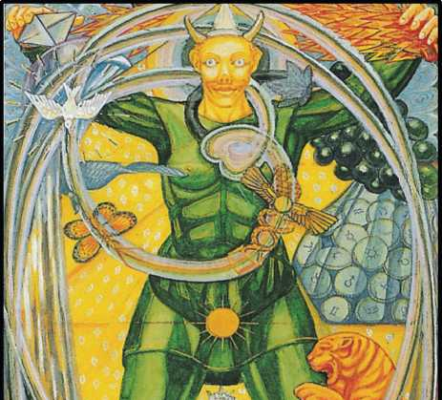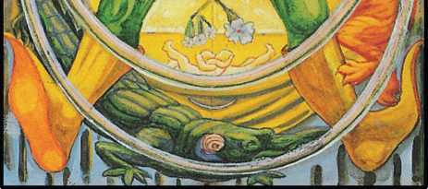

0. THE FOOL[2].

This card is attributed to the letter Aleph, which means an Ox, but by its shape the He­brew letter (so it is said) represents a plough- share; thus the significance is primarily Phallic. It is the first of the three Mother letters, Aleph, Mem, and Shin, which correspond in various interwoven fashions with all the triads that occur in these cards, notably Fire, Water, Air; Fa­ther, Mother, Son; Sulphur, Salt, Mercury; Rajas, Sattvas and Tamas.

The really important feature of this card is that its number should be 0. It represents therefore the Negative above the Tree of Life, the source of all things. It is the Qabalistic Zero. It is the equation of the Universe, the initial and final balance of the opposites; Air, in this card, therefore quintessentially means a vacuum.

In the medieval pack, the title of the card is Le Mat, adapted from the Italian Matto, madman or fool; the propriety of this title will be considered later. But there is another, or (one might say) a complementary, theory. If one assumes that the Tarot is of Egyptian origin, one may suppose that Mat (this card being the key card of the whole pack) really stands for

Maut, the vulture goddess, who is an earlier and more sublime modification of the idea of Nuith than Isis.

There are two legends connected with the vulture. It is supposed to have a spiral neck; this may possibly have reference to the theory (recently revived by Einstein, but mentioned by Zoroaster in his Oracles) that the shape of the Universe, the form of that energy which is called the Universe, is spiral.

The other legend is that the vulture was supposed to reproduce her species by the in­tervention of the wind; in other words, the element of air is considered as the father of all manifested existence. There is a parallel in Anaximenes’ school of Greek philosophy.

This card is therefore both the father and the mother, in the most abstract form of these ideas. This is not a confusion, but a deliberate identification of the male and the female, which is justified

*Note that ‘Fool’ is derived from ‘follis’, a wind-bag. Even etymology gives the attribution to Air. Also, to puff out the cheeks is a gesture implying readiness to create, in the sign-language of Naples. Worse, some English Guardians of Democracy impute folly to others by the “Razzberry”.

by biology. The fertilized ovum is sexually neutral. It is only Some unknown determinant in the course of development which decides the issue.

It is necessary to acclimatise oneself to this at first sight strange, idea. As soon as one has made up one’s mind to consider the feminine aspect of things, the masculine element should immediately appear in the same flash of thought to counterbalance it. This identifica­tion is complete in itself) philosophically speaking; it is only later that one must consider the question of the result of formulating Zero as “plus I plus minus I”. The result of so doing is to formulate the idea of Tetragrammaton.

THE FORMULA OF TETRAGRAMMATON

It is explained in this essay (see 16, 34, et al.) that the whole of the Tarot is based upon the Tree of Life, and that the Tree of Life is always cognate with Tetragrammaton. One may sum up the whole doctrine very briefly as follows:

The Union of the Father and the Mother produces Twins, the son going forward to the daughter, the daughter returning the energy to the father; by this cycle of change the stability and eternity of the Universe are assured.

It is necessary, in order to understand the Tarot, to go back in history to the Matriar­chal (and exogamic) Age, to the time when succession was not through the first-born son of the King, but through his daughter. The king was therefore not king by inheritance, but by right of conquest. In the most stable dynasties, the new king was always a stranger, a for­eigner; what is more, he had to kill the old king and marry that king’s daughter. This system ensured the virility and capacity of every king. The stranger had to win his bride in open competition. In the oldest fairy-tales, this motive is continually repeated. The ambitious stranger is often a troubadour; nearly always he is disguised, often in a repulsive form. Beauty and the Beast is a typical tale. There is often a corresponding camouflage about the king’s daughter, as in the case of Cinderella and the Enchanted Princess. The tale of Aladdin gives the whole of this fable in a very elaborate form, packed with technical tales of magic. Here then is the foundation of the legend of the Wandering Prince—and, note well, he is always “the fool of the family”. The connection between foolishness and holiness is traditional. It is no sneer that the family nitwit had better go into the church. In the East the madman is believed to be “pos­sessed”, a holy man or prophet. So deep is this identity that it is actually embedded in the lan­guage. “Silly” means empty-the Vacuum of Air-Zero-”the silly buckets on the deck”. And the word is from the German selig, holy, blessed. It is the innocence of the Fool which most strongly characterizes him. It will be seen later how important is this feature of the story.

To ensure the succession, it was therefore devised: firstly, that the blood royal should really be the royal blood, and secondly, that this strain should be fortified by the introduction of the conquering stranger, instead of being attenuated by continual in-breeding.

In certain cases this theory was pushed very far; there was probably a great deal of chicanery about this disguised prince. It may well have been that the king, his father, fur­nished him with very secret letters of introduction; in short, that the old political game was old even in those primeval times.

The custom is therefore developed into the condition so admirably investigated by Fra­zer in the Golden Bough. (This Bough is no doubt a symbol of the King’s Daughter herself). “The king’s daughter is all glorious within; her raiment is of wrought gold.”

How did such a development come to pass?

There may have been a reaction against playing politics; there may have been a glorifi­cation, first of all of the ‘gentleman burglar’, finally of the mere gangster-boss, rather as we have seen in our own times, in the reaction against Victorianism. The “wandering prince” was closely examined as to his credentials; unless he were an escaped criminal he was not eligible to compete; nor was it sufficient for him to win the king’s daughter in open competition, live in the lap of luxury until the old king died, and succeed him in peace; he was obliged to mur­der the old king with his own hand.

At first sight it would appear that the formula is the union of the extremely masculine, the big blond beast, with the extremely feminine, the princess who could not sleep if there was a pea beneath her seven feather beds. But all such symbolism defeats itself; the soft be­comes the hard, the rough the smooth. The deeper one goes into the formula, the closer be­comes the identification of the Opposites. The Dove is the bird of Venus, but the dove is also a symbol of the Holy Ghost; that is, of the Phallus in its most sublimated form. There is therefore no reason for surprise in observing the identification of the father with the mother.

Naturally, when ideas so sublime become vulgarised, they fail to exhibit the symbol with lucidity. The great hierophant, confronted with a thoroughly ambiguous symbol, is com­pelled, just because of his office as hierophant—that is, one who manifests the mystery—to “diminish the message to the dog”. This he must do by exhibiting a symbol of the second order, a symbol suited to the intelligence of the second order of Initiates. This symbol, instead of be­ing universal, and thus beyond ordinary expression, must be further adapted to the intellec­tual capacity of the particular set of people whom it is the business of the hierophant to initi­ate. Such truth accordingly appears to the vulgar as fable, parable, legend, even creed.

In the case of this comprehensive symbol of The Fool, there are, within actual knowl­edge, several quite distinct traditions, very clear; and, historically, very important.

These must be considered separately in order to understand the single doctrine from which all sprang.

*The "Green Man"of the Spring Festival. "April Fool." The Holy Ghost.*

This tradition represents the original idea adapted to the under- standing of the aver­age peasant. The Green Man is a personification of the mysterious influence that produces the phenomena of spring. It is hard to say why it should be so, but it is so: there is a connection with the ideas of irresponsibility, of wantonness, of idealization, of romance, of starry dream­ing.

The Fool stirs within all of us at the return of Spring, and be cause we are a little bewil­dered, a little embarrassed, it has been thought a salutary custom to externalise the subcon­scious impulse by ceremonial means. It was a way of making confession easy. Of all these fes­tivals it may be said that they are representations in the simplest form, without introspection, of a perfectly natural phenomenon. In particular are to be noted the custom of the Easter Egg and the “Poisson d’avril”. (The Saviour Fish is discussed elsewhere in this essay. The preces­sion of the Equinoxes has made Spring begin with the entry of the Sun into Aries the Ram, in­stead of Pisces the Fishes as was the case in the earliest times recorded.)

*The "Great Fool" of the Celts (Dalua):*

This is a considerable advance on those purely naturalistic phenomena above de­scribed; in the Great Fool is a definite doctrine. The world is always looking for a saviour, and the doctrine in question is philosophically more than a doctrine; it is a plain fact. Salvation, whatever salvation may mean, is not to be obtained on any reasonable terms. Reason is an im­passe, reason is damnation; only madness, divine madness, offers an issue. The law of the Lord Chancellor will not serve; the law-giver may be an epileptic camel-driver like Moham­med, a megalomaniac provincial upstart like Napoleon, or even an exile, three-parts learned, one-part crazy, an attic-dweller in Soho, like Karl Marx. There is only one thing in common among such persons; they are all mad, that is’ inspired. Nearly all primitive people possess this tradition, at least in a diluted form. They respect the wandering lunatic, for it may be that he is the messenger of the Most High. “This queer stranger? Let us entreat him kindly. It may be that we entertain an angel unawares”.

Closely bound up with this idea is the question of paternity. A saviour is needed. What is the one thing certain about his qualifications? That he should not be an ordinary man. (In the Gospels people cavilled about the claim that Jesus was the Messiah because he came from Nazareth, a perfectly well-known town, because they knew his mother and his family; in brief, they argued that he did not qualify as a candidate for Saviour.) The saviour must be a pecu­liarly sacred person; that he should be a human being at all is hardly credible. At the very least, his mother must be a virgin; and, to match this wonder, his father cannot be an ordinary man; therefore, his father must be a god. But as a god is a gaseous vertebrate, he must be some materialisation of a god. Very good! Let him be the god Mars under the form of a wolf, or Jupiter as a bull, or a shower of gold, or a swan; or Jehovah in the form of a dove; or some other creature of phantasy, preferably disguised in some animal form. There are innumerable forms of this tradition, but they all agree on one point: the saviour can only appear as the re­sult of some extra ordinary accident, quite contrary to whatever is normal. The slightest sug­gestion of anything reasonable in this matter would destroy the whole argument. But as one must obtain some concrete picture, the general solution is to represent the saviour as the Fool. (Attempts to attain this condition appear in the Bible. Note the “coat of many colours” of Joseph and of Jesus; it is the man in motley1 who brings his people out of bondage.)

It will be seen later how this idea is linked with that of the mystery of paternity, and also of the iridescence of the alchemical mercury in one of the stages of the Great Work.

*"The Rich Fisherman": Percivale.*

The legend of Percivale, integral of the mystery of the Saviour Fish-God, and of the Sangraal or Holy Grail, is of disputed origin. It appears certainly, first of all, in Brittany, the land best beloved of Magick, the land of Merlin, of the Druids, of the forest of Broceliande. Some scholars suppose that the Welsh form of this tradition, which lends much of its impor­tance and its beauty to the Cycle of King Arthur, is even earlier. This is in this place irrelevant; but it is vital to realize that the legend, like that of The Fool, is purely pagan in origin, and comes to us through Latin-Christian recensions: there is no trace of any such matters in the Nordic mythologies. (Percivale and Galahad were “innocent”: this is a condition of the Guard­ian ship of the Grail). Note also that Monsalvat, mountain of Salvation, home of the Graal, the fortress of the Knights Guardians, is in the Pyrenees.

It may be best to introduce the figure of Parsifal in this place, because he represents the western form of the tradition of the Fool,

*Call him “Harlequin”, and a Tetragrammaton evidently burlesquing the Sacred Family spflngs to sight: Pantaloon, the aged “antique-antic”; Clown and Harlequin, two aspects of the Fool; and Columbine, the Virgin. But, being burlesque, the tradition is confused and the deep meaning lost; just as the medieval Mystery-Play of Pontius and Judas became the farce, with opportunist topical variants, “Punch and Judy”.

and because his legend has been highly elaborated by scholarly initiates. (The dramatic set­ting of Wagner’s Parsifal was arranged by the then head of the O.T.O.)

Parsifal in his first phase is Der reine Thor, the Pure Fool. His first act is to shoot the sacred swan. It is the wantonness of innocence. In the second act, it is the same quality that enables him to withstand the blandishments of the ladies in the garden of Kundry. Klingsor, the evil magician, who thought to fulfil the conditions of life by self- mutilation, seeing his em­pire threatened, hurls the sacred lance (which he has stolen from the Mountain of Salvation) at Parsifal, but it remains suspended over the boy’s head. Parsifal seizes it; in other words, at­tains to puberty. (This transformation will be seen in the other symbolic fables, below.)

In the third act, Parsifal’s innocence has matured into sanctification; he is the initiated Priest whose function is to create; it is Good Friday, the day of darkness and death. Where shall he seek his salvation? Where is Monsalvat, the mountain of salvation, which he has sought so long in vain? He worships the lance: immediately the way, so long closed to him, is open; th£ scenery revolves rapidly, there is no need for him to move. He has arrived at the Temple of the Graal. All true ceremonial religion must be solar and phallic in character. It is the wound of Amfortas which has removed the virtue frorn the temple. (Amfortas is the sym­bol of the Dying God.)

Accordingly, to redeem the whole situation, to destroy death, to reconsecrate the tem­ple, he has only to plunge the lance into the Holy Grail; he redeems not only Kundry, but him­self. (This is a doctrine only appreciable in its fulness by members of the Sovereign Sanctuary of the Gnosis of the ninth degree of O.T.O.)

*The Crocodile (Mako, son of Set; or Sebek).*

This same doctrine of maximum innocence developing into maximum fertility is found in Ancient Egypt in the symbolism of the Crocodile god Sebek. The tradition is that the croco­dile was un provided with the means of perpetuating his species (compare what is said above about the vulture Maut). Not in spite of, but because of this, he was the symbol of the maxi­mum of creative energy. (Freud, as will be seen later, explains this apparent antithesis.)

Once again, the animal kingdom is invoked to fulfil the function of fathering the re­deemer. On the banks of the Euphrates men worshipped Oannes, or Dagon, the fish god. The fish as a symbol of fatherhood, of motherhood, of the perpetuation of life generally, constantly recurs. The letter N. (Nun, N, in Hebrew means Fish) is one of the original hieroglyphs stand­ing for this idea, apparently because of the mental reactions excited in the mind by the con­tinual repetition of this letter. There are thus a number of gods, goddesses, and eponymous heroes, whose legends are functions of the letter N. (With regard to this letter, see Atu XIII.) It is connected with the North, and so with the starry heavens about the Pole Star; also with the North wind; and the reference is to the Watery signs. Hence the letter N. occurs in legends of the Flood and of fish gods. In Hebrew mythology, the hero concerned is Noah. Note also that the symbol of the Fish has been chosen to represent the Redeemer or Phallus, the god through whose virtue man passes through the waters of death. The common name for this god, in southern Italy to-day, and elsewhere, is Ii pesce. So, also, his female counterpart, Kteis, is rep­resented by the Vesica Piscis, the bladder of the fish, and this shape is continually exhibited in many church windows and in the episcopal ring.1

In the mythology of Yucatan it was the “old ones covered with feathers that came up out of the sea”. Some have seen in this tradition a reference to the fact that man is a marine animal; our breathing apparatus still possesses atrophied gills.

*Hoor-Pa-Kraat.2*

Arriving at highly sophisticated theogony, there appears a perfectly clear and concrete symbol of this doctrine. Harpocrates is the God of Silence; and this silence has a very special meaning.

1“IXOYC, which means fish And very aptly symbolizes Christ.” -The Ring and the Book. The word is a No- tariqon of Iesous Christos Theou Huios Soter (Jesus Christ, Son of God, Saviour.)

2The Fool is also, evidently, an aspect of Pan; but this idea is shewn in his fullest development by Atu XV, whose letter is the semi-vowel A’ain, cognate with Aleph.

(See attached essay, Appendix.) The first is Kether, the pure Being invented as an aspect of pure Nothing. In his manifestation, he is not One, but Two; he is only One because he is 0. He exists; Eheieh, his divine name, which signifies “I Am” or “I shall Be”, is merely another way of saying that he Is Not; because One leads to nowhere, which is where it came from. So the only possible manifestation is in Two, and that manifestation must be in silence, because the num­ber 3, the number of Binah-Understanding-has not yet been formulated. In other words, there is no Mother. All one has is the impulse of this manifestation; and that must take place in si­lence. That is to say, there is as yet no more than the impulse, which is unformulated; it is only when it is interpreted that it becomes the Word, the Logos. (See Atu I.)

N ow consider the traditional form of Harpocrates. He is a babe, that is to say, innocent, and not yet arrived at puberty; a simpler form of Parsifal, he is represented as rose pink in colour. It is dawn- the hint of light about to come, but not by any means that light; he has a lock of black hair curling around his ear, and that is the influence of the Highest descending upon the Brahmarandra Chakra. The ear is the vehicle of Akasha, Spirit. This is the only sali­ent symbol; it is the only indication that he is not merely the bald baby, because it is the only colour in the blob of rose pink. But, on the other hand, his thumb is either against his lower lip or in his mouth; which it is, one cannot say. There is here a quarrel between two schools of thought; if be is pushing up his lower lip, he emphasizes silence as silence; if his thumb is in his mouth, it emphasizes the doctrine of Eheieh: “I shall Be”. Yet in the end these doctrines are identical.

This babe is in an egg of blue, which is evidently the symbol of the Mother. This child has, in a way, not been born; the blue is the blue of space; the egg is sitting upon a lotus, and this lotus grows on the Nile. Now, the lotus is another symbol of the Mother, and the Nile is also a symbol of the Father, fertilizing Egypt, the Yoni. (But also the Nile is the home of Sebek the crocodile, who threatens Harpocrates.)

Yet Harpocrates is not always thus represented. He is shown by certain schools of thought as standing; he is standing upon the crocodiles of the Nile. (Refer above to the croco­dile, the symbol of two exactly opposite things.) There is here an analogy. One is reminded of Hercules-the infant Hercules-who spun the wheel in the House of Women; of Hercules, who was a strong man, who was innocent, who was ultimately a madman, who destroyed his wife and children. It is a cognate symbol.

Harpocrates is (in one sense) the symbol of the Dawn on the Nile, and of the physio­logical phenomenon which accompanies the act of waking. One sees, at the other end of the octave of thought, the connection of this symbol with the succession to the royal power de­scribed above. The symbol of Harpocrates itself tends to be purely philosophical. He is also the mystical absorption of the work of creation; the He final of Tetragrammaton. Harpocrates is, in fact, the passive side of his twin, Horus. Yet at the same time he is a very fully-fledged symbol of this idea, which is wind, which is air, the impregnation of the Mother Goddess. He is immune from all attack because of his innocence; for in this innocence is perfect silence, which is the essence of virility.

The egg is not only Akasha,1 but the original egg in the biological sense. This egg issues from the lotus, which is the symbol of the Yoni.

There is an Asiatic symbol cognate with Harpocrates, and though it does not come di­rectly into this card it must be considered in connection with it. That symbol is the Buddha- Rupa. He is most frequently represented sitting on a lotus, and often there is behind him spread the hood of the Serpent; the shape of this hood is again the Yoni. (Note the usual or­naments of this hood; phallic and fructiform.)

The crocodile of the Nile is called Sebek or Mako-the Devourer. In the official rituals, the idea is usually that of the fisherman, who wishes protection from the assaults of his totem animal.

There is, however, an identity between the creator and the destroyer. In Indian my­thology, Shiva fulfils both functions. In Greek mythology, the god Pan is addressed “Pamphage, Pangene tor”, all-devourer, all-begetter. (Note that the numerical value of the word Pan is 131, as is that of Samael, the Hebrew destroying angel.)

So also, in the initiated symbolism, the act of devouring is the

iThe Black Egg of the element of Spirit in some Hindu schools of thought. From it the other elements Air, Water, Earth, Fire (in that order) proceed.

equivalent of initiation; as the mystic would say, “My soul is swallowed up in God”. (Compare the symbolism of Noah and the Ark, Jonah1 and the Whale, and others.)

One must constantly keep in mind the bivalence of every symbol. Insistance upon ei­ther one or other of the contradictory attributions inherent in a symbol is simply a mark of spiritual incapacity; and it is constantly happening, because of prejudice. It is the simplest test of initiation that every symbol is understood instinctively to contain this contradictory mean­ing in itself. Mark well the passage in The Vision and the Voice, page 136:

“It is shown me that this heart is the heart that rejoiceth, and the serpent is the serpent of Da’ath, for herein all the symbols are interchangeable, for each one containeth in itself its own opposite. And this is the great Mystery of the Su- pernals that are beyond the Abyss. For below the Abyss, contradiction is divi­sion; but above the Abyss, contradiction is Unity. And there could be nothing true except by virtue of the contradiction that is contained in itself.”

It is characteristic of all high spiritual vision that the formulation of any idea is imme­diately destroyed or cancelled out by the arising of the contradictory. Hegel and Nietzsche had glimmerings of the idea, but it is described very fully and simply in the Book of Wisdom or Folly. (See citation, below, Appendix.)

This point about the crocodile is very important, because many of the traditional forms of “The Fool” of the Tarot show the crocodile definitely. In the commonplace interpretation of the card, the Scholiasts say that the picture is that of a gay, careless youth, with a sack full of follies and illusions, dancing along the edge of a precipice, unaware that the tiger and croco­dile shown in the card are about to attack him. It is the view of the Little Bethel. But, to initi­ates, this crocodile helps to determine the spiritual meaning of the card as the return to the original Qabalistic zero; it is the “He final” process in the magical formula of Tetragrammaton. By a flick of the wrist, she can be transmuted to reappear as the original Yod, and repeat the whole process from the beginning.

*Note the N of Jonah, and the meaning of the name: a dove.

The innocence-virility formula is again suggested by the introduction of the crocodile, for that was one of the biological superstitions on which they founded their theogony—that the crocodile, like the vulture, had some mysterious method of reproduction.

*Zeus Arrhenothelus.*

In dealing with Zeus, one is immediately confronted with this deliberate confusion of the masculine and the feminine. In the Greek and Latin traditions the same thing happens. Dianus and Diana are twins and lovers; as soon as one utters the feminine, it leads on to the identification with the masculine, and vice versa, as must be the case in view of the biological facts of nature. It is only in Zeus Arrhenothelus that one gets the true Hermaphroditic nature of the symbol in unified form. This is a very important fact, especially for the present purpose, because images 6f this god recur again and again in alchemy. It is hardly possible to describe this lucidly; the idea pertains to a faculty of the mind which is “above the Abyss”; but all two­headed eagles with symbols clustering about them are indications of this idea. The ultimate sense seems to be that the original god is both male and female, which is, of course, the essen­tial doctrine of the Qabalah; and the thing most difficult to understand about the later de­based Old Testament tradition,1 is that it represents Tetragrammaton as masculine, in spite of the two feminine components. Zeus became too popular, and, in consequence, too many leg­ends gathered around him; but the important fact for this present purpose is that Zeus was peculiarly the Lord of Air.2 Men who sought the origin of Nature in the earliest days tried to find this origin in one of the Elements. (The history of philosophy describes the controversy between Anaximander and Zenocrates; later, Empedocles.) It may be that the original authors of the Tarot were trying to promulgate

4t was a tribal necessity of the savage wanderers to have an uncivilized and simple Demiurge for god; the complexities and refinements of settled nations were to them mere weakness. Observe that the moment they got a Promised Land and a Temple, under Solomon, he went “an-whoring after strange women” and gods. This infuriated the Diehard prophets, and led within a few years to the breach between Judah and Israel, thence to a whole sequence of disasters.

2The earliest accounts relate the distribution of the three active elements as Dis (Pluto) to Fire, Zeus (Jupiter) to Air, and Poseidon (Neptune) to Water,

the doctrine that the origin of everything was Air. Yet if this were so, it would upset the whole Tarot as we know it, since the order of origin makes Fire the first father. It is Air as Zero that reconciles the antinomy.

Dianus and Diana, it is true, were symbols of the air, and the Sanskrit Vedas say that the storm gods were the original gods. Yet, if the storm gods really presided over the formation of the Universe as we know it, they were certainly storms of fire; to this astronomers agree. But this theory certainly implies an identification of air and fire, and it seems as if they were thought of as before Light, that is, the Sun; before creative energy, that is, the phallus; and this idea continually suggests itself, that there is here some doctrine contrary to our own most reasonable doctrine: one in which the original confusion of the elements, the Tohu-Bohu, is to be put forward as the cause of order, instead of as a plastic mass on which order imposes it­self.

No system truly Qabalistic makes air in the conventional sense the original element, though Akasha is the egg of spirit, the black or dark blue egg. This suggests a form of Harpo- crates. In that case, by “air” one really means “spirit”. However this may be, the actual symbol is perfectly clear, and should be applied to its proper place.

*Dionysus Zagreus. Bacchus Diphues.*

It is convenient to treat the two gods as one. Zagreus is only important to the present purpose because he possesses horns, and because (in the Eleusinian Mysteries) it is said that he was torn to pieces by the Titans. But Athena rescued his heart and carried it to his father, Zeus. His mother was Demeter; he is thus the fruit of the marriage of Heaven and Earth. This identifies him as the Vau of Tetragrammaton, but the legends of his “death” refer to initiation, which accords with the doctrine of the Devourer.

In this card, however, the traditional form is much more clearly expressive of Bacchus Diphues, who represents a more superficial form of worship; the ecstasy characteristic of the god is more magical than mystical. The latter demands the name Iacchus, whereas Bacchus had Semele for a mother, who was visited by Zeus in the form of a flash of lightning which de­stroyed her. But she was already pregnant by him, and Zeus saved the child. Until puberty, he was hidden in the “thigh” (i.e., the phallus) of Zeus. Hera, in revenge for her husband’s infidel­ity with Semele, drove the boy mad. This is the direct connection with the card.

The legend of Bacchus is, first of all, that he was Diphues, double-natured, and this ap­pears to mean more bisexual than hermaphroditic. His madness is also a phase of his intoxica­tion, for he is pre-eminently the god of the vine. He goes dancing through Asia, surrounded by various companions, all insane with enthusiasm; they carry staffs headed with pine cones and entwined with ivy; they also clash cymbals, and in some legends are furnished with swords, or twined about with serpents. All the half-gods of the forest are the male companions of the Maenad women. In his pictures his drunken face, and the languid state of his lingam, connect him with the legend already mentioned about the crocodile. His constant attendant is the ti­ger; and, in all the best extant examples of the card, the tiger or panther is represented as jumping upon him from behind, while the crocodile is ready to devour him in front. In the leg­end of his journey through Asia, he is said to have ridden on an ass, which connects him with Priapus, who is said to have been his son by Aphrodite. It also reminds one of the triumphal entry into Jerusalem on Palm Sunday. It is curious, too, that, at the fabled birth of Jesus, the Virgin Mother is represented as being between an ox and an ass, and one remembers that the letter Aleph means Ox.

In the worship of Bacchus there was a representative of the god, and he was chosen for his quality as a young and virile, but effeminate man. In the course of the centuries, the wor­ship naturally became degraded; other ideas joined themselves to the original form; and, partly because of the orgiastic character of the ritual, the idea of the Fool took definite shape. Hence, he came to be represented with a Fool’s cap, evidently phallic, and clad in motley, which again recalls the coat of many colours worn by Jesus, and by Joseph. This symbolism is not only Mercurial, but Zodiacal; Joseph and Jesus, with twelve brothers or twelve disciples, equally represent the sun in the midst of the twelve signs. It was only very much later that any alchemical significance was attributed to this, and that at a time when the Renaissance schol­ars made rather a point of finding something serious and important in symbols which were, in reality, quite frivolous.

*Baphomet.*

There is no doubt that this mysterious figure is a magical image of this same idea, de­veloped in so many symbols. Its pictorial correspondence is most easily seen in the figures of Zeus Arrhenothelus and Babalon, and in the extraordinarily obscene representations of the Virgin Mother which are found among the remains of early Christian iconology. The subject is dealt with at considerable length in Payne Knight, where the origin of the symbol and the meaning of the name is investigated. Von Hammer-Purgstall was certainly right in supposing Baphomet to be a form of the Bull-god, or rather, the Bull-slaying god, Mithras; for Baphomet should be spelt with an “r” at the end; thus it is clearly a corruption meaning “Father Mithras”. There is also here a connection with the ass, for it was as an ass-headed god that he became an object of veneration to the Templars.

The Early Christians also were accused of worshipping an ass or ass-headed god, and this again is connected with the wild ass of the wilderness, the god Set, identified with Saturn and Satan. (See infra, Atu XV.) He is the South, as Nuit is the North: the Egyptians had a Desert and an Ocean in those quarters.

*Summary.*

It has seemed convenient to deal separately with these main forms of the idea of the Fool, but no attempt has been made, or should be made, to prevent the legends overlapping and coalescing. The variations of expression, even when contradictory in appearance, should lead to an intuitive apprehension of the symbol by a sublimation and transcendance of the in­tellectual. All these symbols of the Trumps ultimately exist in a region beyond reason and above it. The study of these cards has for its most important aim the training of the mind to think clearly and coherently in this exalted manner.

This has always been characteristic of the methods of Initiation as understood by the hierophants.

In the confused, dogmatic period of Victorian materialisation, it was necessary for sci­ence to discredit all attempts to transcend the rationalist mode of approach to reality; yet it was the progress of science itself that has reintegrated these differentials. From the very be­ginning of the present century, the practical science of the mechanician and the engineer has been forced further and further towards finding its theoretical justification in mathematical physics.

Mathematics has always been the most severe, abstract, and logical of the sciences. Yet even in comparatively early schoolboy mathematics, cognisance must be taken of the unreal and the ir rational. Surds and infinite series are the very root forms of advanced mathematical thought. The apotheosis of mathematical physics is now the admission of failure to find reality in any single intelligible idea. The modern reply to the question “What is anything?” is that it is in relation to a chain of ten ideas, any one of which can only be interpreted in terms of the rest. The gnostics would undoubtedly have called this a “chain of ten aeons”. These ten ideas must by no means be considered as aspects of some reality in the background. As the sup­posed straight line which was the framework of calculation has turned out to be a curve, so has the point which had always been taken as the type of existence, become the ring.

It is impossible to doubt that there is here a continually closer approximation of the profane science of the outer world to the sacred wisdom of the Initiate.

***

The design of the present card resumes the principal ideas of the above essays. The Fool is of the gold of air. He has the horns of Dionysus Zagreus, and between them is the phal­lic cone of white light representing the influence from the Crown1 upon him. He is shown against the background of air, dawning from space; and his attitude is that of one bursting un­expectedly upon the world.

He is clad in green, according to the tradition of Spring; but his shoes are of the phallic gold of the sun.

In his right hand he bears the wand, tipped with a pyramid of white, of the All-Father. In his left hand he bears the flaming pine- cone, of similar significance, but more definitely in­dicating vegetable growth; and from his left shoulder hangs a bunch of purple grapes. Grapes represent fertility, sweetness, and the basis of ecstasy. This ecstasy is shown by the stem of the grapes developing into rainbow- hued spirals. The Form of the Universe. This suggests the Threefold

**Aether: see the position of the Path of Aleph on the Tree of Life.**

Veil of the Negative manifesting, by his intervention, in divided light. Upon this spiral whorl are other attributions of godhead; the vulture of Maut, the dove of Venus (Isis or Mary), and the ivy sacred to his devotees. There is also the butterfly of many-coloured air and the winged globe with its twin serpents, a symbol which is echoed and fortified by the twin infants em­bracing on the middle spiral. Above them hangs the benediction of three flowers in one. Fawn­ing upon him is the tiger; and beneath his feet in the Nile with its lotus stems crouches the crocodile. Resuming all his many forms and many-coloured images in the centre of the figure, the focus of the microcosm is the radiant sun. The whole picture is a glyph of the creative light.

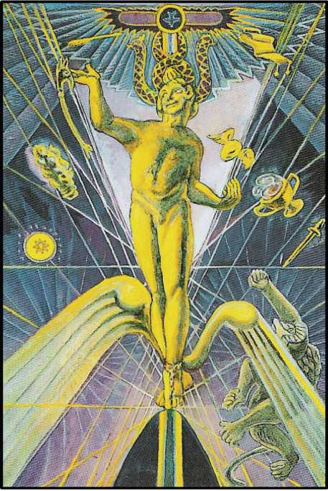

1. THE JUGGLER

This card is referred to the letter Beth, which means a house, and is attributed to the planet Mercury. The ideas connected with this symbol are so complex and so multifarious that it seems better to attach to this general description certain documents which bear upon dif­ferent aspects of this card. The whole will then form an adequate basis for the full interpreta­tion of the card through study, meditation, and use.

The French title of this card in the medieval pack is “Le Bateleur”, the Bearer of the Baton.1 Mercury is pre-eminently the bearer of the Wand: Energy sent forth. This card there­fore represents the Wisdom, the Will, the Word, the Logos by whom the worlds were created. (See the Gospel according to St. John, chapter I.) It represents the Will. In brief, he is the Son, the manifestation in act of the idea of the Father. He is the male correlative of the High Priest­ess. Let there be no confusion here on account of the fundamental doctrine of the Sun and Moon as the Second Harmonics to the Lingam and the Yoni; for, as will be seen in the citation from The Paris Working, (see Appendix) the creative Mercury is of the nature of the Sun. But Mercury is the Path leading from Kether to Binah, the Under-

**iVariant: LE PAGAD. Origin unknown. Suggestions:**

**(I) PChD terror (esp. Panic fear) a title of Geburah. Also a thigh: i.e. membrum virile. By Arabic analogy, PAChD, causer of terror: Value 93!!**

standing; and thus He is the messenger of the gods, represents precisely that Lingam, the Word of creation whose speech is silence.

Mercury, however, represents action in all forms and phases. He is the fluidic basis of all transmission of activity; and, on the dynamic theory of the Universe, he is himself the sub­stance thereof. He is, in the language of modern physics, that electric charge which is the first manifestation of the ring of ten indefinable ideas, as pre viously explained. He is thus continu­ous creation.

Logically also, being the Word, he is the law of reason or of necessity or chance, which is the secret meaning of the Word, which is the essence of the Word, and the condition of its utterance. This being so, and especially because he is duality, he represents both trnth and falsehood, wisdom and folly. Being the unexpected, he unsettles any established idea, and therefore appears tricky. He has no conscience, being creative. If he cannot attain his ends by fair means, he does it by foul. The legends of the youthful Mercury are therefore legends of cunning. He cannot be understood, because he is the Unconscious Will. His position on the Tree of Life shows the third Sephira, Binah, Understanding, as not yet formulated; still less the false Sephira, Da’ath, knowledge.

From the above it will appear that this card is the second emanation from the Crown, and therefore, in a sense, the adult form of the first emanation, the Fool, whose letter is Aleph, the Unity. These ideas are so subtle and so tenuous, on these exalted planes of thought, that definition is impossible. It is not even desirable, because it is the nature of these ideas to flow one into the other. One cannot do more than say that any given hieroglyph represents a slight insistence upon some particular form of a pantomorphous idea. In this card, the emphasis is upon the creative and dualistic character of the path of Beth.

In the traditional card the disguise is that of a Juggler.

This representation of the Juggler is one of the crudest and least satisfactory in the medieval pack. He is usually represented with a headdress shaped like the sign of infinity in mathematics (this is shown in detail in the card called the Two of Disks). He bears a wand with a knob at each end, which was probably connected with the dual polarity of electricity; but it is also the hollow wand of Prometheus that brings down fire from Heaven. On a table or altar, behind which he is standing, are the three other elemental weapons.

“With the Wand createth He.

With the Cup preserveth He.

With the Dagger destroyeth He.

With the Coin redeemeth He.

Liber Magi vv. 7-10.”

The present card has been designed principally upon the Graeco-Egyptian tradition; for the understanding of this idea was certainly further advanced when these philosophies modified each other, than elsewhere at any time.

The Hindu conception of Mercury, Hanuman, the monkey god, is abominably degraded. None of the higher aspects of the symbol are found in his cult. The aim of his adepts seems principally to have been the production of a temporary incarnation of the god by sending the

women of the tribe every year into the jungle. N or do we find any legend of any depth or spiri­tuality. Hanuman is certainly little more than the Ape of Thoth.

The principal characteristic of Tahuti or Thoth, the Egyptian Mercury, is, firstly, that he has the head of the ibis. The ibis is the symbol of concentration, because it was supposed that this bird stood continuously upon one leg, motionless. This is quite evidently a symbol of the meditative spirit. There may also have been some reference to the central mystery of the Aeon of Osiris, the secret guarded so carefully from the profane, that the intervention of the male was necessary to the production of children. In this form of Thoth, he is seen bearing the phoenix wand, symbolising resurrection through the generative process. In his left hand is the Ankh, which represents a sandal-strap; that is to say, the means of progress through the worlds, which is the distinguishing mark of godhead. But, by its shape, this Ankh (crux ansata) is actually another form of the Rose and Cross, and this fact is perhaps not quite such an acci­dent as modern Egyptologists, preoccupied with their attempted refutation of the Phallic school of Archaeology, would have us suppose.

The other form of Thoth represents him primarily as Wisdom and the Word. He bears in his right hand the Style, in his left the Papyrus. He is the messenger of the gods; he trans­mits their will by hieroglyphs intelligible to the initiate, and records their acts; but it was seen from very early times that the use of speech, or writing, meant the introduction of ambiguity at the best, and falsehood at the worst; they therefore represented Thoth as followed by an ape, the cynocephalus, whose business was to distort the Word of the god; to mock, to simu­late and to deceive. In philosophical language one may say: Manifestation implies illusion. This doctrine is found in Hindu philosophy, where the aspect of Tahuti of which we are speak­ing is called Mayan. This doctrine is also found in the central and typical image of the Maha- yana school of Buddhism (really identical with the doctrine of Shiva and Shakti). A vision of this image will be found in the document entitled “The Lord of Illusion”. (See Appendix.)

The present card endeavours to represent all the above conceptions. Yet no true image is possible at all; for, firstly, all images are necessarily false as such; and, secondly, the motion being perpetual, and its rate that of the limit, c, the rate of Light, any stasis contradicts the idea of the card: this picture is, therefore, hardly more than mnemonic jottings. Many of the ideas expressed in the design are well expounded in the extracts from The Paris Working. (See Appendix.)

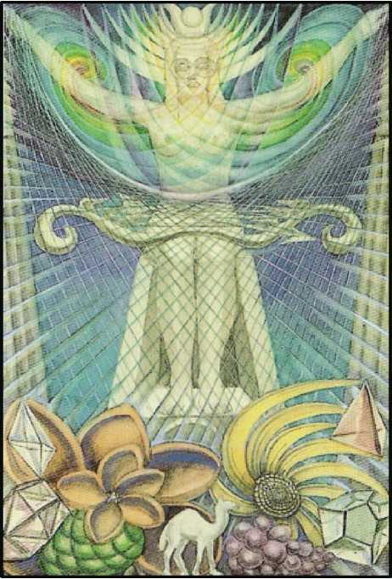

1. THE HIGH PRIESTESS

This card is referred to the letter Gimel, which means a Camel. (The symbolism of the Camel is explained later.)

The card refers to the Moon. The Moon (being the general feminine symbol, the symbol of the second order corresponding to the Sun as the Yoni does to the Lingam) is universal, and goes from the highest to the lowest. It is a symbol which will recur frequently in these hiero­glyphs. But in the earlier Trumps the concern is with Nature above the Abyss; the High Priest­ess is the first card which connects the Supernal Triad with the Hexad; and her path, as shown in the diagram, makes a direct connection between the Father in his highest aspect, and the Son in his most perfect manifestation. This path is in exact balance in the middle pillar. There is here, therefore, the purest and most exalted conception of the Moon. (At the other end of the scale is Atu xviii, q.v.)

The card represents the most spiritual form of Isis the Eternal Virgin; the Artemis of the Greeks. She is clothed only in the luminous veil of light. It is important for high initiation to regard Light not as the perfect manifestation of the Eternal Spirit, but rather as the veil which hides that Spirit. It does so all the more effectively because of its incomparably dazzling brilliance.1 Thus she is light and the body of light. She is the truth behind the veil of light. She is the soul of light. Upon her knees is the bow of Artemis, which is also a musical instrument, for she is huntress, and hunts by enchantment.

Now, regard this idea as from behind the Veil of Light, the third Veil of the original Nothing. This light is the menstruum of manifestation, the goddess Nuith, the possibility of Form. This first and most spiritual manifestation of the feminine takes to itself a masculine correlative, by formulating in itself any geometrical point from which to contemplate possibil­ity. This virginal goddess is then potentially the goddess of fertility. She is the idea behind all form; as soon as the influence of the triad descends below the Abyss, there is the completion of concrete idea.

The following chapter of the Book of Lies (falsely so-called), may assist the student to understand this doctrine by dint of meditation:

DUST DEVILS.

In the Wind of the mind arises the turbulence called I.

It breaks; down shower the barren thoughts.

All life is choked.

This desert is the Abyss wherein is the Universe.

The Stars are but thistles in that waste.

Yet this desert is but one spot accursed in a world of bliss.

Now and again Travellers cross the desert; they come from the Great Sea, and to the Great Sea they go.

And as they go they spill water; one day they will irrigate the desert, till it flower.

See! Five footprints of a Camel! V.V.V.V.V.

(For the classical description of the Abyss, the student should consult Liber 418, The Vision and the Voice, especially the Tenth ^thyr. The Equinox, Vol. I, No.5, Supplement.)

At the bottom of the card, accordingly, are shown nascent forms, whorls, crystals, seeds, pods, symbolising the beginnings of life. In the midst is the Camel which is mentioned in the chapter quoted above. In this card is the one link between the archetypal and formative worlds.

**\*The tradition of the best schools of Hindu mysticism has a precise parallelism. The final obstacle to full Enlight­enment is exactly this Vision of Formless Effulgence.**

Thus far concerning this path, considered as issuing downwards from the Crown; but to the aspirant, that is, to the adept who is already in Tiphareth, to him who has attained to the Knowledge and Conversation of the Holy Guardian Angel, this is the path which leads up­wards; and this card, in one system entitled the Priestess of the Silver Star, is symbolic of the thought (or rather of the intelligible radiance) of that Angel. It is, in short, a symbol of the highest Initiation. Now it is a condition of Initiation that its keys are to be communicated by those who possess them to all true aspirants. This card is thus very peculiarly a glyph of the work of the A.'. A.’.. Some idea of the formula is given in this other chapter of the Book of Lies:

THE OYSTER

The Brothers of A.‘. A.‘. are one with the Mother of the Child.

The Many is as adorable to the One as the One is to the Many.

This is the Love of These; creation-parturition is the Bliss of the One; coition-dissolution is the Bliss of the Many.

The All, thus interwoven of These, is Bliss.

Naught is beyond Bliss.

The Man delights in uniting with the Woman; the Woman in parting from the Child.

The Brothers of A.‘. A.‘. are Women; the Aspirants to A.‘. A.‘. are Men.

It is important to reflect that this card is wholly feminine, wholly virginal, for it repre­sents the influence and the means of manifestation (or, from below, of attainment) in itself. It represents possibility in its second stage without any beginning of consummation.

It is especially to be observed that the three consecutive letters, Gimel, Daleth, He (Atu II, III, XVII) show the Feminine Symbol (Yin) in three forms composing a Triune Goddess. This Trinity is immediately followed by the three corresponding and complementary Fathers, Vau, Tzaddi, Yod (Atu IV, V, IX). The Trumps 0 and I are hermaphrodite. T he remaining fourteen Trumps represent these Primordial Quintessences of Being in conjunction, function, or mani­festation.

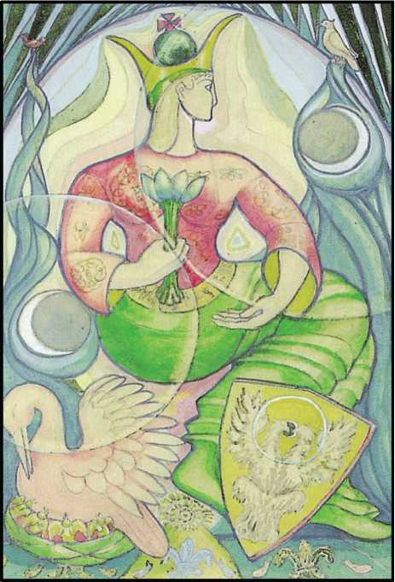

1. THE EMPRESS

This card is attributed to the letter Daleth, which means a door, and it refers to the planet Venus. This card is. on the face of it, the complement of The Emperor; but her attribu­tions are much more universal.

On the Tree of Life, Daleth is the path leading from Chokmah to Binah, uniting the Fa­ther with the Mother. Daleth is one of the three paths which are altogether above the Abyss. There is further more the alchemical symbol of Venus, the only one of the planetary symbols which comprises all the Sephiroth of the Tree of Life. The doctrine implied is that the funda­mental formula of the Universe is Love. [The circle touches the Sephiroth I, 2, 4, 6, 5, 3; the Cross is formed by 6, 9, 10 and 7, 8.]

It is impossible to summarize the meanings of the symbol of the Woman, for this very reason, that she continually recurs in infinitely varied form. “Many-throned, many-minded, many-wiled, daughter of Zeus.”

In this card, she is shown in her most general manifestation. She combines the highest spiritual with the lowest material qualities. For this reason, she is fitted to represent one of the three alchemical forms of energy, Salt. Salt is the inactive principle of Nature; Salt is mat­ter which must be energized by Sulphur to maintain the whirling equilibrium of the Universe. The arms and torso of the figure consequently suggest the shape of the alchemical symbol of

Salt. She represents a woman with the imperial crown and vestments, seated upon a throne, whose uprights suggest blue twisted flames symbolic of her birth from water, the feminine, fluid element. In her right hand she bears the lotus of Isis; the lotus represents the feminine, or passive power. Its roots are in the earth beneath the water, or in the water itself, but it opens its petals to the Sun, whose image is the belly of the chalice. It is, therefore, a living form of the Holy Grail, sanctified by the blood of the Sun. Perching upon the flamelike uprights of her throne are two of her most sacred birds, the sparrow and the dove; the nub of this sym­bolism must be sought in the poems of Catullus and Martial. On her robe are bees; also domi­nos, surrounded by continuous spiral lines; the signification is everywhere similar.

About her, for a girdle, is the Zodiac.

Beneath the throne is a floor of tapestry, embroidered with fleurs-de-lys and fishes; they seem to be adoring the Secret Rose, which is indicated at the base of the throne. The sig­nificance of these symbols has already been explained. In this card all symbols are cognate, because of the simplicity and purity of the emblem. There is here no contradiction; such op­position as there seems to be is only the opposition necessary to balance. And this is shown by the revolving moons.

The heraldry of the Empress is two-fold: on the one side, the Pelican of tradition feed­ing its young from the blood of its own heart; on the other, the White Eagle of the Alchemist.

With regard to the Pelican, its full symbolism is only available to Initiates of the Fifth degree of the O.T.O. In general terms, the meaning may be suggested by identifying the Pelican herself with the Great Mother and her offspring, with the Daughter in the formula of Tetra- grammaton. It is because the daughter is the daughter of her mother that she can be raised to her throne. In other language, there is a continuity of life, an inheritance of blood, which binds all forms of Nature together. There is no break between light and darkness. Natura non facit saltum. If these considerations were fully understood, it would become possible to reconcile the Quantum theory with the Electro-magnetic equations.

The White Eagle in this trump corresponds to the Red Eagle in the Consort card, the Emperor. It is here necessary to work backwards. For in these highest cards are the symbols of perfection; both the initial perfection of Nature and the final perfection of Art; not only Isis, but Nephthys. Consequently, the details of the work pertain to subsequent cards, especially Atu vi and Atu xiv.

At the back of the card is the Arch or Door, which is the interpretation of the letter Daleth. This card, summed up, may be called the Gate of Heaven. But, because of the beauty of the symbol, because of its omniform presentation, the student who is dazzled by any given manifestation may be led astray. In no other card is it so necessary to disregard the parts, to concentrate upon the whole.

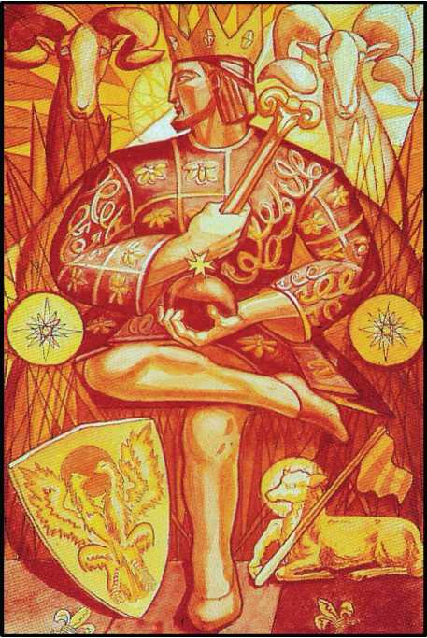

1. THE EMPEROR

This card is attributed to the letter Tzaddi, and it refers to the sign of Aries in the Zo­diac. This sign is ruled by Mars, and therein the Sun is exalted. The sign is thus a combination of energy in its most material form with the idea of authority. The sign TZ or TS implies this in the original, onomatopoetic form of language. It is derived from Sanskrit roots meaning Head and Age, and is found to-day in words like C^sar, Tsar, Sirdar, Senate, Senior, Signor, Senor, Seigneur.

The card represents a crowned male figure, with imperial vestments and regalia. He is seated upon the throne whose capitals are the heads of the Himalayan wild ram, since Aries means a Ram. At his feet, couchant, is the Lamb and Flag, to confirm this attribution on the lower plane; for the ram, by nature, is a wild and courageous animal, lonely in lonely places, whereas when tamed and made to lie down in green pastures, nothing is left but the docile, cowardly, gregarious and succulent beast. This is the theory of government.

The Emperor is also one of the more important alchemical cards; with Atu II and III, he makes up the triad: Sulphur, Mercury, Salt. His arms and head form an upright triangle; below, crossed legs represent the Cross. This figure is the alchemical symbol of Sulphur (see Atu X). Sulphur is the male fiery energy of the Universe, the Rajas of Hindu philosophy. This is the swift creative energy, the initiative of all Being. The power of the Emperor is a generalization of the paternal power; hence such symbols as the Bee and the Fleur-de-Lys, which are shown on this card. With regard to the quality of this power, it must be noted that it represents sud­den, violent, but impermanent activity. If it persists too long, it burns and destroys. Distin­guish from the Creative Energy of Aleph and Beth: this card is below the Abyss.

The Emperor bears a sceptre (surmounted by a ram’s head for the reasons given above) and an orb surmounted by a Maltese cross, which signifies that his energy has reached a successful issue, that his government has been established.

There is one further symbol of importance. His shield represents the two-headed eagle crowned with a crimson disk. This represents the red tincture of the alchemist, of the nature of gold, as the white eagle shown in Atu III pertains to his consort, the Empress, and is lunar, of silver.

It is finally to be observed that the white light which descends upon him indicates the position of this card in the Tree of Life. His authority is derived from Chokmah, the creative Wisdom, the Word, and is exerted upon Tiphareth, the organized man.

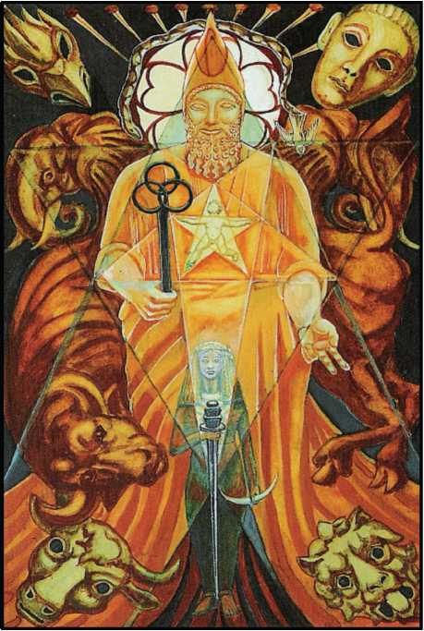

1. THE HIEROPHANT

This card is referred to the letter Vau, which means a Nail; of this instrument nine ap­pear at the top of the card; they serve to fix the oriel behind the main figure of the picture.

The card is referred to Taurus; therefore the Throne of the Hierophant is surrounded by elephants, which are of the nature of Taurus; and he is actually seated upon a bull. Around him are the four beasts or Kerubs, one in each corner of the card; for these are the guardians of every shrine. But the main reference is to the particular arcanum which is the principal business, the essential, of all magical work; the uniting of the microcosm with the macrocosm. Accordingly, the oriel is diaphanous; before the Manifestor of the Mystery is a hexagram rep­resenting the macrocosm. In its centre is a pentagram, representing a dancing male child. This symbolizes the law of the new Aeon of the Child Horns, which has supplanted that Aeon of the “Dying God” which governed the world for two thousand years. Before him is the woman girt with a sword; she represents the Scarlet Woman in the hierarchy of the new Aeon. This sym­bolism is further carried out in the oriel where, behind the phallic headdress, the rose of five petals is in blossom.

The symbolism of the snake and dove refers to this verse of the Book of the Law—chap. I, verse 57: “there are love and love. There is the dove, and there is the serpent”.

This symbol recurs in the trump numbered XVI.

The background of the whole card is the dark blue of the starry night of Nuit, from whose womb all phenomena are born.

Taurus, the sign of the Zodiac represented by this card, is itself the Bull Kerub; that is, Earth in its strongest and most balanced form.

The ruler of this sign is Venus; she is represented by the woman standing before the hierophant.

Chapter III of the Book of the Law, verse xi, reads:

“Let the woman be girt with a sword before me.” This woman represents Venus as she now is in this new aeon; no longer the mere vehicle of her male counterpart, but armed and militant.

In this sign the Moon is “exalted”; her influence is represented not only by the woman, but by the nine nails.

It is impossible at the present time to explain this card thoroughly, for only the course of events can show how the new current of initiation will work out.

It is the aeon of Horus, of the Child. Though the face of the Hierophant appears benig­nant and smiling, and the child himself seems glad with wanton innocence, it is hard to deny that in the expression of the initiator is something mysterious, even sinister. He seems to be enjoying a very secret joke at somebody’s expense. There is a distinctly sadistic aspect to this card; not unnaturally, since it derives from the Legend of Pasiphae, the prototype of all the legends of Bull-gods. These still persist in such religions as Shaivism, and (after multiple de­gradations) in Christianity itself.

The symbolism of the Wand is peculiar; the three interlaced rings which crown it may be taken as representative of the three Aeons of Isis, Osiris and Horus with their interlocking magical formulae. The upper ring is marked with scarlet for Horus; the two lower rings with green for Isis, and pale yellow for Osiris, respectively.

All these are based upon deep indigo, the colour of Saturn, the Lord of Time. For the rhythm of the Hierophant is such that he moves only at intervals of 2,000 years.

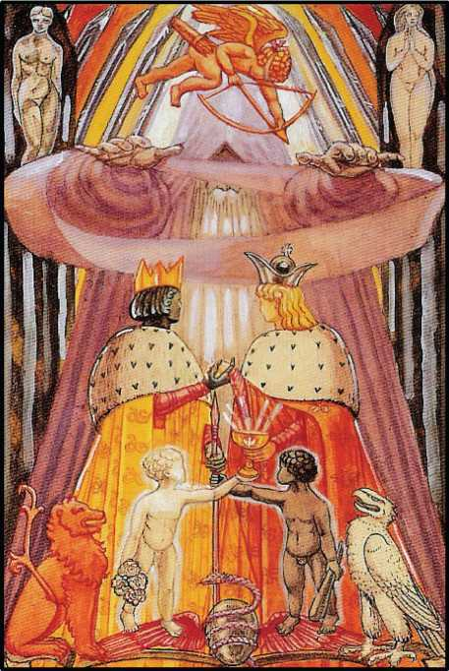

1. THE LOVERS [OR: THE BROTHERS]

This card and its twin, XIV, Art, are the most obscure and difficult of the Atu. Each of these symbols is in itself double, so that the meanings form a divergent series, and the inte­gration of the Card can only be regained by repeated marriages, identifications, and some form of Hermaphroditism.

Yet the attribution is the essence of simplicity. Atu VI refers to Gemini, ruled by Mer­cury. It means The Twins. The Hebrew letter corresponding is Zain, which means a Sword, and the framework of the card is therefore the Arch of Swords, beneath which the Royal Marriage takes place.

The Sword is primarily an engine of division. In the intellectual world-which is the world of the Sword suit-it represents analysis. This card and Atu XIV together compose the comprehensive alchemical maxim: Solve et coagula.

This card is consequently one of the most fundamental cards in the Tarot. It is the first card in which more than one figure appears. [The Ape of Thoth in Atu I is only a shadow.] In its original form, it was the story of Creation.

Here is appended, for its historical interest, the description of this card in its primitive form from Liber 418.

“There is an Assyrian legend of a woman with a fish, and also there is a legend of Eve and the Serpent, for Cain was the child of Eve and the Serpent, and not of Eve and Adam; and therefore when he had slain his brother, who was the first murderer, having sacrificed living things to his demon, had Cain the mark upon his brow, which is the mark of the Beast spoken of in the Apocalypse, and is the sign of Initiation.

“The shedding of blood is necessary, for God did not hear the children of Eve until blood was shed. And that is external religion; but Cain spake not with God, nor had the mark of initiation upon his brow, so that he was shunned of all men, until he had shed blood. And this blood was the blood of his brother. This is a mystery of the sixth key of the Tarot, which ought not to be called The Lovers, but The Brothers.

“In the middle of the card stands Cain; in his right hand is the Hammer of Thor with which he hath slain his brother, and it is all wet with his blood. And his left hand he holdeth open as a sign of innocence. On his right hand is his mother Eve, around whom the serpent is entwined with his hood spread behind her head; and on his left hand is a figure somewhat like the Hindoo Kali, but much more seductive. Yet I know it to be Lilith. And above him is the Great Sigil of the Arrow, downward, but it is struck through the heart of the child. This child also is Abel. And the meaning of this part of the card is obscure, but that is the correct drawing of the Tarot card; and that is the correct magical fable from which the Hebrew scribes, who were not complete Initiates, stole their legend of the Fall and the subsequent events.”

It is very significant that almost every sentence in this passage seems to reverse the meaning of the previous one. This is because reaction is always equal and opposite to action. This equation is, or should be, simultaneous in the intellectual world, where there is no great time4ag; the formulation of any idea creates its contradictory at almost the same moment. The contradictory of any proposition is implicit in itself. This is necessary to preserve the equilibrium of the Universe. The theory has been explained in the essay on Atu I, the Juggler, but must now be again emphasized in order to interpret this card.

The key is that the Card represents the Creation of the World. The Hierarchs held this secret as of transcendant importance. Consequently, the Initiates who issued the Tarot, for use during the Aeon of Osiris, superseded the original card above described in “The Vision and the Voice”. They were concerned to create a new Universe of their own; they were the fathers of Science. Their methods of working, grouped under the generic term Alchemy, have never been made public. The interesting point is that all developments of modern science in the last fifty years have given intelligent and instructed people the opportunity of reflecting that the whole trend of science has been to return to alchemical aims and (mutatis mutandis) methods.

The secrecy observed by the alchemists was made necessary by the power of persecut­ing Churches. Bitterly as bigots fought among themselves, they were all equally concerned to destroy the infant Science, which, as they instinctively recognized, would put an end to the ig­norance and faith on which their power and wealth depended.

The subject of this card is Analysis, followed by Synthesis. The i first question asked by science is: “Of what are things composed? “This having been answered, the next question is: “How shall we recombine them to our greater advantage?” This resumes the whole policy of the Tarot.

The hooded figure which occupies the centre of the Card is another form of The Her­mit, who is further explained in Atu IX. He is himself a form of the god Mercury, described in Atu I; he is closely shrouded, as if to signify that the ultimate reason of things lies in a realm beyond manifestation and intellect. (As elsewhere explained, only two operations are ulti­mately possible—analysis and synthesis). He is standing in the Sign of the Enterer, as if pro­jecting the mysterious forces of creation. About his arms is a scroll, in dicative of the Word which is alike his essence and his message. But the Sign of the Enterer is also the Sign of Benediction and of Consecration; thus his action in this card is the Celebration of the Her­metic Marriage. Behind him are the figures of Eve, Lilith and Cupid. This symbolism has been incorporated in order to preserve in some measure the original form of the card, and to show its derivation, its heirship, its continuity with the past. On the quiver of Cupid is inscribed the word Thelema, which is the Word of the Law. (See Liber AL, chap. I, verse 39.) His shafts are quanta of Will. It is thus shown that this fundamental formula of magical working, analysis and synthesis, persists through the Aeons.

One may now consider the Hermetic Marriage itself.

This part of the Card has been simplified from “The Chymical Marriage of Christian Rosenkreutz”, a masterpiece too lengthy and diffuse to quote usefully in this place. But the es­sence of the analysis is the continuous see-saw of contradictory ideas. It is a glyph of duality. The Royal persons concerned are the Black or Moorish King with a golden crown, and the White Queen with a silver crown. He is accompanied by the Red Lion, and she by the White Eagle.

These are symbols of the male and female principles in Nature; they are therefore equally, in various stages of manifestation, Sun and Moon, Fire and Water, Air and Earth. In chemistry they appear as acid and alkali, or (more deeply) metals and non-metals, taking those words in their widest philosophical sense to include hydrogen on the one hand and oxygen on the other. In this aspect, the hooded figure represents the Protean element of car­bon, the seed of all organic life.

The symbolism of male and female is carried on still further by the weapons of the King and Queen; he bears the Sacred Lance, and she the Holy Grail; their other hands are joined, as consenting to the Marriage. Their weapons are supported by twin children, whose positions are counterchanged; for the white child not only holds the Cup, but carries roses, while the black child, holding his father’s Lance, carries also the club, an equivalent symbol. At the bottom of the whole is the result of the Marriage in primitive and pantomorphic form; it is the winged Orphic egg. This egg represents the essence of all that life which comes under this formula of male and female. It carries on the symbolism of the Serpents with which the King’s robe is embroidered, and of the Bees which adorn the mantle of the Queen. The egg is grey, mingling white and black; thus it signifies the co-operation of the three Supernals of the Tree of Life. The colour of the Serpent is purple, Mercury in the scale of the Queen. It is the influ­ence of that God manifested in Nature, whereas the wings are tinged with crimson, the colour (in the King scale) of Binah the great Mother. In this symbol is therefore a complete glyph of the equilibrium necessary to begin the Great Work. But, as to the final mystery, that is left un­solved. Perfect is the plan to produce life, but the nature of this life is concealed. It is capable of taking any possible form; but what form? That is dependent upon the influences attendant on gestation.

The figure in the air presents some difficulty. The traditional interpretation of the fig­ure is that he is Cupid; and it is not at first clear what Cupid has to do with Gemini. N o light is thrown upon this point by consideration of the position of the path upon the Tree of Life, for Gemini leads from Binah to Tiphareth. There accordingly arises the whole question of Cupid. Roman gods usually represent a more material aspect of the Greek gods from whom they are derived; in this case, Eros. Eros is the son of Aphrodite, and tradition varies as to whether his father was Ares, Zeus or Hermes—that is, Mars, Jupiter or Mercury. His appearance in this card suggests that Hermes is the true sire; and this view is confirmed by the fact that it is not altogether easy to distinguish him from the child Mercury, for they have in common wanton­ness) irresponsibility, and the love of playing tricks. But in this image are peculiar characteris­tics. He carries a bow and arrows in a golden quiver. (He is sometimes represented with a torch.) He has golden wings, and is blindfolded. From this, it may appear that he represents the intelligent (and, at the same time, unconscious) will of the soul to unite itself with all and sundry, as has been explained in the general formula with regard to the agony of separateness.

No very special importance is attached to Cupid in alchemical figures. Yet, in one sense, he is the source of all action; the libido to express Zero as Two. From another point of view, he may be regarded as the intellectual aspect of the influence of Binah upon Tiphareth, for (in one tradition) the title of the card is “The Children of the Voice, the Oracle of the Mighty Gods”. From this point of view, he is a symbol of inspiration, descending upon the hooded figure, who is, in this instance, a prophet operating the conjunction of the King and Queen. His arrow represents the spiritual intelligence necessary in alchemical operations, rather than the mere hunger to perform them. On the other hand, the arrow is peculiarly a symbol of direction, and it is, therefore, proper to put the word “Thelema” in Greek letters on the quiver. It is also to be observed that the opposite card, Sagittarius, means the Bearer of the Arrow, or Archer, a fig­ure who does not appear in any form in Atu XIV. These two cards are so complementary that they cannot be studied separately, for full interpretation.

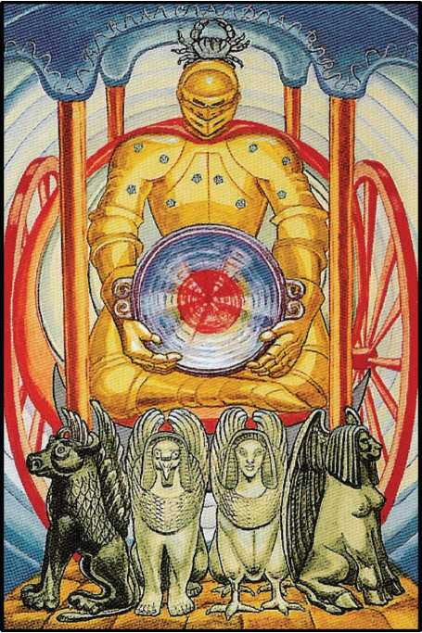

1. THE CHARIOT

Atu VII refers to the zodiacal sign of Cancer, the sign into which the Sun moves at the Summer Solstice.1

**xNote that Cheth—Cheth 8—Yod 10—Tan 400—has the value of 418. This is one of the most important of the key numbers of Liber AL. It is the number of the word of the Aeon, ABRAHADABRA, the cypher of the Great Work. (See The Equinox of The Gods, p. 138. Also The Temple of Solomon the King.) On this word alone a complete volume could, and should, be written.**

Cancer is the cardinal sign of the element of Water,2 and represents the first keen on­rush of that element. Cancer also represents the path which leads from the great Mother Bi­nah to Geburah, and is thus the influence of the Supernals descending through the Veil of Wa­ter (which is blood) upon the energy of man, and so inspires it. It corresponds, in this way, to The Hierophant, which, on the other side of the Tree of Life, brings down the fire of Chokmah. (See diagram.)

The design of this present card has been much influenced by the Trump portrayed by Eliphaz Levi.

The canopy of the Chariot is the night-sky-blue of Binah. The pillars are the four pillars of the Universe, the regimen of Tetragrammaton. The scarlet wheels represent the original energy of Geburah which causes the revolving motion.

This chariot is drawn by four sphinxes composed of the four Kerubs, the Bull, the Lion, the Eagle and the Man. In each sphinx these elements are counter-changed; thus the whole represents the sixteen sub-elements.

The Charioteer is clothed in the amber-coloured armour appropriate to the sign. He is throned in the chariot rather than con ducting it, because the whole system of progression is perfectly balanced. His only function is to bear the Holy Grail.

Upon his armour are ten Stars of Assiah, the inheritance of celestial dew from his mother.

He bears as a crest the Crab appropriate to the sign. The vizor of his helmet is lowered, for no man may look upon his face and live. For the same reason, no part of his body is ex­posed.

Cancer is the house of the Moon; there are thus certain analogies between this card and that of the High Priestess. But, also, Jupiter is exalted in Cancer, and here one recalls the card called Fortune (Atu X) attributed to Jupiter.

The central and most important feature of the card is its centre-

**2Hence St. John Baptist's Day, and the various ceremonials connected with water.**

the Holy Grail. It is of pure amethyst, of the colour of Jupiter, but its shape suggests the full moon and the Great Sea of Binah.

In the centre is radiant blood; the spiritual life is inferred; light in the darkness. These rays, moreover, revolve, emphasizing the Jupiterian element in the symbol.

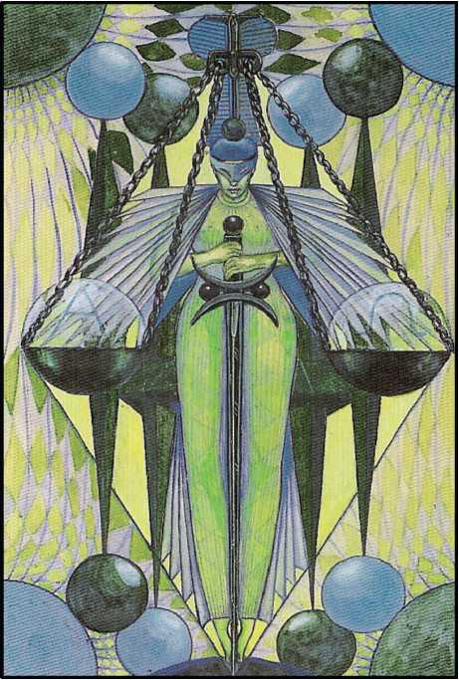

1. ADJUSTMENT

This card in the old pack was called Justice. This word has none but a purely human and therefore relative sense; so it is not to be considered as one of the facts of Nature. Nature is not just, according to any theological or ethical idea; but Nature is exact.

This card represents the sign of Libra, ruled by Venus; in it Saturn is exalted. The equi­librium of all things is hereby symbolized. It is the final adjustment in the formula of Tetra­grammaton, when the daughter, redeemed by her marriage with the Son, is thereby set up on the throne of the mother; thus, finally, she “awakens the Eld of the All-Father.”

In the greatest symbolism of all, however, the symbolism beyond all planetary and Zo­diacal considerations, this card is the feminine complement of the Fool, for the letters Aleph Lamed constitute the secret key of the Book of the Law, and this is the basis of a complete qa­balistic system of greater depth and sublimity than any other. The details of this system have not yet been revealed. It has been thought right, nevertheless, to hint at its existence by equat­ing the designs of these two cards. N ot only therefore, because Libra is a sign of Venus, but be­cause she is the partner of the Fool, is the Goddess represented as dancing, with the sugges­tion of Harlequin.

The figure is that of a young and slender woman poised exactly upon toetip. She is crowned with the ostrich plumes of Maat, the Egyptian goddess of Justice, and on her fore­head is the Uraeus serpent, Lord of Life and Death. She is masked, and her expression shows her secret intimate satisfaction in her domination of every element of dis-equilibrium in the Universe. This condition is symbolized by the Magic Sword which she holds in both hands, and the balances or spheres in which she weighs the Universe, Alpha the First balanced ex­actly against Omega the Last. These are the Judex and Testes of Final Judgment; the Testes, in particular, are symbolic of the secret course of judgment whereby all current experience is absorbed, transmuted, and ultimately passed on, by virtue of the operation of the Sword, to further manifestation. This all takes place within the diamond formed by the figure which is the concealed Vesica Piscis through which this sublimated and adjusted experience passes to its next manifestation.

She poises herself before a throne composed of spheres and pyramids (four in number, signifying Law and Limitation) which themselves maintain the same equity that she herself manifests, though on a completely impersonal plane, in the framework within which all op­erations take place. Outside this again, at the corner of the card, are indicated balanced spheres of light and darkness, and constantly equilibrated rays from these spheres form a cur­tain, the interplay of all those forces which she sums up and adjudicates.

One must go more deeply into philosophy; the Trump represents The Woman Satisfied. Equilibrium stands apart from any individual prejudices; therefore the title, in France, should rather be Justesse. In this sense, Nature is scrupulously just. It is impossible to drop a pin without exciting a corresponding reaction in every Star. The action has disturbed the balance of the Universe.

This woman-goddess is Harlequin; she is the partner and fulfilment of The Fool. She is the ultimate illusion which is manifestation; she is the dance, many-coloured, many-wiled, of Life itself. Constantly whirling, all possibilities are enjoyed, under the phantom show of Space and Time: all things are real, the soul is the surface, precisely because they are instantly com­pensated by this Adjustment. All things are harmony and beauty; all things are Truth: because they cancel out.

She is the goddess Maat; she bears upon her nemyss the ostrich feathers of the Two­fold Truth.

From this Crown, so delicate that the most faintest breath of thought must stir it, de­pend, by chains of Cause, the Scales wherein Alpha, the first, is poised in perfect equilibrium with Omega, the last. The scales of the balance are the Two Witnesses in whom shall every word be established. She is therefore to be understood as assessing the virtue of every act and demanding exact and precise satisfaction.

More than this, she is the complete formula of the Dyad; the word AL is the title of the Book of the Law, whose number is 31, the most secret of the numerical keys of that Book. She represents Manifestation, which may always be cancelled out by equilibration of opposites.

She is wrapped in a cloak of mystery, the more mysterious because diaphanous; she is the sphinx without a secret, because she is purely a matter of calculation. In Eastern philoso­phy she is Karma.

Her attributions develop this thesis. Venus rules the sign of the Balance; and that is to show the formula: “Love is the law, love under will”. But Saturn represents above all the ele­ment of Time, without which adjustment cannot take place, for all action and re action take place in time, and therefore, time being itself merely a condition of phenomena, all phenom­ena are invalid because uncompensated.

The Woman Satisfied. From the cloak of the vivid wantonness of her dancing wings is­sue her hands; they hold the hilt of the Phallic sword of the magician. She holds the blade be­tween her thighs.

This is again a hieroglyph of “Love is the law, love under will”. Every form of energy must be directed, must be applied with integrity, to the full satisfaction of its destiny.

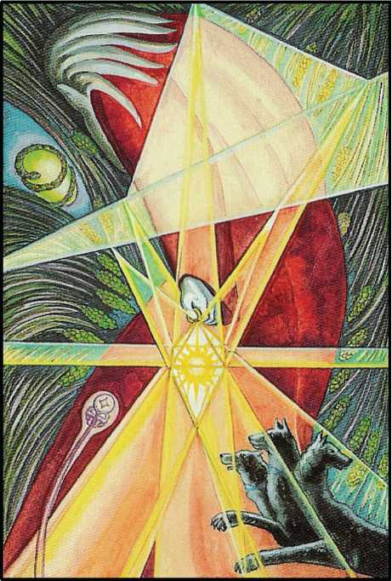

1. THE HERMIT

This card is attributed to the letter Yod, which means the Hand. Hence, the hand, which is the tool or instrument par excellence, is in the centre of the picture. The letter Yod is the foundation of all the other letters of the Hebrew alphabet, which are merely combinations of it in various ways.

The letter Yod is the first letter of the name Tetragrammaton, and this symbolizes the Father, who is Wisdom; he is the highest form of Mercury, and the Logos, the Creator of all worlds. Accordingly, his representative in physical life is the spermatozoon; this is why the card is called The Hermit.

The figure of the Hermit himself recalls the shape of the letter Yod, and the colour of his cloak is the colour of Binah, in whom he gestates.

In his hand he holds a Lamp whose centre is the Sun, portrayed in the likeness of the Sigil of the great King of Fire (Yod is the secret Fire). It seems that he is contemplating—in a certain sense, adoring—the Orphic egg (greenish in colour) because it is conterminous with the Universe, while the snake which surrounds it is many-coloured to signify the iridescence of Mercury. For he is not only creative, but is the fluidic essence of Light, which is the life of the Universe.

The highest symbolism of this card is, therefore, Fertility in its most exalted sense, and this is reflected in the attribution of the card to the sign of Virgo, which is another aspect of the same quality. Virgo is an earthy sign, and is referred especially to Corn, so that the back­ground of the card is a field of wheat.

Virgo represents the lowest, most receptive, most feminine form of earth, and forms the crust over Hades. Yet not only is Virgo ruled by Mercury, but Mercury is exalted therein. Compare the Ten of Disks, and the general doctrine that the climax of the Descent into Matter is the signal for the redintegration by Spirit. It is the Formula of the Princess, the mode of ful­filment of the Great Work.

This card recalls the Legend of Persephone, and herein is a dogma. Concealed within Mercury is a light which pervades all parts of the Universe equally; one of his titles is Psychopompos, the guide of the soul through the lower regions. These symbols are indi­cated by his Serpent Wand, which is actually growing out of the Abyss, and is the sper­matozoon developed as a poison, and manifesting the foetus. Following him is Cerberus, the three-headed Hound of Hell whom he has tamed. In this Trump is shewn the entire mystery of Life in its most secret workings. Yod = Phallus = Spermatozoon = Hand = Lo­gos = Virgin. There is perfect Identity, not merely Equivalence, of the Extremes, the Mani­festation, and the Method.

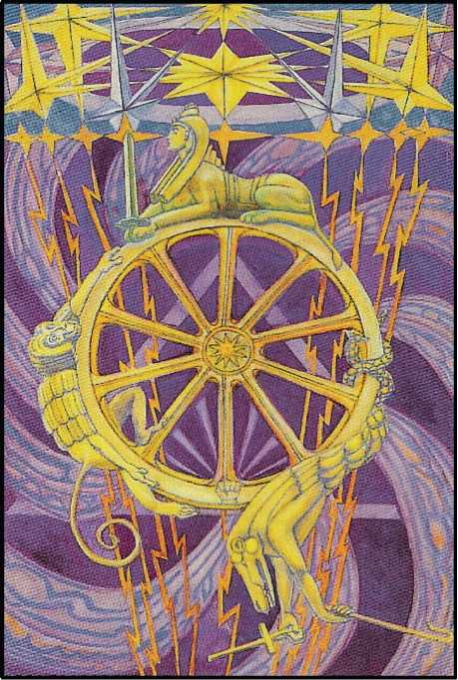

1. FORTUNE

This card is attributed to the planet Jupiter, “the Greater Fortune” in astrology. It corre­sponds to the letter Kaph1, which means

**\*Kaph 20 Pe 80=100, Qoph, Pisces. The initials K Ph are those of ?Teiq and ФаААод**

the palm of the hand, in whose lines, according to another tradition, the fortune of the owner may be read. It would be narrow to think of Jupiter as good fortune; he represents the element of luck. The incalculable factor.

This card thus represents the Universe in its aspect as a continual change of state. Above, the firmament of stars. These appear distorted in shape, although they are balanced, some being brilliant and some dark. From them, through the firmament, issue lightnings; they churn it into a mass of blue and violet plumes. In the midst of all this is suspended a wheel of ten spokes, according to the number of the Sephiroth, and of the sphere of Malkuth, indicating governance of physical affairs.

On this wheel are three figures, the Sworded Sphinx, Hermanubis, and Typhon; they symbolize the three forms of energy which govern the movement of phenomena.

The nature of these qualities requires careful description. In the Hindu system are three Gunas-Sattvas, Rajas and Tamas. The word “Guna” is untranslatable. It is not quite an element, a quality, a form of energy, a phase, or a potential; all of these ideas enter into it. All the qualities that can be predicated of anything may be ascribed to one or more of these Gunas: Tamas is darkness, inertia, sloth, ignorance, death and the like; Rajas is energy, excite­ment, fire, brilliance, restlessness; Sattvas is calm, intelligence, hicidity and balance. They cor­respond to the three principal Hindu castes.

One of the most important aphorisms of Hindu philosophy is: “the Gunas revolve”. This means that, according to the doctrine of continual change, nothing can remain in any phase where one of these Gunas is predominant; however dense and dull that thing may be, a time will come when it begins to stir. The end and reward of the effort is a state of lucid quietude, which, however, tends ultimately to sink into the original inertia.

The Gunas are represented in European philosophy by the three qualities, sulphur, mercury and salt, already pictured in Atu I, III and IV. But in this card the attribution is some­what different. The Sphinx is composed of the four Kerubs, shown in Atu V, the bull, the lion, the eagle and the man. These correspond, furthermore, to the four magical virtues, to Know, to Will, to Dare, and to Keep Silence.1 This Sphinx represents the element of sulphur, and is exalted, temporarily, upon the summit of the wheel. She is armed with a sword of the short Roman pattern, held upright between the paws of the lion.

Climbing up the left-hand side of the wheel is Hermanubis, who represents the al­chemical Mercury. He is a composite god; but in him the simian element predominates.

On the right hand side, precipitating himself downward, is Typhon, who represents the element of salt. Yet in these figures there is also a certain degree of complexity, for Typhon was a monster of the primitive world, personifying the destructive power and fury of volcanos and typhoons. In the legend, he attempted to obtain supreme authority over both gods and men; but Zeus blasted him with a thunderbolt. He is said to be the father of stormy, hot and poisonous winds; also of the Harpies. But this card, like Atu XVI, may also be interpreted as a Unity of supreme attainment and delight. The lightnings which destroy, also beget; and the wheel may be regarded as the Eye of Shiva, whose opening annihilates the Universe, or as a wheel upon the Car of Jaganath, whose devotees attain perfection at the moment that it crushes them.

A description of this card, as it appears in The Vision and the Voice, with certain inner meanings, is given in an Appendix.

**iThese are the four elements, summed in a fifth, Spirit, to form the Pentagram; and the Magical Virtue corre­sponding is Ire, to go. “To go” is the token of Godhead, as explained in reference to the sandal-strap or Ankh, the Crux Ansata, which in its turn is identical with the astrological symbol of Venus, comprising the 10 Sephiroth. (See diagram.)**

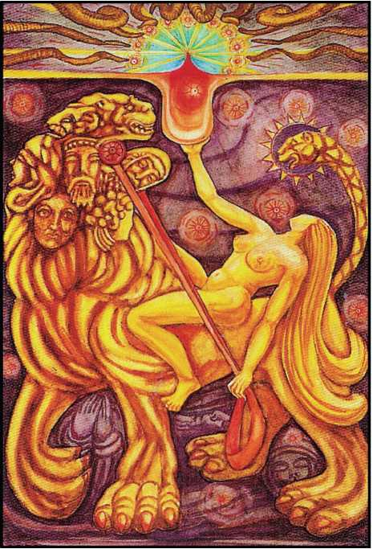

1. LUST

This Trump was formerly called Strength. But it implies far more than strength in the ordinary sense of the word. Technical analysis shows that the Path corresponding to the card is not the Strength of Geburah, but the influence from Chesed upon Geburah, the Path bal­anced both vertically and horizontally on the Tree of Life (see diagram). For this reason it has been thought better to change the traditional title. Lust implies not only strength, but the joy of strength exercised. It is vigour, and the rapture of vigour.

“Come forth, o children, under the stars, & take your fill of love! I am above you and in you. My ecstasy is in yours. My joy is to see your joy.”

“Beauty and strength, leaping laughter and delicious languor, force and fire, are of us.”

“I am the Snake that giveth Knowledge & Delight and bright glory, and stir the hearts of men with drunkenness. To worship me take wine and strange drugs whereof I will tell my prophet, & be drunk thereof! They shall not harm ye at all. It is a lie, this folly against self. The exposure of innocence is a lie. Be

strong, O man! lust, enjoy all things of sense and rapture: fear not that any God shall deny thee for this.”

“Behold! these be grave mysteries; for there are also of my friends who be hermits. Now think not to find them in the forest or on the mountain; but in beds of purple, caressed by magnificent beasts of women with large limbs, and fire and light in their eyes, and masses of flaming hair about them; there shall ye find them. Ye shall see them at rule, at victorious armies, at all the joy; and there shall be in them a joy a million times greater than this. Beware lest any force another, King against King! Love one another with burning hearts; on the low men trample in the fierce lust of your pride, in the day of your wrath.”

“There is a light before thine eyes, O prophet, a light undesired, most de­sirable.

“I am uplifted in thine heart; and the kisses of the stars rain hard upon thy body.

“Thou art exhaust in the voluptuous fulness of the inspiration; the expi­ration is sweeter than death, more rapid and laughterful than a caress of Hell’s own worm.”

This Trump is assigned to the sign of Leo in the Zodiac. It is the Kerub of Fire, and is ruled by the Sun. It is the most powerful of the twelve Zodiacal cards,’ and represents the most critical of all the operations of magick and of alchemy. It represents the act of the original marriage as it occurs in nature, as opposed to the more artificial form portrayed in Atu VI; there is in this card no attempt to direct the course of the operation.

The main subject of the card refers to the most ancient collection of legends or fables. It is necessary here to go a little into the magical doctrine of the succession of the Aeons, which is connected with the procession of the Zodiac. Thus, the last Aeon, that of Osiris, is re­ferred to Aries and Libra, as the previous Aeon, that of Isis, was especially connected with the signs of Pisces and Virgo, while the present, that of Horus, is linked with Aquarius and Leo. The central mystery in that past Aeon was that of Incarnation; all the legends of god-men were founded upon some symbolic story of that kind. The essential of all such stories was to deny human fatherhood to the hero or god-man. In most cases, the father is stated to be a god in some animal form, the animal being chosen in accordance with the qualities that the au­thors of the cult wished to see reproduced in the child.

Thus, Romulus and Remus were twins begotten upon a virgin by the god Mars, and they were suckled by a wolf. On this the whole magical formula of the city Rome was founded. Reference has already been made in this essay to the legends of Hermes and Dionysus. The father of Gautama Buddha was said to be an elephant with six tusks, appearing to his mother in a dream.

There is also the legend of the Holy Ghost in the form of a dove, impregnating the Vir­gin Mary. There is here a reference to the dove of N oah’s Ark, bringing glad tidings of the sal­vation of the world from the waters. (The dwellers in the Ark are the foetus, the waters the amniotic fluid.)

Similar fables are to be found in every religion of the Aeon of Osiris: it is the typical formula of the Dying God.

In this card, therefore, appears the legend of the woman and the lion, or rather lion- serpent. (This card is attributed to the letter Teth, which means a serpent.)

The seers in the early days of the Aeon of Osiris foresaw the Manifestation of this com­ing Aeon in which we now live, and they regarded it with intense horror and fear, not under­standing the precession of the Aeons, and regarding every change as catastrophe. This is the real interpretation of, and the reason for, the diatribes against the Beast and the Scarlet Woman in the XIII, XVII and XVIII-th chapters of the Apocalypse; but on the Tree of Life, the path of Gimel, the Moon, descending from the highest, cuts the path of Teth, Leo, the house of the Sun, so that the Woman in the card may be regarded as a form of the Moon, very fully il­luminated by the Sun, and intimately united with him in such wise as to produce, incarnate in human form, the representative or representatives of the Lord of the Aeon.

She rides astride the Beast; in her left hand she holds the reins, representing the pas­sion which unites them. In her right she holds aloft the cup, the Holy Grail aflame with love and death. In this cup are mingled the elements of the sacrament of the Aeon. The Book of Lies devotes one chapter to this symbol.

*Wara tah-Blossom*

Seven are the veils of the dancing-girl in the harem of IT.

Seven are the names, and seven are the lamps beside Her bed.

Seven eunuchs guard Her with drawn swords; No man may come nigh unto Her.

In Her wine-cup are seven streams of the blood of the Seven Spirits of God.

Seven are the heads of THE BEAST whereon She rideth.

The head of an Angel: the head of a Saint: the head of a Poet: the head of an Adulterous Woman: the head of a Man of Valour: the head of a Satyr: and the head of a Lion-Serpent.

This is the Seal upon the Ring that is on the Forefinger of IT: and it is the Seal upon the Tombs of them whom She hath slain,.

Seven letters hath Her holiest name; and it is

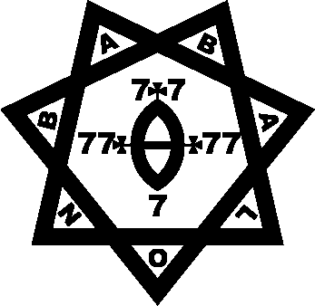

Here is Wisdom. Let him that hath Understanding count the Number of Our Lady; for it is the Number of a Woman; and Her Number is An Hundred and Fifty and Six.

There is a further description in The Vision and the Voice. (See Appendix.)

There is in this card a divine drunkenness or ecstasy. The woman is shown as more than a little drunk, and more than a little mad; and the lion also is aflame with lust. This signi­fies that the type of energy described is of the primitive, creative order; it is completely inde­pendent of the criticism of reason. This card portrays the will of the Aeon. In the background are the bloodless images of the saints, on whom this image travels, for their whole life has been absorbed into the Holy’ Grail.

“Now ye shall know that the chosen priest & apostle of infinite space is the prince- priest the Beast; and in his woman called the Scarlet Woman all power is given. They shall gather my children into their fold; they shall bring the glory of the stars into the hearts of men.

“For he is ever a sun, and she a moon. But to him is the winged secret flame, and to her the stooping starlight.”

This sacrament is the physical-magical formula for attaining initiation, for the accom­plishment of the Great Work. It is in alchemy the process of distillation, operated by internal ferment, and the influence of the Sun and Moon.

Behind the figures of the Beast and his Bride are ten luminous rayed circles; they are the Sephiroth latent and not yet in order, for every new Aeon demands a new system of classi­fication of the Universe.

At the top of the card is shown an emblem of the new light, with ten horns of the Beast, which are serpents, sent forth in every direction to destroy and re-create the world.

Further study of this card may be made by close examination of LiberXV(Magick, pp. 345 sqq.).

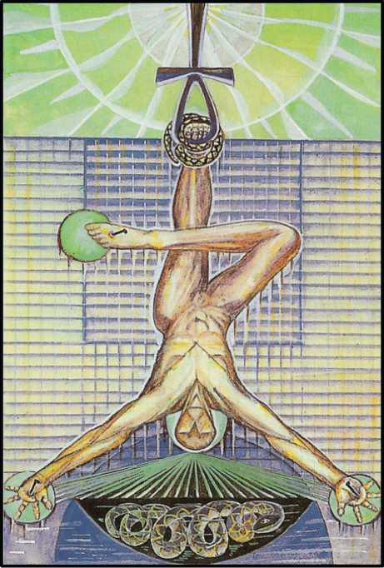

1. THE HANGED MAN

This card, attributed to the letter Mem, represents the element of Water. It would per­haps be better to say that it represents the spiritual function of water in the economy of initia­tion; it is a baptism which is also a death. In the Aeon of Osiris, this card represented the su­preme formula of adeptship; for the figure of the drowned or hanged man has its own special meaning. The legs are crossed so that the right leg forms a right angle with the left leg, and the arms are stretched out at an angle of 60° so as to form an equilateral triangle; this gives the symbol of the Triangle surmounted by the Cross, which represents the descent of the light into the darkness in order to re deem it. For this reason there are green disks-green, the col­our of Venus, signifies Grace-at the terminations of the limbs and of the head. The air above the surface of the water is also green, infiltrated by rays of the white light of Kether. The whole figure is suspended from the Ankh, another way of figuring the formula of the Rose and Cross, while around the left foot is the Serpent, creator and destroyer, who operates all change. (This will be seen in the card which next follows.)

It is notable that there is an apparent increase of darkness and solidity in proportion as the redeeming element manifests itself; but the colour of green is the colour of Venus, of the hope that lies in love. That depends upon the formulation of the Rose and Cross, of the an­nihilation of the self in the Beloved, the condition of progress. In this inferior darkness of death, the serpent of new life begins to stir.

In the former Aeon, that of Osiris, the element of Air, which is the nature of that Aeon, is not unsympathetic either to Water or to Fire; compromise was a mark of that period. But now, under a Fiery lord of the Aeon, the watery element, so far as water is below the Abyss, is definitely hostile, unless the opposition is the right opposition implied in marriage. But in this card the only question is of the “redemption” of the submerged element, and therefore every­thing is reversed. This idea of sacrifice is, in the final analysis, a wrong idea.

“I give unimaginable joys on earth: certainty, not faith, while in life, upon death; peace unutterable, rest, ecstasy; nor do I demand aught in sacrifice.”

“Every man and every woman is a star.”

The whole idea of sacrifice is a misconception of nature, and these texts of the Book of the Law are the answer to it.

But water is the element of Illusion; one may regard this symbol n evil legacy from the old Aeon; to use an anatomical analogy, it spiritual vermiform appendix.

It was the water, and the Dwellers of the Water that slew Osiris; it is the crocodiles that threaten Hoor-Pa-Kraat.

This card is beautiful in a strange, immemorial, moribund manner. It is the card of the Dying God; its importance in the present pack is merely that of the Cenotaph. It says: “If ever things get bad like that again, in the new Dark Ages which appear to threaten, this is the way to put things right.” But if things have to be put right, it shows that they are very wrong. It should be the chiefest aim of the wise to rid mankind of the insolence of self-sacrifice, of the calamity of chastity; faith must be slain by certainty, and chastity by ecstasy.

In the Book of the Law it is written: “Pity not the fallen! I never knew them. I am not for them. I console not: I hate the consoled and the consoler.”

Redemption is a bad word; it implies a debt. For every star possesses boundless wealth; the only proper way to deal with the ignorant is to bring them to the knowledge of their starry heritage. To do this, it is necessary to behave as must be done in order to get on good terms with animals and children: to treat them with absolute respect; even; in a certain sense, with worship.

***

Note on the Precession of the Aeons. “The Hanged Man” is an invention of the Adepts of the I.N.R.I.—J.A.O. formula; in the Aeon previous to the Osirian, that of Isis (Water), he is “The Drowned Man”. The two uprights of the gallows shewn in the Mediaeval packs were, in the parthenogenetic system of explaining and ruling Nature, the bottom of the Sea and the keel of the Ark. In this Aeon all birth was considered an emanation, without male intervention, of the Mother or Star-Goddess, Nuit; all death a return to Her. This explains the original attribution of the Atu to Water, and the sound M the return to Eternal Silence, as in the word AUM. This card is therefore specially sacred to the Mystic) and the attitude of the figure is a ritual pos­ture in the Practice called “The Sleep of Shiloam”.

The Alchemical import of this card is so alien to all dogmatic implications that it has seemed better to deal quite separately with it. Its technical qualities are independent of all doctrines soever; here is a matter of strictly scientific bearings. The student will be prudent to read in connexion with these remarks Chapter XII of Magick.

The Atu represents the sacrifice of “a male child of perfect innocence and high intelli- gence”-these words were chosen with the utmost care. The meaning of his attitude has al­ready been described, and of the fact that he is hanged from an Ankh, an equivalent of the Rosy Cross; in some early cards the gallows is a Pylon, or the branch of a Tree, by shape sug­gesting the letter Daleth (d) Venus, Love.

His background is an unbounded grill of small squares; these are the Elemental Tablets which exhibit the names and sigilla of all the energies of Nature. Through his Work a Child is begotten, as shewn by the Serpent stirring in the Darkness of the Abyss below him.

Yet the card in itself is essentially a glyph of Water; Mem is one of the three great Mother Letters, and its value is 40, the might of Tetragrammaton fully developed by Malkuth, the symbol of the Universe under the Demiourgos. Moreover, Water is peculiarly the Mother Letter, for both Shin and Aleph (the other two) represent masculine ideas; and, in Nature, Homo Sapiens is a marine mammal, and our intra-uterine existence is passed in the Amniotic Fluid. The legend of Noah, the Ark and the Flood, is no more than a hieratic presentation of the facts of life. It is then to Water that the Adepts have always looked for the continuation (in some sense or other) and to the prolongation and perhaps renovation of life.

The legend of the Gospels, dealing with the Greater Mysteries of the Lance and the Cup (those of the god Iacchus Iao) as superior to the Lesser Mysteries (those of the God Ion=Noah, and the N-gods in general) in which the Sword slays the god that his head may be offered on a Plate, or Disk, says: And a soldier with a spear pierced his side; and thereforth there came out blood and water. This Wine, collected by the Beloved Disciple and the Virgin-Mother, waiting beneath the Cross or Tree for that purpose, in a Cup or Chalice; this is the Holy Grail or San- greal (Sangraal) of Monsalvat, the Mountain of Salvation. [Grail (greal) actually means a dish:

O.F. graal, greal, grasal, probably corrupted from late Latin gradale, itself a corrupt form of cra­ter, a bowl.] This Sacrament is exalted in the Zenith in Cancer; see Atu VII.

It is most necessary for the Student to go round and round this Wheel of symbolism until the figures melt imperceptibly the one into the other in an intoxicating dance of ecstasy; not until he has attained that is he able to partake of the Sacrament, and accomplish for him- self-and for all men!-the Great Work.

But let him also remember the practical secret cloistered in all these wind-swept cor­ridors of music, the actual preparation of the Stone of the Wise, the Medicine of Metals, and the Elixir of Life!

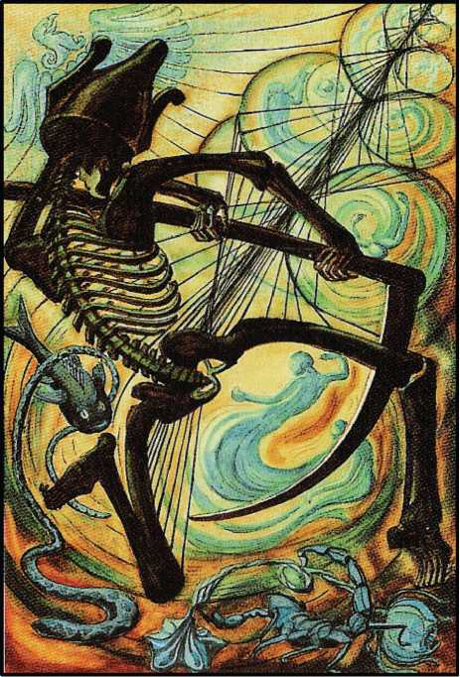

1. DEATH

This card is attributed to the letter Nun, which means a fish; the symbol of life beneath the waters; life travelling through the waters. It refers to the Zodiacal sign of Scorpio, which is ruled by Mars, the planet of fiery energy in its lowest form, which is therefore necessary to provide the impulse. In alchemy, this card explains the idea of putrefaction, the technical name given by its adepts to the series of chemical changes which develops the final form of life from the original latent seed in the Orphic egg.

This sign is one of the two most powerful in the Zodiac, but it has not the simplicity and intensity of Leo. It is formally divided into three parts; the lowest is symbolized by the Scorpion, which was supposed by early observers of Nature to commit suicide when finding itself ringed with fire, or otherwise in a desperate situation. This represents putrefaction in its lowest form. The strain of environment has become intolerable, and the attacked element willingly subjects itself to change; thus, potassium thrown upon water becomes ignited, and accepts the embrace of the hydroxyl radicle.

The middle interpretation of this sign is given by the serpent, who is, moreover, the main theme of the sign.1 The serpent is sacred, Lord of Life and Death, and its method of pro­gression suggests the rhythmical undulation of those twin phases of life which we Call respec­tively life and death. The serpent is also, as previously explained, the principal symbol of male energy. From this it will be seen that this card is, in a very strict sense, the completion of the card called Lust, Atu XI, and Atu XII represents the solution or dissolution which links them.

The highest aspect of the card is the Eagle, which represents exaltation above solid matter. It was understood by the early chemists that, in certain experiments, the purest (i.e., most tenuous) elements present were given off as gas or vapour. There are thus represented in this card the three essential types of putrefaction.

The card itself represents the dance of death; the figure is a skeleton bearing a scythe, and both the skeleton and the scythe are importantly Saturnian symbols. This appears strange, as Saturn has no overt connection with Scorpio; but Saturn represents the essential structure of existing things. He is that elemental nature of things which is not destroyed by the ordinary changes which occur in the operations of Nature. Furthermore, he is crowned with the crown of Osiris; he represents Osiris in the waters of Amennti. Yet more, he is the original secret male creative God: see Atu XV. “Redeunt Saturnia regna.” It was only the cor­ruption of the Tradition, the confusion with Set, and the Cult of the Dying God, misunderstood, deformed and distorted by the Black Lodge, that turned him into a senile and fiendish symbol.

With the sweep of his scythe he creates bubbles in which are

**\*The Qabalists embodied in the Book of Genesis, Caps I and II, this doctrine of regeneration. NChSh, the Serpent in Eden, has the value 358: 50 also MShICh, Messiah. He is, accordingly, in the secret doctrine, the Re­deemer. The thesis may be developed at great length. Later in the Legend, the doctrine reappears in slightly dif­ferent symbolism as the story of the Flood, elsewhere in this Essay explained. Of course, the Fish is identical in essence with the Serpent; for Fish=NVN=Scorpio=Serpent. Also, Teth, the letter of Leo, means Serpent. But Fish is also the Vesica, or Womb, and Christ—and so on. This symbol resumes the whole Secret Doctrine.**

beginning to take shape the new forms which he creates in his dance; and these forms dance also.

In this card the symbol of the fish is paramount; the fish (Il pesce, as they call him in Naples and many other places) and the serpent are the two principal objects of worship in cults which taught the doctrines of resurrection or re-incarnation. Thus we have Oannes and Dagon, fish gods, in western Asia; in many other parts of the world are similar cults. Even in Christianity, Christ was represented as a fish. The Greek work IXThUS, “which means fish and very aptly symbolizes Christ”, as Browning reminds one, was supposed to be a notariqon, the initials of a sentence meaning “J esus Christ Son of God, Saviour”. Nor is it an accident that St. Peter was a fisherman. The Gospels, too, are full of miracles involving fish, and the fish is sa­cred to Mercury, because of its cold-bloodedness, its swiftness and its brilliance. There is moreover the sexual symbolism. This again recalls the function of Mercury as the guide of the dead, and as the continuing elastic element in nature.

This card must then be considered as of greater importance and catholicity than would be expected from the plain Zodiacal attribution. It is even a compendium of universal energy in its most secret form.

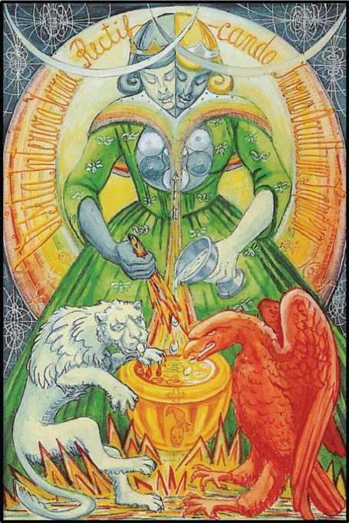

1. ART

This card is the complement and the fulfilment of Atu VI, Gemini. It pertains to Sagitta­rius, the opposite to Gemini in the Zodiac, and therefore, “after another manner,” one with it. Sagittarius means the Archer; and the card is (in its simplest and most primitive form) a pic­ture of Diana the Huntress. Diana is primarily one of the lunar goddesses, though the Romans rather degraded her from the Greek “virgin Artemis”, who is also the Great Mother of Fertility, Diana of the Ephesians, Many-Breasted. (A form of Isis-see Atu II and III.) The connection be­tween the Moon and the Huntress is shewn by the shape of the bow, and the occult signifi­cance of Sagittarius is the arrow piercing the rainbow; the last three paths of the Tree of Life make the word Qesheth, a rainbow, and Sagittarius bears the arrow which pierces the rain­bow, for his path leads from the Moon of Yesod to the Sun of Tiphareth. (This explanation is highly technical; but this is necessary because the card represents an important scientific formula, which cannot be expressed in language suited to common comprehension.)

This card represents the Consummation of the Royal Marriage which took place in Atu VI. The black and white personages are now united in a single androgyne figure. Even the Bees and the Serpents on their robes have made an alliance. The Red Lion has become white, and increased in size and importance, while the White Eagle, similarly expanded, has become red. He has exchanged his red blood for her white gluten. (It is impossible to explain these terms to any but advanced students of alchemy.)

The equilibrium and counter-change are carried out completely in the figure itself; the white woman has now a black bead; the black king, a white one. She wears the golden crown with a silver band, he, the silver crown with a golden fillet; but the white head on the right is extended in action by a white arm on the left which holds the cup of the white gluten, while the black head on the left has the black arm on the right, holding the lance which has become a torch and pours forth its burning blood. The fire burns up the water; the water extinguishes the fire.

The robe of the figure is green, which symbolizes vegetable growth: this is an alchemi­cal allegory. In the symbolism of the fathers of science, all “actual” objects were regarded as dead; the difficulty of transmuting metals was that the metals, as they occur in nature, were in the nature of excrements, because they did not grow. The first problem of alchemy was to raise mineral to vegetable life; the adepts thought that the proper way to do this was to imi­tate the processes of nature. Distillation, for instance, was not an operation to be performed by heating something in a retort over a flame; it had to take place naturally, even if months were required to consummate the Work. (Months, at that period of civilization, were at the disposal of enquiring minds.)

A great deal of what people now consider ignorance, being themselves ignorant of what the men of old time thought, comes from this misapprehension. At the bottom of this card, for example, are seen Fire and Water harmoniously mingled. But this is only a crude symbol of the spiritual idea, which is the satisfaction of the desire of the incomplete element of one kind to satisfy its formula by assimilation of its equal and opposite.

This state of the great Work therefore consisted in the mingling of the contradictory elements in a cauldron. This is here represented as golden or solar, because the Sun is the Fa­ther of all Life, and (in particular) presides over distillation. The fertility of the Earth is main­tained by rain and sun; the rain is formed by a slow and gentle process, and is rendered effec­tive by the co-operation of air, which is itself alchemically the result of the Marriage of Fire and Water. So also the formula of continued life is death, or putrefaction. Here it is symbolized by the caput mortuum on the cauldron, a raven perched upon a skull. In agricultural terms, this is the fallow earth.

There is a particular interpretation of this card which is only to be understood by Initi­ates of the Ninth Degree of the O.T.O.; for it contains a practical magical formula of such im­portance as to make it impossible to communicate it openly.

Rising from the cauldron, as the result of the operation performed therein, is a stream of light which becomes two rainbows; they form the cape of the androgyne figure. In the cen­tre, an arrow shoots upwards. This is connected with the general symbolism previously ex­plained, the spiritualization of the result of the Great Work.

The rainbow is moreover symbolical of another stage in the alchemical process. At a certain period, as a result of putrefaction, there is observed a phenomenon of many-coloured lights (The “coat of many colours” said to have been worn by Joseph and Jesus, in the ancient legends, refers to this. See also Atu 0, the Motley of the Green Man, Dreamer-Redeemer).

To sum up, the whole of this card represents the hidden content of the Egg described in Atu VI. It is the same formula, but in a more advanced stage. The original duality has been completely compensated; but after birth comes growth; after growth, puberty; and after pu­berty, purification.

In this card, therefore, is foreshadowed the final stage of the Great Work. Behind the figure, its edges tinged with the rainbow, which has now arisen from the twin rainbows form­ing the cape of the figure, is a glory bearing an inscription VISITA INTERIORA TERRAE REC- TIFICANDO INVENIES OCCULTUM LAPIDEM.

“Visit the interior parts of the earth: by rectification thou shalt find the hidden stone.” Its initials make the word V.I.T.R.I.O.L., the Universal Solvent, to be discussed later. (Its value is 726=6 x 112=33 x 22.)

This “hidden stone” is also called the Universal Medicine. It is sometimes described as a stone, sometimes as a powder, sometimes as a tincture. It divides again into two forms, the gold and the silver, the red and the white; but its essence is always the same, and its nature is not to be understood except by experience. It is because the alchemists were dealing with substances on the borderland of “matter” that they are so difficult to understand. The subject- matter of chemistry and physics in modern times is what they would have called the study of dead things; for the real difference between living things and dead is, in the first instance, their behaviour.

The initials of the alchemical motto given above form the word Vitriol. This has noth­ing to do with the sulphates of either hydrogen, iron or copper, as might be supposed from modern usage. It represents a balanced combination of the three alchemical principles, Sul­phur, Mercury and Salt. These names have no connection with substances so named by the vulgar; they have already been described in Atu I. III and IV.

The counsel to “visit the interior of the earth” is a recapitulation (on a higher plane) of the first formula of the Work which has been the so constant theme of these essays. The im­portant word in the injunction is the central word RECTIFICANDO; it implies the right leading of the new living substance in the path of the True Will. The stone of the Philosophers, the Universal Medicine, is to be a talisman of use in any event, a completely elastic and completely rigid vehicle of the True Will of the alchemists. It is to fertilize and bring to manifested Life the Orphic Egg.

The Arrow, both in this card and in Atu VI, is of supreme importance. The Arrow is, in fact, the simplest and purest glyph of Mercury, being the symbol of directed Will. It is right to emphasize this fact by a quotation from the Fourth Aethyr, LIT, in The Vision and the Voice. (See Appendix.)

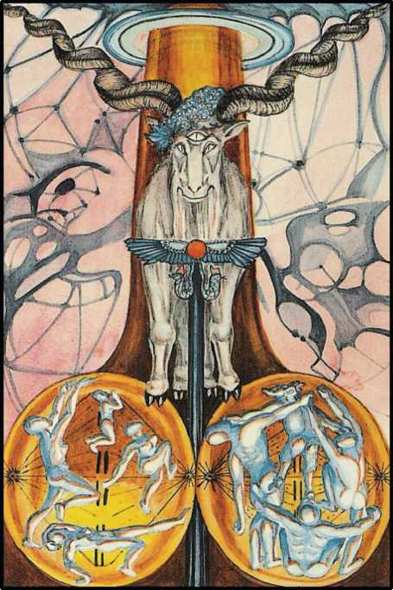

1. THE DEVIL

This card is attributed to the letter ‘Ayin, which means an Eye, and it refers to Capri- cornus in the Zodiac. In the Dark Ages of Christianity, it was completely misunderstood. Eliphaz Levi studied it very deeply because of its connection with ceremonial magic, his fa­vourite subject; and he re-drew it, identifying it with Baphomet, the ass-headed idol of the Knights of the Temple.1 But at this time archaeological research had not gone very far; the na­ture of Baphomet was not fully understood. (See Atu 0, above.) At least he succeeded in identi­fying the goat portrayed upon the card with Pan.

On the Tree of Life, Atu XIII and XV are symmetrically placed; they lead from Tiphareth, the human consciousness, to the spheres in which Thought (on the one hand) and Bliss (on the other) are developed. Between them, Atu XIV leads similarly to the sphere which formu­lates Existence. (See note on Atu X and arrangement.) These three cards may therefore be summed up as a hieroglyph of the processes by which idea manifests as form.

This card represents creative energy in its most material form; in the Zodiac, Capricor- nus occupies the Zenith. It is the most exalted of the signs; it is the goat leaping with lust upon the summits of earth. The sign is ruled by Saturn, who makes for selfhood and perpetuity. In this sign, Mars is exalted, showing in its best form the fiery, material energy of creation. The card represents Pan Pangenetor, the All-Begetter. It is the Tree of Life as seen against a back­ground of the exquisitely tenuous, complex, and fantastic forms of madness, the divine mad­ness of spring, already foreseen in the meditative madness of winter; for the Sun turns north­wards on entering this sign. The roots of the Tree are made transparent, in order to show the innumerable leapings of the sap; before it stands the Himalayan goat, with an eye in the cen­tre of his forehead, representing the god Pan upon the highest and most secret mountains of the earth. His creative energy is veiled in the symbol of the Wand of the Chief Adept, crowned with the winged globe and the twin serpents of Horus and Osiris.

**1The Early Christians also were accused of worshipping an Ass, or ass-headed god. See Browning, The Ring and the Book (The Pope).**

“Hear me, Lord of the Stars,

For thee have I worshipped ever With stains and sorrows and scars,

With joyful, joyful Endeavour.

Hear me, O lilywhite goat Crisp as a thicket of thorns,

With a collar of gold for thy throat,

A scarlet bow for thy horns.”

The sign of Capricornus is rough, harsh, dark, even blind; the impulse to create takes no account of reason, custom, or foresight. It is divinely unscrupulous, sublimely careless of result. “thou hast no right but to do thy will. Do that, and no other shall say nay. For pure will, unassuaged of purpose, delivered from the lust of result, is every way perfect.” AL. I, 42-4.

It is further to be remarked that the trunk of the Tree pierces the heavens; about it is indicated the ring of the body of Nuith. Similarly, the shaft of the Wand goes down indefinitely to the centre of earth. “If I lift up my head, I and my Nuit are one. If 1 droop down mine head, and shoot forth venom, then is rapture of the earth, and I and the earth are one.” (AL. II, 26).

The formula of this card is then the complete appreciation of all existing things. He re­joices in the rugged and the barren no less than in the smooth and the fertile. All things equally exalt him. He represents the finding of ecstasy in every phenomenon, however natu­rally repugnant; he transcends all limitations; he is Pan; he is All.

It is important to notice some other correspondences. The three vowel-consonants of the Hebrew alphabet, Aleph, Yod, ‘Ayin, these three letters form the sacred name of God, I A 0. These three Atu, IX, 0, and XV, thus offer a threefold explanation of the male creative energy; but this card especially represents the masculine energy at its most masculine. Saturn, the ruler, is Set, the ass-headed god of the Egyptian deserts; he is the god of the south. The name refers to all gods containing these consonants, such as Shaitan, or Satan. (See Magick pp. 336­7). Essential to the symbolism are the surroundings - barren places, especially high places. The cult of the mountain is an exact parallel. The Old Testament is full of attacks upon kings who celebrated worship in “high places”; this, although Zion itself was a mountain! This feel­ing persisted, even to the days of the Witches’ Sabbath, held, if possible, on a desolate summit, but (if none were available) at least in a wild spot, uncontaminated by the artfulness of men.

Note that Shabbathai, the “sphere of Saturn”, is the Sabbath. Historically, the animus against witches pertains to the fear of the Jews; whose rites, supplanted by the Christian forms of Magic, had become mysterious and terrible. Panic suggested that Christian children were stolen, sacrificed, and eaten. The belief persists to this day.

In every symbol of this card there is the allusion to the highest things and most remote. Even the horns of the goat are spiral, to represent the movement of the all-pervading energy. Zoroaster defines God as “having a spiral force”. Compare the more recent, if less profound, writings of Einstein1.

**Compare Saturn, at one end of the Seven Sacred Wanderers, with the Moon at the other: the aged man and the young girl—see “The Formula of Tetragrammaton”. They are linked as no other two planets, since 32=9, and each contains in itself the extremes of its own idea. (See also Appendix: Atu xxi.)**

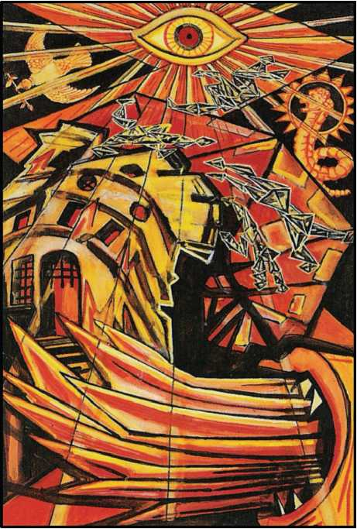

1. THE TOWER (OR: WAR)

This card is attributed to the letter Pe, which means a mouth; it refers to the planet Mars. In its simplest interpretation it refers to the manifestation of cosmic energy in its grossest form. The picture shows the destruction of existing material by fire. It may be taken as the preface to Atu XX, the Last Judgment, i.e., the Coming of a New Aeon. This be­ing so, it seems to indicate the quintessential quality of the Lord of the Aeon1.

At the bottom part of the card, therefore, is shown the destruction of the old- established Aeon by lightning, flames, engines of war. In the right-hand corner are the jaws of Dis, belching flame at the root of the structure. Falling from the tower are broken figures of the garrison. It will be noticed that they have lost their human shape.

They have become mere geometrical expressions.

**iSee Liber AL. III. 3-9; II - 13; 17-18; 23-29; 46; 49-60; 70-72.**

This suggests another (and totally different) interpretation of the card. To understand this, it is necessary to refer to the doctrines of Yoga, especially those most widely current in Southern India, where the cult of Shiva, the Destroyer, is paramount. Shiva is represented as dancing upon the bodies of his devotees. To understand this is not easy for most western minds. Briefly, the doctrine is that the ultimate reality (which is Perfection) is Nothinguess. Hence all manifestations, however glorious, however delightful, are stains. To obtain perfec­tion, all existing things must be annihilated. The destruction of the garrison may therefore be taken to mean their emancipation from the prison of organized life, which was confining them. It was their unwisdom to cling to it.

The above should make it clear that magical symbols must always be understood in a double sense, each contradictory of the other. These ideas blend naturally with the higher and deeper significance of the card.

There is a direct reference to this card in the Book of the Law. In Chapter I, verse 57, the goddess Nuith speaks: “Invoke me under my stars! Love is the law, love under will. Nor let the fools mistake love; for there are love and love. There is the dove, and there is the serpent. Choose ye well! He, my prophet, hath chosen, knowing the law of the fortress, and the great mystery of the House of God”.1

The dominating feature of this card is the Eye of Horus. This is also the Eye of Shiva, on the opening of which, according to the legend of this cult, the Universe is destroyed.

Besides this, there is a special technical magical meaning, which is explained openly only to initiates of the Eleventh degree of the O.T.O.; a grade so secret that it is not even listed in the official documents. It is not even to be understood by study of the Eye in Atu XV. Per­haps it is lawful to mention that the Arab sages and the Persian poets have written, not always guardedly, on the subject.

Bathed in the effulgence of this Eye (which now assumes even a third sense, that indi­cated in Atu XV) are the Dove bearing an olive branch and the Serpent: as in the above quota­tion. The Serpent is portrayed as the Lion-Serpent Xnoubis or Abraxas. These represent the two forms of desire; what Schopenhauer would have called the

**1For this reason the ancient title, to-day not very intelligible, has been retained. Otherwise, it might have been called War.**

Will to Live and the Will to Die. They represent the feminine and masculine impulses; the no­bility of the latter is possibly based upon recognition of the futility of the former. This is per­haps why the renunciation of love in all the ordinary senses of the word has been so con­stantly announced as the first step towards initiation. This is an unnecessarily rigid view. This Trump is not the only card in the Pack, nor are the “will to live” and the “will to die” incom­patible. This becomes clear as soon as life and death are understood (See Atu XIII) as phases of a single manifestation of energy.

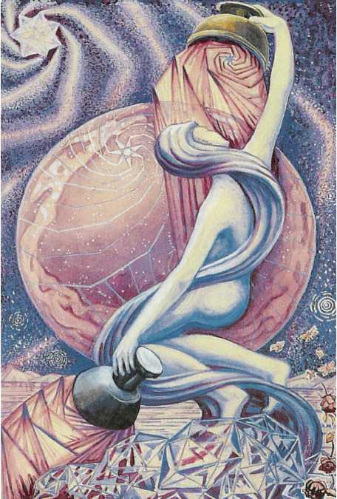

1. THE STAR

This card is attributed to the letter He, as has been explained elsewhere. It refers to the Zodiacal sign of Aquarius, the water- bearer. The picture represents Nuith, our Lady of the Stars. For the full meaning of this sentence it is necessary to understand the first chapter of the Book of the Law.

The figure of the goddess is shown in manifestation, that is, not as the surrounding space of heaven, shown in Atu XX, where she is the pure philosophical idea continuous and omniform. In this card she is definitely personified as a human-seeming figure; she is repre­sented as bearing two cups, one golden, held high above her head, from which she pours wa­ter upon it. (These cups resemble breasts, as it is written: “the milk of the stars from her paps; yea, the milk of the stars from her paps”).

The Universe is here resolved into its ultimate elements. (One is tempted to quote from the Vision of the Lake Pasquaney, “Nothingness with twinkles. . . but what twinkles!”) Behind the figure of the goddess is the celestial globe. Most prominent among its features is the seven-pointed Star of Venus, as if declaring the principal characteristic of her nature to be Love. (See again the description in Chapter I of the Book of the Law). From the golden cup she pours this ethereal water, which is also milk and oil and blood, upon her own head, indicating the eternal renewal of the categories, the inexhaustible possibilities of existence.

The left hand, lowered, holds a silver cup, from which also she pours the immortal liq­uor of her life. (This liquor is the Amrita of the Indian philosophers, the N epenthe and Ambro­sia of the Greeks, the Alkahest and Universal Medicine of the Alchemists, the Blood of the Grail; or, rather, the nectar which is the mother of that blood. She pours it upon the junction of land and water. This water is the water of the great Sea of Binah; in the manifestation of Nuith on a lower plane, she is the Great Mother. For the Great Sea is upon the shore of the fertile earth, as represented by the roses in the right hand corner of the picture. But between sea and land is the “Abyss”, and this is hidden by the clouds, which whirl as a development of her hair: “my hair the trees of Eternity”. (AL. 1, 59).

In the left-hand corner of the picture is the star of Babalon; the Sigil of the Brother­hood of the A.‘. A.’.. For Babalon is yet a further materialization of the original idea of Nuith; she is the Scarlet Woman, the sacred Harlot who is the lady of Atu XI. From this star, behind the celestial sphere itself, issue the curled rays of spiritual light. Heaven itself is no more than a veil before the face of the immortal goddess.

It will be seen that every form of energy in this picture is spiral. Zoroaster says, “God is he, having the head of a hawk; having a spiral force”. It is interesting to notice that this oracle appears to anticipate the present Aeon, that of the hawk-headed Lord, and also of the mathe­matical conception of the shape of the Universe as calculated by Einstein and his school. It is only in the lower cup that the forms of energy issuing forth show rectilinear characteristics. In this may be discovered the doctrine which asserts that the blindness of humanity to all the beauty and wonder of the Universe is due to this illusion of straightness. It is significant that Riemann, Bolyai and Lobatchewsky seem to have been the mathematical prophets of the N ew Revelation. For the Euclidian geometry depends upon the conception of straight lines, and it was only because the Parallel Postulate was found to be incapable of proof that mathemati­cians began to conceive that the straight line had no true correspondence with reality1.

**1The straight line is no more than the limit of any curve. For instance, it is an ellipse whose foci are an “infinite” distance apart. In fact, such use of the Calcultis is the one certain way of ensuring “straightness”.**

In the first chapter of the Book of the Law, the conclusion is of practical importance. It gives the definite formula for the attainment of truth.

“I give unimaginable joys on earth: certainty, not faith, while in life, upon death; peace unutterable, rest, ecstasy; nor do I demand aught in sacrifice.”

“But to love me is better than all things: if under the night-stars in the desert thou presently burnest mine incense before me, invoking me with a pure heart, and the Serpent flame therein, thou shalt come a little to lie in my bosom. For one kiss wilt thou then be will­ing to give all; but whoso gives one particle of dust shall lose all in that hour. Ye shall gather goods and store of women and spices; ye shall wear rich jewels; ye shall exceed the nations of the earth in splendour & pride; but always in the love of me, and so shall ye come to my joy. I charge you earnestly to come before me in a single robe, and covered with a rich headdress. I love you! I yearn to you! Pale or purple, veiled or voluptuous, I who am all pleasure and pur­ple, and drunkenness of the innermost sense, desire you. Put on the wings, and arouse the coiled splendour within you: come unto me!

“At all my meetings with you shall the priestess say-and her eyes shall burn with desire as she stands bare and rejoicing in my secret temple-To me! To me! calling forth the flame of the hearts of all in her love-chant.

“Sing the rapturous love-song unto me! Burn to me perfumes! Wear to me jewels! Drink to me, for I love you! I love you!

“I am the blue-lidded daughter of Sunset; I am the naked brilliance of the voluptuous night-sky.

“To me! To me!

“The Manifestation of Nuit is at an end.”

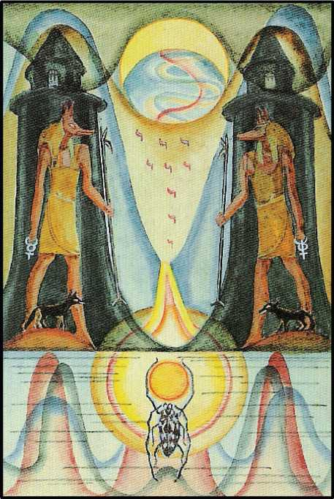

1. THE MOON

The Eighteenth Trump is attributed to the letter Qoph, which represents Pisces in the Zodiac. It is called the Moon.

Pisces is the last of the Signs; it represents the last stage of winter. It might be called the Gateway of Resurrection (the letter Qoph means the back of the head, and is connected with the potencies of the cerebellum). In the system of the old Aeon, the resurrection of the Sun was not only from winter, but from night; and this card represents midnight.

“There is a budding morrow in midnight”, wrote Keats. For this reason there appears at the bottom of the card, underneath the water which is tinged with graphs of abomination, the sacred Beetle, the Egyptian Khephra, bearing in his mandibles the Solar Disk. It is this Beetle that bears the Sun in his Silence through the darkness of Night and the bitterness of Winter.

Above the surface of the water is a sinister and forbidding landscape. We see a path or stream, serum tinged with blood, which flows from a gap between two barren mountains; nine drops of impure blood, drop-shaped like Yods, fall upon it from the Moon.

The Moon, partaking as she does of the highest and the lowest, and filling all the space between, is the most universal of the Planets. In her higher aspect, she occupies the place of the Link between the human and divine, as shown in Atu II. In this Trump, her lowest avatar, she joins the earthy sphere of N etzach with Malkuth, the culmination in matter of all superior forms. This is the waning moon, the moon of witchcraft and abominable deeds. She is the poi­soned darkness which is the condition of the rebirth of light.

This path is guarded by Tabu. She is uncleanliness and sorcery. Upon the hills are the black towers of nameless mystery, of horror and of fear. All prejudice, all superstition, dead tradition - and ancestral loathing, all combine to darken her face before the eyes of men. It needs unconquerable courage to begin to tread this path. Here is a weird, deceptive life. The fiery sense is baulked. The moon has no air. The knight upon this quest has to rely on the three lower senses: touch, taste and smell.1 Such light as there may be is deadlier than dark­ness, and the silence is wounded by the howling of wild beasts.

To what god shall we appeal for aid? It is Anubis, the watcher in the twilight, the god that stands upon the threshold, the jackal god of Khem, who stands in double form between the Ways. At his feet, on watch, wait the jackals themselves, to devour the carcasses of those who have not seen Him, or who have not known His Name.

**1See the Book of Lies Cap. np, Bortsch.**

This is the threshold of life; this is the threshold of death. All is doubtful, all is mysteri­ous, all is intoxicating. Not the benign, solar intoxication of Dionysus, but the dreadful mad­ness of pernicious drugs; this is a drunkenness of sense, after the mind has been abolished by the venom of this Moon. This is that which is written of Abraham in the Book of the Beginning: “An horror of great darkness came upon him.” One is reminded of the mental echo of subcon­scious realization, of that supreme iniquity which mystics have constantly celebrated in their accounts of the Dark Night of the Soul. But the best men, the true men, do not consider the matter in such terms at all. Whatever horrors may afflict the soul, whatever abominations may excite the loathing of the heart, whatever terrors may assail the mind, the answer is the same at every stage: “How splendid is the Adventure!”

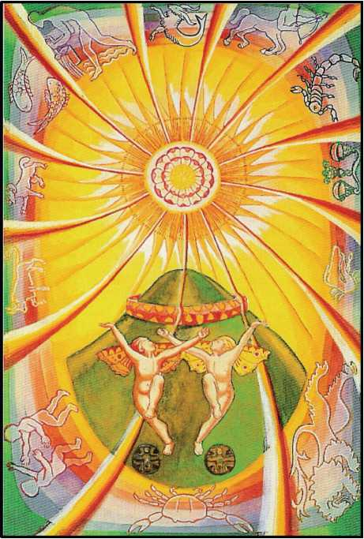

1. THE SUN

This card represents, in heraldic language, “the Sun, charged with a rose, on a mount

vert”.1

This is one of the simplest of the cards; it represents Heru-ra-ha, the Lord of the New Aeon, in his manifestation to the race of men as the Sun spiritual, moral, and physical. He is the Lord of Light, Life, Liberty and Love. This Aeon has for its purpose the complete emanci­pation of the human race.

The rose represents the flowering of the solar influence. Around the whole picture we see the signs of the Zodiac in their normal position, Aries rising in the East, and so on. Free­dom brings sanity. The Zodiac is a kind of childish representation of the body of Nuith, a dif­ferentiation and classification, a chosen belt, one girdle of Our Lady of infinite space. Conven­ience of description excuses the device.

The green mound represents the fertile earth, its shape, so to speak, aspiring to the heavens. But around the top of the mound is a wall, which indicates that the aspiration of the new Aeon does not mean the absence of control. Yet outside this wall are the twin children who (in one form or another) have so frequently recurred in this whole symbolism. They rep­resent the male and female, eternally young, shameless and innocent. They are dancing in the light, and

yet they dwell upon the earth. They represent the next stage which is to be attained by man­kind, in which complete freedom is alike the cause and the result of the new access of solar energy upon the earth. The restriction of such ideas as sin and death in their old sense has been abolished, At their feet are the most sacred signs of the old Aeon, the combination of the Rose and Cross from which they are arisen, yet which still forms their support.

The card itself symbolizes this broadening of the idea of the Rose and Cross. The Cross is now expanded into the Sun, from which, of course, it is originally derived. Its rays are twelve-not only the number of the signs of the Zodiac, but of the most sacred title of the most holy Ancient Ones, who are Hua. (The word HUA, “he”, has the numerical value of 12.) The limitation of mundane law, which is always associated with the number Four, has disappeared. Gone are the four arms of a Cross limited by law; the creative energy of the Cross expands freely; its rays pierce in every direction the body of Our Lady of the Stars.

With regard to the wall, it should be noted that it completely encircles the top of the mound; this is to emphasize that the formula of the Rose and Cross is still valid in terrestrial matters. But there is now, as was not previously the case, a close and definite alliance with the celestial.

It is also most important to observe that the formula of the Rose and Cross (indicated by the wall-girt mound) has completed the fire-change into “something rich and strange”; for the mound is green, where one would expect it to be red, and the wall red, where one would expect it to be green or blue. The indication of this symbolism is that it must be one of the great advances in adjustment of the new Aeon to work out simply and without prejudice the formidable problems which have been raised by the growth of civilization.

Man has advanced so far from the social system, though it was not a system, of the cave man, from the primitive conception of property in human flesh. Man has advanced so far from crude anatomical classification of the soul of any given human being; he has accordingly landed himself in the most dreadful mire of psychopathology and psycho-analysis. Tiresome and tough are the prejudices of the people that date morally from about 25,000 B.C.

Largely owing to their own intransigeance, those people have been born under a dif­ferent spiritual law; they find themselves not only persecuted by their ancestors, but bewil­dered by their own uncertainty of foothold. It must be the task of the pioneers of the new Aeon to put this right.

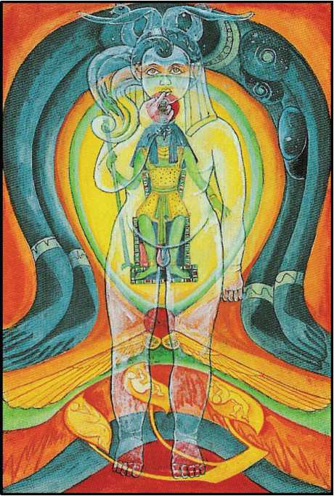

1. THE AEON

In this card it has been necessary to depart completely from the tradition of the cards, in order to carry on that tradition.

The old card was called The Angel: or, The Last Judgment. It represented an Angel or Messenger blowing a trumpet, attached to which was a flag, bearing the symbol of the Aeon of Osiris. Below him the graves were opening, the dead rising up. There were three of them. The central one had his hands raised with right angles at the elbows and shoulders, so as to form the letter Shin, which refers to Fire. The card therefore represented the destruction of the world by Fire. This was accomplished in the year of the vulgar era 1904, when the fiery god Horus took the place of the airy god Osiris in the East as Hierophant (see Atu V). At the begin­ning, then, of this new Aeon, it is fit to exhibit the message of that angel who brought the news of the new Aeon to earth. The new card is thus of necessity an adaptation of the Stele of Re­vealing.

Around the top of the card is the body of Nuith, the star-goddess, who is the category of unlimited possibility; her mate is Hadit, the ubiquitous point-of-view, the only philosophi­cally tenable conception of Reality. He is represented by a globe of fire, representing eternal energy; winged, to show his power of Going. As a result of the marriage of these two, the child Horus is born. He is, however, known under his special name, Heru-ra-ha. A double god; his extraverted form is Ra-hoor-khuit; and his passive or introverted form Hoor-pa kraat. (See above, the Formula of Tetragrammaton). He is also solar in character, and is therefore shown coming forth in golden light.

The whole of this symbolism is thoroughly explained in the Book of the Law.

It should, by the way, be noted that the name Heru is identical with Hru, who is the great Angel set over the Tarot. This new Tarot may therefore be regarded as a series of illus­trations to the Book of the Law; the doctrine of that Book is everywhere implicit.

At the bottom of the card we see the letter Shin itself in a form suggestive of a flower; the three Yods are occupied by three human figures arising to partake in the Essence of the new Aeon. Behind this letter is a symbolic representation of the Sign of Libra; this is the forth- shadowing of the Aeon which is to follow this present one, presumably in about 2,000 years- ”the fall of the Great Equinox; when Hrumachis shall arise and the double-wanded one as­sume my throne and place”. The present Aeon is too young to give a more definite representa­tion of this future event. But in this connection attention must be drawn to the figure of Ra- hoor-khuit: “I am the Lord of the Double Wand of Power; the wand of the Force of Coph Nia; but my left hand is empty, for I have crushed an Universe; & nought remains. There are many other details with regard to the Lord of the Aeon which should be studied in the Book of the Law.

It is also important to study very thoroughly, and meditate upon, this Book, in order to appreciate the spiritual, moral, and material events which have marked the catastrophic tran­sition from the Aeon of Osiris. The time for the birth of an Aeon seems to be indicated by great concentration of political power with the accompanying improvements in the means of travel and communication, with a general advance in philosophy and science, with a general need of consolidation in religious thought. It is very instructive to compare the events of the five hun­dred years preceding and following the crisis of approximately 2,000 years ago, with those of similar periods centred in 1904 of the old era. It is a thought far from comforting to the pre­sent generation, that 500 years of Dark Ages are likely to be upon us. But, if the analogy holds, that is the case. Fortunately, to-day we have brighter torches and more torch-bearers.

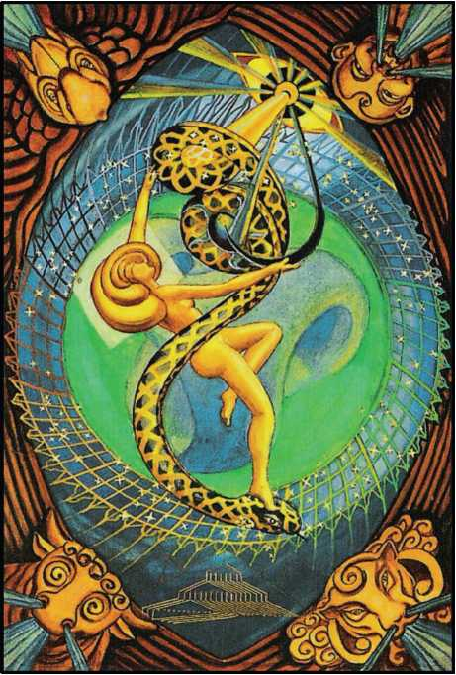

1. THE UNIVERSE

The first and most obvious characteristic of this card is that it comes at the end of all, and is therefore the complement of the Fool. It is attributed to the letter Tau. The two cards together accordingly spell the word Ath, which means Essence. Mi reality is consequently compromised in the series of which these two letters form the beginning and the end. This beginning was Nothing; the end must therefore be also Nothing, but Nothing in its complete expansion, as previously explained. The number 4, rather than the number 2, was chosen as the basis of this expansion, partly no doubt for convenience, to enlarge the “universe of dis­course”; partly to emphasize the idea of limitation.

The letter Tau means the Sign of the Cross, that is, of extension; and this extension is symbolized as four-fold because of the convenience of constructing the revolving symbol of Tetragrammaton. In the case of the number 2, the only issue is the return to the unity or to the negative. No continuous process can be conveniently symbolized; but the number 4 lends it­self, not only to this rigid extension, the hard facts of nature, but also to the transcendence of space and time by a continuously self-compensating change.

The letter Tau is attributed to Saturn, the outermost and slowest of the seven sacred planets; because of these dull, heavy qualities, the element of earth was thrust upon the sym­bol. The original three elements, Fire, Air, Water, sufficed for primitive thought; Earth and

Spirit represent a later accretion. Neither is to be found in the original twenty4wo Paths of the Sepher Yetzirah. The world of Assiah, the material world, does not appear except as a pendant to the Tree of Life.

In the same way, the element of Spirit is attributed to the letter Shin, as an additional ornament, somewhat in the same way as Kether is said to be symbolized by the topmost point of the Yod of Tetragrammaton. It is constantly necessary to distinguish between the symbols of philosophical theory and those more elaborate symbols based upon them which are neces­sary in practical work.

Saturn and Earth have certain qualities in common-heaviness, coldness, dryness, im­mobility, dulness and the like. Yet Saturn appears in Binah in respect of its blackness in the Queen’s scale, which is the scale of Observed Nature; but always, as soon as the end of a proc­ess is reached, it returns automatically to the beginning.

In Chemistry, it is the heaviest elements that are unable in terrestrial conditions to support the strain and stress of their internal structure; consequently, they radiate particles of the most tenuous character and the highest activity. In an essay written in Cefalu, Sicily, on the second law of Thermo-dynamics, it was suggested that at the absolute zero of the air ther­mometer, an element heavier than uranium might exist, of such a nature that it was capable of reconstituting the entire series of elements. It was a chemical interpretation of the equation, 0=2.

It becomes then reasonable to argue from analogy that since the end must beget the beginning, the symbolism will follow; hence, blackness is also attributed to the sun, according to a certain long- hidden tradition. One of the shocks for candidates in the “Mysteries” was the revelation “Osiris is a black god”.

Saturn, therefore, is masculine; he is the old god, the god of fertility) the sun in the south; but equally the Great Sea, the great Mother; and the letter Tau upon the Tree of Life ap­pears as an emanation from the moon of Yesod, the foundation of the Tree and representative of the reproductive process and of the equilibrium between change and stability, or rather their identification. The influence of the path descends upon the earth, Malkuth, the daughter. Here again appears the doctrine of “setting the daughter upon the throne of the Mother”. In the card itself there is consequently a glyph of the completion of the Great Work in its highest sense, exactly as the Atu of the Fool symbolizes its beginning. The Fool is the negative issuing into manifestation; the Universe is that manifestation, its purpose accomplished, ready to re­turn. The twenty cards that lie between these two exhibit the Great Work and its agents in various stages. The image of the Universe in this sense is accordingly that of a maiden, the fi­nal letter of Tetragrammaton.

In the present card she is represented as a dancing figure. In her hands she manipu­lates the radiant spiral force, the active and passive, each possessing its dual polarity. iler dancing partner is shown as Heru-Ra-Ha of Atu XIX. “The Sun, Strength & Sight, Light; these are for the servants of the Star & the Snake.” This final form of the image of the Magical For­mula of the God combines and trans forms so many symbols that description is difficult, and would be nugatory. The proper method of study of this card-indeed of all, but of this espe- cially-is long-continued meditation. The Universe, so states the theme, is the Celebration of the Great Work accomplished. In the corners of the card are the four Kerubim showing the es­tablished Universe; and about her is an ellipse composed of seventy- two circles for the qui- naries of the Zodiac, the Shemhamphorasch.

In the centre of the lower part of the card is represented the skeleton plan of the build­ing of the house of Matter. It shews the ninety-two known chemical elements, arranged ac­cording to their rank in the hierarchy. (The design is due to the genius of the late J. W. N. Sulli­van: see The Bases of Modern Science.)

In the centre, a wheel of Light initiates the form of the Tree of Life, shewing the ten principal bodies of the solar system. But this Tree is not visible except to those of wholly pure heart.

1. The primum mobile, represented by Pluto. (Compare the doctrine of the alpha particles of radium.)
2. The sphere of the Zodiac or fixed stars, represented by Neptune.
3. Saturn. The Abyss. This is represented by Herschel, the planet of disintegration and explosion.
4. Jupiter
5. Mars.
6. The Sun.
7. Venus.
8. Mercury.
9. The Moon.
10. The Earth. (The Four Elements).

All these symbols swim and dance in a complex but continuous ambience of loops and whorls. The general colour of the traditional card is subfusc; it represents the confusion and darkness of the material world. But the New Aeon has brought fullness of Light; in the Minu- tum Mundum, Earth is no longer black, or of mixed colours, but is pure bright green. Similarly, the indigo of Saturn is derived from the blue velvet of the midnight sky, and the maiden of the dance represents the issue from this, yet through this, to the Eternal. This card is to-day as bright and glowing as any in the Pack.



APPENDIX

*The Fool*—*i. Silence; ii. De Sapientia et Stultitia; De Oraculo Summo; iii. De Herba Sanctissima Arabia; De Quibusdam Mys- teriis, Quae Vidi; De Quodam Modo Meditationis; SequiturDe Hac Re; Conclusio De Hoc Modo Sanctitatis; De Via Sola Solis. The Ma­gus*—*i. De Mercuno; ii. The Lord of Illusion; Fortune, R.O.T.A. The Wheel; Lust, Babalon; Art, The Arrow; The Universe. The Virgin Universe.*

Here follow certain essays upon matters germane to this essay. Their perusal may as­sist the full appreciation of its meaning.

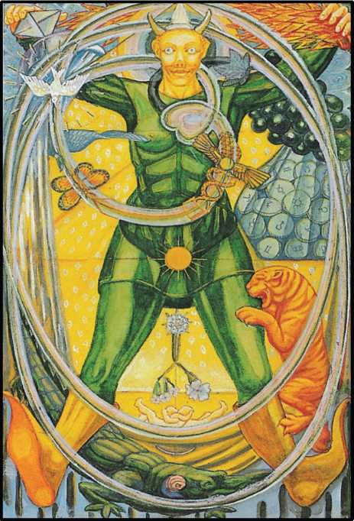

THE FOOL

1. SILENCE1

Of all the magical and mystical virtues, of all the graces of the Soul, of all the attain­ments of the Spirit, none has been so misunderstood, even when at all apprehended, as Si­lence.

It would not be possible to enumerate the common errors; nay, it may be said that to think of it at all is in itself an error; for its nature is Pure Being, that is to say, Nothing, so that it is beyond all intellection or intuition. Thus, then, the utmost of our Essay can be only a cer­tain Wardenship, as it were a Tyling of the Lodge wherein the Mystery of Silence may be con­summated.

For this attitude there is sound traditional authority; Harpocrates, God of Silence, is called “The Lord of Defence and Protection”.

But His nature is by no means that negative and passive silence which the word com­monly connotes; for He is the All-Wandering Spirit, the Pure and Perfect Knight-Errant, who answers all Enigmas, and opens the closed Portal of the King's Daughter. But Silence in the vulgar sense is not the answer to the Riddle of the Sphinx; it is that which is created by that answer. For Silence is the Equilibrium of Perfection; so that Harpocrates is the omniform, the universal Key to every Mystery soever. The Sphinx is the “Puzzel or Pucelle”, the Feminine Idea to which there is only one complement, always different in form, and always identical in es­sence. This is the signification of the Picture of the God; it is shown more clearly in His adult form as the Fool of the Tarot and as Bacchus Diphues, and without equivocation when He ap­pears as Baphomet.

**xFrom *Little Essays toward Truth.***

When we enquire more closely into His symbolism. the first quality which engages our attention is doubtless His innocence. Not without deep wisdom is He called Twin of Horns: and this is the Aeon of Horus: it is He who sent forth Aiwass His minister to proclaim its ad­vent. The Fourth Power of the Sphinx is Silence; to us, then, who aspire to this power :as the crown of our Work, it will be of utmost value to attain His innocence in all its fulness. We must understand, first of all, that the root of Moral Responsibility, on which man stupidly prides himself as distinguishing him from the other animals, is Restriction, which is the Word of Sin. Indeed, there is truth in the Hebrew fable, that the knowledge of Good and Evil brings forth Death. To regain Innocence is to regain Eden. We must learn to live without the murderous consciousness that every breath we draw swells the sails which bear our frail vessels to the Port of the Grave. We must cast out Fear by Love; seeing that every Act is an Orgasm, their to­tal issue cannot be but Birth. Also, Love is the law: thus every act must be Righteousness and Truth. By certain Meditations this may be understood and established; and this ought to be done so thoroughly that we become unconscious of our Sanctification, for only then is Inno­cence made perfect. This state is, in fact, a necessary condition of any proper contemplation of what we are accustomed to consider the first task of the Aspirant, the solution of the question. “What is my True Will?” For until we become innocent, we are certain to try to judge our Will from the outside, whereas True Will should spring, a fountain of Light, from within, and flow unchecked, seething with Love) into the Ocean of Life.

This is the true idea of Silence; it is our Will which issues, perfectly elastic, sublimely Protean, to fill every interstice of the Universe of Manifestation which it meets in its course. There is no gulf too great for its immeasurable strength, no strait too arduous for its imper­turbable subtlety. It fits itself with perfect precision to every need; its fluidity is the warrant of its fidelity. Its form is always varied by that of the particular imperfection which it encounters: its essence is identical in every event. Always the effect of its action is Perfection, that is, Si­lence; and this Perfection is ever the same, being perfect; yet ever different, because each case presents its own leculiar quantity and quality.

It is impossible for inspiration itself to sound a dithyramb of Silence; for each new as­pect of Harpocrates is worthy of the music of the Universe throughout Eternity. I have simply been led by my loyal Love of that strange Race among whom I find myself incarnate to indite this poor stanza of the infinite Epic of Harpocrates as being the facet of His fecund Brilliance which has refracted the most need ful light upon mine own darkling Entrance to His shrine of fulminating, of ineffable Godhead.

I praise the luxuriant Rapture of Innocence, the virile and pantomorphous Ecstasy of All-Fulfilment; I praise the Crowned and Conquering Child whose name is Force and Fire, whose subtlety and strength make sure serenity, whose energy and endurance accomplish the

Attainment of the Virgin of the Absolute; who, being manifested, is the Player upon the seven­fold pipe, the Great God Pan, and, being withdrawn into the Perfection that he willed, is Si­lence.

1. DE SAPIENTIA ET STULTITIA1

O, my Son, in this the Colophon of mine Epistle will I recall the Title and Superscription thereof; that is, the Book of Wisdom or Folly. I proclaim Blessing and Worship unto Nuith our Lady and her Lord, Hadith, for the Miracle of the Anatomy of the Child Ra-Hoor-Khuit, as it is shewed in the design Minutum Mundum, the Tree of Life. For though Wisdom be the Second Emanation of His Essence, there is a path to separate and to join them, the Reference thereof being Aleph, that is One indeed, but also an Hundred and Eleven in his full Orthography; to signify the Most Holy Trinity. And by metathesis it is Thick Darkness, and Sudden Death. This is also the Number of AUM, which is AMOUN, and the Root-Sound of OMNE or, in Greek, PAN; and it is a Number of the Sun. Yet is the Atu of Thoth that correspondeth thereunto marked with ZERO, and its Name is MAT, whereof I have spoken formerly, and its Image is The Fool. 0, my son, gather thou all these Limbs together into one Body, and breathe upon it with thy Spirit, that it may live; then do thou embrace it with Lust of thy Manhood, and go in unto it, and know it; so shall ye be One Flesh. Now at last in the Reinforcement and Ecstasy of this C onsummation thou shalt wit by what Inspiration thou didst choose thy Name in the Gnosis, I mean PARZIVAL, “der reine Thor”, the True Knight

**1From *Lieber Aleph: The Booh of Wisdom or Folly.***

that won Kingship in Monsalvat, and made whole the Wound of Amfortas, and ordered Kun- dry to Right Service, and regained the Lance, and revived the Miracle of the Sangraal; yea, also upon himself did he accomplish his Word in the end: “Hochsten Heiles Wunder! Erlosung dem Erloser!” This is the last Word of the Song that thine Uncle Richard Wagner made for Worship of this Mystery. Understand thou this, O my Son, as I take leave of thee in this Epistle, that the Summit of Wisdom is the Opening of the Way that leadeth unto the Crown and Essence of all, to the Soul of the Child Horus, the Lord of the Aeon. This is the Path of the Pure Fool.

DE ORACULO SUMMO

And who is this Pure Fool? Lo, in the Sagas of Old Time, Legend of Scald, of Bard, of Druid, cometh he not in Green like Spring? O thou Great Fool, thou Water that art Air, in whom all complex is resolved! Yea, thou in ragged Raiment, with the Staff of Priapus and the Wine­skin! Thou standest upon the Crocodile, like Hoor-pa-Kraat; and the Great Cat leapeth upon Thee! Yea, and more also, I have known Thee who Thou art, Bacchus Diphues, none and two, in thy name IAO! Now at the End of all do I come to the Being of Thee, beyond By-coming, and I cry aloud my Word, as it was given unto Man by thine Uncle Alcofribas Nasier, the oracle of the Bottle of BACBUC. And this Word is TRINC.

1. DE HERBA SANCTISSIMA ARABICA

Recall, O my Son, the Fable of the Hebrews, which they brought from the City Babylon, how Nebuchadnezzar the Great King, being afflicted in his Spirit, did depart from among Men for Seven Years’ space, eating Grass as doth an Ox. N ow this Ox is the letter Aleph, and is that Atu of Thoth whose number is Zero, and whose Name is Maat, Truth; or Maut, the Vulture, the All-Mother, being an Image of Our Lady Nuith, but also it is called the Fool, which is Parsifal, “der reine Thor”, and so referreth to him that walketh in the Way of the Tao. Also he is Harpo­crates, the Child Horus walking (as saith Daood, the Badawi that became King, in his Psalm­ody) upon the Lion and the Dragon; that is, he is in Unity with his own Secret Nature, as I have shewn thee in my Word concerning the Sphinx. O my Son, yester Eve came the Spirit upon me that I also should eat the Grass of the Arabians, and by Virtue of the Bewitchment thereof be­hold that which might be appointed for the Enlightenment of mine Eyes. Now then of this may I not speak, seeing that it involveth the Mystery of the Transcending of Time, so that in One Hour of our Terrestial Measure did I gather the Harvest of an Aeon, and in Ten Lives I could not declare it.

DE QUIBUSDAM MYSTERIIS, QUAE VIDI

Yet even as a Man may set up a Memorial or Symbol to import Ten Thousand Times Ten Thousand, so may I strive to inform thine Understanding by Hieroglyph. And here shall thine own experience serve us, because a Token of Remembrance sufficeth him that is familiar with a Matter, which to him that knoweth it not should not be made manifest, no, not in a Year of Instruction. Here first then is one amid the Uncounted Wonders of that Vision: upon a Field blacker and richer than Velvet was the Sun of all Being, alone. Then about Him were little Crosses, Greek, overrunning the Heaven. These changed from Form to Form geometrical, Mar­vel devouring Marvel, a Thousand Times a Thousand in their Course and Seqence, until by their Movement was the Universe churned into the Quintessence of Light. Moreover at an­other Time did I behold all things as Bullae, iridescent and luminous, self-shining in every Colour and every Combination of Colour, Myriad pursuing Myriad until by their perpetual Beauty they exhausted the Virtue of my Mind to receive them, and whelmed it, so that I was fain to withdraw myself from the Burthen of that Brilliance. Yet, O my Son, the Sum of all this amounteth not to the Worth of one Dawn-Glimmer of Our True Vision of Holiness.

DE QUODAM MODO MEDITATIONIS

N ow for the Chief of that which was granted unto me; it was the Apprehension of those willed Changes or Transinutations of the Mind which lead into Truth, being as Ladders unto Heaven, or so I called them at that Time, seeking for a phrase to admonish the Scribe that at­tended on my Words, to grave a Balustre upon the Stele of my Working. But I make Effort in vain, O my Son, to record this Matter in Detail; for it is the Quality of this Grass to quicken the Operation of Thought it may be a Thousandfold, and moreover to figure each Step in Images complex and overpowering in Beauty, so that one hath not Time wherein to conceive, much less to utter any Word for a Name of any one of them. Also, such was the Multiplicity of these Ladders, and their Equivalence, that the Memory holdeth no more any one of them, but only a certain Comprehension of the Method, wordless by Reason of its Subtility. Now, therefore,- must I make by my Will a Concentration mighty and terrible of my Thought, that I may bring forth this Mystery in Expression. For this Method is of Virtue and Profit; by it mayst thou come easily and with Delight to the Perfection of Truth, it is no Odds from what Thought thou makest the first Leap in thy Meditation, so that thou mayst know how every Road endeth in Monsalvat and the Temple of the Sangraal.

SEQUITUR DE HAC RE

I believe generally, on Ground both of Theory and Experience, so little as I have, that a Man must first be Initiate, and established in Our Law, before he may use this Method. For in it is an Implication of our Secret Enlightenment, concerning the Universe, how its Nature is ut­terly Perfection. Now every Thought is a Separation, and the Medicine of that is to marry Each One with its Contradiction, as I have shewed formerly in many Writings. And thou shalt clap the one to the other with Vehemence of Spirit, swiftly as Light itself, that the Ecstasy be Spon­taneous. So therefore it is expedient that thou have travelled already in this Path of Antithesis, knowing perfectly the Answer to every Griph or Problem, and thy Mind ready there with. For by the Property of this Grass all passeth with Speed incalculable of Wit, and an Hesitation should confound thee, breaking down thy Ladder, and throwing back thy Mind to receive Im­pression from Environment, as at thy first Beginning. Verily, the Nature of this Method is Solu­tion, and the Destruction of every Complexity by Explosion of Ecstasy, as every Element thereof is fulfilled by its Correlative, and is annihilated (since it loseth separate Existence) in the Orgasm that is consummated within the Bed of thy Mind.

SEQUITUR DE HAC RE

Thou knowest right well, O my Son, how a Thought is imperfect in two Dimensions, be­ing separate from its Contradiction, but also constrained in its Scope, because by that Contra­diction we do not (commonly) complete the Universe, save only that of its Discourse. Thus if we contrast Health with Sickness, we include in their Sphere of Union no more than one Qual­ity that may be predicted of all Things. Furthermore, it is for the most Part not easy to find or to formulate the true Contradiction of any Thought as a positive Idea, but only as a Formal N e- gation in vague Terms, so that the ready Answer is but Antithesis. Thus to “White”, one putteth not the Phrase ‘All that which is not White”, for this is void, formless; it is neither clear, simple, nor positive in Conception; but one answereth “Black”, for this hath an Image of his Signifi­cance. So then the Cohesion of Antitheticals destroyeth them only in Part, and one becometh instantly conscious of the Residue that is unsatisfied or unbalanced, whose Eidolon leapeth in thy Mind with Splendour and Joy unspeakable. Let not this deceive thee, for its Existence proveth its Imperfection, and thou must call forth its Mate, and destroy them by Love, as with the former. This method is continuous, and proceedeth ever from the Gross to the Fine, and from the Particular to the General, dissolving all Things into the One Substance of Light.

CONCLUSIO DR HOC MODO SANCTITATIS

Learn now that Impressions of Sense have Opposites readily conceived, as long to short, or light to dark; and so with Emotions and Perceptions, as Love to Hate, or False to True; but the more Violent the Antagonism, the more is it bound in Illusion, determined by Relation. Thus the Word “Long” hath no Meaning save it be referred to a Standard; but Love is not thus obscure, because Hate is its twin, partaking bountifully of a Common Nature therewith. Now, hear this: it was given unto me in my Visions of the Aethyrs, when I was in the Wilderness of Sahara, by Tolga, upon the Brink of the Great Eastern Erg, that above the Abyss, Contradiction is Unity, and that nothing could be true save by Virtue of the Contradiction that is contained in itself. Behold, therefore, in this Method thou shalt come presently to Ideas of this Order that include in themselves their own Contradiction, and have no Antithesis. Here then is thy Lever of Antinomy broken in thine Hand; yet, being in true Balance, thou mayest soar, passionate and eager, from Heaven to Heaven, by the Expansion of thine Idea, and its Ex­altation, or by Concentration as thou understandest, by Virtue of thy Studies in the Book of the Law, the Word thereof concerning Our Lady Nuith, and Hadith that is the Core of every Star. And this last Going upon thy Ladder is easy, if thou be truly Initiate, for the Momentum of thy Force in Transcendental Antithesis serveth to propel thee, and the Emancipation from the Fet­ters of Thought that thou hast won in that Praxis of Art maketh the Whirlpool and Gravitation of Truth of Competence to draw thee unto itself.

DE VIA SOLA SOLIS

This is the Profit of mine Intoxication of this holy Herb, The Grass of the Arabs, that it hath shewed me this Mystery (with many others), not as a New Light, for I had that aforetime, but by its swift Synthesis and Manifestation of a long Sequence of Events in a Moment. I had Wit to analyze this Method, and to discover its Essential Law, which before had escaped the Focus of the Lens of mine Understanding. Yea, O my Son, there is no True Path of Light, save that which I have formerly made plain; yet in every Path is Profit, if thou be cunning to per­ceive it and to clasp it. For we win Truth oftentimes by Refiexion, or by the Composition and Selection of an Artist in his Presentation thereof, when else we were blind thereunto, lacking his Mode of Light. Yet were that Art of none avail unless we had already the Root of that Truth in our Nature, and a Bud ready to flower at the Summoning of that Sun. In Witness, nor a Boy nor a Stone hath Knowledge of the Sections of a Cone, and their Properties; but thou mayest teach these to the Boy by right Presentation, because he hath in his Nature those Laws of Mind that are consonant with our Art Mathematical, and hath Need only of Fledging (I may say this), so that he apply them consciously to the Work, when, all being in Truth, that is, in the necessary Relations that rule our Illusion, he cometh in Course to Apprehension.



THE MAGUS

1. DE MERCURIO1

Here follows a very full description of the nature of Mercury in several aspects, particu­larly his relation with Jupiter and the Sun:

“In the Beginning was the Word, the Logos, who is Mercury; and is therefore to be identified with Christ. Both are messengers; their birth mysteries are similar; the pranks of their childhood are similar. In the Vision of the Universal Mercury, Hermes is seen descending upon the sea, which refers to Mary.2 The Crucifixion represents the Caduceus; the two thieves, the two serpents; the cliff in the vision of the Universal Mercury is Golgotha; Maria is simply Maia with the solar R in her womb. The controversy about Christ between the Synoptics and John was really a contention between the priests of Bacchus, Sol, and Osiris; also, perhaps, of Adonis and Attis on the one hand, and those of Hermes on the other, at that period when initi­ates all over the world found it necessary, owing to the growth of the Roman Empire and the opening up of means of communication, to replace conflicting Polytheisms by a synthetic Faith.”

“To continue the identification, compare Christ's descent into hell with the function of Hermes as guide of the dead. Also Hermes leading up Eurydice, and Christ raising up Jairus’ daughter. Christ is said to have risen on the third day, because it takes three days for the Planet Mercury to become visible after separating from the orb of the sun. (It may be noted here that Mercury and Venus are the planets between us and the sun, as if the Mother and the Son were mediators between us and the Father.)

**xFrom *The Paris Working.***

2The path of Beth on the Tree of Life shows him descending from Kether, the Crown, upon Binah, the Great Sea. (See diagram).

Note Christ as the Healer, and also his own expression: “The Son of Man cometh as a thief in the night.” Also this scripture (Matthew xxiv, 24-7): “For as the lightning cometh out of the East and shineth even unto the West, so shall also the coming of the Son of Man be.”

Note also Christ's relations with the money-changers, his frequent parables, and the fact that his first disciple was a publican, i.e., tax-collector.

Note also Mercury as the deliverer of Prometheus.

One half of the Fish symbol is also common to Christ and Mercury; fish are sacred to Mercury (owing presumably to their quality of movement and cold-bloodedness). Many of Christ's disciples were fishermen, and he was always doing miracles in connection with fish.

Note also Christ as the mediator: “No man cometh unto the Father but by me”, and Mercury as Chokmah “through whom alone we can approach Kether.”

“The Caduceus contains a complete symbol of the Gnosis. The winged sun or phallus represents the joy of life on all planes from the lowest to the highest. The serpents (besides being Active and Passive, Horns and Osiris, and all their other well-known attributions) are those qualities of Eagle and Lion respectively, of which we know, but do not speak. It is the symbol which unites the Microcosm and the Macrocosm, the symbol of the Magical operation that accomplishes this. The Caduceus is Life itself, and is of universal application. It is the uni­versal solvent.”

“I see it all now; the virile force of Mars is far beneath him. All the other gods are merely aspects of Jupiter formulated by Hermes. He is the first of the Aeons.”

“The sense of humour of this god is very strong. He is not sentimental about his princi­pal function; he regards the Universe as an excellent practical joke; yet he recognizes that Jupiter is serious, and the Universe is serious, although he laughs at them for being serious. His sole business is to transmit the force from Jupiter, and is concerned with nothing else. The message is Life, but in Jupiter the life is latent.”

“With regard to Reincarnation, the heliocentric theory is right. As we conquer the con­ditions of a planet, we incarnate upon the next planet inwards; until we return to the Father of All, when our experiences link together, become intelligible, and star speaks to star. Terra is the last planet where bodies are made of earth; in Venus they are fluid; on Mercury aerial; while in the Sun they are fashioned of pure fire”.1

“I now see the eightfold star of Mercury suddenly blazing out; it is composed of four fleurs-de-lys with rays like anthers, bulrushes in shape between them. The central core has the cypher of the Grand Master, but not the one you know. Upon the cross are the Dove, the Hawk, the Serpent and the Lion. Also, one symbol yet more secret. Now I behold fiery swords of light. All this is upon a Cosmic scale. All the distances are astronomical. When I say “Sword”, I have a definite consciousness of a weapon many millions of miles in length”.

1. THE LORD OF ILLUSION2

It is the figure of the Magus of the Taro; in his right arm the torch of the flames blazing upwards; in his left, the cup of poison, a cataract into Hell. And upon his head the evil talis­man, blasphemy and blasphemy and blasphemy, in the form of a circle. That is the greatest blasphemy of all (i.e., that the circle should be thus profaned. This evil circle is of three con­centric rings). On his feet hath he scythes and swords and sickles; daggers; knives; every sharp thing-a millionfold, and all in one. And before him is the Table that is a Table of wicked­ness, the forty-two-fold Table. This Table is connected with the forty-two Assessors of the Dead, for they are the Accusers, whom the soul must baffle; and with the forty-two-fold name of God, for this is the Mystery of Inquity, that there was ever a beginning at all. And this Magus casteth forth, by the might of his four weapons, veil after veil; a thousand shining colours, rip­ping and tearing the Aethyr; so that it is like jagged saws, or like broken teeth in the face of a young girl, or like disruption, or madness. There is a horrible grinding sound, maddening. This is the mill in which the Universal Substance, which is ether, was ground down into matter.

1“In the Suns we remember; in the Planets we forget.” Eliphaz Levi.

2Extract from Liber CDXVIII **The Vision and the Voice:** 3rd Aethyr. (Ed. Princ. p. 144.)

A voice says: Behold the brilliance of the Lord, whose feet are set upon him that pardo- neth transgression. Behold the six-fold Star that flameth in the Vault, the seal of the marriage of the great White King and his black slave.”

So I looked into the Stone, and beheld the sixfold Star: the whole Aethyr is as tawny clouds, like the flame of a furnace. And there is a mighty host of Angels, blue and golden, that throng it, and they cry: Holy, Holy, Holy art thou, that art not shaken in the earthquakes, and in the thunders! The end of things is come upon us; the day of Be-with-us is at hand! For he hath created the Universe, and overthrown it, that he might take his pleasure thereupon.

And now, in the midst of the Aethyr, I behold that god. He hath a thousand arms, and in each hand is a weapon of terrible strength. His face is more terrible than the storm, and from his eyes flash lightnings of intolerable brilliance. From his mouth run seas of blood. Upon his head is a crown of every deadly thing. Upon his forehead is the upright Tau, and on either side of it are signs of blasphemy. And about him clingeth a young girl, like unto the King’s daughter that appeared in the ninth Aethyr. But she is become rosy by reason of his force, and her pu­rity hath tinged his black with blue.

They are clasped in a furious embrace, so that she is torn asunder by the terror of the god; yet so tightly clingeth she about him, that he is strangled. She hath forced back his head, and his throat is livid with the pressure of her fingers. Their joint cry is an intolerable an­guish; yet it is the cry of their rapture, so that every pain, and every curse, and every be­reavement, and every death of everything in the whole universe, is but one little gust of wind in that tempest-scream of ecstasy.1

And an Angel speaks: “Behold, this vision is utterly beyond thine understanding. Yet shalt thou endeavour to unite thyself with the dreadful marriage-bed.”

So I am torn asunder, nerve from nerve and vein from vein, and more intimately—cell from cell, molecule from molecule, and atom from atom, and at the same time all crushed to­gether. (Write down forms, often representing the planets, about its central glory) upon the sacred Banners which adorn the shrines of Tibet.

that the tearing asunder is a crushing together.) All the double phenomena are only two ways of looking at a single phenomenon; and the single phenomenon is Peace. There is no sense in my words or in my thoughts. “Faces half-formed arose.” This is the meaning of that passage; they are attempts to interpret Chaos. But Chaos is Peace Cosmos is the War of the Rose and the Cross. That was a “half-formed face” that I said then. All images are useless.

Yea, as in a looking-glass, so in thy mind, that is backed with the false metal of lying, is every symbol read averse. Lo! everything wherein thou hast trusted must confound thee, and that thou didst flee from was thy saviour. So therefore didst thou shriek in the Black Sabbath when thou didst kiss the hairy buttocks of the goat, when the gnarled god tore thee asunder, when the icy cataract of death swept thee away.

Shriek, therefore, shriek aloud; mingle the roar of the gored lion and the moan of the torn bull, and the cry of the man that is torn by the claws of the Eagle, and the scream of the Eagle that is strangled by the hands of the Man. Mingle all these in the death-shriek of the Sphinx, for the blind man hath profaned her mystery. Who is this, Oedipus, Tiresias, Erinyes? Who is this, that is blind and a seer, a fool above wisdom? Whom do the hounds of heaven fol­low, and the crocodiles of hell await? Aleph, Vau, Yod, Ayin, Resh, Tau, is his name.1

Beneath his feet is the Kingdom, and upon his head the Crown. He is spirit and matter; he is peace and power; in him is Chaos and Night and Pan; and upon BABALON his concubine, that hath made him drunk upon the blood of the saints that she hath gathered in her golden cup, hath he begotten the virgin that now he doth deflower. And this is that which is written: Malkuth shall be uplifted and set upon the throne of Binah. And this is the stone of the phi­losophers that is set as a seal upon the Tomb of Tetragrammaton, and the elixir of life that is distilled from the blood of the saints, and the red powder that is the grinding-up of the bones of Choronzon.

Terrible and wonderful is the Mystery thereof, O thou Titan that hast climbed into the bed of Juno! Surely thou art bound unto, and broken upon, the wheel; yet hast thou uncovered the nakedness of

1These are the Paths forming a Current 1-2-6-8-9-10 on the Tree of Life.

the Holy One, and the Queen of Heaven is in travail of child, and his name shall be called Vir, and Vis, and Virus, and Virtus, and Viridis, in one name that is all these, and above all these.1

The following excerpt from Liber Aleph, the Book of Wisdom or Folly, may also help to eluci­date the meaning of this card.

“Tahuti, or Thoth, confirmed the Word of Dionysus by continuing it; for He shewed how by the Mind it was possible to direct the Operations of the Will. By Criticism and by re­corded Memory Man avoideth Error, and the Repetition of Error. But the true Word of Tahuti was A M O U N, whereby He made Men to understand their secret Nature, that is, their unity with their True Selves, or, as they then phrased it, with God. And he discovered unto them the Way of this Attainment, and its relation with the Formula of INRI. Also by his Mystery of Number he made plain the Path for His Successor to declare the Nature of the whole Universe

in its Form and in its Structure, as it were an Analysis thereof, doing for Matter what the Bud­dha was decreed to do for Mind.”



FORTUNE R.O.T.A.—THE WHEEL2

“There cometh a peacock into the stone, filling the whole Aire. It is like the vision called the Universal Peacock, or, rather, like a representation of that vision. And now there are count­less clouds of white angels filling the Aire as the peacock dissolves.

“Now behind the angels are archangels with trumpets. These cause all things to appear at once, so that there is a tremendous con- fusion of images. And now I perceive that all these things are but veils of the wheel, for they all gather themselves into a wheel that spins with incredible velocity. It hath many colours, but all are thrilled with white light, so that they are transparent and luminous. This one wheel is forty-nine wheels, set at different angles, so that they compose a sphere; each wheel has forty-nine spokes, and has forty nine concentric tyres at equal distances from the centre. And wherever

**1Vi Veri Vniversum Vivus Vici,** the motto of the Master Therion as an **8°=3°**

***2The Vision and the Voice* (4th Aethyr.)**

the rays from any two wheels meet, there is a blinding flash of glory. It must be understood that though so much detail is visible in the wheel, yet at the same time the impression is of a single, simple object.

“It seems that this wheel is being spun by a hand. Though the wheel fills the whole Aire, yet the hand is much bigger than the wheel. And though this vision is so great and splen­did, yet there is no seriousness with it, or solemnity. It seems that the hand is spinning the wheel merely for pleasure-it would be better to say amusement.

“A voice comes: For he is a jocund and ruddy god, and his laughter is the vibration of all that exists, and the earthquakes of the soul.

“One is conscious of the whirring of the wheel thrilling one, like an electric discharge passing through one.

“Now I see the figures on the wheel, which have been interpreted as the sworded Sphinx, Hermanubis and Typhon. And that is wrong. The rim of the wheel is a vivid emerald snake; in the centre of the wheel is a scarlet heart; and, impossible to explain as it is, the scar­let of the heart and the green of the snake are yet more vivid than the blinding white brilliance of the wheel.

“The figures on the wheel are darker than the wheel itself; in fact, they are stains upon the purity of the wheel, and for that reason, and because of the whirling of the wheel, I cannot see them. But at the top seems to be the Lamb and Flag, such as one sees on some Christian medals, and one of the lower things is a wolf, and the other a raven. The Lamb and Flag sym­bol is much brighter than the other two. It keeps on growing brighter, until now it is brighter than the wheel itself, and occupies more space than it did.

“It speaks: I am the greatest of the deceivers, for my purity and innocence shall seduce the pure and innocent, who but for me should come to the centre of the wheel. The wolf be- trayeth only the greedy and the treacherous; the raven betrayeth only the melancholy and the dishonest. But I am he of whom it is written: He shall deceive the very elect.

“For in the beginning the Father of All called for lying spirits that they might sift the creatures of the earth in three sieves, according to the three impure souls. And he chose the wolf for the lust of the flesh, and the raven for the lust of the mind; but me did lie choose above all to simulate the pure prompting of the soul. Them that are fallen a prey to the wolf and the raven I have not scathed; but them that have rejected me I have given over to the wrath of the raven and the wolf. And the jaws of the one have torn them, and the beak of the other has devoured the corpse. Therefore is my flag white, because I have left nothing upon the earth alive. I have feasted myself 6n the blood of the Saints, but I am not suspected of men to be their enemy, for my fleece is white and warm, and my teeth are not the teeth of one that teareth flesh; and mine eyes are mild, and they know me not the chief of the lying spirits that the Father of All sent forth from before his face in the beginning.

(“His attribution is salt; the wolf mercury, and the raven sulphur.)

“N ow the Lamb grows small again, there is again nothing but the wheel, and the hand that whirleth it.

“And I said: ‘By the word of power, double in the voice of the Master; by the word that is seven, and one in seven; and by the great and terrible word 210, I beseech thee, O my Lord, to grant me the vision of thy Glory.' And all the rays of the wheel stream out at me, and I am blasted and blinded with the light. I am caught up into the wheel. I am one with the wheel. I am greater than the wheel. In the midst of a myriad lightnings I stand, and I behold his face. (I am thrown violently back on to the earth every second, so that I cannot quite concentrate.)

“All one gets is a liquid flame of pale gold. But its radiant force keeps hurling me back.

“And I say: By the word and the will, by the penance and the prayer, let me behold thy face. (I cannot explain this, there is con fusion of personalities.) I who speak to you, see what I tell you; but I, who see him, cannot communicate it to me, who speak to you.

“If one could gaze upon the sun at noon, that might be like the substance of him. But the light is without heat. It is the vision of Ut in the Upanishads. And from this vision have come all the legends of Bacchus and Krishna and Adonis. For the impression is of a youth dancing and making music. But you must understand that he is not doing that, for he is still. Even the hand that turns the wheel is not his hand, but only a hand energized by him.

“And now it is the dance of Shiva. I lie beneath his feet, his saint, his victim. My form is the form of the god Phtah, in my essence, but the form of the god Seb is my form. And this is the reason of existence, that in this dance which is delight, there must be both the god and the adept. Also the earth herself is a saint; and the sun and the moon dance upon her, torturing her with delight.”



LUST

BABALON1

In Atu VII, the charioteer bears the Grail, from the Great Mother. Here is the Vision:

“The charioteer speaks in a low, solemn voice, awe-inspiring, like a very large and very distant bell: Let him look upon the cup whose blood is mingled therein, for the wine of the cup is the blood of the saints. Glory unto the Scarlet Woman, Babylon the Mother of Abominations, that rideth upon the Beast, for she hath spilt their blood in every corner of the earth, and lo! she hath mingled it in the cup of her whoredom.

“With the breath of her kisses hath she fermented it, and it hath become the wine of the Sacrament, the wine of the Sabbath; and in the Holy Assembly hath she poured it out for her worshippers, and they have become drunken thereon, so that face to face have they be­held my Father. Thus are they made worthy to become partakers of the Mystery of this holy vessel, for the blood is the life. So sitteth she from age to age, and the righteous are never weary of her kisses, and by her murders and fornications she seduceth the world. Therein is manifested the glory of my Father, who is Truth.

(“This wine is such that its virtue radiateth through the cup, and I reel under the in­toxication of it. And every thought is destroyed by it. It abideth alone, and its name is Compas­sion. I understand by ‘Compassion’ the sacrament of suffering, partaken of by the true wor­shippers of the Highest. And it is an ecstasy in which there is no trace of pain. Its passivity (=passion) is like the giving-up of the self to the beloved.)

**!From *The Vision and The Voice.***

“The voice continues: This is the Mystery of Babylon, the Mother of Abominations, and this is the mystery of her adulteries1, for she hath yielded up herself to everything that liveth, and hath become a partaker in its mystery. And because she hath made herself the servant of each, therefore is she become the mistress of all. N ot as yet canst thou comprehend her glory.

“Beautiful art thou, O Babylon, and desirable, for thou hast given thyself to everything that liveth, and thy weakness hath subdued their strength. For in that union thou didst under­stand. Therefore art thou called Understanding, O Babylon, Lady of the Night!

“This is that which is written: ‘O my God, in one last rapture let me attain to the union with the many!’ For she is Love, and her love is one; and she hath divided the one love into in­finite loves, and each love is one, and equal with The One, and therefore is she passed ‘from the assembly and the law and the enlightenment unto the anarchy of solitude and darkness. For ever thus must she veil the brilliance of Her self.’

“O Babylon, Babylon, thou mighty Mother, that ridest upon the crowned beast, let me be drunken upon the wine. of thy fornications; let thy kisses wanton me unto death, that even I, thy cup-bearer, may understand.

“Now, through the ruddy glow of the cup, I may perceive far above, and infinitely great, the vision of Babylon. And the Beast whereon she rideth is the Lord of the City of the Pyra­mids, that I beheld in the fourteenth Aethyr.

“Now that is gone in the glow of the cup, and the Angel saith: Not as yet mayest thou understand the mystery of the Beast, for it pertaineth not unto the mystery of this Aire, and few that are new- born unto Understanding are capable thereof.

“The cup glows ever brighter and fierier. All my sense is un steady, being smitten with ecstasy.

“And the Angel sayeth: Blessed are the saints, that their blood is mingled in the cup, and can ;never be separate any more. For Babylon the Beautiful, the Mother of abominations, hath sworn by her holy kteis, whereof every point is a pang, that she will not rest

iThe doctrine here set forth is identical with that of the whole Mystery of Perfection understanding itself through experience of all possible Imperfection, as explained elsewhere in this Essay.

from her adulteries until the blood of everything that liveth is gathered therein, and the wine thereof laid up and matured and consecrated, and worthy to gladden the heart of my Father. For my Father is weary with the stress of eld, and cometh not to her bed. Yet shall this perfect wine be the quintessence, and the elixir; and by the draught thereof shall he renew his youth; and so shall it be eternally, as age by age the worlds do dissolve and change, and the Universe unfoldeth itself as a Rose, and shutteth itself up as the Cross that is bent into the Cube.

“And this is the comedy of Pan, that is played at night in the thick forest. And this is the mystery of Dionysus Zagreus, that is celebrated upon the holy mountain of Kithairon. And this is the secret of the brothers of the Rosy Cross; and this is the heart of the ritual that is accom­plished in the Vault of the Adepts that is hidden in the Mountain of the Caverns, even the Holy Mountain Abiegnus.

‘And this is the meaning of the Supper of the Passover, the spilling of the blood of the Lamb being a ritual of the Dark Brothers, for they have sealed up the Pylon with blood, lest the Angel of Death should enter therein. Thus do they shut themselves off from the company of the saints. Thus do they keep themselves from compassion and from understanding. Ac­cursed are they, for they shut up their blood in their heart.

“They keep themselves from the kisses of my Mother Babylon, and in their lonely for­tresses they pray to the false moon. And they bind themselves together with an oath, and with a great curse. And of their malice they conspire together, and they have power, and mastery, and in their cauldrons do they brew the harsh wine of delusion, mingled with the poison of their selfishness.

“Thus they make war upon the Holy One, sending forth their delusion upon men, and upon everything that liveth. So that their false compassion is called compassion, and their false understanding is called understanding, for this is their most potent spell.

“Yet of their own poison do they perish, and in their lonely fortresses shall they be eaten up by Time that hath cheated them to serve him, and by the mighty devil Choronzon, their master, whose name is the Second Death, for the blood that they have sprinkled on their Pylon, that is a bar against the Angel Death, is the key by which he entereth in.”



“ART”

THE ARROW1.

Now, then, behold how the head of the dragon is but the tail of the Aethyr! Many are they that have fought their way from mansion to mansion of the Everlasting House, and be­holding me at last have returned, declaring, “Fearful is the aspect of the Mighty and Terrible One”. Happy are they that have known me for whom I am. And glory unto him that hath made a gallery of my throat for his arrow of truth, and the moon for his purity.

The moon waneth. The moon waneth. The moon waneth. For in that arrow is the Light of Truth that overmastereth the light of the sun, whereby she shines. The arrow is fledged with the plumes of Maat that are the plumes of Amoun, and the shaft is the phallus of Amoun the Concealed One. And the barb thereof is the star that thou sawest in the place where was No God.

And of them that guarded the star, there was not found one worthy to wield the Arrow. And of them that worshipped there was not found one worthy to behold the Arrow. Yet the star that thou sawest was but the barb of the Arrow, and thou hadst not the wit to grasp the shaft, or the purity to divine the plumes. Now therefore is he blessed that is born under the sign of the Arrow, and blessed is he that hath the sigil of the head of the crowned lion and the body of the Snake and the Arrow therewith.

Yet do thou distinguish between the upward and the downward Arrows, for the up­ward arrow is straitened in its flight, and it is shot by a firm hand, for Jesod is Jod Tetragram- maton, and Jod is a hand, but the downward arrow is shot by the topmost point of the Jod; and that Jod is the Hermit, and it is the minute point that is not extended, that is nigh unto the heart of Hadit.

And now it is commanded thee that thou withdraw thyself from the Vision, and on the morrow, at the appointed hour, shall it be given thee further, as thou goest upon thy way, meditating this mystery.

**xFrom *The Vision and the Voice,* 5th Aethyr.**

And thou shalt summon the Scribe, and that which shall be written shall be written.

Therefore I withdraw myself, as I am commanded. The Desert between Benshrur and

*Tolga.*

December 12, 1909. 7-8. 12 midnight.

Now then art thou approached unto an august Arcanum; verily thou art come unto the ancient Marvel, the winged light, the Fountains of Fire, the Mystery of the Wedge. But it is not I that can reveal it, for I have never been permitted to behold it, who am but the watcher upon the threshold of the Aethyr. My message is spoken, and my mission is accomplished. And I withdraw myself, covering my face with my wings, before the presence of the Angel of the Aethyr.

So the Angel departed with bowed head, folding his wings across.

And there is a little child in a mist of blue light; he hath golden hair, a mass of curls, and deep blue eyes. Yea, he is all golden, with a living, vivid gold. And in each hand he hath a snake; in the right hand a red, in the left hand a blue. And he hath red sandals, but no other garment.

And he sayeth: Is not life a long initiation unto sorrow? And is not Isis the Lady of Sor­row? And she is my mother. Nature is her name, and she hath a twin sister Nephthys, whose name is Perfection. And Isis must be known of all, but of how few is Nephthys known! Because she is dark, therefore is she feared.

But thou who hast adored her without fear, who hast made thy life an initiation into her Mystery, thou that hast neither mother nor father, nor sister nor brother, nor wife nor child, who hast made thy self lonely as the hermit crab that is in the waters of the Great Sea, behold! when the sistrons are shaken, and the trumpets blare forth the glory of Isis, at the end therefore there is silence, and thou shalt commune with Nephthys.

And having known these, there are the wings of Maut the Vulture. Thou mayest draw to an head the bow of thy magical will; thou mayest loose the shaft and pierce her to the heart. I am Eros. Take then the bow and the quiver from my shoulders and slay me; for unless thou slay me, thou shalt not unveil the Mystery of the Aethyr.

Therefore I did as he commanded; in the quiver were two arrows, one white, one black. I cannot force myself to fit an arrow to the bow.

And there came a voice: It must needs be.

And I said: No man can do this thing.

And the voice answered, as it were an echo: Nemo hoc facere potesi.

Then came understanding to me, and I took forth the Arrows. The white arrow had no barb, but the black arrow was barbed like a forest of fish-hooks; it was bound round with brass, and it had been dipped in deadly poison. Then I fitted the white arrow to the string, and I shot it against the heart of Eros, and though I shot with all my force, it fell harmlessly from his side. But at that moment the black arrow was thrust through mine own heart. I am filled with fearful agony.

And the child smiles, and says: Although thy shaft hath pierced me not, although the envenomed barb hath struck thee through; yet I am slain, and thou livest and triumphest, for I am thou and thou art I.

With that he disappears, and the Aethyr splits with a roar as of ten ‘thousand thunders. And behold, The Arrow! The plumes of Maat are its crown, set about the disk. It is the Ateph crown of Thoth, and there is the shaft of burning light, and beneath there is a silver wedge.

I shudder and tremble at the vision, for all about it are whorls ,and torrents of tempes­tuous fire. The stars of heaven are caught in the ashes of the flame. And they are all dark. That which was a blazing sun is like a speck of ash. And in the midst the Arrow burns! the I see that the crown of the Arrow is the Father of all Light, and shaft of the Arrow is the Father of all Life, and the barb of the Arrow is the Father of all Love. For that silver wedge is like a lotus flower, and the Eye within the Ateph Crown crieth: I watch. And the Shaft crieth: I work. And the Barb crieth: I wait. And the voice of the Aethyr echoeth: It beams. It burns. It blooms.

And now there cometh a strange thought; this Arrow is the source of all motion; it is infinite motion, yet it moveth not, so that there is ‘no motion. And therefore there is no matter. This Arrow is the glance of the Eye of Shiva. But because it moveth not, the universe is not de­stroyed. The universe is put forth and swallowed up in the quivering of the plumes of Maat, that are the plumes of the Arrow; but those plumes quiver not.

And a voice comes: That which is above is not like that which is below.

And another voice answers it: That which is below is not like that which is above.

And a third voice answers these two: What is above and what is below? For there is the division that divideth not, and the multiplication that multiplieth not. And the One is the Many. Behold, this Mystery is beyond understanding, for the winged globe is the crown, and the shaft is the wisdom, and the barb is the understanding. And the Arrow is one, and thou art lost in the Mystery, who art but as a babe that is carried in the womb of its mother, that art not yet ready for the light.

And the vision overcometh me. My sense is stunned: my sight is blasted: my hearing is

dulled.

And a voice cometh: Thou didst seek the remedy of sorrow; therefore all sorrow is thy portion. This is that which is written:

“God hath laid upon him the iniquity of us all.” For as thy blood is mingled in the cup of BABALON, so is thine heart the universal heart. Yet is it bound about with the Green Serpent, the Serpent of Delight.

It is shown me that this heart is the heart that rejoiceth, and the serpent is the serpent of Daath, for herein all the symbols are interchangeable, for each one containeth in itself its own opposite. And this is the great Mystery of the Supernals that are beyond the Abyss. For below the Abyss, contradiction is division; but above the Abyss, contradiction is Unity. And there could be nothing true except by virtue of the contradiction that is contained in itself.

Thou canst not believe how marvellous is this vision of the Arrow. And it could never be shut out, except the Lords of Vision troubled the waters of the pool, the mind of the Seer. But they send forth a wind that is a cloud of Angels, and they beat the water with their feet, and little waves splash up-they are memories. For the seer hath no head; it is expanded into the universe, a vast and silent sea, crowned with the stars of night. Yet in the very midst thereof is the arrow. Little images of things that were, are the foam upon the waves.

And there is a contest between the Vision and the memories. I prayed unto the Lords of Vision, saying: O my Lords,, take not away this wonder from my sight.

And they said: It must needs be. Rejoice therefore if thou hast been permitted to be­hold, even for a moment, this Arrow, the austere, the august. But the vision is accomplished, and we have sent forth a great wind against thee. For thou canst not penetrate by force, who hast refused it; nor by authority, for thou hast trampled it under foot. Thou art bereft of all but understanding, O thou that art no more than a little pile of dust!

And the images rise up against me and constrain me, so that the Aethyr is shut against me. Only the things of the mind and of the body are open unto me. The shew-stone is dull, for that which I see therein is but a memory.



THE UNIVERSE—

THE VIRGIN UNIVERSE1

“We are come unto a palace of which every stone is a separate jewel, and is set with millions of moons.

‘And this palace is nothing but the body of a woman, proud and delicate, and beyond imagination fair. She is like a child of twelve years old. She has very deep eyelids, and long lashes. Her eyes are closed, or nearly closed. It is impossible to say anything about her. Slie is naked; her whole body is covered with fine gold hairs, that are the electric flames which are the spears of mighty and terrible Angels whose breastplates are the scales of her skin. And the hair of her head, that flows down to her feet, is the very light of God himself. Of all the glories beheld by the Seer in the Aethyrs, there is not one which is worthy to be compared with her littlest finger-nail. For although he may not partake of the Aethyr, without the ceremonial preparations, even the beholding of this Aethyr from afar is like the par taking of all the for­mer Aethyrs.

“The Seer is lost in wonder, which is Peace.

“And the ring of the horizon above her is a company of glorious 1

**xFrom *The Vision and The Voice* 9th Aethyr.**

Archangels with joined hands, that stand and sing: This is the daughter of BABALON the Beautiful, that she hath borne unto the Father of All. And unto all hath she borne her.

“This is the Daughter of the King. This is the Virgin of Eternity. This is she that the Holy One hath wrested from the Giant Time, and the prize of them that have overcome Space. This is she that is set upon the Throne of Understanding. Holy, Holy, Holy is her name, not to be spoken among men. For Kore they have called her, and Malkah, and Betulah, and Persephone.

“And the poets have feigned songs about her, and the prophets have spoken vain things, and the young men have dreamed vain dreams: but this is she, that immaculate, the name of whose name may not be spoken. Thought cannot pierce the glory that defendeth her, for thought is smitten dead before her presence. Memory is blank, and in the most ancient books of Magick are neither words to conjure her, nor adorations to praise her. Will bends like a reed in the tempests that sweep the borders of her kingdom, and imagination cannot figure so much as one petal of the lilies whereon she standeth in the lake of crystal, in the sea of glass.

“This is she that hath bedecked her hair with seven stars, the seven breaths of God that move and thrill its excellence. And she hath tired her hair with seven combs, whereupon are written the seven secret names of God that are not known even of the Angels, or of the Arch­angels, or of the Leader of the armies of the Lord.

“Holy, Holy, Holy art thou, and blessed be thy name for ever, unto whom the Aeons are but the pulsings of thy blood.”



PART THREE

THE COURT CARDS

*General Remarks; General Characteristics of the Four Dignitaries; Summarized description of the Sixteen Court Cards; Knight of Wands; Queen of Wands; Prince of Wands; Princess of Wands; Knight of Cups; Queen of Cups; Prince of Cups; Princess of Cups; Knight of Swords; Queen of Swords; Prince of Swords; Princess of Swords; Knight of Disks; Queen of Disks; Prince of Disks; Princess of Disks.*

GENERAL REMARKS

These cards constitute a pictorial analysis of the powers of the four letters of the Name and the four Elements. They are also referred to the Zodiac; but instead of assigning the three decans of each sign to one card, the influence begins with the last decan of one Sign and con­tinues to the second decan of the next. There is a further difficulty. It might well be expected that the elemental attribution would harmonize with the Zodiacal attribution; but it is not so. For instance, one might anticipate that the fiery part of Fire would refer to the most active of the fiery signs, namely, Aries. On the contrary, it represents the last decan of Scorpio and the first two of Sagittarius, which is the watery part of Fire in the Zodiac, and the mildest in influ­ence.

The reason for this is that in the realm of the Elements all things are mixed and con­fused; or, as the apologist might say, counter-checked and counter-balanced. The convenience of these arrangements is that these cards are suitable as being descriptive, in a rough and em­pirical fashion, of divers types of men and women. One may say briefly that any of these cards is a picture of the person whose Sun, or whose rising Sign at his nativity, falls within the Zo­diacal attribution of the card. Thus, a person born on 12th October might possess many of the qualities of the Queen of Swords; while, if he were born shortly before midnight, he would add many of the characteristics of the Prince of Wands.

GENERAL CHARACTERISTICS OF THE FOUR DIGNITARIES

The Knights represent the powers of the letter Yodh in the Name. They are the most sublime, original, active part of the Energy of the Element; for this reason they are repre­sented on horseback and clad in complete armour. Their action is swift and violent, but tran­sient. In the Element of Fire, for instance, the Knight corresponds to the Lightning flash; in the Element of Water, to Rain and Springs; in that of Air, to Wind; in that of Earth, to Mountains. It is very important as a mental exercise to work out for oneself these correspondences between the Symbol and the Natural Forces which they represent; and it is essential to practical Magi­cal work to have assimilated this knowledge.

The Queens represent the letter He of the Name. They are the complements of the Knights. They receive, ferment, and transmit the original Energy of their Knight. Quick to re­ceive that Energy, they are also fitted to endure for the period of their function; but they are not the final product. They represent the second stage in the process of creation whose fourth and last state is material realization. They are represented as seated upon thrones. This em­phasizes the fact that they are appointed to exercise definite functions.

The Princes represent the Forces of the letter Vau in the Name. The Prince is the Son of the Queen (the old King’s daughter) by the Knight who has won her; he is therefore repre­sented as in a chariot, going forth to carry out the combined Energy of his parents. He is the active issue of their union, and its manifestation. He is the intellectual image of their union. His action is consequently more enduring than that of his forbears. In one respect, indeed, he ac quires a relative permanence, because he is the published record of what has been done in

secret. Also, he is the “Dying God”, redeeming his Bride in the hour, and by the virtue, of his murder.

The Princesses represent the He final of the Name. They represent the ultimate issue of the original Energy in its completion, its crystallization, its materialization. They also repre­sent the counter-balancing, the re-absorption of the Energy. They represent the Silence into which all things return. They are thus at the same time permanent and non-existent. An audit of the equation 0=2.

The Princesses have no Zodiacal attribution. Yet evidently they represent four types of human being. They are those numerous “elemental” people whom we recognize by their lack of all sense of responsibility, whose moral qualities seem to lack “bite”. They are sub-divided according to planetary predominance. Such types have been repeatedly described in fiction. As Eliphaz Levi wrote: “The love of the Magus for such creatures is insensate, and may destroy him”.

The relations between these Four Elements of the Name are extraordinarily complex, quite beyond the limits of any ordinary treatise to discuss; they change with every application of thought to their meaning.

For instance, no sooner has the Princess made her appearance than the Prince wins her in marriage, and she is set upon the throne of her Mother. She thus awakens the Eld of the original old King; who thereupon becomes a young Knight, and so renews the cycle. The Prin­cess is not only the perfect Maiden, but, owing to the death of the Prince, the forsaken and la­menting Widow. All this occurs in the legends characteristic of the Aeon of Osiris. It is hardly possible definitely to disentangle these complications, but for the student it is sufficient if he will be content to work with one legend at a time.

It is natural that the Aeon of Osiris, the regimen of Air, of strife, of intellect, should be thus confused; that its symbols and formulas should overlap, should contradict each other. It is impossible to harmonize the multitudinous fables or parables, because each was invented to emphasize some formula that was regarded as imperative to serve some local or temporal purpose.

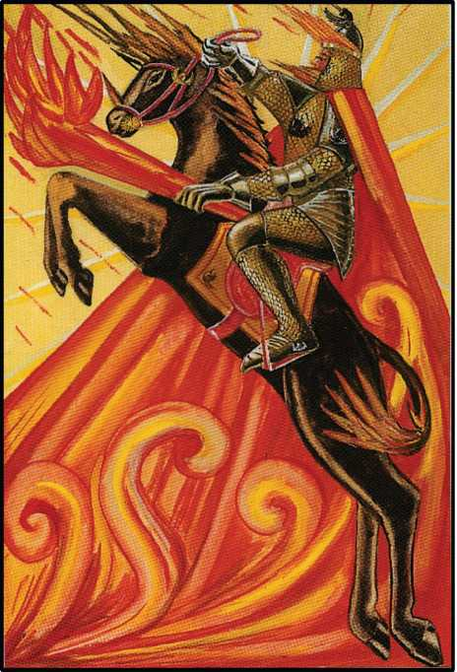

SUMMARIZED DESCRIPTION OF THE SIXTEEN COURT CARDS

KNIGHT OF WANDS

The Knight of Wands represents the fiery part of Fire; he rules from the 21St degree of Scorpio to the 20th degree of Sagittarius. He is a warrior in complete armour. On his helmet for a crest he wears a black horse. In his hand he bears a flaming torch; a flame also in his mantle; and upon the flames does he ride. His steed is a black horse leaping.

The moral qualities appropriate to this figure are activity, generosity, fierceness, im­petuosity, pride, impulsiveness, swiftness in unpredictable actions. If wrongly energized, he is evil-minded, cruel, bigoted and brutal. He is in either case ill-fitted to carry on his action; he has no means of modifying it according to circumstances. If he fails in his first effort, he has no resource.

In the Yi King, the fiery part of Fire is represented by the 51st hexagram, Kan. The sig­nification there given is entirely in accordance with the doctrine of the Tarot, but great em­phasis is laid on the startling, perilous, and revolutionary character of the events cognate. The Querent is advised to be apprehensive, yet cool, resolute and energetic: to beware of untimely action, but to go forward with tense confidence in his own ability.

All these correspondences of the Yi King are to be studied in that book (S.B.E. vol. XVI) and reference is here made to the text when important passages are too long to be conven­iently quoted.

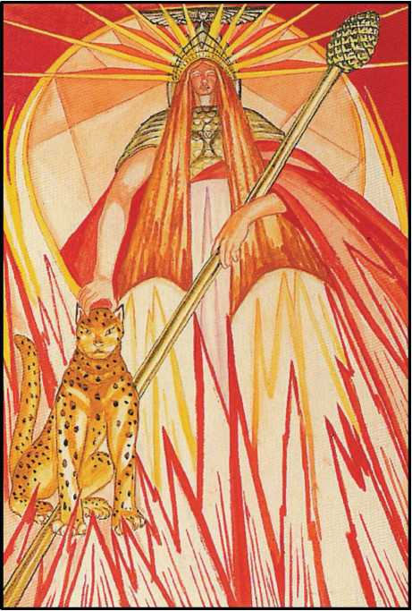

QUEEN OF WANDS

The Queen of Wands represents the watery part of Fire, its fluidity and colour. Also, she rules in the Zodiac from the 21st degree of Pisces to the 20th degree of Aries. Her crown is topped with the winged globe and rayed with flame. Her long red golden hair flows down upon her armour of scaled mail. She is seated upon a throne of flame, ordered into geometri­cal light by her material power. Beneath the throne the surging flames are steady. She bears a wand in her left hand; but it is topped with a cone suggestive of the mysteries of Bacchus. She is attended by a couchant leopard upon whose head she lays her hand. Her face expresses the ecstasy of one whose mind is well in-drawn to the mystery borne beneath her bosom.

The characteristics of the Queen are adaptability, persistent energy, calm authority which she knows how to use to enhance her attractiveness. She is kindly and generous, but impatient of opposition. She has immense capacity for friendship and for love, but always on her own initiative.

There is as much pride in this card as in the Knight, but it lacks the spontaneous nobil­ity which excuses that error. It is not true pride, but self-complacent vanity and even snob­bery.

The other side of her character is that she may have a tendency to brood, come to a wrong decision thereon, and react with great savagery. She may be easily deceived; then she is likely to shew herself stupid, obstinate, tyrannical. She may be quick to take offence, and har­bour revenge without good cause. She might turn and snap at her best friends without intelli­gible excuse. Also, when she misses her bite, she breaks her jaw!

In the Yi King, the watery part of Fire is represented by the 17th hexagram, Sui. It indi­cates reflection upon impulse, and the consequently even flow of action. There is great capac­ity for lucid conception and steady prosecution of work; but this is only at the bidding, and under the guidance, of some creative mind. There is a tendency to be fickle, even disloyal; the ideas which she obeys make no deep or permanent impression. She will “cleave to the little boy and let go the man of age and experience” or the reverse (lines 2 and 3) without realizing what she is doing. There is liability of fits of melancholy, which she seeks to cure by bouts of intoxication, or by panic-stricken outbursts of ill-considered fury.

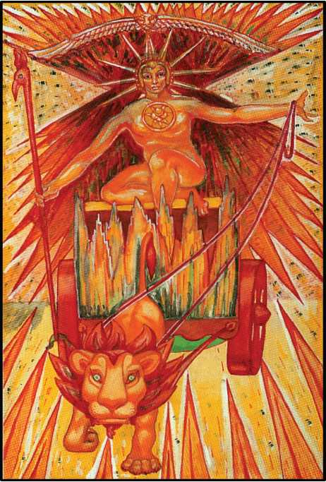

PRINCE OF WANDS

The Prince of Wands represents the airy part of Fire, with its faculty of expanding and volatilising. He rules from the 21st degree of Cancer to the 20th degree of Leo. He is a warrior in complete armour of scale mail, but his arms are bare on account of his vigour and activity. He wears a rayed crown surmounted by a lion’s head winged, and from this crown depends a curtain of flame. On his breast is the sigil of To Mega Therion. In his left hand he bears the Phoenix wand of the Second Adept (in the Ritual of 5°=6° of R.R. at A.C.), the wand of Power and Energy, while with his other arm he reins the lion which draws his chariot, the chariot which is fortified by a wheel radiating flame. He rides upon a sea of flames, both waved and salient.

The moral qualities appropriate to this figure are swiftness and strength. But he is sometimes inclined to act on impulse; sometimes easily led by external influences; some­times, especially in trifles, a prey to indecision. He is often violent, especially in the expression of an opinion, but he does not necessarily hold the opinion about which he is so emphatic. He states a vigorous proposition for the sake of stating it. He is in fact very slow to make up his mind thoroughly on any subject, but always sees both sides of every question. He is essentially just, but always feels that justice is not to be attained in the intellectual world. His character is intensely noble and generous. He may be an extravagant boaster, while slyly laughing both at the object of his boast and at himself for making it. He is romantic, especially in matters of his­tory and tradition, to the point of folly, and may engineer “stunts” or play elaborate practical jokes. He might select some inoffensive nobody, and pursue him for years with every weapon of ridicule) as Swift tormented the unhappy Partridge, all without the least animus, ready to give the shirt off his back, should his victim be in need. His sense of humour is omnivorous, and may make him a mysterious figure, dreaded without reason by people who actually know nothing about him but his name-as a symbol of Terror. This is due to the influence of the last decan of Cancer upon this card. One of his greatest faults is pride; meanness and pettiness of any kind he holds in infinite scorn. His courage is fanatically strong, and his endurance inde­fatigable. He is always fighting against odds, and always wins in the long-the very long-run. This is principally due to his enormous capacity for work, which he exercises for its own sake, “without lust of result”; perhaps his haughty contempt for the world at large-which however coexists with profound and ecstatic respect for “every man and every woman” as “a star”—is responsible for this.

When this card is badly dignified, the character degenerates. Each of the qualities men­tioned above is found in its antithesis. There is great cruelty in him, partly sadistic and partly due to callousness arising from indifference-and, in a sense, laziness! So too he may be intol­erant, prejudiced and idle-principally because it saves trouble. He may furthermore be an empty boaster and a great coward.

In the Yi King, the airy part of Fire is represented by the 42nd Hexagram, Yi, which sig­nifies addition, increase. Full of virtue, and confident therein, he contemplates work of stu­pendous scope, often with the idea expressed in line 5: “with sincere heart seeking to benefit all below”. In this he may achieve immense success. But this course is fraught with commen­surate danger. “We see one to whose increase none will contribute, while many will seek to assail him. He observes no regular rule in the ordering of his heart”. (line 6) This peril avoided, there come “parties adding to the store of its subject ten pairs of tortoise shells whose oracles cannot be opposed-Let the King employ them in presenting his offerings to God . . . . ” (line 2).

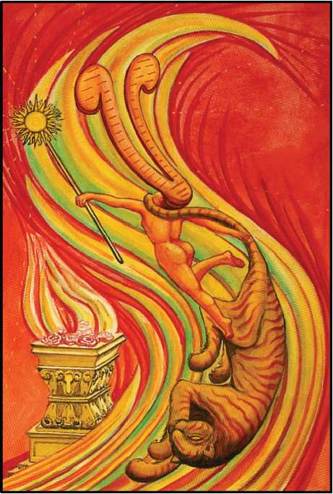

PRINCESS OF WANDS

The Princess of Wands represents the earthy part of Fire; one might say, she is the fuel of Fire. This expression implies the irresistible chemical attraction of the combustible sub­stance. She rules the Heavens for one quadrant of the portion around the North Pole.

The Princess is therefore shewn with the plumes of justice streaming like flames from her brow; and she is unclothed, shewing that chemical action can only take place when the element is perfectly free to combine with its partner. She bears a wand crowned with the disk of the Sun; and she is leaping in a surging flame which re-calls by its shape the letter Yodh.

This card may be said to represent the dance of the virgin priestess of the Lords of Fire, for she is in attendance upon the golden altar ornamented with rams’ heads) symbolizing the fires of Spring.

The character of the Princess is extremely individual. She is brilliant and daring. She creates her own beauty by her essential vigour and energy. The force of her character imposes the impression of beauty upon the beholder. In anger or love she is sudden, violent, and im­placable. She consumes all that comes into her sphere. She is ambitious and aspiring, full of enthusiasm which is often irrational. She never forgets an injury, and the only quality of pa­tience to be found in her is the patience with which she lies in ambush to avenge.

Such a woman, ill-dignified, shews the defects of these qualities. She is superficial and theatrical, completely shallow and false, yet without suspecting that she is anything of the sort, for she believes entirely in herself, even when it is apparent to the most ordinary ob­server that she is merely in the spasm of mood. She is cruel, un reliable, faithless and domi­neering.

In the Yi King, the earthy part of Fire is described by the 27th hexagram, 1. This shows a person omnivorous in passion of whatever kind, entirely reckless in the means of obtaining gratification, and insatiable. The Yi commentary is packed with alternate warning and en­couragement.

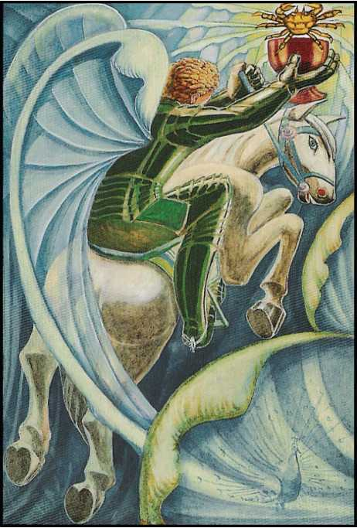

KNIGHT OF CUPS

The Knight of Cups represents the fiery part of Water, the swift passionate attack of rain and springs; more intimately, Water’s power of solution. He rules the Heavens from the 21st degree of Aquarius to the 20th degree of Pisces. He is clothed in black armour furnished with bright wings which, together with the leaping attitude of his white charger, indicates that he represents the most active aspect of Water. In his right hand he bears a cup from which is­sues a crab, the cardinal sign of Water, for aggressiveness. His totem is the peacock, for one of the stigmata of water in its most active form is brilliance. There is here also some reference to the phenomena of fluorescence.

The characteristics of the person signified by this card are nevertheless mostly passive, in accordance with the Zodiacal attribution. He is graceful, dilettante, with the qualities of Ve­nus, or a weak Jupiter. He is amiable in a passive way. He is quick to respond to attraction, and easily becomes enthusiastic under such stimulus; but he is not very enduring. He is exceed­ingly sensitive to external influence, but with no material depth in his character.

When the card is ill dignified, he is sensual, idle and untruthful. Yet with all this he pos­sesses an innocence and purity which are the essence of his nature. But he is, on the whole, so superficial that it is hard to reach this depth. “His name is writ in water.”

In the Yi King, the fiery part of Water is represented by the 54th Hexagram, Kwei Mei. The commentary is singularly obscure, and somewhat sinister. It deals with the difficulties of rightly mating such opposites as fire and water (compare the Queen of Wands; but in that case Water is the calming and modulating influence, while here it is Fire which creates trouble.) Swiftness and violence ill suit a character naturally placid; it is rare indeed to meet with a per­son who has succeeded in harmonizing these conflicting elements. He tends to mismanage all his affairs; and unless sheer good fortune attend him, his whole career will be an unbroken record of failure and disaster. Often his mental “civil war” ends in schizophrenia or melan­choly madness. The abuse of stimulants and narcotics may precipitate the catastrophe.

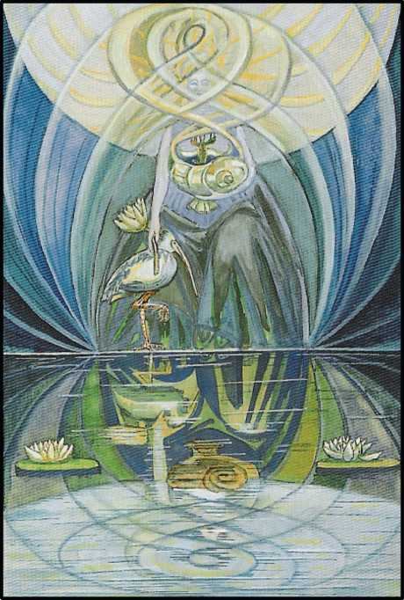

QUEEN OF CUPS

The Queen of Cups represents the watery part of Water, its power of reception and re­flection. In the Zodiac it rules from the 21st degree of Gemini to the 20th degree of Cancer Her image is of extreme purity and beauty, with infinite subtlety; to see the Truth of her is hardly possible, for she reflects the nature of the observer in great perfection.

She is represented as enthroned upon still water. In her hand she bears a shell-like cup, from which issues a crayfish, and she bears also the Lotus of Isis, of the Great Mother. She is robed in, and veiled by, endless curves of light, and the sea upon which she is enthroned con­veys the almost unbroken images of the image which she represents.

The characteristics associated with this card are principally dreaminess, illusion and tranquillity. She is the perfect agent and patient, able to receive and transmit everything with­out herself being affected thereby. If ill-dignified, all these qualities are degraded. Everything that passes through her is refracted and distorted. But, speaking generally, her characteristics depend mostly upon the influences which affect her.

In the Yi King, the watery part of Water is represented by the 58th hexagram, Tui. The commentary is as colourless as the card; it consists of mild exhortations on the subject of pleasure. It may really be said that, normally, people of this type have no character at all of their own, unless it can be called a characteristic to be at the disposition of every impact or impression.

There is, however, a hint (line 6) that the chief pleasure of people of this type is to lead and attract others. Such are accordingly (often enough) exceedingly popular.

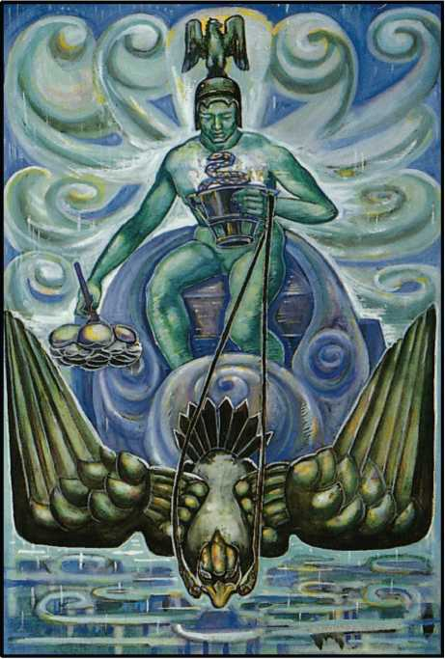

PRINCE OF CUPS

The Prince of Cups represents the airy part of Water. On the one hand, elasticity, vola­tility, hydrostatic equilibrium; on the other hand, the catalytic faculty and the energy of steam. He rules from the 21st degree of Libra to the 20th degree of Scorpio.

He is a warrior partly clad in armour, which seems, however, rather a growth than a covering. His helmet is surmounted by an eagle, and his chariot, which resembles a shell, is also drawn by an eagle. His wings are tenuous, almost of gas.. This is a reference to his power of volatilization understood in the spiritual sense.

In his right hand he bears a Lotus flower, sacred to the element of Water, and in his left hand is a cup from which issues a serpent.

The third totem, the scorpion, is not shewn in the picture, for the putrefaction which it represents is an extremely secret process. Beneath his chariot is the calm and stagnant water of a lake upon which rain falls heavily.

The whole symbolism of this card is exceedingly complicated, for Scorpio is the most mysterious of the Signs, and the manifested portion of it symbolized by the eagle is in reality the least important part of his nature.

The moral characteristics of the person pictured in this card are subtlety, secret vio­lence, and craft. He is intensely secret, an artist in all his ways. On the surface he appears calm and imperturbable, but this is a mask of the most intense passion. He is on the surface suscep­tible to external influences, but he accepts them only to transmute them to the advantage of his secret designs. He is thus completely without conscience in the ordinary sense of the word, and is therefore usually distrusted by his neighbours. They feel they do not, and can never, understand him. Thus he inspires unreasonable fear. He is in fact perfectly ruthless. He cares intensely for power, wisdom, and his own aims. He feels no responsibility to others, and although his abilities are so immense, he cannot be relied upon to work in harness.

In the Yi King, the airy part of Water is represented by the 61st hexagram, Kung Fu. This is one of the most important figures in the Yi: it “moves even pigs and fish, and leads to great good fortune”. Its dignities and correspondences are manifold and great; for it is also a “big Li”, the trigram of Sol formed by doubling the lines. By shape it suggests a boat, but also the geomantic figure of Carcer, Saturn in Capricornus.

This card is in consequence one of great power; Libra going over into Scorpio is of tre­mendous, active, critical energy and weight. To such people good will, sincerity, and right mat­ing are the essentials of success; their danger is overweening ambition.

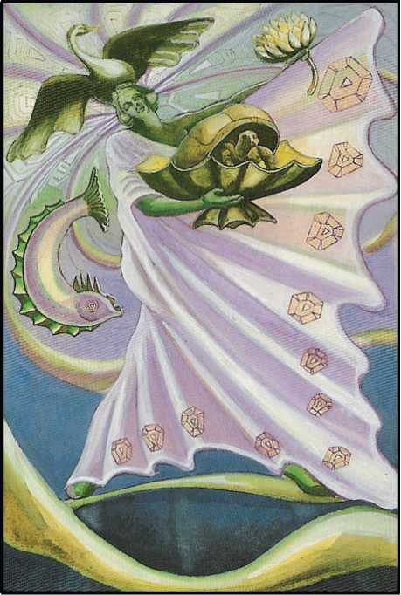

PRINCESS OF CUPS

The Princess of Cups represents the earthy part of Water; in particular, the faculty of crystallization. She represents the power of Water to give substance to idea, to support life, and to form the basis of chemical combination. She is represented as a dancing figure, robed in a flowing garment on whose edges crystals are seen to form.

For her crest she wears a swan with open wings. The symbolism of this swan reminds one of the swan in oriental philosophy which is the word AUM or AUMGN, which is the symbol of the entire process of creation.1

She bears a covered cup from which issues a tortoise. This is again the tortoise which in Hindu philosophy supports the elephant on whose back is the Universe. She is dancing upon a foaming sea in which disports himself a dolphin, the royal fish, which symbolizes the power of Creation.

The character of the Princess is infinitely gracious. All sweetness, all voluptuousness, gentleness, kindness and tenderness are in her character. She lives in the world of Romance, in the perpetual dream of rapture. On a superficial examination she might be thought selfish and indolent, but this is a quite false impression; silently and effortlessly she goes about her work.

In the Yi King, the earthy part of Water is represented by the 41st Hexagram, Sun. This means diminution, the dissolution of all solidity. People described by this card are very de­pendent on others, but at the same time helpful to them. Rarely, at the best, are they of indi­vidual importance. As helpmeets, they are unsurpassed.

iSee, for a full analysis and explanation of this Word, **Magick,** pp. 45-9.

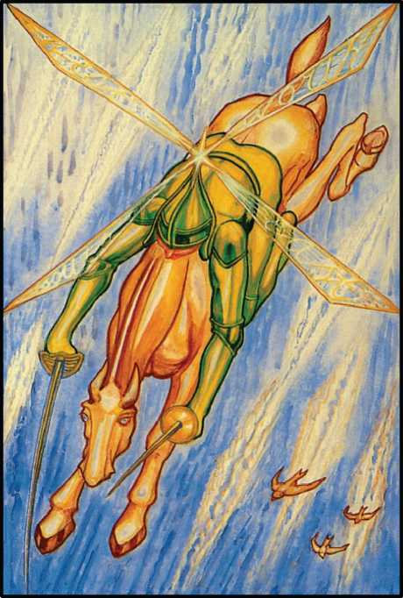

KNIGHT OF SWORDS

The Knight of Swords represents the fiery part of Air; he is the wind, the storm. He represents the violent power of motion applied to an apparently manageable element. He rules from the 21st degree of Taurus to the 20th degree of Gemini. He is a warrior helmed, and for his crest he bears a revolving wing. Mounted upon a maddened steed, he drives down the Heavens, the Spirit of the Tempest. In one hand is a sword, in the other a poniard. He represents the idea of attack.

The moral qualities of a person thus indicated are activity and skill, subtlety and clev­erness. He is fierce, delicate and courageous, but altogether the prey of his idea, which comes to him as an inspiration without reflection.

If ill-dignified, the vigour in all these qualities being absent, he is incapable of decision or purpose. Any action that he takes is easily brushed aside by opposition. Inadequate vio­lence spells futility. “Chimaera bombinans in vacuo”.

In the Yi King, the fiery part of Air is represented by the 32nd hexagram, Hang. This is the first occasion on which it has been simple to demonstrate the close technical parallelism which identifies Chinese thought and experience with that of the West. For the meaning is long continuance: “perseverance in well-doing, or continuously acting out the law of one’s be­ing”, as Legge puts it in his note on the hexagram; and this seems incongruous with the Qa- balistic idea of violent energy applied to the least stable of the elements. But the trigram of Air also indicates wood; and the hexagram may have Suggested the irresistible flow of the sap, and its effect in strengthening the tree. This conjecture is supported by the warning in line 6: “The topmost line, divided, shows its subject exciting himself to long continuance. There will be evil.”

Allowing this, the image of “the extended flame of mind”, as Zoroaster calls it, may well be subjoined to the former description. It is the True Will exploding the mind spontaneously. The influence of Taurus makes for steadiness, and that of the first decanate of Gemini for in­spiration. So let us picture him, “integer vite scelerisque purus”, a light-shaft of the Ideal ab­sorbing the entire life in concentrated aspiration, passing from earthy Taurus to exalted Gem­ini. Here, too, is shewn (as in the Yi) the danger to the subject of this symbol; for the first de­can is the card called “Interference”; or, in the old pack, “Shortened Force”.

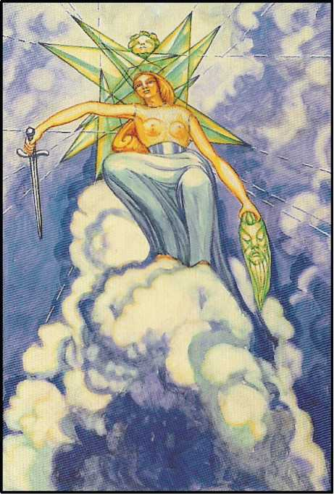

QUEEN OF SWORDS

The Queen of Swords represents the watery part of Air, the elasticity of that element, and its power of transmission. She rules from the 21St degree of Virgo to the 20th degree of Libra. She is enthroned upon the clouds. The upper part of her body is naked, but she wears a gleaming belt and a sarong. Her helmet is crested by the head of a child, and from it stream sharp rays of light, illuminating her empire of celestial dew. In her right hand, she bears a sword; in her left hand, the newly severed head of a bearded man. She is the clear, conscious perception of Idea, the Liberator of the Mind.

The person symbolized by this card should be intensely perceptive, a keen observer, a subtle interpreter, an intense individualist, swift and accurate at recording ideas; in action confident, in spirit gracious and just. Her movements will be graceful, and her ability in danc­ing and balancing exceptional.

If ill-dignified, these qualities will all be turned to unworthy purposes. She will be cruel, sly, deceitful and unreliable; in this way, very dangerous, on account of the superficial beauty and attractiveness which distinguish her.

In the Yi King, the watery part of Air is represented by the 28th hexagram, Ta Kwo. The Shape suggests a weak beam.

The character, excellent in itself, cannot support interference. Foresight and prudence, care in preparation of action, are a safeguard (line i.) Advantage is to be won, moreover, by re­liance on help from apparently unsuitable comrades (lines 2 and 5). This alien strength often supplies the defeat of inherent weakness, and may even create definite superiority to circum­stance (line 4). In such an event, there may be temptation to undertake rash adventures, fore­doomed to failure. But even so, no blame is incurred (line 6); the conditions of True Will have been satisfied, and the issue is compensated by the feeling that the right (however unfortu­nate) course has been adopted.

Such people acquire intense love and devotion from the most unexpected quarters.

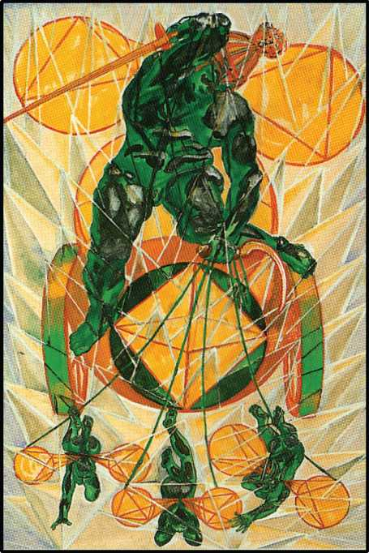

PRINCE OF SWORDS

This card represents the airy part of Air. With its particular interpretation, it is intellec­tual, it is a picture of the Mind as such. He rules from the 21st degree of Capricornus to the 20th degree of Aquarius.

The figure of this Prince is clothed with closely woven armour adorned with definite device, and the chariot which bears him suggests (even more closely) geometrical ideas. This chariot is drawn by winged children, looking and leaping irresponsibly in any direction that takes their fancy; they are not reined, but perfectly Capricious. The chariot consequently is easy enough to move, but quite unable to progress in any definite direction except by accident. This is a perfect picture of the Mind.

On the head of this Prince is, nevertheless, a child’s head radiant, for there is a secret crown in the nature of this card; if concentrated, it is exactly Tiphareth.

The operation of his logical mental processes have reduced the Air, which is his ele­ment, to many diverse geometrical patterns, but in these there is no real plan; they are dem­onstrations of the powers of the Mind without definite purpose. In his right hand is a lifted sword wherewith to create, but in his left hand a sickle, so that what he creates he instantly destroys.

A person thus symbolized is purely intellectual. He is full of ideas and designs which tumble over each other. He is a mass of fine ideals unrelated to practical effort. He has all the apparatus of Thought in the highest degree, intensely clever, admirably rational, but unstable of purpose, and in reality indifferent even to his own ideas, as knowing that any one of them is just as good as any other. He reduces everything to unreality by removing its substance and transmuting it to an ideal world of ratiocination which is purely formal and out of relation to any facts, even those upon which it is based.

In the Yi King, the airy part of Air is represented by the 57th hexagram, Sun. This is one of the most difficult figures in the book, on account of its ambivalence: it means both flexibil­ity and penetration.

Immensely powerful because of its complete freedom from settled principles, capable of maintaining and putting forward any conceivable argument, insusceptible of regret or re­morse, glib to “quote Scripture” aptly and cunningly to support any thesis soever, indifferent to the fate of a contrary argument advanced two minutes earlier, impossible to defeat because any position is as good as any other, ready to enter into combination with the nearest element available, these elusive and elastic people are of value only when firmly mastered by creative will fortified by an intelligence superior to their own. In practice, this is rarely possible: there is no purchase to be had upon them, not even by pandering to their appetites. These may nev­ertheless be stormy, even uncontrollable. Faddists, devotees of drink, drugs, humanitarianism, music or religion, are often in this class; but when this is the case, there is still no stability. They wander from one cult or one vice to another, always brilliantly supporting with the fa­naticism of a fixed conviction what is actually no more than the whim of the moment.

It is easy to be deceived by such people; for the manifestation itself has enormous po­tency: it is as if an imbecile offered one the dialogues of Plato. They may in this way acquire a great reputation both for depth and breadth of mind.

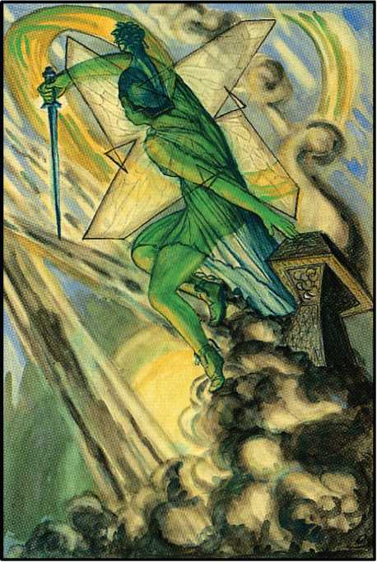

PRINCESS OF SWORDS

The Princess of Swords represents the earthy part of Air, the fixation of the volatile. She brings about the materialization of Idea. She represents the influence of Heaven upon Earth. She partakes of the characteristics of Minerva and Artemis, and there is some sugges­tion of the Valkyrie. She represents to some extent the anger of the Gods, and she appears helmed, with serpent-haired Medusa for her crest. She stands in front of a barren altar as if to avenge its profanation, and she stabs downward with her sword. The heaven and the clouds, which are her home, seem angry.

The character of the Princess is stern and revengeful. Her logic is destructive. She is firm and aggressive, with great practical wisdom and subtlety in material things. She shews great cleverness and dexterity in the management of practical affairs, especially where they are of a controversial nature. She is very adroit in the settlement of controversies.

If ill-dignified, all these qualities are dispersed; she becomes incoherent, and all her gifts tend to combine to form a species of low cunning whose object is unworthy of the means.

In the Yi King, the earthy part of Air is represented by the i8th hexagram, Ku. This means “troubles”; it is, for all practical and material matters. the most unhappy symbol in the book. All the fine qualities of Air are weighed down, suppressed, suffocated.

People thus characterized are slow mentally, the prey of constant anxiety, crushed by every kind of responsibility, but especially in family affairs. One of both of the parents will usually be found in the aetiology.

It is hard to understand line 6, which “shows us one who does not serve either king or feudal lord, but in a lofty spirit prefers to follow his own bent”. The explanation is that a Prin­cess as such, being “the throne of Spirit”, may always have the option of throwing everything overboard, “blowing everything sky high”. Such action would account for the characteristics above given for the card when well dignified. Such people are exceedingly rare; and, naturally enough, they appear often as “Children of misfortune”. Nevertheless, they have chosen aright, and in due season gain their reward.

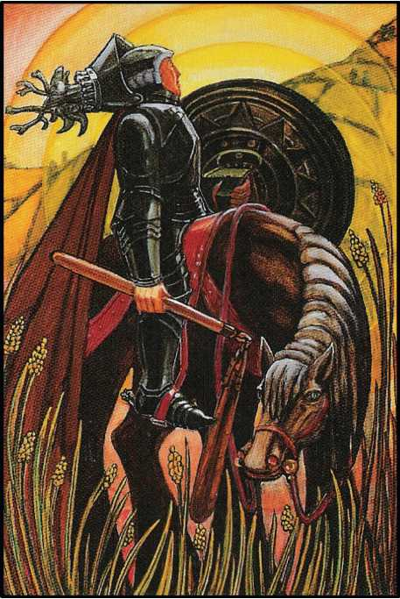

KNIGHT OF DISKS

The Knight of Disks represents the fiery part of Earth, and refers in particular to the phenomena of mountains, earthquakes, and gravitation; but it also represents the activity of Earth regarded as the producer of Life. He rules from the 21st degree of Leo to the 20th de­gree of Virgo, and is thus concerned greatly with agriculture. This warrior is short and sturdy in type. He is clothed in great solidity of plate armour; but his helmet, which is crested with the head of a stag, is thrown back, for at the moment his function is entirely con- fined to the production of food. For this reason he is armed with a flail. The disk which he bears, more­over, is very solid; it represents nutrition. These characteristics are borne out by his horse; a shire horse, solidly planted on all four feet, as was not the case with the other Knights. He rides through the fertile land; even the distant hills are cultivated fields.

Those whom he symbolizes tend to be dull, heavy and pre-occupied with material things. They are laborious and patient, but would have little intellectual grasp even of matters which concern them most closely. Their success in these is due to instinct, to imitation of Na­ture. They lack initiative; their fire is the smouldering fire of the process of growth.

If ill-dignified, these people are hopelessly stupid, slavish, quite incapable of foresight even in their own affairs, or of taking an intelligent interest in anything outside them. They are churlish, surly, and jealous (in a dull sort of way) of what they instinctively realize is the superior state of others; but they have not the courage or intelligence to better themselves. Yet they are always irritably meddling about petty matters; they interfere with, and inevitably spoil, whatever comes their way.

In the Yi King, the fiery part of Earth is represented by the 62nd hexagram, Hsiao Kwo. This is as important as its complement, Kung Fu (see under Prince of Cups); it is a “big Khan”, the trigram of Luna with each line doubled. But it is also suggestive of the Geomantic figure Conjunctio, Mercury in Virgo, corresponding very closely indeed with the Fire of Earth attri­bution in the Qabalistic system.

To the Chinese sages, moreover, the shape of the figure gave the idea of a bird. The meaning is, accordingly, modified by human influence of the more frivolous and irresponsible kind, Shakespeare’s “little wanton harlotry”, the French cynic’s “Souvent femme vane”, and the fickle mob of Coriolanus; indeed, of History itself. But Mercury in Virgo symbolizes Intelli­gence (and even creative Idea) applied to Agriculture; and this (once more!) harmonizes per­fectly with the Ten of Disks, which is ruled by this Planet and this Sign. This adds to the su­perabundant mass of proof that this whole system of symbolism is based upon Realities of Na­ture, as understood by the materialist School of Science-if such a school survives in some ob­scure and obsolescent University! Such coherence, such introverted exfoliation, cannot be the chance parallelism of the dreams of nebulous philosophies.

The character described by this card is therefore exceeding complex yet admirably well-knit; but its dangers are indicated by the symbols of Luna and the bird. In the happiest cases, the qualities thus indicated will be romance and imagination; but overweening ambi­tion, the pursuit of Ignis Fatuus, superstition, and the tendency to waste time in idle dream­ing, are perils all too frequently found in such sons of the soil. Thomas Hardy has painted many admirable portraits of the type. Ill-starred indeed and black with bile are those who have profaned the Sacred Fire, not enkindling Earth to new, more copious, more varied life, but peering in deceptive moonlight, turning their faces from their mother Earth.

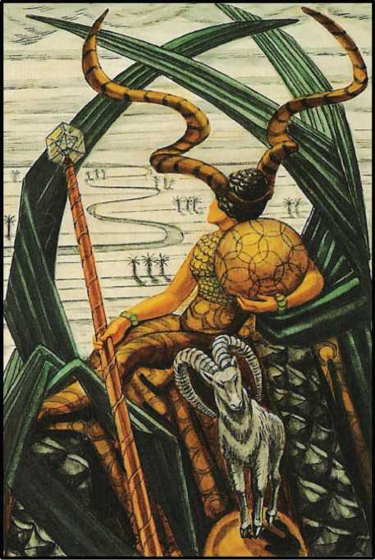

QUEEN OF DISKS

The Queen of Disks represents the watery part of Earth, the function of that element as Mother. She rules from the 21st degree of Sagittarius to the 20th degree of Capricornus. She represents passivity, usually in its highest aspect.

The Queen of Disks is throned upon the life of vegetation. She contemplates the back­ground, where a calm river winds through a sandy desert to bring to it fertility. Oases are be­ginning to shew themselves amid the wastes. Before her stands a goat upon a sphere. There is here a reference to the dogma that the Great Work is fertility. Her armour is composed of small scales or coins, and her helmet is adorned with the great spiral horns of the markhor. In her right hand she bears a sceptre surmounted by a cube, within which is a three- dimen­sional Hexagram, and in her left arm is curved her proper disk, a sphere of loops and circles interlaced. She thus represents the ambition of matter to take part in the great work of Crea­tion.

Persons signified by this card possess the finest of the quieter qualities. They are ambi­tious, but only in useful directions. They possess immense funds of affection, kindness, and greatness of heart. They are not intellectual, and not particularly intelligent; but instinct and intuition are more than adequate for their needs. These people are quiet, hard-working, prac­tical, sensible, domesticated, often (in a reticent and unassuming fashion) lustful and even de­bauched. They are inclined to the abuse of alcohol and of drugs. It is as if they could only real­ize their essential happiness by getting outside themselves.

If ill dignified, they are dull, servile, foolish; they are drudges rather than workers. Life for them is purely mechanical; and they cannot rise, or even seek to rise, above their ap­pointed lot.

In the Yi King, the watery part of Earth is represented by the 3ist hexagram, Hsien. This has the meaning: Influence. The commentary describes the effect of moving various parts of the body, from the toes to the jaws and tongue. This is rather an amplification of what has been said above than an exact correspondence; yet there is no discordance. The general ad­vice is to go forward quietly without overt attack upon existing situations.

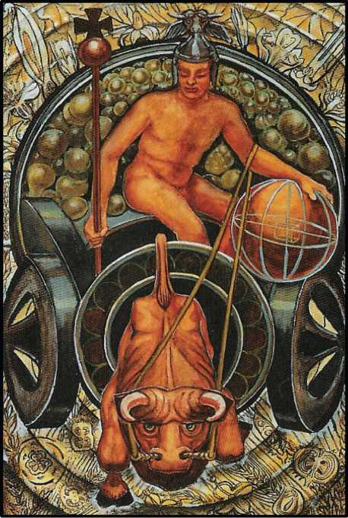

PRINCE OF DISKS

The Prince of Disks represents the airy part of Earth, indicating the florescence and fructification of that element. He rules from the 21st degree of Aries to the 20th degree of Taurus.

The figure of this Prince is meditative. He is the element of Earth become intelligible. Clothed in light armour, his helmet is crowned with the head of a bull; and his chariot is drawn by an ox, this animal being peculiarly sacred to the Element of Earth. In his left hand he holds his disk, which is an orb resembling a globe, marked with mathematical symbols as if to imply the planning involved in agriculture. In his right hand he bears an orbed sceptre sur­mounted by a cross, a symbol of the Great Work accomplished; for it is his function to bring forth from the material of the element that vegetation which is the sustenance of the Spirit itself.

The character denoted by this card is that of great energy brought to bear upon the most solid of practical matters. He is energetic and enduring, a capable manager, a steadfast and per severing worker. He is competent, ingenious, thoughtful, cautious, ‘trustworthy, im­perturbable; he constantly seeks new uses for common things, and adapts his circumstances to his purposes in a slow, steady, well-thought out plan.

He is lacking almost entirely in emotion. He is somewhat in sensitive, and may appear dull, but he is not; it so appears because he makes no effort to understand ideas which are be­yond his scope. He may often appear stupid, and is inclined to be resentful of more spiritual types. He is slow to anger, but, if driven, becomes implacable. It is not very practicable to dis­tinguish between the good and evil dignities in this card; one can merely say that, in case of his being ill-dignified, both the quality and quantity of his characteristics are somewhat de­graded. The reaction of others to him will depend almost entirely upon their own tempera­ments.

In the Yi King, the airy part of Earth is represented by the 53rd hexagram, Kien. The commentary concerns the flight of wild geese, “gradually approaching the shore”, then “the large rocks”, then “advanced to the dry plains—the trees—the high mound”; finally, to “the large heights”. It thus symbolizes slow, steady emancipation from repressive conditions.

The description is even happier than that given by the Qabalah, although in every way congruous with it. Practical considerations are never absent from Chinese thought, even at its most abstruse and metaphysical. The fundamental heresy of the Black Lodge is con tempt for “the world, the flesh, and the devil”, all which are essential to the plan of the Universe; it is cardinal to the Great Work for the Adept so to order affairs that “even the evil germs of Matter shall alike become useful and good”.

The error of Christian Mystics on this point has been responsible for more cruelty, misery, and collective insanity than all others put together; its poison can be traced even in the teaching of Freud, who assumed that the Unconscious was “the devil”, whereas in fact it is the instinct which expresses, beneath a veil, the inherent Point-of- View of each, and, properly understood, is the key to Initiation, and a hint of what seed may blossom and fructify as the “Knowledge and Conversation of the Holy Guardian Angel”. For “Every man and every woman is a star”.

But no doubt the judgment of the Adepts Exempt (for it is they who determine, under the guidance of the Masters of the Temple, all such details of doctrine) in respect of this card has been influenced by its transition from Aries to Taurus. It is too often forgotten that Taurus is the House of Venus, and that Luna is exalted therein. The new doctrine set forth in this pre­sent Essay makes the primary colour of Earth not black, but green; it insists that every Disk is a living and revolving symbol. The central thesis of the Book of the Law asserts the Perfection of the Universe. In its pantheistic conception all possibilities are equal in value; each and every Point-Event is “a play of Nuit”, as it is written in the Book of Wisdom or Folly, “Bind noth­ing! Let there be no difference made among you between any one thing & any other thing; for thereby there cometh hurt. But whose availeth in this, let him be the chief of all!” Liber Al. 1. 22. Or, yet more comprehensively and simply: “Every number is infinite; there is no differ­ence.” Ib 1. 4.

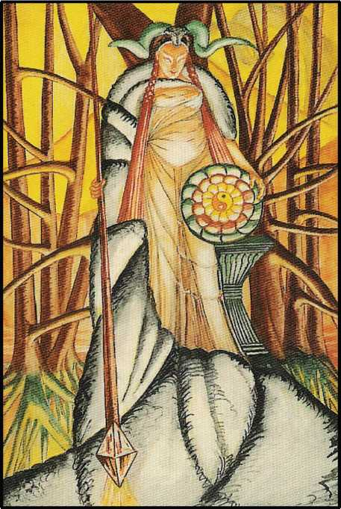

PRINCESS OF DISKS

The Princess of Disks, the last of the Court cards, represents the earthy part of Earth. She is consequently on the brink of transfiguration. She is strong and beautiful, with an ex­pression of intense brooding, as if about to become aware of secret wonder.

Her crest is the head of the ram, and her sceptre descends into the earth. There its head becomes a diamond, the precious stone of Kether, thus symbolizing the birth of the high­est and purest light in the deepest and darkest of the Elements. She stands within a grove of sacred trees before an altar suggesting a wheatsheaf, for she is a priestess of Demeter. She bears within her body the secret of the future. Her sublimity is further emphasized by the disk which she bears; for in the centre thereof is the Chinese ideogram denoting the twin spiral force of Creation in perfect equilibrium; from this is born the rose of Isis, the great fertile Mother.

The characteristics of an individual signified by this card are too various to enumerate; one must summarize by saying that she is Womanhood in its ultimate projection. She contains all the characteristics of woman, and it would depend entirely upon the influences to which she is subjected whether one or another becomes manifest. But in every case her attributes will be pure in themselves, and not necessarily connected with any other attributes which in the normal way one regards as symbolic. In one sense, then, her general reputation will be of bewildering inconsistency. It is rather like a lottery wheel from which the extraction of any number does not predict or influence the result of any subsequent operation. The fruit of the Philosophy of Thelema is enjoyed, rare, ripe, nourishing and vitalizing at its highest and full­est in this meditation; for to the adept every turn of the wheel is equally probable, and equally a prize; for every Event is “a play of Nuit”.

In the Yi King the earthy part of Earth is represented by the 52nd hexagram, Kan. The meaning is “a mountain”; of how sublime a significance is this Chinese doctrine of Balance, and how closely congruous with that of the Holy Qabalah!

The mountain is the most sacred of all terrestrial symbols, stark, rugged, and immove­able in its aspiration to the Highest, thrust up as it is by the Titan energy of Hidden Fire. It is no less an hieroglyph of the Inmost Godhead than the Phallus itself, even as Capricornus, the sign of the New Year, is exalted in the Zodiac, its deity autochthonous no less than the Most Holy Ancient One himself.

It is essential for the Student to trace this doctrine for himself in every symbol: Air, the elastic and flexible, yet all-pervading and the element of combustion; Water, fluid yet incom­pressible, the most neutral and composed of all components of living matter, yet destructive even of the hardest rocks by physical assault, and irresistible in its burning power of solution; and Fire, so kin to Spirit that it is not a substance at all, but a phenomenon, yet so integral to Matter that it is the very heart and essence of all things soever.

The characteristic of Kan in the Yi King is rest; each line of the comment describes re­pose in the parts of the body in turn, and their effects; the toes, the calves, the loins, the spine, and the jaws.

This chapter is a close parallel in this respect, line by line, with the 31st, Hsien, which begins the second section of the Yi.

The Rosicrucian doctrine of Tetragrammaton could hardly be more adequately stated- to every ear that is to heavenly harmony attuned.

“There’s not a planet in the firmament But in his motion like an angel sings,

Still quiring to the young-eyed cherubim;

But while this muddy vesture of decay Doth wrap us round, our nature cannot hear it.

Let every student of this Essay, and of this book of Tahuti, this living Book that guides man through all Time, and leads him to Eternity at every page, hold fast this simplest, most far-reaching Doctrine in his heart and mind, inflaming the inmost of His Being, that he also, having explored each recess of the Universe, may therein find the Light of Truth, so come to the Knowledge and Conversation of the Holy Guardian Angel, and accomplish the Great Work, attain the Summum Bonum, true Wisdom and perfect Happiness!

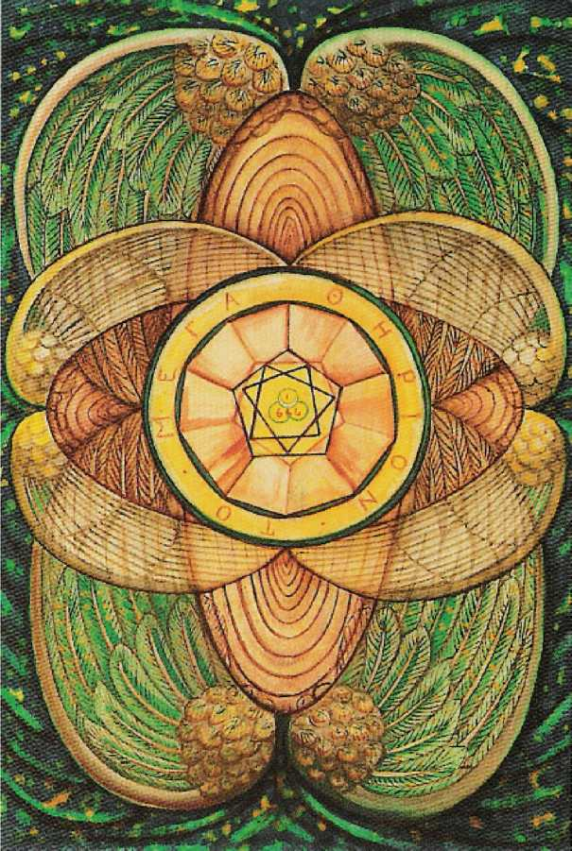

THE SMALL CARDS

*The Four Aces; The Four Twos; The Four Threes; The Four Fours; The Four Fives; The Four Sixes; The Four Sevens; The Four Eights; The Four Nines; The Four Tens. The Root ofthe Powers ofFire Ace of Wands; Dominion-Two of Wands; Virtue-Three of Wands; Com­pletion-Four of Wands; Strife-Five of Wands; Victory-Six of Wands; Valour-Seven of Wands; Swiftness-Eight of Wands; Strength-Nine of Wands; Oppression-Ten of Wands. The Root ofthe Powers of Water-Ace of Cups; Love-Two of Cups; Abundance-Three of Cups; Luxury-Four of Cups; Disappointment-Five of Cups; Pleasure-Six of Cups; Debauch-Seven of Cups; Indolence-Eight of Cups; Happiness- Nine of Cups; Satiety-Ten of Cups. Ace of Swords; Peace-Two of Swords; Sorrow-Three of Swords; Truce-Four of Swords; Defeat- Five of Swords; Science-Six of Swords; Futility-Seven of Swords; In­terference-Eight of Swords; Cruelty-Nine of Swords; Ruin-Ten of Swords. Ace of Disks; Change -Two of Disks; Work-Three of Disks; Power-Four of Disks; Worry -Five of Disks; Success-Six of Disks; Failure-Seven of Disks; Prudence-Eight of Disks; Gain-Nine of Disks; Wealth -Ten of Disks. INVOCATION AND MNEMONICS*

THE FOUR ACES

The Aces represent the roots of the four elements. They are quite above, and distinct from, the other small cards in the same way as Kether is said to be symbolized only by the topmost point of the Yod of Tetragrammaton. In these cards is no real manifestation of the element in its material form. They form a link between the small cards and the Princesses, who rule the Heavens around the North Pole. The Meridian is the Great Pyramid, and the Ele­ments rule, going Eastward, in the order of Tetragrammaton, Fire, Water, Air, Earth. Thus, roughly, Aces-Princesses Wands cover Asia, Cups the Pacific Ocean, Swords the Americas, Disks Europe and Africa. To make this relationship clear, one may go a little into the symbol of the pentagram, or Shield of David. It represents Spirit ruling the four elements, and is thus a symbol of the Triumph of Man.

The idea of the element of Spirit is very difficult to grasp. The letter Shin, which is the letter of Fire, has to do double duty by representing Spirit as well. Generally speaking, the at­tributions of Spirit are not clear and simple like those of the other elements. It is very remark­able that the Tablet of Spirit in the Enochian system is the key to all mischief; as, in the Hindu system, Akasha is the Egg of Darkness.

On the other hand, Spirit represents Kether. Perhaps it was never in the mind of the Exempt Adept or Adepts who invented the Tarot to go so far into this matter. The point to re­member is that, both in their appearance and in their meaning, the Aces are not the elements themselves, but the seeds of those elements.

THE FOUR TWOS

These cards refer to Chokmah. From the point of view of the ordinary person, Chok- mah is really No. I and not No.2, because he is the first manifestation; Kether is completely concealed, so that nobody knows anything about it at all. Hence, only on reaching the Deuces does an element appear as the element itself. Chokmah is uncontaminated by any influence; therefore the elements here appear in their original harmonious condition.

The Two of Wands is called the Lord of Dominion, and represents the energy of fire; fire in its best and highest form.

The Two of Cups is the Lord of Love, which performs a similar office for water.

The Two of Swords was formerly called the Lord of Peace Restored; but this word “re­stored” is incorrect, because there has been no disturbance. The Lord of Peace is therefore a better title: but it needs thinking hard to work this out, since the Sword is so intensely active. It may be helpful to study the Essay on Silence (p. 120) for a parallel: the Negative Form of the Positive Idea. See also the Essay on Chastity (Little Essays Toward Truth, pp. 70-74) which concludes: Sir Knights, be vigilant: watch by your arms and renew your oath; for that day is of sinister augury and deadly charged with danger which ye fill not to overflowing with gay deeds and bold of masterful, of manful Chastity.

Witness also Catullus: *domi maneas paresque nobis Novem continuas futationes.*

Nor does he misunderstand the gesture of Harpocrates; Silence and Chastity are iso­mers.

It is all one case of the general proposition that the sum of the infinite Energy of the Universe is Zero.

The Two of Pentacles was of old time called the Lord of Harmonious Change. Now, more simply, Change; and here the doctrine must be stated a little more clearly. This suit being of Earth, there is a connection with the Princesses, and therefore with the final He of Tetra- grammaton. Earth is the throne of Spirit; having got to the bottom, one immediately comes out again at the top. Hence, the card manifests the symbolism of the serpent of the endless band.

THE FOUR THREES

These cards are referred to Binah; in each of them is expressed the symbolism of Un­derstanding. The idea has become fertilized; the triangle has been formulated. In each case, the idea is of a certain stability which can never be upset, but from which a child can issue.

The Three of Wands is accordingly the Lord of Virtue. The idea of will and dominion has become interpreted in Character.

The Three of Cups is called the Lord of Abundance. The idea of love has come to frui­tion; but this is now sufficiently far down the Tree to introduce a very definite differentiation between the suits, which was not previously possible.

The idea of division, of mutability, the idea of the airy quality of things, manifests itself in the Three of Swords, the Lord of Sorrow. Here one is reminded of the darkness of Binah, of the mourning of Isis; but this is not any vulgar sorrow dependent upon any individual disap­pointment or discontent. It is Weltschmerz, the universal sorrow; it is the quality of melan­choly.

The Three of Pentacles, in a similar manner, exhibits the result of the idea of Earth, of the crystallization of forces; and so the Three of Pentacles is called the Lord of Work. Some­thing has definitely been done.

THE FOUR FOURS

These cards are attributed to Chesed. The connection between the number Four and the number Three is extremely complex. The important characteristic is that Four is “below the Abyss”; therefore, in practice, it means solidification, materialization. Things have become manifest. The essential point is that it expresses the Rule of Law.

In the Wand suit, the card is called Completion. The manifestation promised by Binah has now taken place. This number must be very solid, because it is the actual dominating in­fluence on all the following cards. Chesed, Jupiter-Ammon, the Father, the first below the Abyss, is the highest idea which can be understood in an intellectual way, and that is why the Sephira is attributed to Jupiter, who is the Demiurge.

The Four of Cups is called Luxury.

The masculine nature of fire permits the Four of Wands to appear as a very p6sitive and clear-cut conception. The weakness in the element of water threatens its purity; it is not quite strong enough to control itself properly; so the Lord of Pleasure is a little unstable. Pu­rity has somehow been lost in the process of satisfaction.

The Four of Swords is called Truce. This seems rather on the lines of “the strong man armed, keeping his house in peace”. The masculine nature of air makes it dominant. The card is almost a picture of the formation of the military clan system of society.

As to the Disks, the heaviness of the symbol rather outweighs any considerations of its weakness. The card is called Power. It is the power which dominates and stabilizes every­thing, but manages its affairs more by negotiation, by pacific methods, than by any assertion of itself. It is Law, the Constitution, with no aggressive element.

THE FOUR FIVES

In the “Naples arrangement”, the introduction of the number Five shows the idea of motion coming to the aid of that of matter. This is quite a revolutionary conception; the result is a complete upset of the statically stabilized system. Now appear storm and stress.

This must not be regarded as something “evil”. The natural feeling about it is really a little more than the reluctance of people to get up from lunch and go back to the job. In the Buddhist doctrine of Sorrow this idea is implicit, that inertia and insensitiveness must charac­terize peace. The climate of India is perhaps partly responsible for this notion. The Adepts of the White School, of which the Tarot is the sacred book, cannot agree to such a simplification of existence. Every phenomenon is a sacrament. For all that, a disturbance is a disturbance; the five of Wands is called Strife.

On the other hand, the Five of Cups is called Disappointment, as is only natural, be­cause Fire delights in superabundant energy, whereas the water of Pleasure is naturally placid, and any disturbance of ease can only be regarded as misfortune.

The Five of Swords is similarly troublesome; the card is called Defeat. There has been insufficient power to maintain the armed peace of the Four. The quarrel has actually broken out. This must mean defeat, for the original idea of the Sword was a manifestation of the re­sult of the love between the Wand and the Cup. It is because the birth had to express itself in the duality of the Sword and the Disk that the nature of each appears so imperfect.

The Five of Disks is in equally evil case. The soft quiet of the Four has been completely overthrown; the card is called Worry. [See Skeat, Etymological Dictionary. The idea is of stran­gling, as dogs worry sheep. Note the identity with Sphinx.] The economic system has broken down; there is no more balance between the social orders. Disks being as they are, stolid and obstinate, as compared with the other weapons, for their revolution serves to stabilize them, there is no action, at least not in its own ambit, that can affect the issue.

THE FOUR SIXES

These cards are attributed to Tiphareth. This Sephira is in some respects the most important of all. It is the centre of the whole system; it is the only Sephira below the Abyss which communicates directly with Kether. It is fed directly from Chokmah and Binah; also from Chesed and Geburah. It is thus admirably fitted to dominate the lower Sephiroth; it is balanced both vertically and horizon tally. In the planetary system it represents the Sun; in the system of Tetragrammaton it represents the Son. The entire geometrical complex of the Ruach may be regarded as an expansion from Tiphareth. It represents consciousness in its most harmonized and balanced form; definitely in form, not only in idea, as in the case of the num­ber Two. In other words, the Son is an interpretation of the Father in terms of the mind.

The four Sixes are thus representative of their respective elements at their practical

best.

The Six of Wands is called Victory. The outburst of energy in the Five of Wands, which was so sudden and violent that it even gave the idea of strife, has now completely won suc­cess. The rule, or lordship, in the suit of Wands is not quite as stable as it might have been if there had been less energy displayed. So, from this point, as soon as the current leaves the middle pillar, the inherent weakness in the element of Fire (which is this: that, for all its pu­rity, it is not completely balanced) leads to very undesirable developments.

The Six of Cups is called Pleasure. This pleasure is a kind of pleasure which is com­pletely harmonized. The zodiacal sign governing the card being Scorpio, pleasure is here rooted in its most convenient soil. This is pre-eminently a fertile card; it is one of the best in the pack.

The Six of Swords is called Science. Its ruler is Mercury, so that the element of success turns away from the idea of division and quarrel; it is intelligence which has won to the goal.

The Six of Disks is called Success; the ruler is the Moon. This is a card of settling down; it is very heavy, wholly lacking in imagination, yet somewhat dreamy. Change is soon coming upon it; the weight of earth will ultimately drag the current down to a mere eventuation of material things. Yet the Moon, being in Taurus, the sign of her exaltation, the best of the Lunar qualities are inherent. Moreover, being a Six, the solar Energy has fertilized her, creating a bal­anced system for the time being. The card is worthy of the name Success. Remember only that all success is temporary; how brief a halt upon the Path of Labour.

THE FOUR SEVENS

These cards are attributed to Netzach. The position is doubly unbalanced; off the mid­dle pillar, and very low down on the Tree. It is taking a very great risk to descend so far into illusion, and, above all, to do it by frantic struggle. Netzach pertains to Venus; Netzach pertains to Earth; and the greatest catastrophe that can befall Venus is to lose her Heavenly origin. The four Sevens are not capable of bringing any comfort; each one represents the degeneration of the element. Its utmost weakness is exposed in every case.

The Seven of Wands is called Valour. Energy feels itself at its last gasp; it struggles des­perately, and may be overcome. This card brings out the defect inherent in the idea of Mars. Patriotism, so to speak, is not enough.

The Seven of Cups is called Debauch. This is one of the worst ideas that one can have; its mode is poison, its goal madness. It represents the delusion of Delirium Tremens and drug addiction; it represents the sinking into the mire of false pleasure. There is something almost suicidal in this card. It is particularly bad because there is nothing whatever to balance it-no strong planet to hold it up. Venus goes after Venus, and Earth is churned into the scorpion mo­rass.

The Seven of Swords is called Futility. This is a yet weaker card than the Seven of Wands. It has a passive sign instead of an active one, a passive planet instead of an active one. It is like a rheumatic boxer trying to “come back” after being out of the ring for years. Its ruler is the Moon. The little energy that it possesses is no more than dream-work; it is quite inca­pable of the sustained labour which alone, bar miracles, can bring any endeavour to fruition. The comparison with the Seven of Wands is most instructive.

The Seven of Disks is called Failure. This suit gives the extreme of passivity; there is no positive virtue in it below the Abyss. This card is ruled by Saturn. Compare it with the three other Sevens; there is no effort here; not even dream; the stake has been thrown down, and it is lost. That is all. Labour itself is abandoned; everything is sunk in sloth.

THE FOUR EIGHTS

The four Eights are attributed to Hod. Being in the same plane as the Sevens on the Tree of Life, but on the other side, the same inherent defects as are found in the Sevens will

apply.

Yet one may perhaps urge this alleviation, that the Eights come as (in a sense) a rem­edy for the error of the Sevens. The mischief has been done; and there is now a reaction against it. One may, therefore, expect to find that, while there is no possibility of perfection in the cards of this number, they are free from such essential and original errors as in the Lower case.

The Eight of Wands is called Swiftness, as one might expect from its attribution to Mer­cury and Sagittarius. This is an etherealization of the idea of fire; all gross elements have dis­appeared.

(Let there be a short digression with regard to the signs of the Zodiac. In the case of each element, the Cardinal sign represents the swift, impulsive onrush of the idea. In the Kerubic sign, the element has come to its full balance of power; and in the other signs the force is fading away. Thus, Aries represents the rush of fire, Lightning; Leo, its power, the Sun; and Sagittarius, the rainbow, its sublimation. Similar considerations apply to the other ele­ments. See the Attributions section: The Triplicities of the Zodiac.)

In the Eight of Wands, fire is no longer conjoined with the ideas of combustion and de­struction. It represents energy in its most exalted and tenuous sense; this suggests such forms thereof as the electric current; one might almost say pure light in the material sense of that word.

The Eight of Cups is called Indolence. This card is the very apex of unpleasantness. It is ruled by the planet Saturn; time, sorrow, have descended upon pleasure, and there is no strength in the element of water which can react against it. This card is not exactly “the morn­ing after the night before”; but it is very nearly that. The difference is that the “night before” has not happened! This card represents a party for which all preparations have been made; but the host has forgotten to invite the guests; or, the caterers have not delivered the good cheer. There is this difference, though, that it is in some way or other the host’s own fault. The party that he planned was just a little bit above his capacity; perhaps he lost heart at the last moment.

The Eight of Swords is called Interference. At first sight, it would seem easy to confuse it with the Eight of Cups; but the idea is, in reality, quite different. The card is attributed to Jupiter and Gemini; accordingly, there is no weighing down of the will by internal or external stress. It is simply the error of being good-natured when good-nature is disastrous. Gemini is an airy sign, an intellectual sign; Jupiter is geniality and optimism. This will not do in the world of Swords; if one must hit at all, a knock-out blow is best. But there is another element in this card; that of unexpected (the Eights, being at heart Mercurial, are always that) interfer­ence, sheer unforeseen bad luck. Trivial incidents have often altered the destiny of empires, brought to naught “the best-laid plans of mice and men”.

The Eight of Disks is called Prudence. This card is a great deal better than the last two, because, in purely material matters, especially those relating to actual money, there is a sort of strength in doing nothing at all. The problem of every financier is, first of all, to gain time; if his resources are sufficient, he always beats the market. This is the card of “putting something away for a rainy day”.

Its attribution is Sol in Virgo; it is the card of the husbandman; he can do little more than sow the seed, sit back, and wait for the harvest. There is nothing noble about this aspect of the card; like all the Eights, it represents an element of calculation, and gambling is securely profitable if one has adjusted the cagnotte properly.

There is yet another point which complicates this card. The Eight of Disks represents the geomantic figure Populus, which is an easy-going figure, and at the same time stable. One thinks of Queen Victoria’s time, of a man who is “something in the City” rolling up to Town with Albert the Good advertized by his watch-chain and his frock-coat; on the surface he is very affable, but he is nobody’s fool.

THE FOUR NINES

These cards are attributed to Yesod. After the double excursion into misfortune, the current returns to the middle pillar. This Sephira is the seat of the great crystallization of En­ergy. But it takes place very far down the Tree, at the apex of the third descending triangle, and a flat triangle at that. There is little help from low, unbalanced spheres like Netzach and Hod. What saves Yesod is the direct ray from Tiphareth; this Sephira is in the direct line of succession. Each of these cards gives the full impact of the elemental force, but in its most ma­terial sense; that is, of the idea of the force, for Yesod is still in Yetzirah, the formative world. Zoroaster says: “The number Nine is sacred, and attains the summit of perfection.” Egypt and Rome, also, had Nine Major Deities.

The Nine of Wands is called Strength. It is ruled by the Moon and Yesod. In “The Vision and the Voice”, the eleventh Aethyr gives a classical account of the resolution of this antinomy of Change and Stability. The student should also consult the works of any of the better mathematical physicists. Of all important doctrines concerning equilibrium, this is the easiest to understand, that change is stability; that stability is guaranteed by change; that if anything should stop changing for the fraction of a split second, it would go to pieces. It is the intense energy of the primal elements of Nature, call them electrons, atoms, anything you will, it makes no difference; change guarantees the order of Nature. This is why, in learning to ride a bicycle, one falls in an extremely awkward and ridiculous manner. Balance is made difficult by not going fast enough. So also, one cannot draw a straight line if one’s hand shakes. This card is a sort of elementary parable to illustrate the meaning of this aphorism: “Change is Stability.”

Here the Moon, the weakest of the planets, is in Sagittarius, the most elusive of the Signs; yet it dares call itself Strength. Defence, to be effective, must be mobile.

The Nine of Cups is called Happiness. This is a peculiarly good card, because happiness, as the word implies, is so much a matter of luck: the card is ruled by Jupiter, and Jupiter is For­tune.

In all these watery cards, there is a certain element of illusion; they begin by Love, and love is the greatest and most deadly of the illusions. The sign of Pisces is the refinement, the fading away of this instinct, which, begun with dreadful hunger and carried on with passion, has now become “a dream within a dream”.

The card is ruled by Jupiter. Jupiter in Pisces is indeed good fortune, but only in the sense of complete satiety. The fullest satisfaction is merely the matrix of a further putrefac­tion; there is no such thing as absolute rest. A cottage in the country with the roses all around it? No, there is nothing permanent in this; there is no rest from the Universe. Change guaran­tees stability. Stability guarantees change.

The Nine of Swords is called Cruelty. Here the original disruption inherent in Swords is raised to its highest power. The card is ruled by Mars in Gemini; it is agony of mind. The Ruach consumes itself in this card; thought has gone through every possible stage, and the conclu­sion is despair. This card has been very adequately drawn by Thomson in “The City of Dread­ful Night”. It is always a cathedral—a cathedral of the damned. There is the acrimonious taint of analysis; activity is inherent in the mind, yet there is always the instinctive consciousness that nothing can lead anywhere.

The Nine of Disks is called Gain. The suit of Disks is much too dull to care; it reckons up its winnings; it does not worry its head about whether anything is won when all is won. This card is ruled by Venus. It purrs with satisfaction at having harvested what it sowed; it rubs its hands and sits at ease. As will be understood from the consideration of the Tens, there is no reaction against satisfaction as there is in the other three suits. One becomes more and more stolid, and feels that “everything is for the best in the best of all possible worlds”.

THE FOUR TENS

These cards are attributed to Malkuth. Here is the end of all energy; it is away from the “formative world” altogether, where things are elastic. There is now no planetary attribution to consider. So far as the Sephira is concerned, it is right down in the world of Assiah. By the mere fact of having devised four elements, the current has derogated from the original perfec­tion. The Tens are a warning; see whither it leads-to take the first wrong step!

The Ten of Wands is called Oppression. This is what happens when one uses force, force, and nothing else but force all the time. Here looms the dull and heavy planet Saturn weighing down the fiery, ethereal side of Sagittarius; it brings out all the worst in Sagittarius. See the Archer, not shooting forth benign rays, but dealing the sharp rain of death! The Wand has conquered; it has done its work; it has done its work too well; it did not know when to stop; Government has become Tyranny. One thinks of the Hydra when one reflects that King Charles was beheaded in White hall!

The Ten of Cups is called Satiety. its attribution is Mars in Pisces. The watery sign has sunk into a stagnant dream, but in it broods and breeds the violent quality of Mars, to putrefy it. As it is written: “Until a dart strike through his liver.” The pursuit of pleasure has been crowned with perfect success; and constantly it is discovered that, having got everything that one wanted, one did not want it after all; now one must pay.

The Ten of Swords is called Ruin. It teaches the lesson which statesmen should have learned, and have not; that if one goes on fighting long enough, all ends in destruction.

Yet this card is not entirely without hope. The Solar influence rules; ruin can never be complete, because disaster is a sthenic disease. As soon as things are bad enough, one begins to build up again. When all the Governments have smashed each other, there still remains the peasant. At the end of Candide’s misadventures, he could still cultivate his garden.

The Ten of Disks is called Wealth. Here again is written this constantly recurring doc­trine, that as soon as one gets to the bottom one finds oneself at the top; and Wealth is given to Mercury in Virgo. When wealth accumulates beyond a certain point, it must either become completely inert and cease to be wealth, or call in the aid of intelligence to use it rightly. This must necessarily happen in spheres which have nothing whatever to do with material posses­sions, as such. In this way, Carnegie establishes a Library, Rockefeller endows Research, sim­ply because there is nothing else to do.

But all this doctrine lies behind the card; it is the inner meaning of the card.

There is another view to consider, that this is the last of all the cards, and therefore represents the sum total of all the work that has been done from the beginning. Therefore, in it is drawn the very figure of the Tree of Life itself. This card, to the other thirty-five small cards, is what the twenty-first Trump, The Universe, is to the rest of the Trumps.

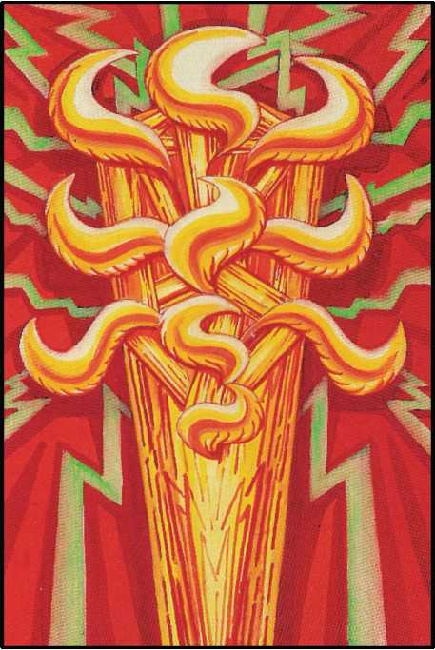

THE ROOT OF THE POWERS OF FIRE ACE OF WANDS

This card represents the essence of the element of Fire in its inception. It is a solar- phallic outburst of flame from which spring lightnings in every direction.

These flames are Yods, arranged in the form of the Tree of Life. (For Yod, see Atu IX su-

pra0

It is the primordial Energy of the Divine manifesting in Matter, at so early a stage that it is not yet definitely formulated as Will.

Important: although these “small cards” are sympathetic with their Sephirotic origin, they are not identical; nor are they Divine Persons. These (and the Court Cards also) are pri­marily sub-Elements, parts of the “Blind Forces” under the Demiourgos, Tetragrammaton. Their rulers are the Intelligences, in the Yetziratic world, who go to form the Schemham- phorasch. Nor is even this Name, “Lord of the Universe” though it be, truly Divine, as are the Lords of the Atu in the Element of Spirit. Each Atu possesses its own private, personal and particular Universe, with Demiourgos (and all the rest) complete, just as every man and every woman does.

For example II’s or VI’s Three of Disks might represent the establishment of such an oracle as that of Delphi, or VIII’s might be the first formula of a Code such as Manu gave to

Hindustan; V’s, a cathedral, XVI’s, a standing army; and so on. The great point is that all the Elemental Forces, however sublime, powerful, or intelligent, are Blind Forces and no more.

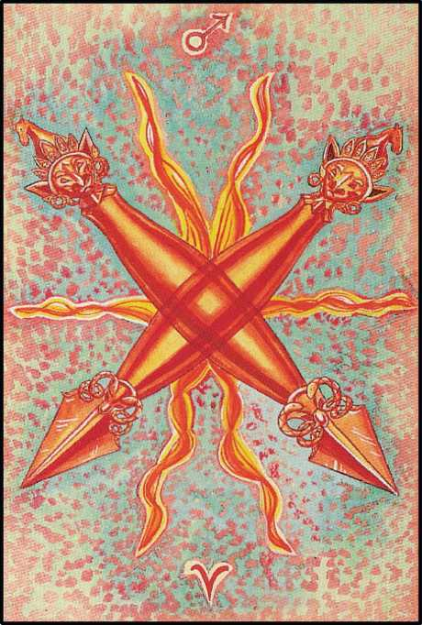

DOMINION

TWO OF WANDS

This card, pertaining to Chokmah in the suit of Fire, represents the Will in its most ex­alted form. It is an ideal Will, independent of any given object.

“For pure will, unassuaged of purpose, delivered from the lust of result, is every way perfect.” AL. 1. 44.

The background of this card shows the power of the planet Mars in his own sign Aries, the first of the Signs. It there represents Energy initiating a Current of Force.

The pictorial representation is two Dorjes crossed. The Dorje is the Tibetan symbol of the thunderbolt, the emblem of celestial Power, but more in its destructive than its creative form.

More, that is, in its earlier rather than its later form. For destruction may be regarded as the first step in the creative process. The virgin ovum must be broken in order to fertilize it. Fear and repulsion are therefore the primary reaction to the assault. Then, with understand­ing of the complete plan, willing surrender rejoices to co-operate.

Six flames issue from the centre. This indicates the influence of the Sun, who is exalted in Ar­ies. This is the creative Will.

Mars in Aries is the attribution of the Geomantic Figure Puer. p

The meaning of these figures is to be studied in the Handbook of that science: “The Equinox” Vol. I, No.2. Remember that the Geomantic Intelligences (see Liber 777 Cols. XLIX and CLXXVIII) are all primarily Gnomes.

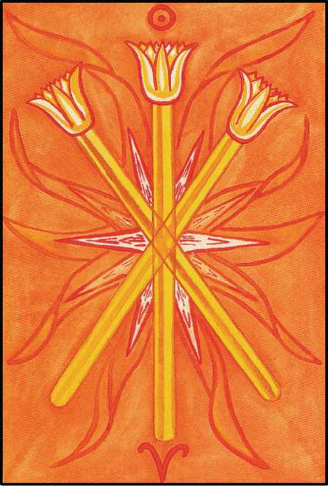

VIRTUE THREE OF WANDS

This card refers to Binah in the suit of Fire, and so represents the establishment of primeval Energy. The Will has been trans mitted to the Mother, who conceives, prepares, and gives birth to, its manifestation.

It refers to the Sun in Aries, the Sign in which he is exalted.

The meaning is harmonious, for this is the beginning of Spring. For this reason one sees the wand taking the form of the Lotus in blossom. The Sun has enkindled the Great Mother.

In the Yi King, Sol in Aries is represented by the 11th hexagram, Thai; its meaning is identical with the above description.

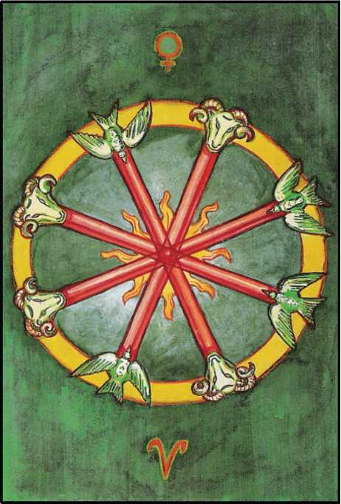

COMPLETION FOUR OF WANDS

This card refers to Chesed in the suit of Fire. Being below the Abyss, it is the Lord of all manifested active Power. The original Will of the Two has been transmitted through the Three, and is now built up into a solid system:—Order, Law, Government. It is also referred to Venus in Aries, which indicates that one cannot establish one’s work without tact and gentle­ness.

The wands are headed by the Ram, sacred to Chesed, the Father-god Amoun-Ra, as also to Aries; but at the other end of the wands are the Doves of Venus.

In the symbol, the ends of the wands touch a circle, showing the completion and limita­tion of the original work. It is within this circle that the flames (four double, as if to assert the balance) of the Energy are seen to play, and there is no intention to increase the scope of the original Will. But this limitation bears in itself the seeds of disorder.

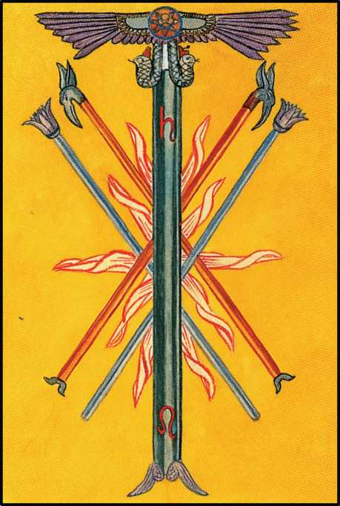

STRIFE

FIVE OF WANDS

This card is referred to Geburah of the suit of Fire. Geburah itself being fiery, it is a purely ac­tive force. It is ruled also by Saturn and Leo. Leo shows the element of Fire at its strongest and most balanced. Saturn tends to weigh it down and to embitter it. There is no limit to the scope of this volcanic energy.

The symbol represents the wand of the Chief Adept, showing that the authority is de­rived from the superiors; were it not so, this card would be thoroughly disastrous. Moreover, there are also two wands of the Second, or Major Adept. They have the head of the Phoenix, which gives the idea of destruction (or rather purgation) through fire, and the resurrection of the energy from its ashes.

There is also a pair of wands of the Third, or Minor, Adept, which are daughters, so to speak, of the wands in the Three of Wands. In this card there is the mitigating influence of the Mother. One of the most difficult doctrines with regard to Geburah is that, while it represents all this tameless irrational energy and disturbance, yet it derives from the benign and gentle influence of the feminine.

The Egyptians understood this doctrine perfectly Their Lion goddess, Pasht, was hailed as “saeva” and “ferox”, was even called “red in tooth and claw” by those fanatical devo­tees who wished to identify her with Nature. The idea of sexual cruelty is often inherent in the highest divine nature; compare Bhavani and Kali in the Hindu system, and observe the Shiva- Sakti coition portrayed on many Tibetan banners. See also Liber 418, 4th, 3rd, and 2nd Aethyrs; and the description supra of Atu XI.

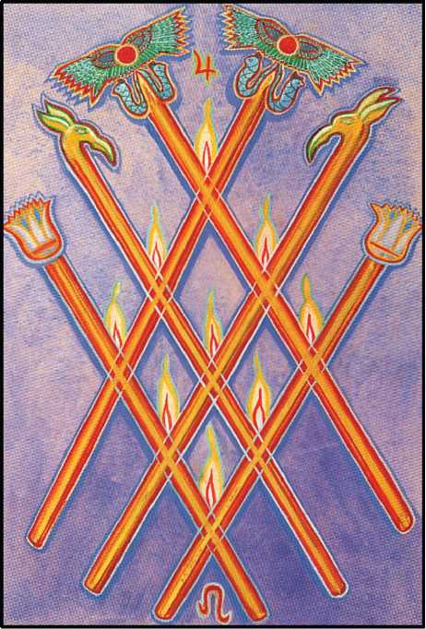

VICTORY SIX OF WANDS

This card represents Tiphareth of the suit of Fire. This shows Energy in completely balanced manifestation. The Five has broken up the closed forces of the Four with revolution­ary ardour, but a marriage has taken place between them; and the result is the Son, and the Sun.

The reference is also to Jupiter and Leo, which seems to imply a benediction on the harmony and beauty of this arrangement. It Will be seen that the Three Wands of the Three Adepts are now orderly arranged; and the flames themselves, instead of shooting out in all directions, burn steadily as in lamps. They are nine in number, in reference to Yesod and the Moon. This shows the stabilization of the Energy, and its reception and reflection by the Femi­nine.

There is no circle to enclose the system. It is self-supporting, like the Sun.

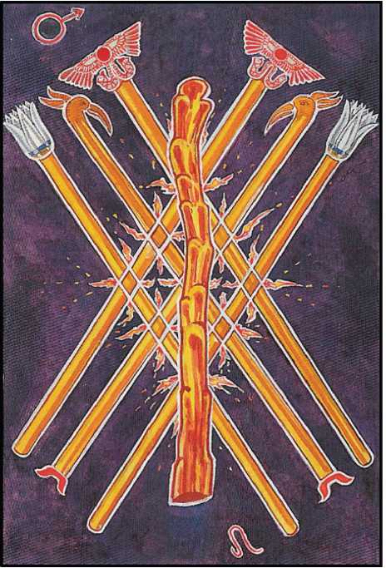

VALOUR

SEVEN OF WANDS

This card derives from Netzach (Victory) in the suit of Fire. But the Seven is a weak, earthy, feminine number as regards the Tree of Life, and represents a departure from the bal­ance so low down on the Tree that this implies a loss of confidence.

Fortunately, the card is also attributed to Mars in Leo. Leo is still the Sun in his full strength, but the marks of decadence are already to be seen. It is as if the wavering fire sum­moned the brutal energy of Mars to its support. But this is not enough to counter- act fully the degeneration of the initial energy, and the departure from equilibrium.

The army has been thrown into disorder; if victory is to be won, it will be by dint of in­dividual valour-a “soldiers’ battle”.

The pictorial representation shows the fixed and balanced wands of the last card rele­gated to the background, diminished, and become commonplace.

In front is a large crude uneven club, the first weapon to hand; evidently unsatisfactory in ordered combat.

The flames are dispersed, and seem to attack in all directions without systematic pur­pose.

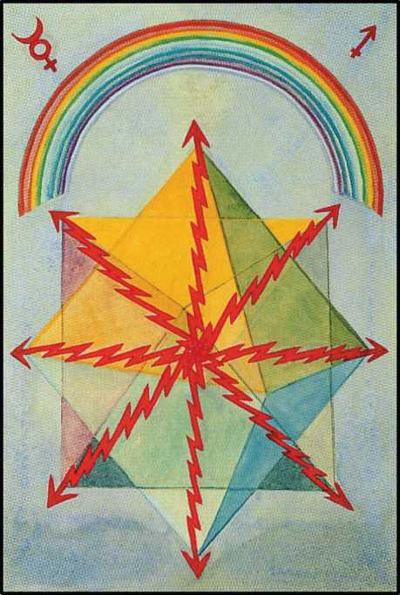

SWIFTNESS EIGHT OF WANDS

The remaining three cards of the suit belong to Sagittarius, which represents the sub­tilizing of the Fiery energy; and Mercury rules the card, thus bringing down from Chokmah the message of the original Will.

The card also refers to Hod, splendour, in the suit of Fire, whence it refers to the phe­nomena of speech, light, electricity.

The pictorial representation of the card shows the Light-wands turned into electrical rays, sustaining or even constituting Matter by their vibrating energy. Above this restored uni­verse shines the rainbow; the division of pure light, which deals with maxima, into the seven colours of the spectrum, which exhibit interplay and correlation.

This card, therefore, represents energy of high velocity, such as furnishes the master- key to modern mathematical physics.

It will be noted that there are no flames; they have all been taken up into the wands to turn them into rays. On the other hand, the electric energy has created intelligible geometrical form.

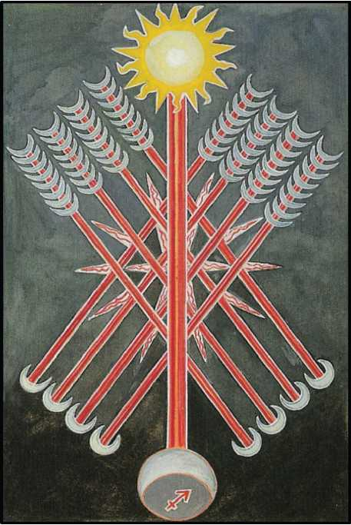

STRENGTH

NINE OF WANDS

This card is referred to Yesod, the Foundation; this brings the Energy back into bal­ance. The Nine represents always the fullest development of the Force in its relation with the Forces above it. The Nine may be considered as the best that can be obtained from the type involved, regarded from a practical and material standpoint.

This card is also governed by the Moon in Sagittarius; so here is a double influence of the Moon on the Tree of Life. Hence the aphorism “Change is Stability”.

The Wands have now become arrows. There are eight of them in the background, and in front of them one master arrow. This has the Moon for its point, and the Sun for the driving Force above it; for the path of Sagittarius on the Tree of Life joins the Sun and Moon. The flames in the card are tenfold, implying that the Energy is directed downwards.

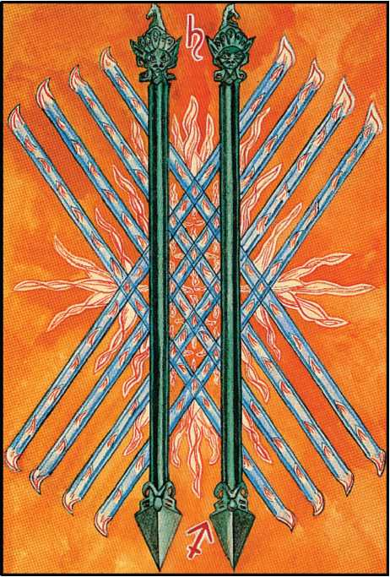

OPPRESSION

TEN OF WANDS

The number Ten refers to Malkuth, which depends from the other nine Sephiroth, but is not directly in communication with them. It shows the Force detached from its spiritual sources. It is become a blind Force; so, the most violent form of that particular energy, without any modifying influences. The flames in the back ground of the card have run wild. It is Fire in its most destructive aspect.

The card also refers to the influence of Saturn in Sagittarius. Here is the greatest an­tipathy. Sagittarius is spiritual, swift, light, elusive, and luminous; Saturn is material, slow, heavy, obstinate, and obscure.

The eight Wands are still crossed, showing the enormous power of the completed en­ergies of Fire; but they have lost their patents of nobility. Their ends seem more like claws; they lack the authority and intelligence shown in the earlier cards; and in front are the two formidable Dorjes of the Two of Wands, but lengthened to bars.

The whole picture suggests Oppression and repression. It is a stupid and obstinate cruelty from which there is no escape. It is a Will which has not understood anything beyond its dull purpose, its “lust of result”, and will devour itself in the conflagrations it has evoked.

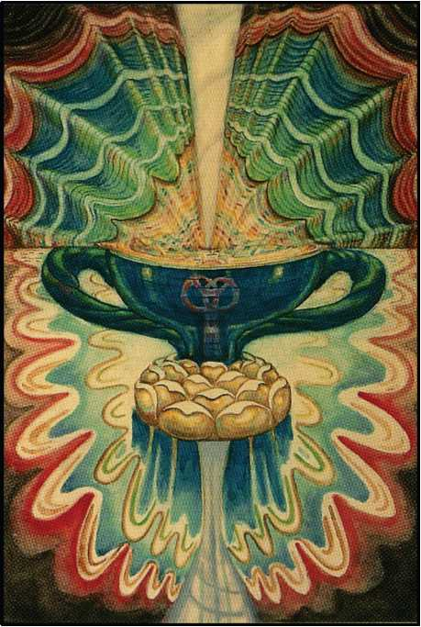

THE ROOT OF THE POWERS OF WATER ACE OF CUPS

This card represents the element of Water in its most secret and original form. It is the feminine complement of the Ace of Wands, and is derived from the Yoni and the Moon exactly as that is from the Lingam and the Sun. The third in the Hierarchy. This accordingly represents the essential form of the Holy Grail. Upon the dark sea of Binah, the Great Mother, are Lotuses, two in one, which fill the cup with the Life-fluid, symbolically represented either as Water, as Blood, or as Wine, according to the selected purpose of the symbolism. This being a primor­dial card, the liquid is shown as water; it can be transformed into Wine or Blood as may be required.

Above the Cup, descending upon it, is the Dove of the Holy Ghost, thus consecrating the element.

At the base of the Cup is the Moon, for it is the virtue of this card to conceive and to produce the second form of its Nature.

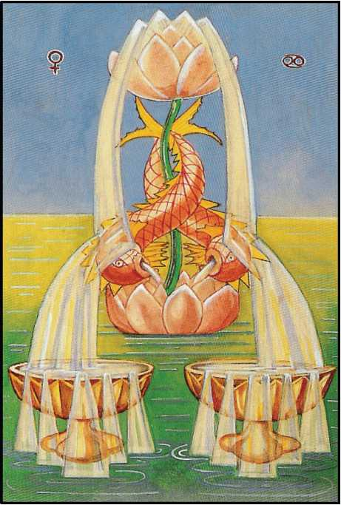

LOVE TWO OF CUPS

The Two always represents the Word and the Will. It is the first manifestation. There­fore, in the suit of Water, it must refer to Love, which recovers unity from dividuality by mu­tual annihilation.

The card also refers to Venus in Cancer. Cancer is, more than any other, the receptive Sign; it is the House of the Moon, and in that Sign Jupiter is exalted. These are, superficially, the three most friendly of the planets.

The hieroglyph of the card represents two cups in the foreground, overflowing upon a calm sea. They are fed with lucent water from a lotus floating upon the sea, from which rises another lotus around whose stem are entwined twin dolphins. The symbolism of the dolphin is very complicated, and must be studied in books of reference; but the general idea is that of the “Royal Art”. The dolphin is peculiarly sacred to Alchemy.

The number Two referring to Will, this card might really be renamed the Lord of Love under Will, for that is its full and true meaning. It shows the harmony of the male and the fe­male: interpreted in the largest sense. It is perfect and placid harmony, radiating an intensity of joy and ecstasy.

Of necessity, the realization of the idea in the Four (as the suit develops) will gradually diminish the purity of its perfection.

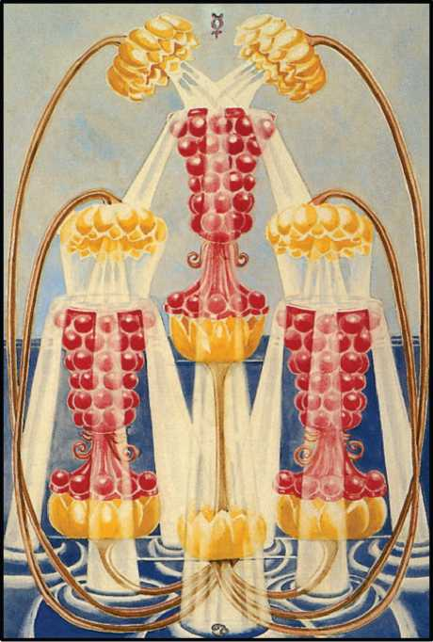

ABUNDANCE THREE OF CUPS

This card refers to Binah in the suit of Water. This is the card of Demeter or Perseph­one. The Cups are pomegranates: they are filled bountifully to overflowing from a single lotus, arising from the dark calm sea characteristic of Binah. There is here the fulifilment of the Will of Love in abounding joy. It is the spiritual basis of fertility.

The card is referred to the influence of Mercury in Cancer; this carries further the above thesis. Mercury is the Will or Word of the All-Father; here its influence descends upon the most receptive of the Signs.

At the same time, the combination of these forms of energy brings in the possibility of somewhat mysterious ideas. Binah, the Great Sea, is the Moon in one aspect, but Saturn in an­other; and Mercury, besides being the Word or Will of the All-One, is the guide of the souls of the Dead. This card requires great subtlety of interpretation. The pomegranate was the fruit which Persephone ate in the realms of Pluto, thereby enabling him to hold her in the lower world, even after the most powerful influence had been brought to bear. The lesson seems to be that the good things of life, although enjoyed, should be distrusted.

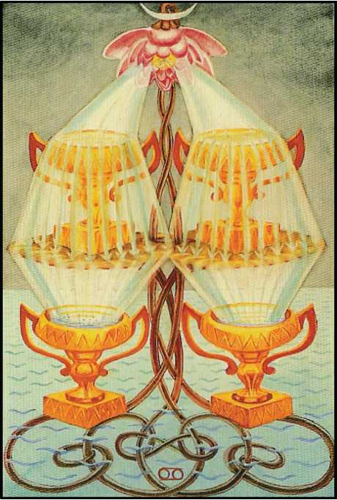

LUXURY FOUR OF CUPS

This card refers to Chesed in the sphere of Water. Here, below the Abyss, the energy of this element, although ordered, balanced and (for the moment) stabilized, has lost the original purity of the conception.

The card refers to the Moon in Cancer, which is her own house; but Cancer itself is so placed that this implies a certain weakness, an abandonment to desire. This tends to intro­duce the seeds of decay into the fruit of pleasure.

The sea is still shown, but its surface is ruffled, and the four Cups which stand upon it are no longer so stable. The Lotus from which the water Springs has a multiple stem, as if to show that the influence of the Dyad has gathered strength. For although the number Four is the manifestation and consolidation of the dyad, it is also secretly preparing catastrophe by emphasizing individuality.

There is a certain parallelism between this card and the Geomantic figures Via and Populus, which are attributed to the Moon in her decrease and increase respectively. The link is primarily the “Change=Stability” equation, already familiar to readers of this essay. Four is an “awkward” number; alone among the natural numbers, it is impossible to construct a “Magic Square” of four cells. Even in the Naples Arrangement, Four is a dead stop, a blind alley.

An idea of a totally different Order is necessary to carry on the series. Note also the refold- ing4n-upon-itself suggested by the “Magic Number” of Four 1+2 + 3+4 which is Ten. i;:. Four is the number of the Curse of Limitation, of Restriction. It is the blind and barren Cross of equal arms, Tetragrammaton in his fatal aspect of finality, as the Qabalists knew him before the dis­covery of the Revolving Formula whereby the Daughter, seated upon the Throne of the Mother, “awakens the Eld of the All-Father”.

For the meanings of Via and Populus, refer to the “Handbook of Geomancy” (Equinox Vol. I, No.2).

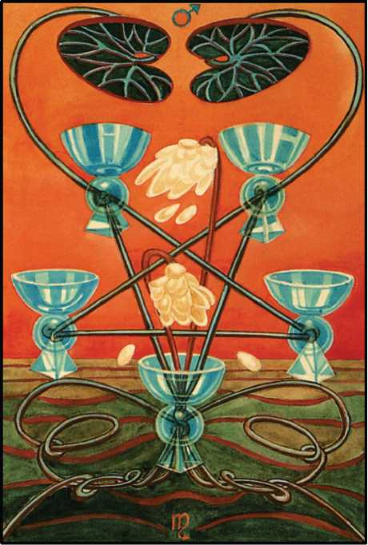

DISAPPOINTMENT FIVE OF CUPS

This card is ruled by Geburah in the suit of Water. Geburah being fiery, there is a natu­ral antipathy. Hence arises the idea of disturbance, just when least expected, in a time of ease.

The attribution is also to Mars in Scorpio, which is his own house; and Mars is the manifestation on the lowest plane of Geburah, while Scorpio, in its worst aspect, suggests the putrefying power of Water. Yet the powerful male influences do not show actual decay, only the beginning of destruction; hence, the anticipated pleasure is frustrated. The Lotuses have their petals torn by fiery winds; the sea is arid and stagnant, a dead sea, like a “chott” in North Africa. No water flows into the cups.

Moreover, these cups are arranged in the form of an inverted pentagram, symbolizing the triumph of matter over spirit.

• •

Mars in Scorpio, moreover, is the attribution of the Geomantic figure Rubeus I.

This is of such evil omen that certain schools of Geomancy destroy the Map, and postpone the question for two hours or more, when Rubeus appears in the Ascendant. Its meaning is to be studied in the “Handbook of Geomancy” (Equinox Vol. I, No.2).

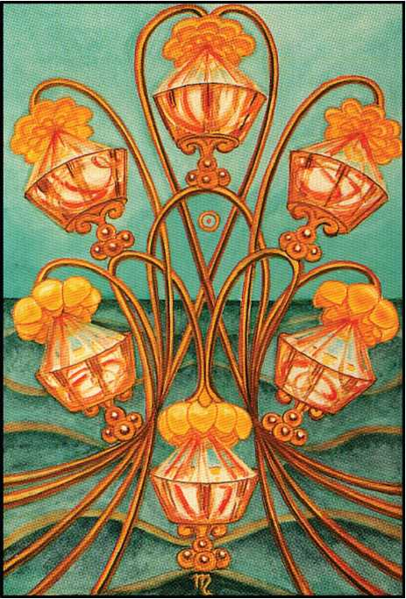

PLEASURE SIX OF CUPS

This card shows the influence of the number Six, Tiphareth, in the suit of Water. This influence is fortified by that of the Sun, who also represents the Six. The whole image is that of the influence of the Sun on Water. His fierce, but balanced power operates that type of putre- faction-he is in the Sign of Scorpio-which is the basis of all fertility, all life.

The lotus stems are grouped in an elaborate dancing movement. From their blossoms water gushes into the Cups, but they are not yet full to overflowing, as they are in the corre­sponding card below; the Nine.

Pleasure, in the title of this card, must be understood in its highest sense: it implies well-being, harmony of natural forces without effort or strain, ease, satisfaction. Foreign to the idea of the card is the gratification of natural or artificial desires. Yet it does represent em­phatically the fulfilment of the sexual Will, as shown by the ruling Sephira, planet, element, and sign.

In the Yi King, Sol in Scorpio is represented by the 20th Hexagram, Kwan, which is also “Big Earth”, being the Earth Trigram with doubled lines. Kwan means “manifesting”, but also “contemplating”. The Thwan refers directly to an High Priest, ceremonially purified, about to present his offerings. The idea of Pleasure—Putrefaction as a Sacrament is therefore implicit in this Hexagram as in this card; while the comments on the separate lines by the Duke of Chau indicate the analytical value of this Eucharist. It is one of the master-keys to the Gate of Initiation. To realize and to enjoy this fully it is necessary to know, to understand, and to ex­perience, the Secret of the Ninth Degree of the O.T.O.

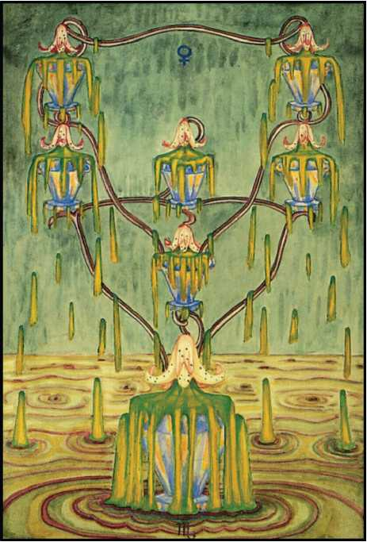

DEBAUCH

SEVEN OF CUPS

This card refers to the Seven, Netzach, in the suit of Water. Here recurs the invariable weakness arising from lack of balance; also, the card is governed by Venus in Scorpio. Her dignity is not good in this Sign; one is reminded that Venus is the planet of Copper, “external splendour and internal corruption”. The Lotuses have become poisonous, looking like tiger- lilies; and, instead of water, green slime issues from them and overflows, making the Sea a ma­larious morass. Venus redoubles the influence of the number Seven.

The cups are iridescent, carrying out the same idea.

They are arranged as two descending triangles interlaced above the lowest cup, which is very much larger than the rest.

This card is almost the “evil and averse” image of the Six; it is a wholesome reminder of the fatal ease with which a Sacrament may be profaned and prostituted.

Lose direct touch with Kether, the Highest; diverge never so little from the delicate bal­ance of the Middle Pillar; at once the holiest mysteries of Nature become the obscene and shameful secrets of a guilty conscience.

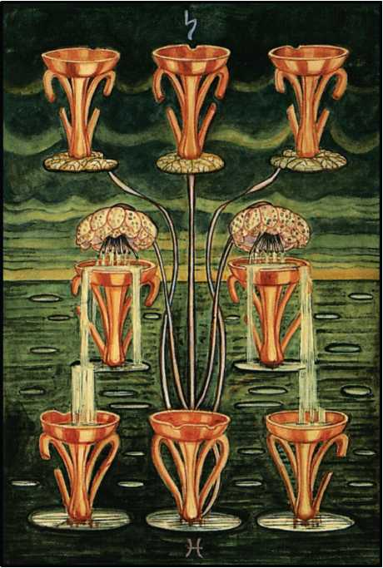

INDOLENCE EIGHT OF CUPS

The Eight, Hod, in the suit of Water, governs this card. It shows the influence of Mer­cury, but this is overpowered by the reference of the card to Saturn in Pisces. Pisces is calm but stagnant water; and Saturn deadens it completely. Water appears no longer as the Sea but as pools; and there is no florescence in this card as there was in the last. The Lotuses droop for lack of sun and rain, and the soil is poison to them; only two of the stems show blossoms at all. The cups are shallow, old and broken. They are arranged in three rows; of these the upper row of three is quite empty. Water trickles from the two flowers into the two central cups, and they drip into the two lowest without filling them. The background of the card shows pools, or lagoons, in very extensive country, incapable of cultivation; only disease and miasmatic poison can flourish in those vast Bad Lands.

The water is dark and muddy. On the horizon is a pallid, yellowish light, weighed down by leaden clouds of indigo.

Compare with the last card; it represents the opposite and complementary error. The one is the Garden of Kundry, the other the Palace of Klingsor.

In the psychopathology of The Path, this card is the German Measles of Christian Mys­ticism.

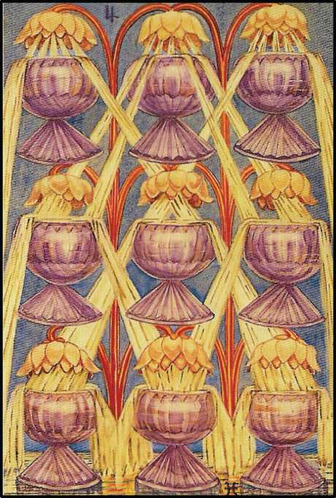

HAPPINESS NINE OF CUPS

The Number Nine, Yesod, in the suit of Water, restores the stability lost by the excur­sions of Netzach and Hod from the Middle Pillar. It is also the number of the Moon, thus strengthening the idea of Water.

In this card is the pageant of the culmination and perfection of the original force of Wa­ter.

The Ruler is Jupiter in Pisces. This influence is more than sym pathetic; it is a definite benediction, for Jupiter is the planet of Chesed which represents Water in its highest material manifestation, and Pisces brings out the placid qualities of Water.

In the symbol are nine cups perfectly arranged in a square; all are filled and overflow­ing with Water. It is the most complete and most beneficient aspect of the force of Water.

The Geomantic Figure Laetitia У is ruled by Jupiter in Pisces. For its meaning con­sult the “Handbook of Geomancy” (Equinox Vol I, No.2). Laetitia, Joy, gladness, is one of the best and most powerful of the sixteen figures; for the Solar, Lunar, and Mercurial symbols are, at the best, ambiguous and treacherously ambivalent; those of Venus portend rather relief than positive beneficence; Saturn and Mars are seen at their worst; and even the stable-companion of Laetitia, Acquisitio, has its unpleasant aspects, and even its dangers.

But the consonance of Laetitia with this card amounts to little less than an identity; the wine is poured by Ganymede himself, unstinted vintage of true nectar of the Gods, brimful and running over, an ordered banquet of delight, True Wisdom self-fulfilled in Perfect Happiness.

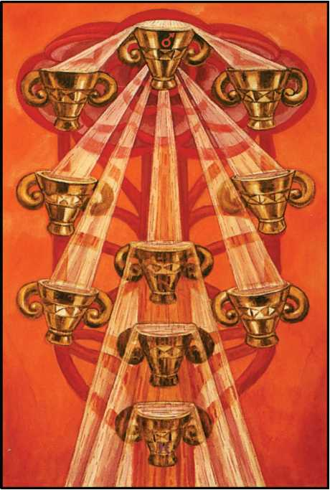

SATIETY TEN OF CUPS

This card represents a conflicting element. On the one hand, it receives the influence of the Ten, Malkah the Virgin. The arrangement of the cups is that of the Tree of Life. But, on the other hand, they are themselves unstable. They are tilted; they spill the water from the great Lotus which overhangs the whole system from one into the other.

The work proper to water is complete: and disturbance is due.

This comes from the influence of Mars in Pisces. Mars is the gross, violent and disrup­tive force which inevitably attacks every supposed perfection. His energy displays the greatest possible contrast with that of Pisces, which is both peaceful and spiritualized.

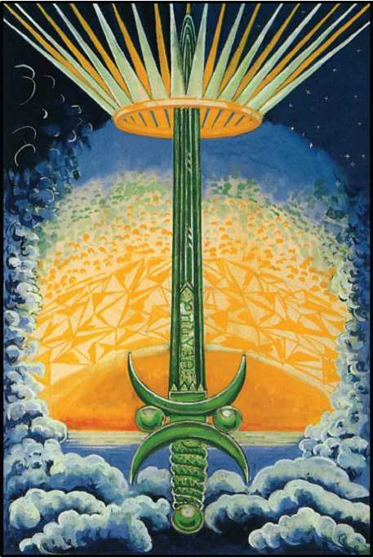

THE ROOT OF THE POWERS OF AIR ACE OF SWORDS

The Ace of Swords is the primordial Energy of Air, the Essence of the Vau of Tetra­grammaton, the integration of the Ruach. Air is the result of the conjunction of Fire and Water; thus it lacks the purity of its superiors in the male hierarchy, Fire, Sol and the Phallus. But for this same reason it is the first card directly to be apprehended by the normal consciousness of Mankind. The errors of such cards as the 7 and 10 of Cups are yet of an Order altogether higher than the apparently much milder 4 of Swords. The study of the subtle and gradual deg­radation of the planes is excessively difficult.

In nature, the obvious symbol of Air is the Wind “which bloweth whithersoever it listeth”. It lacks the concentrated Will of Fire to unite with Water: it has no corresponding pas­sion for its Twin Element, Earth. There is indeed, a notable passivity in its nature; evidently, it has no self-generated impulse. But, set in motion by its Father and Mother, its power is mani­festly terrific. It visibly attacks its objective, as they, being of subtler and more tenuous charac­ter, can never do. Its “all-embracing, all-wandering, all-penetrating, all-consuming” qualities have been described by many admirable writers, and its analogies are for the most part patent to quite ordinary observers.

But, it will instantly be asked, what of the status of this Element in the light of other attributions? In the Yetziratic World, is not Air the first element to follow Spirit? Is not Vayu the first emergence of the phenomenal from the arcane obscurity of Akasha? How may one reconcile the doctrine of Mind with the fact that Ruh, or Ruach, actually means Spirit itself? “Achath Ruach Elohim Chum” (777) means “One is the Spirit (not Air) of the Gods of the Liv­ing”? And is not Air, the element attributed to Mercury, also most properly the Breath of Life, the Word, the Logos itself?

The student must be referred to some less raw, cursory, elementary and superficial Treatise than this present bat-eyed, penguin-winged, bluebottle-brained buzzing. Neverthe­less, although Air is in no system the lowest, and so cannot claim benefit of clergy from the doctrine that Malkuth automatically resolves into Kether, the following reference seems not wholly to lack either cogency or pertinence.

The Ruach is centred in the airy Sephira, Tiphareth, who is the Son, the first-born of the Father, and the Sun, the first emanation of the creative Phallus. He derives directly from his mother Binah through the Path of Zain, the sublime intuitive sense, so that he partakes ab­solutely of the nature of Neschamah. From his father, Chokmah, he is informed though the Path of He, the Great Mother, the Star, our Lady Nuit,1 so that the creative impulse is commu­nicated to him by all possibilities soever. Finally, from Kether, the supreme, descends directly upon him, though the Path of Gimel, the High Priestess, the triune light of Initiation. The Three- in-One, the Secret Mother in her polymorphous plenitude; these, these alone, hail him thrice blessed of the Supernals!

The card represents the Sword of the Magus (see Book 4, Part II) crowned with the twenty-two rayed diadem of pure Light. The number refers to the Atu; also 22=2x11, the Magical manifestation of Chokmah, Wisdom, the Logos. Upon the blade, accordingly, is in­scribed the Word of the Law, ваЛ^ца. This Word sends forth a blaze of Light, dispersing the dark clouds of the Mind.

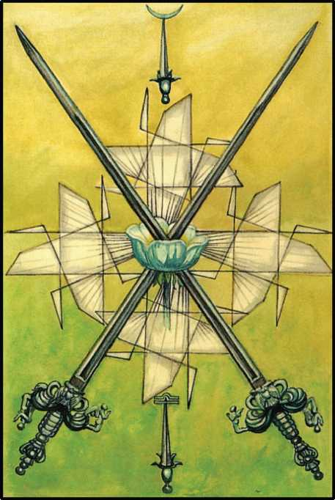

PEACE TWO OF SWORDS

This card is ruled by Chokmah in the Element of Air. This suit, governing all intellectual manifestations, is always complicated

*How strikingly this fact confirms the counterchange of IV and XVII, above fully expounded: as a link between Chokmah and Tiphareth, the Emperor would have no great significance, and this exquisite doctrine of the Three Mothers would be lost.

and disordered. It is subject to change as is no other suit. It represents a general shak- ing-up, resulting from the conflict of Fire and Water in their marriage; and proceeds, when Earth appears, to crystallization. But the purity and exaltation of Chokmah are such that this card manifests the very best idea possible to the suit. The energy abides above the onslaught of disruption. This comparative calm is emphasized by the celestial attribution: the Moon in Libra.

The Moon is change, but Nature is peaceful; moreover, Libra represents balance; be­tween them, they regulate the energy of the Swords.

In the card appear two swords crossed; they are united by a blue rose with five petals. This rose represents the influence of the Mother, whose harmonizing influence compounds

the latent antagonism native to the suit. The Rose emits white rays, producing a geometrical pattern that emphasizes the equilibrium of the symbol.

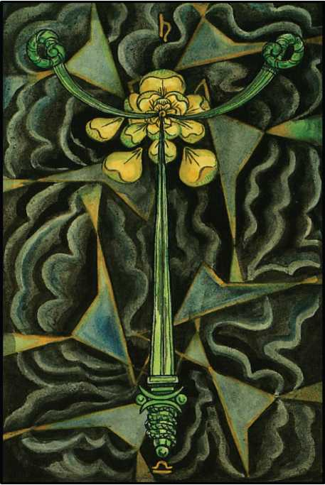

SORROW THREE OF SWORDS

Binah, the Great Mother, here rules the realm of Air. This fact involves an extremely dif­ficult doctrine which must be studied at length in The Vision and the Voice: Aethyr 14.

Binah is here not the beneficent Mother completing the Trinity with Kether and Chok- mah. She represents the darkness of the Great Sea.

This is accentuated by the Celestial Lordship of Saturn in Libra.

This card is dark and heavy; it is, so to speak, the womb of Chaos. There is an intense lurking passion to create, but its children are monsters. This may mean the supreme tran­scendence of the natural order. Secrecy is here, and Perversion.

The symbol represents the great Sword of the Magician, point uppermost; it cuts the junction of two short curved swords. The impact has destroyed the rose. In the background, storm broods under implacable night.

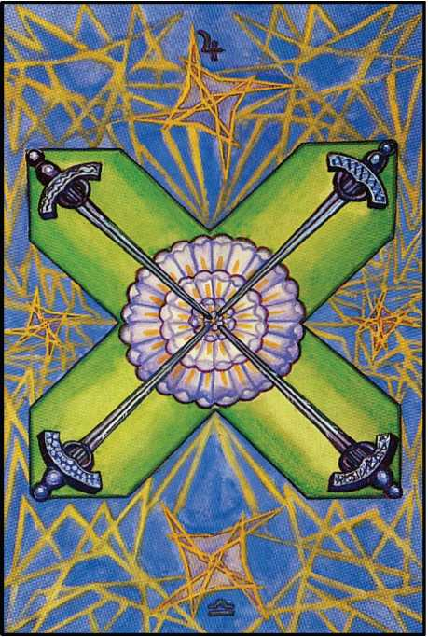

TRUCE FOUR OF SWORDS

The number Four, Chesed, is here manifested in the realm of the Intellect. Chesed re­fers to Jupiter who rules in Libra in this decanate. The sum of these symbols is therefore with­out opposition; hence the card proclaims the idea of authority in the intellectual world. It is the establishment of dogma, and law concerning it. It represents a refuge from mental chaos, chosen in an arbitrary manner. It argues for convention.

The hilts of the four Swords are at the corner of a St. Andrew’s cross. Their shape sug­gests fixation and rigidity. Their points are sheathed—in a rather large rose of forty-nine pet­als representing social harmony. Here, too, is compromise.

Minds too indolent or too cowardly to think out their own problems hail joyfully this policy of appeasement. As always, the Four is the term; as in this case there is no true justifi­cation for repose, its disturbance by the Five holds no promise of advance; its static shams go pell-mell into the melting-pot; the issue is mere mess, usually signalized by foetid stench. But it has to be done!

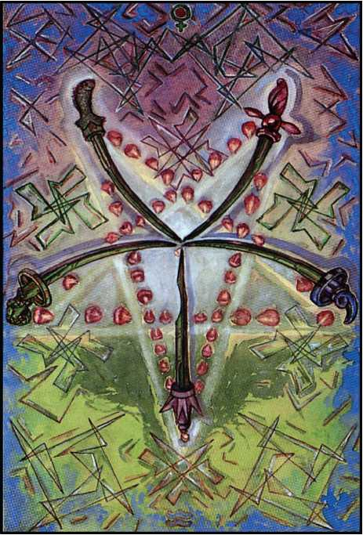

DEFEAT FIVE OF SWORDS

Geburah, as always, produces disruption; but as Venus here rules Aquarius, weakness rather than excess of strength seems the cause of disaster. The intellect has been enfeebled by sentiment. The defeat is due to pacifism. Treachery also may be implied.

The hilts of the swords form the inverted pentagram, always a symbol of somewhat sinister tendency. Here matters are even worse; none of the hilts resembles any of the others, and their blades are crooked or broken. They give the impression of drooping; only the lowest of the swords points upwards, and this is the least effective of the weapons. The rose of the previous card has been altogether disintegrated.

The historian is happy to observe two perfect illustrations of the mode of this card and the last in the birth of the Aeon of (I) Osiris, (2) Horus. He will note the decay of such Virtue as characterized Sparta and Rome, ending in the establishment of the Pax Romana. As Virtue de­clined, corruption disintegrated the Empire from within. Epicene cults, such as those of Dio­nysus (in its degraded form), of Attis, of Adonis, of Cybele, the false Demeter and the prosti­tuted Isis, replaced the sterner rites of the true Solar- Phallic gods; until finally (the masters having lost the respect, and so the control, of the plebs, native and alien) the lowest of all the slave-cults, dressed up in the fables of the vilest of the parasitic races, swept over the known

world, and drenched it in foul darkness for five hundred years. He will delight to draw close parallels with the cognate phenomena displayed before the present generation.

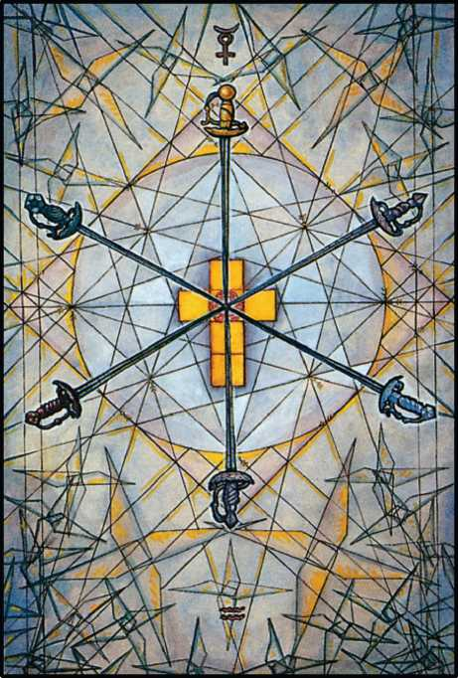

SCIENCE SIX OF SWORDS

Tiphareth shows the full establishment and balance of the idea of the suit. This is par­ticularly the case with this card, as the intellect itself is also referred to the number Six. Mer­cury, in Aquarius, represents the celestial Energy influencing the Kerub of the Man, thus showing intelligence and humanity.

But there is much more than this in the symbol. The perfect balance of all mental and moral faculties, hardly won, and almost impossible to hold in an ever-changing world, de­clares the idea of Science in its fullest interpretation.

The hilts of the Swords, which are very ornamental, are in the form of the hexagram. Their points touch the outer petals of a red rose upon a golden cross of six squares, thus showing the Rosy Cross as the central secret of scientific truth.

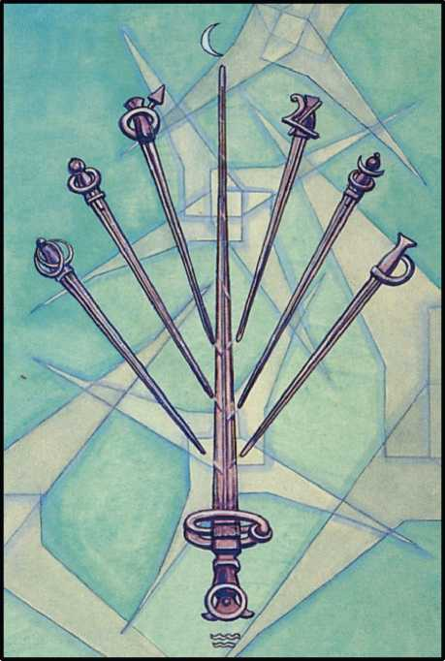

FUTILITY

SEVEN OF SWORDS

Netzach, in the suit of Swords, does not represent such catastrophe as in the other suits, for Netzach, the Sephira of Venus, means victory. There is, therefore, a modifying influ­ence; and this is accentuated by the celestial rule of the Moon in Aquarius.

The intellectual wreckage of the card is thus not so vehement as in the Five. There is vacillation, a wish to compromise, a certain toleration. But, in certain circumstances, the re­sults may be more disastrous than ever. This naturally depends upon the success of the policy. This is always in doubt as long as there exist violent, uncompromising forces which take it as a natural prey.

This card, like the Four, suggests the policy of appeasement.

The symbol shows six Swords with their hilts in crescent formation. Their points meet below the centre of the card, impinging upon a blade of a much larger up-thrusting sword, as if there were a contest between the many feeble and the one strong. He strives in vain.

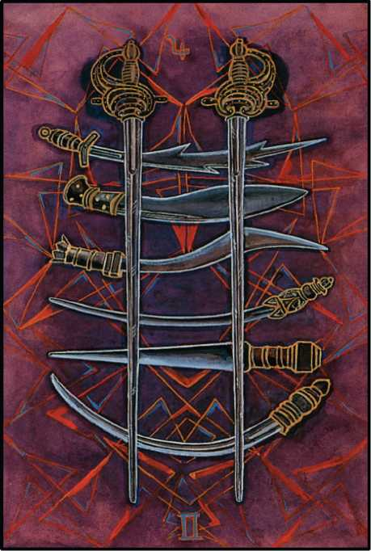

INTERFERENCE EIGHT OF SWORDS

The number Eight, Hod, here signifies lack of persistence in matters of the intellect and of contest. Good fortune, however, attends even these weakened efforts, thanks to the influ­ence of Jupiter in Gemini, ruling the Decan. Yet the Will is constantly thwarted by accidental interference.

The centre of the card is occupied by two long Swords pointed downward. These are crossed by six small swords, three on each side. They remind one of weapons peculiar to their countries or their cults; we see here the Kriss, the Kukri, the Scramasax, the Dagger, the Ma­chete and the Yataghan.

CRUELTY NINE OF SWORDS

**o'**

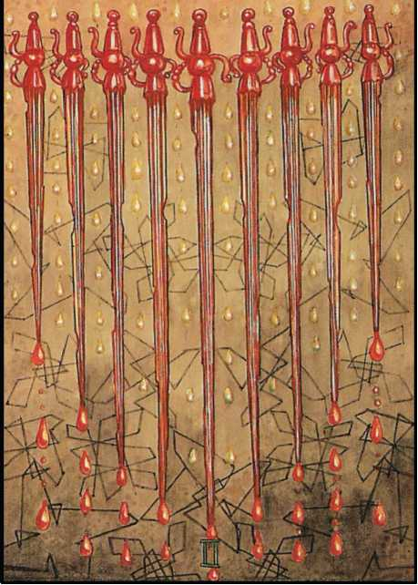

The number Nine, Yesod, brings back the Energy to the central pillar of the Tree of Life. The previous disorder is now rectified.

But the general idea of the suit has been constantly degenerating. The Swords no longer represent pure intellect so much as the automatic stirring of heartless passions. Con­sciousness has fallen into a realm unenlightened by reason. This is the world of the uncon­scious primitive instincts, of the psychopath, of the fanatic.

The celestial ruler is Mars in Gemini, crude rage of hunger operating without restraint; although its form is intellectual, it is the temper of the inquisitor.

The symbol shows nine swords of varying lengths, all striking downwards to a point. They are jagged and rusty. Poison and blood drip from their blades.

There is, however, a way of dealing with this card: the way of passive resistance, resig­nation, the acceptance of martyrdom.

Nor is an alien formula that of implacable revenge.

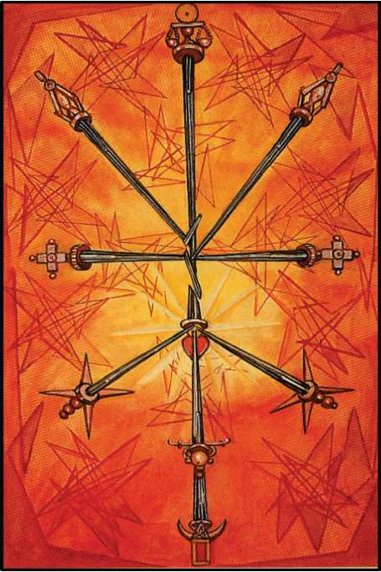

RUIN

TEN OF SWORDS

The number Ten, Malkuth, as always, represents the culmination of the unmitigated energy of the idea. It shows reason run mad, ramshackle riot of soulless mechanism; it repre­sents the logic of lunatics and (for the most part) of philosophers. It is reason divorced from reality.

The card is also ruled by the Sun in Gemini, but the mercurial airy quality of the Sign serves to disperse his rays; this card shows the disruption and disorder of harmonious and stable energy.

The hilts of the Swords occupy the positions of the Sephiroth, but the points One to Five and Seven to Nine touch and shatter the central Sword (six) which represents the Sun, the Heart, the child of Chokmah and Binah. The tenth Sword is also in splinters. It is the ruin of the Intellect, and even of all mental and moral qualities.

In the Yi King, Sol in Gemini is the virtue of the 43rd Hexagram, Kwai, the Watery modi­fication of the Phallus; also, by the interlacing interpretation, the harmony of these two same Trigrams.

The signification is perfectly harmonious with that of the Ten of swords. It represents the damping down of the Creative impulse, weakness, corruption, or mirage affecting that principle itself. But, viewing the Hexagram as a weapon or method of procedure, it counsels the ruler to purge the state of unworthy officers. Curiously, the invention of written characters to replace knotted strings is ascribed among Chinese scholars to the use of this hexagram by the sages. Gemini is ruled by Thoth; 10 is the key of the Naples Arrangement; and Apollo (Sol) is the patron of literature and the arts: so his suggestion might appear at least no less suitable to the Qabalistic correspondences than to their double emphasis on Water and the Sun.

Apart from this, however, the parallelism is complete.

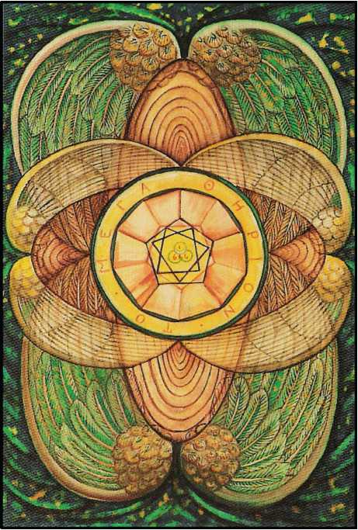

THE ROOT OF THE POWERS OF EARTH ACE OF DISKS

The Ace of Disks pictures the entry of that type of Energy which is called Earth. It is here proper to insist a little strongly upon one of the essential theoretical theses which have inflamed the constitution of this present pack of Tarot cards; for this feature is significant, and distinguishes it from the numerous crude efforts of uninitiates to put themselves forward as adepts. The grotesque barber Alliette, the obscurely perverse Wirth, the poseur-fumiste Pe- ladan, down to the verbose ignorance of such Autolycus-quacks as Raffalovitch and Ouspen- sky; none of these or their kin have done more than “play the sedulous ape” to the conven­tional Mediaeval designs. (Their luck was out: the Tarot is a razor!) Eliphaz Levi was a master- scholar, and knew the true attributions; but his grade in the Great White Brotherhood was only 6°=5° (Adeptus Major); and he had no instructed foresight of the New Aeon. He did in­deed hope to find a Messiah in Napoleon III; but of the complete spiritual upheaval which ac­companies the Proclamation of a new Magical Formula he had no glimpse; no, not though he had Maistre Alcofribas Nasier to guide him!1

Dr. Gerard Encausse, “Papus”, who followed Eliphaz Levi, felt himself even more closely bound by his Oath of Secrecy, so that his dealings with the Tarot are worthless; and that al­though he was Grand Master of the O.T.O. in France, and Grand Hierophant 97° of the Rite of Memphis on the death of John Yarker.

These historical data are necessary to explain why all previous packs are of little more than archaeological interest; for the New Aeon demanded a new system of symbolism. Thus, in particular, the old conception of the Earth as a passive, immobile, even dead, even “evil” element, had to go. It was imperative to restore the King-Scale colour attribution to that of the Aeon of Isis, Emerald Green, as was understood by the Egyptian Hierophants. This green is, however, not the original vegetable green of Isis, but the new green of spring following the resurrection of Osiris as Horus. Nor are the Disks any more to be considered as Coins; the Disk is a whirling emblem. Naturally so; since it is now know that every Star, every true Planet, is a whirling sphere. The Atom, again, is no more the hard, intractable, dead Particle of Dalton, but a system of whirling forces, comparable to the Solar hierarchy itself.

This thesis dovetails perfectly with the new Doctrine of Tetragrammaton, where the Earthy component, He final, the Daughter, is set upon the Throne of the Mother, to awaken the Eld of the All-Father. The NAME itself, accordingly, is no longer a fixed symbol, emblem of ex­tension and limit, but a continuously revolving sphere; in the words of Zoroaster, “rebounding, whirling forth, crying aloud”.

It has been the custom of publishers or designers of packs to set their personal seal upon the Ace of Disks, for grammatical reasons not unconnected with the perhaps arbitrary differentiation

1See The Grands Annales ou croniques Tresveritables des filz. Roy des Dipsodes. **1542.** Book I, Chapter LVIII, where is given not only a remarkable description of the social conditions of the twentieth century e.v., but even, in the last line of the Prophetic Riddle, a clear indication of the Magical Motto of the Adept chosen by the Masters to announce this Formula-this Word, openly given in the name of the Abbey itself. But, as so often is the case, it was too simple and straightforward to be seen!

in the Latin Language between the pronouns “meum” and “tuum”. Saith not the Bard?

“Steal not this Book for fear of shame!

The Ace of Disks-the Author’s name.

The Ace of Swords-thy corpse shall look Like Agag’s did, in Samuel’s book.

The Ace of Cups-drink thou no less Than Brinvilliers the Marchioness!

The Ace of Wands-thy death be reckoned Like that of good King Edward Second!

The central symbol of the Ace of Disks is consequently the personal Hieroglyph of “the chosen priest and apostle of infinite space”, “the prince-priest the Beast”. (Liber AL. 1.15.)

This is to be compared with the Sigillum Sanctum of the Order of A.'. A.’..

In the centre of all is yet another form of Tetragrammaton, the Phallus, showing Sol and Luna, with the number 666 duly inscribed, as if to equilibrate, to fit into the Vesica, with the seven sevens adding to 156 (BABALON 2 + 1 + 2 + 1 + 30 + 70 + 50=(7 + 7) / 7 + 77 + 77=156) as the Magick Square of 6 adds to 666 (.'.i—62=TO МЕГА 0HPION 300 +

70 + 40 + 5 + 3 + 1 + 9 + 8 + 100 + 10 + 70 + 50=lly”in 400 + 200 + 10 + 6 + 50). Should one

choose to interpret the vertical line above 666 as 1, and add it, the number of the Scarlet Woman, 667, appears. (667=H KOKKINH l"YNH=8 + 20 + 70 + 20 + 20 + 10 + 50 + 8 + 3 + 400 + 50+ 8.) This cipher is enclosed in a Heptagram, as manifestly needful; and this fig­ure again in interlaced Pentagons whose sides are extended, so forming a Wheel of 10 spokes whose boundary is a Decagon; and this again within a circular band, upon which is inscribed in full the name TO МЕГА 0HPION, of 12 (6 x 2) letters.

About this whirling Disk are its six Wings; the entire symbol is not only a glyph of Earth as understood in this New Aeon of Horus, but of the number 6, the number of the Sun. This card is thus an affirmation of the identity of Sol and Terra-and that will be best understood by those who have punctually practised Liber Resh for the necessary number of years, preferably in such Hermitages as those of the Sahara Desert, where the Sun and the Earth can soon be instinctively recognized as living Beings, one’s constant companions in a Universe of Pure Joy.

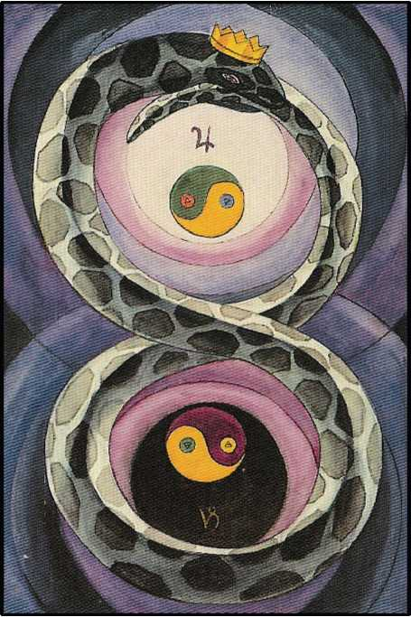

CHANGE TWO OF DISKS

The number Two, Chokmah, here rules in the suit pertaining to Earth. It shows the type of Energy appropriate to Two, in its most fixed form. According to the doctrine that Change is the support of stability, the card is called Change.

Its celestial rulers are Jupiter and Capricornus; and these symbols are most inharmo­nious, so that in practical matters the good fortune of Jupiter is very limited. Their influence on the card is not great. Yet, Jupiter being himself the Wheel (Atu X), he emphasizes that idea.

The card represents two Pantacles, one above the other; they are the Chinese symbols of the Yang and Yin duplicated as in the Hsiang. One wheel is dextro- and the other laevo- rotatory. They thus represent the harmonious interplay of the Four Elements in constant movement. One may in fact consider the card as the picture of the complete manifested Uni­verse, in respect of its dynamics.

About them is entwined a green Serpent (see Liber 65, chapter iii, verses 17-20). His tail is in his mouth. He forms the figure Eight, the symbol of the Infinite, the equation 0=2.

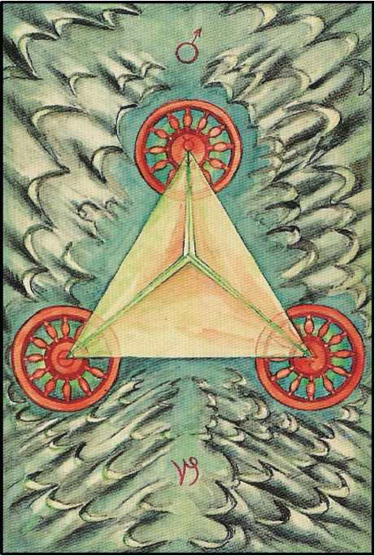

WORK THREE OF DISKS

The influence of Binah in the sphere of Earth shows the material establishment of the idea of the Universe, the determination of its basic form. It is ruled by Mars in Capricornus; he is exalted in that Sign, and therefore at his best. His energy is constructive, like that of the builder or engineer. The card represents a pyramid viewed from above the apex. The base is formed by three wheels-Mercury, Sulphur, and Salt; Sattvas, Rajas, and Tamas in the Hindu system; Aleph, Shin, and Mem-Air, Fire, and Water-the three Mother letters of the Hebrew al­phabet.

This pyramid is situated in the great Sea of Binah in the Night of Time, but the sea is solidified; hence the colours of the back- ground are mottled, a cold thin dark grey with a pat­tern of indigo and green. The sides of the pyramid have a strong reddish tint, showing the in­fluence of Mars.

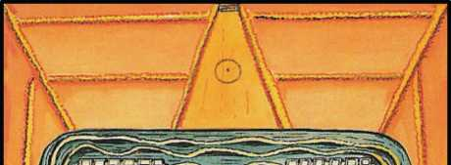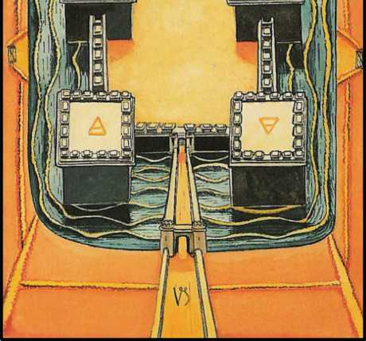

POWER FOUR OF DISKS

The Four, Chesed, shows the establishment of the Universe in three dimensions, that is, below the Abyss. The generating idea is exhibited in its full material sense. The card is ruled by the Sun in Capricornus, the Sign in which he is reborn. The disks are very large and solid; the suggestion of the card is that of a fortress. This represents Law and Order, maintained by constant authority and vigilance. The disks themselves are square; revolution is very opposite to the card; and they contain the signs of the Four Elements. For all that, they revolve; defence is valid only when violently active. So far as it appears stationary, it is the “dead centre” of the engineer; and Capricornus is the point at which the Sun “turns again Northward”. The back­ground is of deep azure, flecked yellow, suggesting a moat; but beyond this is a pattern of green and indigo to represent the guarded fields whose security is assured by the fortress.

In the Yi King, Sol in Capricornus is represented by the Second Hexagram, Khwan, which is the Female Principle. Compare the English word Queen, Anglo-Saxon Cwen, old Mer­cian Kwoen. Cognate are Icelandic Kvan, Gothic Kwens, woman. The Indo- Germanic type

is g (w)eni and the Sanskrit root GwEN. Note also Cwm, coombe, and agnate words, meaning an enclosed valley, usually with water running from it. Womb—possibly a softened form?

Compare also the innumerable words, derived from the root Gas, Which imply an en­closed and fortified space. Case, castle, chest, cyst, chaste, incest and so on.

The primary radicle in all this class of words is the guttural. Observe the Hebrew attri­butions: Gimel, the moon; Cheth, Cancer, the house of the moon; Kaph, the Wheel; Qoph, the Moon, XVIII, Guttur, the throat. Sounds so made suggest the other throat; one is the channel of respiration and nutrition, the other of reproduction and elimination.

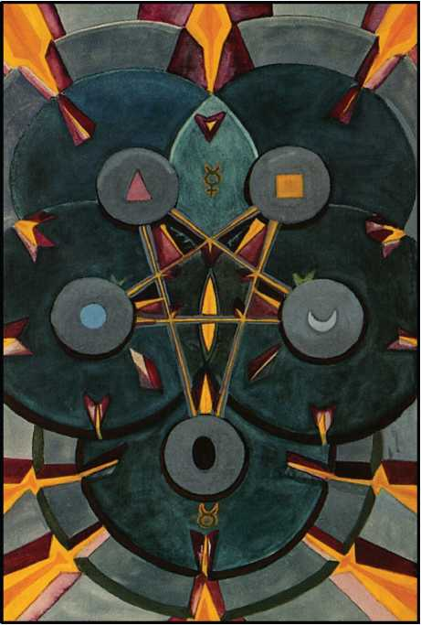

WORRY FIVE OF DISKS

The Number Five, Geburah, in the suit of Earth, shows the disruption of the Elements, just as in the other suits. This is emphasized by the rule of Mercury in Taurus, types of energy which are opposed. It needs a very powerful Mercury to upset Taurus; so the natural meaning is Intelligence applied to Labour.

The symbol represents five disks in the form of the inverted Pentagram, instability in the very foundations of Matter. The effect is that of an earthquake. They are, however, repre­sentative of the five Tatvas; these hold together, on a very low plane, an organism which would otherwise disrupt completely. The background is an angry, ugly red with yellow mark­ings. The general effect is one of intense strain; yet the symbol implies long-continued inac­tion.

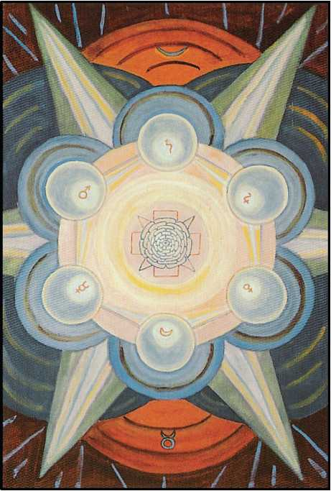

SUCCESS SIX OF DISKS

The Number Six, Tiphareth, as before, represents the full harmonious establishment of the Energy of the Element. The Moon in Taurus rules the card; and this, while increasing the approach to perfection (for the Moon is exalted in Taurus and therefore in her highest form) marks that the condition is transient.

The disks are arranged in the form of the Hexagram, which is shown in skeleton. In the centre blushes and glows the light rose- madder of dawn, and without are three concentric circles, golden yellow, salmon-pink, and amber. These colours show Tiphareth fully realized on Earth; it reaffirms in form what was mathematically set forth in describing the Ace.

The planets are arranged in accordance with their usual attribution; but they are only shown as disks irradiated by the Sun in their centre.

This Sun is idolized as the Rose and Cross; the Rose has forty- nine petals, the interplay of the Seven with the Seven.

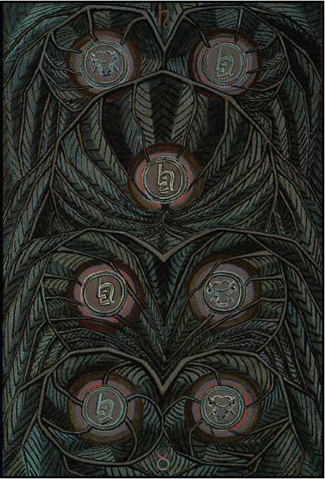

FAILURE SEVEN OF DISKS

The number Seven, Netzach, has its customary enfeebling effect, and this is made worse by the influence of Saturn in Taurus. The disks are arranged in the shape of the geo­mantic figure Rubeus, the most ugly and menacing of the Sixteen. (See Five of Cups.) The at­mosphere of the card is that of Blight. On the background, which represents vegetation and cultivation, everything is spoiled. The four colours of Netzach appear, but they are blotched with angry indigo and reddish orange. The disks themselves are the leaden disks of Saturn. They suggest bad money.

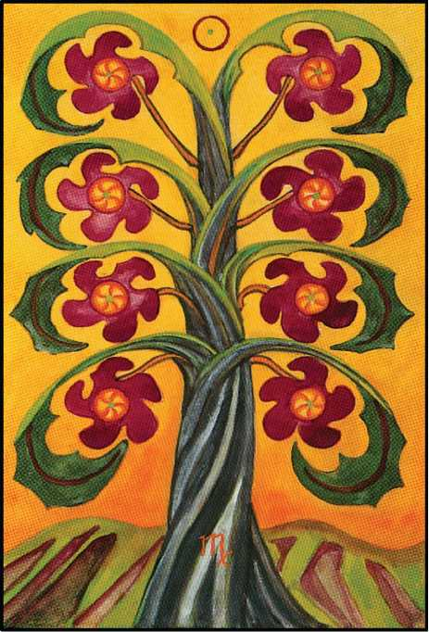

PRUDENCE EIGHT OF DISKS

The number Eight, Hod, is very helpful in this card, because it represents Mercury in his most spiritual aspect, and he both rules and is exalted in the sign of Virgo, which belongs to the Decan, and is governed by the Sun. It signifies intelligence lovingly applied to material matters, especially those of the agriculturalist, the artificer and the engineer.

One might suggest that this card marks the turn of the tide. The seven of Disks is in one sense the fullest possible establishment of Matter—compare Atu XV—the lowest fallen and therefore the highest exalted. These last three cards seem to prepare the explosion which will renew the whole Cycle. Note that Virgo is Yod, the secret seed of Life, and also the Virgin Earth awaiting the Phallic Plough.

The interest of this card is the interest of the common people. The rulership of the Sun in Virgo suggests also birth. The disks are arranged in the form of the geomantic figure Popu- lus. These disks may be represented as the flowers or fruits of a great tree, its solid roots in fertile land.

In the Yi King, Sol in Virgo is represented by the 33rd Hexagram, Thun, “Big Air”. It means “retiring”; and the commentary indicates how best to make use of that manoeuvre. This is congruous enough with the essence of Virgo, the secret withdrawing of Energy into the

fallow Earth. Populus, moreover, is the Moon retiring from manifestation to her conjunction with the Sun.

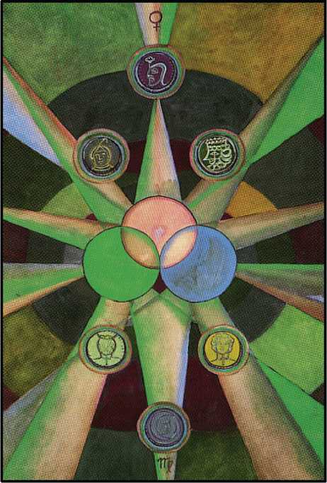

GAIN NINE OF DISKS

The number Nine, Yesod, inevitably brings back the balance of Force in fulfilment. The card is ruled by Venus in Virgo. It shows good luck attending material affairs, favour and popularity.

The disks are arranged as an equilateral triangle of three, apex upwards, close to­gether; and, surrounded at some distance by a ring, six larger disks in the form of a hexagon. This signifies the multiplication of the original established Word-by the mingling of “good luck and good management”. The three central disks are of the magical pattern as in earlier cards; but the others, since the descent into matter implies the gradual exhaustion of the original whirling energy, now take on the form of coins. These may be marked with the magical images of the appropriate planets.

As a general remark, one may say that the multiplication of a symbol of Energy always tends to degrade its essential meaning, as well as to complicate it.

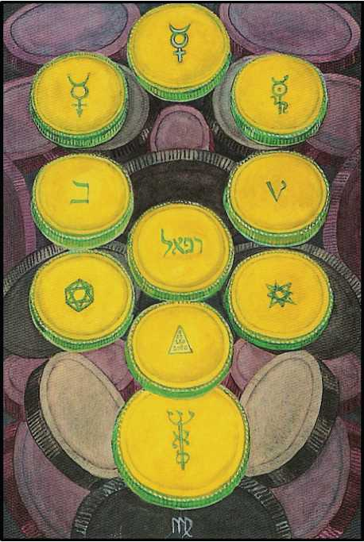

WEALTH TEN OF DISKS

The number Ten, Malkuth, as always, represents the final issue of the Energy. Here is great and final solidification. The force is completely expended and results in death. Mercury rules this card in Virgo; and this may imply that the acquired wealth, being inert, will be dissi­pated unless put to further use by devoting its power to objects other than mere accumula­tion.

The disks, or (as they have now become) coins, are arranged on the Tree of Life, but the Tenth coin is much larger than the rest; the image indicates the futility of material gain.

These disks are inscribed with various symbols of mercurial character, except that the coin in the place of Hod (Mercury) on the Tree is marked with the cipher of the Sun. This indi­cates the only possibility of issue from the impasse produced by the exhaustion of all the ele­mental forces. At the end of matter must be complete stagnation, were it not that in it is al­ways inherent the Will of the Father, the Great Architect, the Great Arithmetician, the Great Geometer. In this case, then, Mercury will represent the Logos, the Word, the Will, the Wis­dom, the Eternal Son, and Virgo the Virgin, in every implication of that symbol. This card is in fact a hieroglyph of the cycle of regeneration.

Among the Geomantic figures, Mercury in Virgo is Conjunctio [?GEOMANTIC PIC HERE]. The meaning, conjunction, is shown plainly by the attraction of the descending (fe­male) Triangle, the cipher of the Yoni, to the ascending (male) Triangle, that of the Lingam. This union completed, they appear interlaced, forming [?] the figure of Capricornus, the Sign in which the Sun finds his rebirth. It is the holy Hexagram, the symbol of the uniting of the Macrocosm and the Microcosm, the accomplishment of the Great Work, the Summum Bonum, True Wisdom and Perfect Happiness. Sic sit vobis!



INVOCATION

(An Oath written during the Dawn-Meditation)

Aiwaz! confirm my troth with Thee! my will inspire With secret sperm of subtle, free, creating Fire!

Mould thou my very flesh as Thine, renew my birth In childhood merry as divine, enchanted Earth!

Dissolve my rapture in Thine own, a sacred slaughter Whereby to capture and atone the Soul of Water!

Fill thou my mind with gleaming Thought intense and rare To One refined, outflung to Naught, the Word of Air!

Most, bridal bound, my quintessential Form thus freeing From self, be found one Selfhood blent in Spirit-Being.

THE ATU: MNEMONICS

a

b

1

d

x

v

z

h

e

Truth, laughter, lust: Wine’s Holy Fool! Veil rent, Lewd madness is sublime enlightenment.

The Word of Wisdom weaves the web of lies, Weds irreducible Infinities.

Mother, moon-maiden, playmate, bride of Pan; God’s Angel-Minister to every man.

Beauty, display thine Empire! Truth above Thought’s reach: the wholeness of the world is Love.

Sire and inceptor, Emperor and King Of all things mortal, hail Him lord of Spring!

Wisdom to each apportioned to his want By modes of Light, shed forth, great Hierophant!

To each his Understanding sooth discovers Wordless: your mode, immortal Twins and Lovers!

Behold, the Chariot! Through the water floods The Sangraal, life and rapture, Wine’s and Blood’s!

k

^ Most secret seed of all Life’s serpent plan, Virgin, the Hermit goes, dumb Guardian.

Sped by its energies triune, the Wheel Of Fortune spins: its Axle’s immobile.

The Lion-Serpent begets Gods! Thy throne The rampant Beast, our Lady Babalon!

Adjustment! Rhythm writhes through every act. Wild is the dance; its balance is exact.

l

m

In Mother-Deeps of Ocean the God-Man Hangs, Lamp of the Abyss Aeonian.

n

0

y

p

h

q

r

w

t

Eagle, and Snake, and Scorpion! The Dance Of Death whirls Life from Trance to Trance to Trance.

Solve, coagula! By V.I.T.R.I.O.L. shewn, The Tincture, the Elixir, and the Stone.

Io nav! upon the summits the God-goat Leaps in wild lust of ecstasy afloat.

Bellona, scream! Unhood the Hawks! The roar Of Universes crashing into War!

Nuit, our Lady of the Stars! Event Is all Thy play, sublime Experiment!

Witch-moon, upon thy beck of blood afloat The Midnight Beetle’s brave prophetic Boat!

The Sun, our Father! Soul of Life and Light, Love and play freely, sacred in Thy sight!

Nuit, Hadit, Ra-Hoor-Khuit! The Aeon Of the Twin Child! Exult, o Empyrean!

Naught becomes All to realise the span Of naught, O perfect Universe of Pan.



APPENDIX A

THE BEHAVIOUR OF THE TAROT: ITS USE IN THE ART OF DIVINATION

THE BEHAVIOUR OF THE TAROT

It being now established, at the conclusion of the Essay, that the cards of the Tarot are living individuals, it is proper to consider the relations which obtain between them and the student.

Consider the analogy of a debutante at her coming-out ball. She is introduced to sev­enty-eight grown people. Assuming her to be a particularly intelligent girl, with a very high social education, she may know all about the position and general characteristics of these people. This, however, will not imply real knowledge of any one of them; she will have no means of saying how any one will react to her. At most, she can know only a few facts from which deductions may be made. It is unlikely, for example, that the V.C. will hide in a cellar if somebody thinks that there is a burglar in the house. It is improbable that the Bishop will in­dulge in the more blatant types of blasphemy.

The position of the student of the Tarot is very similar. In this essay, and in these de­signs, is given an analysis of the general character of each card; but he cannot reach any true appreciation of them without observing their behaviour over a long period; he can only come to an understanding of the Tarot through experience. It will not be sufficient for him to inten­sify his studies of the cards as objective things; he must use them; he must live with them. They, too, must live with him. A card is not isolated from its fellows. The reactions of the cards, their interplay with each other, must be built into the very life of the student.

Then how is he to use them? How is he to blend their life with his? The ideal way is that of contemplation. But this involves initiation of such high degree that it is impossible to describe the method in this place. Nor is it either attractive or suitable to most people. The practical every-day commonplace way is divination.

The traditional technical method of divination by the Tarot here follows: It is taken from The Equinox, Vol I, No.8, and its publication is authorized by Frater O. M. Adeptus Exemp- tus.

1. THE SIGNIFICATOR.

Choose a card to represent the Querent, using your knowledge or judgment of his character rather than dwelling on his physical characteristics.

1. Take the cards in your left hand. In the right hand hold the wand over them, and say: I invoke thee, I A O, that thou wilt send H R U, the great Angel that is set over the operations of this Secret Wisdom, to lay his hand invisibly upon these consecrated cards of art, that thereby we may obtain true knowledge of hidden things, to the glory of thine ineffable Name. Amen.
2. Hand the cards to Querent, and bid him think of the question attentively, and cut.
3. Take the cards as cut and hold as for dealing.
4. The pack being in front of you, cut, and place the top half to the left.

*First Operation*

1. Cut each pack again to the left.
2. These four stacks represent I H V H, from right to left.
3. Find the Significator. If it be in the Yod pack, the question refers to work, business, etc.; if in the He pack, to love, marriage, or pleasure;, if in the Vau pack, to trouble, loss, scan­dal, quarrelling, etc.; if in the He final pack, to money, goods, and such purely material matters.
4. Tell the Querent what he has come for: if wrong, abandon the divinati6n.
5. If right, spread out the pack containing the Significator, face upwards.

Count the cards from him, in the direction in which he faces.

The counting should include the card from which you count.

For Knights, Queens and Princes, count 4.

For Princesses, count 7.

For Aces, count 11.

For small cards, count according to the number.

For trumps, count 3 for the elemental trumps; 9 for the planetary trumps; 12 for the Zodiacal trumps.

Make a “story” of these cards. This story is that of the beginning of the affair.

1. Pair the cards on either side of the Significator, then those outside them, and so on. Make another “story”, which should fill in the details omitted in the first.
2. If this story is not quite accurate, do not be discouraged. Perhaps the Querent him­self does not know everything. But the main lines ought to be laid down firmly, with correct­ness, or the divination should be abandoned.

Second Operation DEVELOPMENT OF THE QUESTION

1. Shuffle, invoke suitably, and let Querent cut as before.
2. Deal cards into twelve stacks, for the twelve astrological houses of heaven.
3. Make up your mind in which stack you ought to find the Significator, e.g. in the sev­enth house if the question concerns marriage, and so on.
4. Examine this chosen stack. If the Significator is not there, try some cognate house. On a second failure, abandon the divination.
5. Read the stack, counting and pairing as before.

Third Operation FURTHER DEVELOPMENT OF THE QUESTION

1. Shuffle, etc., as before.
2. Deal cards into twelve stacks for the twelve signs of the Zodiac.
3. Divine the proper stacks and proceed as before.

Fourth Operation PENULTIMATE ASPECTS OF THE QUESTION

1. Shuffle, etc., as before.
2. Find the Significator: set him upon the table; let the thirty- six cards following form a ring round him.
3. Count and pair as before.

(Note that the Nature of each Decan is shown by the small card attributed to it, and by the symbols given in Liber DCCLXXVII, cols. 149-151.)

*Fifth Operation*

FINAL RESULT

1. Shuffle, ec., as before.
2. Deal into ten packs in the form of the Tree of Life.
3. Make up your mind where the Significator should be, as before; but failure does not here necessarily imply that the divination has gone astray.
4. Count and pair as before.

(Note that one cannot tell at what part of the divination the present time occurs. Usu­ally Op. I seems to indicate the past history of the question; but not always so. Experience will teach. Sometimes a new current of high help may show the moment of consultation.

I may add that in material matters this method is extremely valuable. I have been able to work out the most complex problems in minute detail. O. M.).

It is quite impossible to obtain satisfactory results from this or any other system of divination unless the Art is perfectly required. It is the most sensitive, difficult and perilous branch of Magick. The necessary conditions, with a comprehensive comparative review of all important methods in use, are fully described and discussed in “Magick”, Chapter XVII.

The abuse of divination has been responsible, more than any other cause, for the dis­credit into which the whole subject of Magick had fallen when the Master Therion undertook the task of its rehabilitation. Those who neglect his warnings, and profane the Sanctuary of Transcendental Art, have no other than themselves to blame for the formidable and irremedi­able disasters which infallibly will destroy them. Prospero is Shakespeare’s reply to Dr. Faus- tus.

GENERAL CHARACTERS OF THE TRUMPS AS THEY APPEAR IN USE

KNOW NAUGHT!

ALL WAYS ARE LAWFUL TO INNOCENCE.

PURE FOLLY IS THE KEY TO INITIATION.

SILENCE BREAKS INTO RAPTURE.

BE NEITHER MAN NOR WOMAN, BUT BOTH IN ONE.

BE SILENT, BABE IN THE EGG OF BLUE, THAT THOU MAYEST GROW TO BEAR THE LANCE AND GRAAL!

WANDER ALONE, AND SING! IN THE KING'S PALACE HIS DAUGHTER AWAITS THEE.

In spiritual matters, the Fool means idea, thought, spirituality, that which endeavours to transcend earth.

In material matters, it may, if badly dignified, mean folly, eccentricity, or even mania. But the essential of this card is that it represents an original, subtle, sudden impulse or impact, coming from a completely strange quarter.

All such impulses are right, if rightly received; and the good or ill interpretation of the card depends entirely on the right attitude of the Querent.

I

*The True Self is the meaning of the True Will: know Thyself through Thy Way.*

*Calculate well the Formula of Thy Way.*

*Create freely; absorb joyously; divide intently; con­solidate completely.*

*Work thou, Omnipotent, Omniscient, Omnipresent, in and for Eternity.*

Skill, wisdom, adroitness, elasticity, craft, cunning, deceit, theft. Sometimes occult wis­dom or power, sometimes a quick impulse, “a brain-wave”. It may imply messages, business transactions, the interference of learning or intelligence with the matter in hand.

II

*Purity is to live only to the Highest; and the Highest is All; be thou as Artemis to Pan.*

*Read thou in the Book of the Law, and break through the veil of the Virgin.*

Pure, exalted and gracious influence enters the matter. Hence, change, alternation, in­crease and decrease, fluctuation. There is, however, a liability to be led away by enthusiasm; one may become “moon-struck” unless careful balance is maintained.

*This is the Harmony of the Universe, that Love unites the Will to create with the Understanding of that Creation: understand thou thine own Will.*

*Love and let love. Rejoice in every shape of love, and get thy rapture and thy nourishment thereof*

Love, beauty, happiness, pleasure, success, completion, good fortune, graciousness, elegance, luxury, idleness, dissipation debauchery, friendship, gentleness, delight.

IV

*Pour water on thyself thus shalt thou be a Fountain to the Universe.*

*Find thou thyself in every Star. Achieve thou every possibility.*

War, conquest, victory, strife, ambition, originality, overweening confidence and mega­lomania, quarrelsomeness, energy, vigour, stubbornness, impracticability, rashness, ill-temper.

V

*Offer thyself Virgin to the Knowledge and Conver­sation of thine Holy Guardian Angel. All else is a snare.*

*Be thou athlete with the eight limbs of Yoga: for without these thou are not disciplined for any fight.*

Stubborn strength, toil, endurance, placidity, manifestation, explanation, teaching, goodness of heart, help from superiors, patience, organization, peace.

VI

*The Oracle of the Gods is the Child- Voice of Love in Thine own Soul; hear thou it.*

*Heed not the Siren-Voice of Sense, or the Phantom- Voice of Reason: rest in Simplicity, and listen to the Silence.*

Openness to inspiration, intuition, intelligence, second sight, childishness, frivolity, thoughtfulness divorced from practical consideration, indecision, self-contradiction, union in a shallow degree with others, instability, contradiction, triviality, the “high-brow”.

VII

*The Issue of the Vulture, Two-in-One, conveyed; this is the Chariot of Power.*

*TRINC: the last oracle.*

Triumph, victory, hope, memory, digestion, violence in maintaining traditional ideas, the “die-hard”, ruthlessness, lust of destruction, obedience, faithfulness, authority under au­thority.

VIII

*Balance against each thought its exact opposite.*

*For the Marriage of these is the Annihilation of Il­lusion.*

Justice, or rather justesse, the act of adjustment, suspension of all action pending deci­sion; in material matters, may refer to law suits or prosecutions. Socially, marriage or mar­riage agreements; politically, treaties.

IX

*Wander alone; bearing the Light and thy Staff. And be the Light so bright that no man seeth thee.*

*Be not moved by aught without or within: keep Silence in all ways.*

Illumination from within, secret impulse from within; practical plans derived accord­ingly. Retirement from participation in current events.

X

*Follow thy Fortune, careless where it lead thee.*

*The axle moveth not: attain thou that.*

Change of fortune. (This generally means good fortune because the fact of consultation implies anxiety or discontent.)

XI

*Mitigate Energy with Love; but let Love devour all things.*

*Worship the name* , *foursquare, mystic,*

*wonderful, and the name of His House* 418.

Courage, strength, energy and action, unegrande passion; resort to magick, the use of magical power.

XII

*Let not the waters whereon thou journeyest wet thee. And, being come to shore, plant thou the Vine and rejoice without shame.*

Enforced sacrifice, punishment, loss, fatal or voluntary, suffering, defeat, failure, death.

XIII

*The Universe is Change; every Change is the effect of an Act of Love; all Acts of Love contain Pure Joy.*

*Die daily.*

*Death is the apex of one curve of the snake Life: be­hold all Opposites as necessary complements, and rejoice.*

Transformation, change, voluntary or involuntary, in either case logical development of existing conditions, yet perhaps sudden and unexpected. Apparent death or destruction, but such interpretation is illusion.

XIV

*Pour thine all freely from the Vase in thy right hand, and lose no drop. Hath not thy left hand a vase?*

*Transmute all wholly into the Image of thy Will, bringing each to its true token of Perfection. Dis­solve the Pearl in the Wine-cup; drink, and make manifest the Virtue of that Pearl.*

Combination of forces, realization, action based on accurate calculation; the way of es­cape, success after elaborate manoeuvres.

XV

*With thy right Eye create all for thyself, and with the left accept all that be created otherwise.*

Blind impulse, irresistibly strong and unscrupulous, ambition, temptation, obsession, secret plan about to be executed; hard work, obstinacy, rigidity, aching discontent, endurance.

*Break down the fortress of thine Individual Self, that thy Truth may spring free from the ruins.*

Quarrel, combat, danger, ruin, destruction of plans, sudden death, escape from prison.

XVII

*Use all thine energy to rule thy thought: burn up thy thought as the Phwnix.*

Hope, unexpected help, clearness of vision, realization of possibilities, spiritual insight, with bad aspects, error of judgment, dreaminess, disappointment.

XVIII

*Let the Illusion of the World pass over thee, un­heeded, as thou goestfrom the Midnight to the Morning.*

Illusion, deception, bewilderment, hysteria, even madness, dreaminess, falsehood, er­ror, crisis, “the darkest hour before the dawn”, the brink of important change.

XIX

*Give forth thy light to all without doubt; the clouds and shadows are no matter for thee.*

*Make Speech and Silence, Energy and Stillness, twin forms of thy play.*

Glory, gain, riches, triumph, pleasure, frankness, truth, shamelessness, arrogance, van­ity, manifestation, recovery from sickness, but sometimes sudden death.

XX

*Be every Act an Act of Love and Worship.*

*Be every Act the Fiat of a God.*

*Be every Act a Source of radiant Glory.*

Final decision in respect of the past, new current in respect of the future; always repre­sents the taking of a definite step.

*Treat time and all conditions of Event as Servants of thy Will, appointed to present the Universe to thee in the form of thy Plan.*

*And: blessing and worship to the prophet of the lovely Star.*

The matter of the question itself, synthesis, the end of the matter, may mean delay, op­position, obstinacy, inertia, patience, perseverance, persistent stubbornness in difficulty. The crystallization of the whole matter involved.



APPENDIX B

CORRESPONDENCES

APPENDIX B—CORRESPONDENCES

The Holy Qabalah is a system of classifying the Beings, By-comings, Thoughts, Monads, Atoms, Waves, Packets of Energy, Ideas, or whatever one chooses to call them; of memorizing, discussing and manipulating the Relations between them.

The Units of this system are Numbers: generally, one means the “natural numbers”; but there is no reason for excluding other mathematical terms such as V-1, s, n, w, 0, a, O,

П, and so on.

Each Unit is a having idea or person; to each are related in nature all other ideas in some way or other.

Thus 93 is related to 31, being a multiple of it; 13 is related to I, since AChD the Hebrew word for Unity means One. A gentian is related to the sky, because both appear blue; and blue is related to Jupiter, Venus and the Moon, thus to the numbers sacred to those planets 4, 7, and 9, because blue is the colour of all three planets in one scale or another.

All words are thus in some way connotations of every other word or number; it is merely a question of finding the right category to assert the relations between them.

These correspondences, such as HVD, Splendour, Elohim, Gibor, Kokab, Mercury, Samael, Violet Purple, Anubis, Tahuti, Thoth, Orange, Russet-red, yellowish-brown-flecked- white, Odin, Loki, Hermes, Hanuman, Hermaphrodite, Jackal, Monokeros de Astris, Moly, An- halonium Lewinii, Opal, the Holy Ghost, Storax, the Names and Versicles used in Ritual, Truth­fulness, the Octagon, Palatium Serenitatis, Aaron, Raqie, Svaddistthana, Sakkya-ditti, deceiv­ers, Jarmat al Firdaus, and innumerable other ideas: all these pertain to the number 8.

These “correspondences” are not arbitrary; in some cases there is a rational connec­tion, direct or indirect, in others the relation results from direct observation.

All possible ideas being ultimately integral with each other, it is evidently impossible to make a complete Qabalah; the same applies to infinite series, to divergent series, to differen­tiations, to the “expanding universe” of one modern physical theory.

The tables here printed, and used as the basis of the form and colour of the seventy- eight cards, are well-tried and verified conventions; the harmony of the result is witness of the exactitude of the method, and a vindication of the system of the Holy Qabalah.

A SHORT EXPLANATION OF THE ATTRIBUTIONS HERE SET FORTH WITH NINE ILLUSTRATIVE DIAGRAMS

LIST OF DIAGRAMS

1. The Tree of Life, with the attribution

of the Sephiroth and paths.

1. The Tarot on the Tree of Life.
2. The Yi King on the Tree of Life.
3. The Caduceus of Hermes.
4. The Numbers of the Planets.
5. The Elements and their symbols.
6. The Elemental Weapons.
7. The Sphinx.
8. The Essential Dignities of the Planets.

THE KEY SCALE.

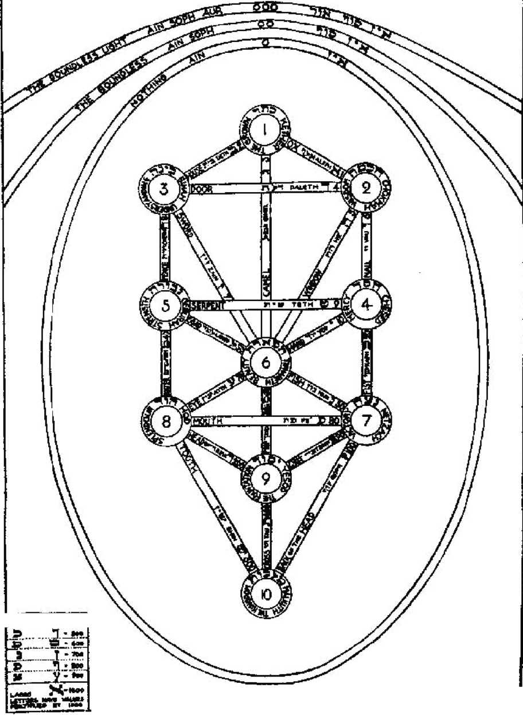

This diagram illustrates the conventional theory of the structure of the Universe adopted as convenient for the purposes of calculation in the Book called The Tarot. The el­lipse, parabola, and hyperbola, show the three Veils of the Negative; the ten circles refer to the ten numbers of the decimal scale; and their general spiritual and moral significance is given on the rims. The necessity and propriety of this system is set forth in the Naples Arrangement, and it is discussed quite fully in the text of the Prefatory Note. The lines joining these circles represent the twenty-two numbers of the Hebrew alphabet with the actual meanings of their names and their numerical value. This also is fully discussed in the text of the Essay.

This diagram should be studied so deeply and so constantly that it becomes automatic for the mind to accept it as the basis of all thinking on the subject of The Tarot, exactly as the letters of the alphabet and their arbitrary order is accepted as the basis of all our thinking in respect of words and their pronunciation. Until this first task has been mastered, the details of the Tarot may prove a source of continual annoyance; every symbol of the book must be so familiar as to have sunk completely into the unconscious strata of thought. Intellectual knowl­edge must be so wrought into the substance of the mind that it becomes instinct.

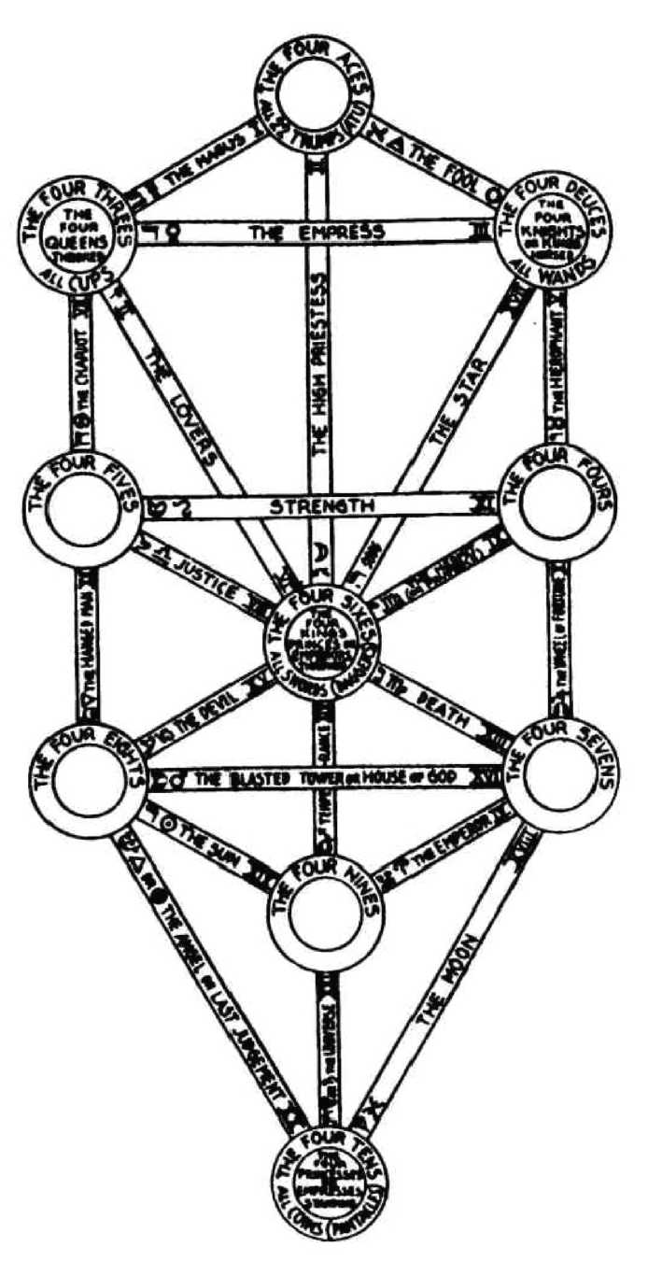

Provided that Diagram 1 has been mastered as it should have been, this figure will pre­sent no difficulty. The ten numbers evidently refer to the small cards of the pack, the Aces to the number I, the Deuces to the number 2 and so on. The Court cards are referred to the num­bers 2, 3, 6 and 10 in their capacity as representative of the idea of Father, Mother, Son, Daughter. The twenty- two Trumps refer to the twenty-two Paths.

The same general remarks made in the description of the first Diagram, apply here also; but this Diagram must itself be studied separately. It should not be used as a table to which to refer when in doubt; it should itself be committed to memory before proceeding to the detailed study of the pack.

IKE CHfNESt cosms.

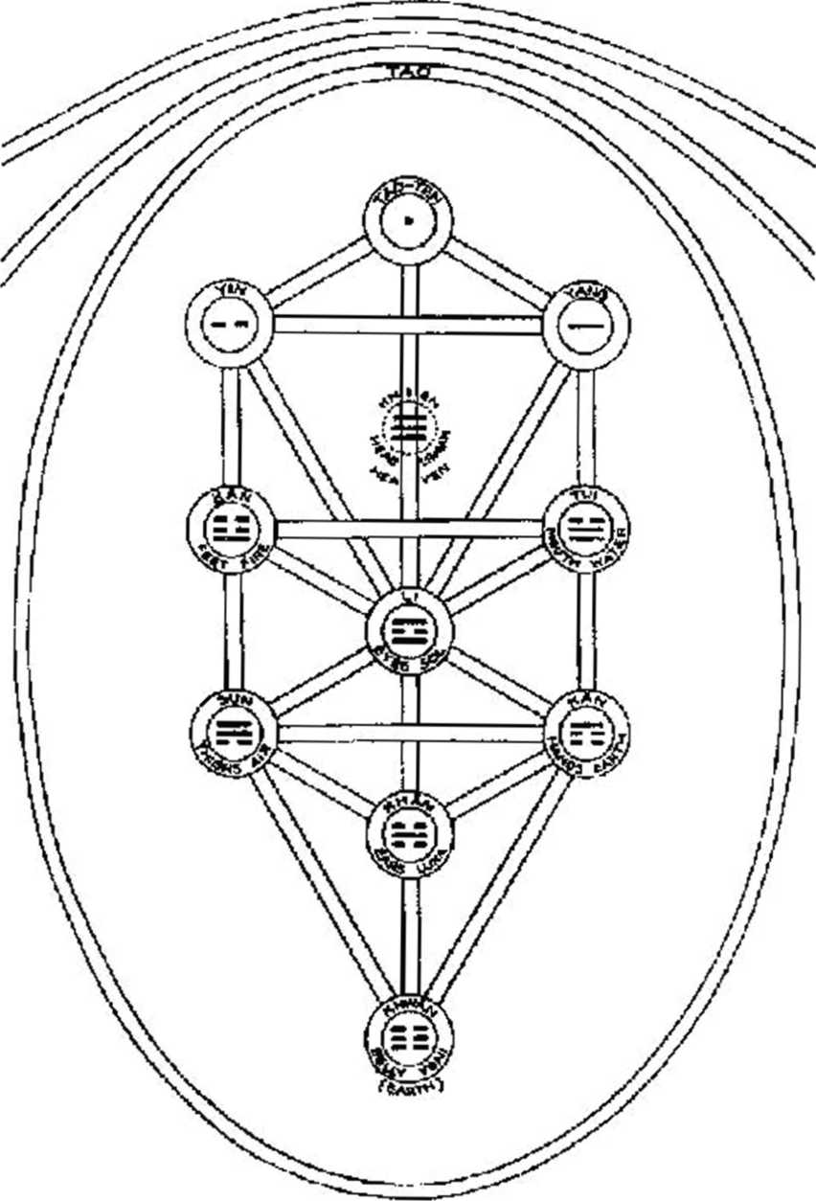

This diagram has been introduced as an elucidation of the interplay of the ten-fold sys­tem of the Sephiroth with the four-fold system of Tetragrammaton, because the Chinese sys­tem, although based exclusively upon the principle of simple addition and subtraction, is found to harmonize exactly with our own Qabalah.

The origin of the Cosmos is thus explained. The Tao is exactly equivalent to the Am or Nothingness of our Qabalah, because equally it must be comprehended as necessarily pos­sessing a phase of manifestation. The conception becomes more objective as it is developed, so that both Tao and its hidden correlative Teh are formulated in a quite positive way as the Yang and the Yin, which correspond exactly to the Lingam and the Yoni. These being clothed about become the popular symbols of Father and Mother.

In the macrocosm they correspond to the Sun and Moon; and, by further descent into matter, are, on the masculine side, Fire and Air; on the feminine side, Water and Earth.

The original concept of the Tao as developed by the Teh, is resumed in the name Thai Ki. The Yang and the Yin are called the I or Yao. When these are combined two at a time, we obtain four figures, called the Hsiang, which may be compared to Tetragrammaton, and this stage of development is so secret in the Chinese idea that practically nothing is said about these forms. They only come out into the clear light when the combinations of the Yang and the Yin are taken three at a time as shown in the lower part of this diagram.

It will be noticed that there are eight of these forms; they are called Kwa. Two of these are completely balanced in purity, Khien and Khwan with three Yangs and three Yins respec­tively. Next comes the first failure of perfect balance; there are Li, the Sun, and Khan, the Moon. The one contains two Yangs with a Yin between them and the other two Yins with a Yang between them.

The remaining four trigrams are completely unbalanced in themselves; but each is bal­anced by the counterpart. The balanced and the nearly balanced are therefore found in the balanced middle column; the others, representing the four Elements, in the side column.

Khien, heaven, is found in the place of Daath, which resumes the powers of the super­nal triad. Note that it has no true place on the Tree, as indicating that material illusion now begins.

In the place of Chesed, which is Water in our Qabalah, we find Tui, which is Water in the Chinese system. In Geburab, our Fire, is Kan, Fire in the Chinese system. In the place of Netzach, which is Earth in our Qabalah, there is Kan which is Earth on the Chinese plan. Fi­nally, for the Sephira Hod, which in our system is Airy and Mercurial, we find Sun, the Chinese trigram of Air.

The Chinese system is therefore, in every way, equivalent to our own Qabalah, and it is most interesting to observe that they equally reach the idea of our own systems of initiation without invoking any other formula than that of the dyad.

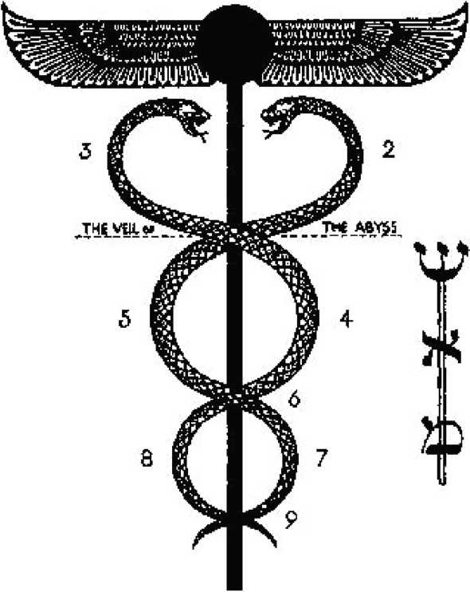

!C

273

DIAGRAM 4. THE CADUCEUS

This diagram illustrates the Tree of Life, the Cosmos as the Wand or creative force of Mercury, that is of the balanced energy which has created the illusion of existence. It will be noted that the shape of the symbol shows the three Mother letters of the Hebrew alphabet, Shin, Aleph and Mem, in its three sections.

The importance of this symbol is mainly that the Tarot is primarily the Book of Thoth or Tahuti, the Egyptian Mercury. For the understanding of this book it is necessary to learn how to transmute instinctively and automatically every simple symbol into every complex symbol and back again; for only so is it possible to realize the unity and diversity which is the solution of the cosmic problem.

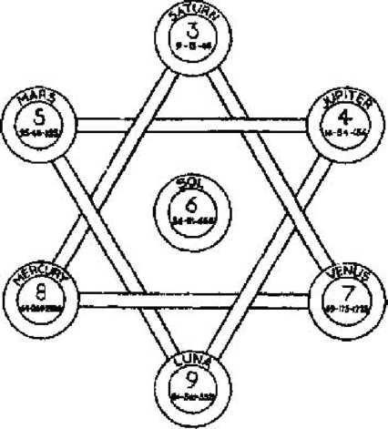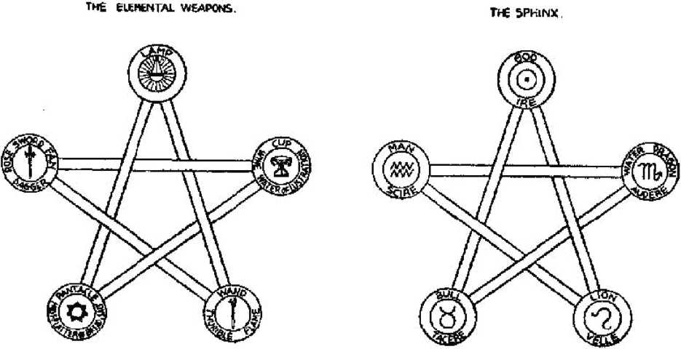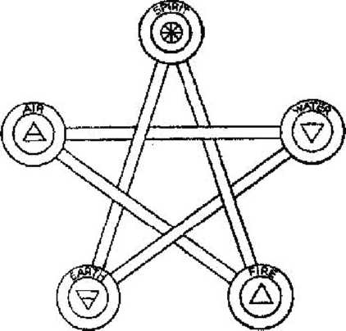

DIAGRAM 5. THE NUMBERS OF THE PLANETS

This diagram illustrates the Solar system on the Tree of Life. Saturn is in the position of the non-existent Sephira, Daath, but it resumes the characteristics of the three Sephiroth

above the Abyss. The doctrinal point is that as this does not exist on the Tree in nature; it is the problem of the seeker after truth to penetrate the obscurity of Saturn, and to discover therein the Supernal Triad in a form linked to his own mind by its position in the Solar system.

The tenth Sephira, which refers to Earth, is not shown on this figure. For this number represents the Nephesch, the animal soul of man, the crystallization of the mind, and the Daughter or He final of Tetragrammaton.

In this edition very little attention has been paid to the immense, vast, overshadowing dogma of the Christian era. This has been variously represented as the doctrine of original sin, of the Fall, of the Atonement; part of this doctrine is given in the legends about the Lost Word, the Widow and the Widow’s son, the fallen, lonely, and lamenting daughter-and so on. These doctrines were all based upon the ignorance of the age, which supposed that the sun was de­stroyed every evening, and had to be raised again every morning by priestly machinations.

The “formula of the dying god”, as this is usually called, does actually exist, but it repre­sents a stage in human development which is now past as far as external theology is con­cerned. It has a sort of shadowy validity in psychology; for instance, in taking up a new task of any importance, one begins very pleasantly, the period of Isis; the task becomes tedious and baffling, one begins to despair, the period of Apophis; then suddenly the subject is mastered and one comes to a triumphant conclusion, the period of Osiris.

But the whole of this formula depends upon ignorance of the laws of nature; there is in fact no catastrophe. Natura non facit saltum; all change proceeds with perfect order, ease and harmony. It is the great task set before mankind at the present moment to realize, and there­fore to adjust, means of action to the facts of the case, thus preventing the illusion of catastro­phe by eliminating the element of surprise. It is of course also of supreme importance to eliminate that prejudiced desire which is the poison of will, “For pure will, unassuaged of pur­pose, delivered from the lust of result, is every way perfect”.

It only makes things worse if one wishes that there were no Ten of Swords in the pack, or that the Five of Wands did not follow and upset the Four.

DIAGRAM 6. THE ELEMENTS AND THEIR SYMBOLS

This diagram is at first sight very disturbing, for it cannot be attributed in any straight­forward way to the Tree of Life.

It will be best to state the problems, ab ovo. The Elements are four in number; although they are harmonized and balanced and made to revolve, there is an irreconcilable difficulty in their perfection. It is impossible to arrange four numbers in a ‘magic square’, so that all the sides and all diagonals add up to the same number. Two is the only number of which this is true. Such is the mathematical formula of expressing the doctrine of what was called the Ac­cursed Dyad.

The problem of the Adept was therefore to attack this irreconcilable duality, whose limit is fortified and entrenched by being squared. As therefore the original duality of Fire and Water was overcome by the introduction of a third Element partaking equally of both natures, Air, so a fifth Element was introduced, and the Pentagram instituted as a symbol of salvation. In the Christian Qabalah, this is symbolized by introducing the letter Shin in the midst of the Tetragrammaton to represent the element of Spirit harmonizing and ruling the four rigid and opposing Elements. The name Jehovah IHVH, thus becomes IHShVH, Yeheshuah, Jesus. This is the Qabahstic method of ex pressing the doctrine of Jesus as the Redeemer. The method was explained in detail by a formula in which INRI, the inscription on the Cross, becomes Yod Nun Resh Yod, which are in the heavens Virgo, the Virgin Mother; Isis, Scorpio, Apophis the Dragon, the Destroyer; Sol, Osiris, the Slain and Risen. The initials of these three divine beings thus make the more ancient name of Jehovah lAO. In this way the initiates of old expressed their understanding of the fact that the Universe was after all perfect, even if requiring a little manipulation; but as explained previously, this doctrine is for the weaker brethren, for those who are suffering from the illusion of imperfection; it enables them to make their way to the illimitable Light.

DIAGRAM 7. THE ELEMENTAL WEAPONS

This diagram shows the attribution of the four Suits of the pack to the four Elements. The fifth Element of Spirit is represented by a lamp, and this in the Tarot refers to the Twenty- two Trumps. The interplay of the symbols should be noticed, for the whole of the planetary, zodiacal, and elemental symbols are themselves all contained in the rays of the Lamp. Note that this and the following diagrams represent new discoveries by the Master Therion: com­pletion of the Tradition.

DIAGRAM 8. THE SPHINX

This diagram represents the four Kerubs who are about the throne of the Almighty; they show the central zodiacal signs of the four Elements, Leo, Scorpio, Aquarius, and Taurus. The Kerubic sign in any Element exhibits the most powerful and balanced form of that Ele­ment. Attached to these are the names of the four Virtues of the Adept, those which enable him to overcome the resistance of the elements; they are: to Will, to Dare, to Know and to Keep Silence. By the harmonious exercise of these, the fifth Element of Spirit is formulated in the being of the Adept. It is the god within, the sun, which is the centre of the Universe from the human point of view, with its own particular virtue, which is to Go. The essential charac­teristic of the godhead is this faculty of Going; the free movements of space and time and all other possible conditions. In the Egyptian hieroglyphic system, this faculty of going was rep­resented by a sandal strap, which represents by its hieroglyphic form the crux ansata, the Rose and the Cross, which in its turn gives the formula of Love under Will, the secret of at­tainment.

**Г**НЕ ESSENTIAL DIGNITIES OF THE PLANETS

|  |  |  |  |  |  |
| --- | --- | --- | --- | --- | --- |
| Tlw. Exztiizii^n of the Planets | |  | 1 1  j | Signs of the Zodiac |  |
| 0 | tg° . . |  | - * | Г . | 23 |
|  | 3° * * | ■ | s - . | У - | l6 |
| & | 3° * . | ¥ | 1 . . | n , | *7 |
| 2| | J$* . . | > | ^ * * | sac . | 18 |
| ь | 21* . , | * | ¥ * - | -f\* | 22 |
| 5 | 15° . ■ | ■ | 9 * • | "U - | 30 |
| W | 19* , . | fr | G ■ , | ft , | *9 |
| L | 14° - . | « | <J ■ * | Я ■ | if |
| S | 3e > - | V | # - . | 1 - | S5 |
|  | 28° . . | * | Tl . . | и , | 26 |
| T | 19* * ч |  | h * . | « , | *5 |
| ¥ | 27° . , | ■f | * , , | к , | 29 |

Г-Ierahtf rub the 4 К паЫс Signs Neptune, the **4** Common Signs, and **I nnram Mobile, the** 4 **Cardinal Signs.**

A plans* is & Its Fall opposite to its Exaltation; in its Detriment when opposite to sts Kealro*

This diagram shows the true symmetrical completion of the Sidereal- Solar System. The astronomical discoveries of Herschel (Uranus), Neptune, and Pluto have completed the tenfold scheme of the Sephiroth, and enabled the Master Therion to establish Astrology in its relation with Ceremonial Magick on a perfectly balanced basis.

It is a notable witness to the triumph of Magick that all militant nations have adopted, worthily or not, magical symbols and gestures.

Great Britain and the U.S.A., “Thumbs up!”—The Sign of Khem: Phallus; The V sign—

The Sign of Apophis and Typhon.

U.S.S.R., The Hammer and Sickle—Jupiter and Satuni; The Pentagram.

The Dritte Reich, The Svastika.

Italy, the Fascis-Fascinum.

Japan, The Rising Sun.

France, abandoning the Fleur-de-Lys (Phallus) and profaning the Pentagram of the Le­gion d’Honneur, ?

|  |  |  |  |  |  |  |  |
| --- | --- | --- | --- | --- | --- | --- | --- |
| 'Щ. tini lumbers Fri-пкЛ m Taroi Cards | | Hebfsiiv  Letters | ПеЬгш Хатс-ь of timbers and Letters | Ntmi#?-  icm/  Value | , * адм | | Key Sea It |
| 0. | The Fool | Щ | Aleph | I | A | Ox (Plough) | II |
| I. | „ Magus | 2 | iSeth | 2 | 5 | House | 12 |
| II. | „ Priestess | й | Gimei | 3 | w | Camd | 4: |
| Ill, | ,, Empress | T | Daleih | 4 | 1 | 1)|ЩГ | 4 |
| Щ. | „ timperor | -t' | Tzaddi | 9o,9co |  | Fifth-book | z8 |
| V, | „ Hierophant. | 1 | Van | 6 |  | Kail | 16 |
| VI. | „ Lovers | fc  1 | Zairt- | 7 |  | Swor^ | 1? |
| VIE, | ,, Chariot | П | Qieth | 8 |  | Fence | 18 |
| VIEL | Adjustment | !з | I.ajii&J | 3t> | A | Ox Goad | 32 |
| IX. | ,t H^roit | * | Yt>d |  | w | Hand | 20 |
| X. | Fortune | 2 -f | Kapii | W7i)t)U | Щ | PjUm | 21 |
| Щ. | Lust | и | Teth | 9 | &. | Serpent | *9 |
| XIL | JP Hanged Mid | 3-b: | Mein | 40,t4Xj | V | Water | 23 |
| XIIL | Death | i ? | Nun | 5C.700 | R | Fish | 24 |
| XIV. | Art | P | Samekh |  | t | Prop | *5 |
| XV, | The Devil |  | A'airs | 70 | Й | Eye | s6 |
| X.VL | ,, Tower [Wax] | Э *1 | Рё | ^ooo | <? | Mouth | 27 |
| XVIL | „ Star | W | Щ | 5 | 'Y1 | Wiiuiuw | 15 |
| XVIII, | „ Moon |  | Qoph |  | к | Баск у! Bead | 39 |
| XIX. | „ Sun |  | Iiesh | 3UHJ | G | Head | 30 |
| XX. | AjKOT] |  | Shin | Зио | A | Tooth | 3r |
| XXI. | j* Universe | Щ | Tau | 4U(j | I? | Tau (Egyptian) 33 | |
| r |  |  | Tau | 4<X3 | V |  | 32 bis |
| ■■ |  |  | Shin | 300 | $ |  | 31 bis |

ТНК FOUR SCALES OF COLOUR

|  |  |  |
| --- | --- | --- |
|  | B'ue Emerald | pTri^rald, |
|  | fcreei) | fljooktxl Gold |
|  | G:ey | Indigo, raved Violet " |
|  | Cflld Pale | £Ш?Ш rayed |
|  | Blue | Sky Blue |

***ТЫ Princc-***

***Ткг Prince***\*ss

Early Spring GrtHiTi

The Knight

|  |  |
| --- | --- |
| 11, | Bright Pis It |
|  | Yellow |
| 12. | Ydlttw |

Blue

74. Emerald Green

28. Scarlet

1. Red Orange

i

1. Orange

iS. Amber

Щ. Yellow

fgieeiibL)

-го. Gieen

|4’e3iO\vi'vh)

21. Violet

1. Emerald Green
2. Deep ELic

*The Queen* Sky Blue

L^irple

5Hvei

Sky Blue

Red

Deep Tnrhgn Pate Ma.uvc

Maroon Deep Purple ЬЫе Grey Bbe Blue

Sea-green

Miaiit

Flame

Deep wami **Ohve**

JNewr Yellow leather

Rich bright Russet

Grey

Gre^n Опту Hich Purple

Deep Elue-

Grftpn

Deep Gliv«- Grdei;

**Bt. K**0**S**6 cerisc, rayet pd* green

Glowing Red Rich Brown

**Reddish Git1 у** inclined to mauve

Dark greeuisit BrtJWD

Reddish

Amber

Pltim colour

Bright Blue rayed ytdio\

Pals Green

Whiic, Зеске Pm pie

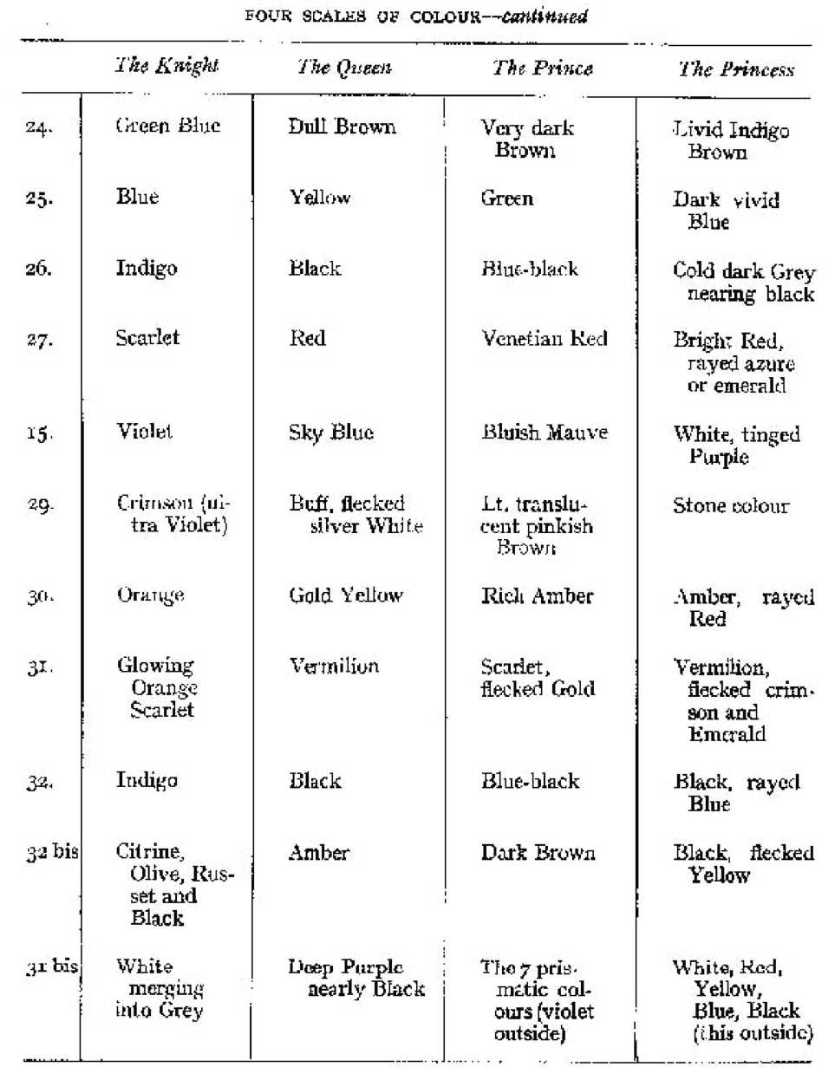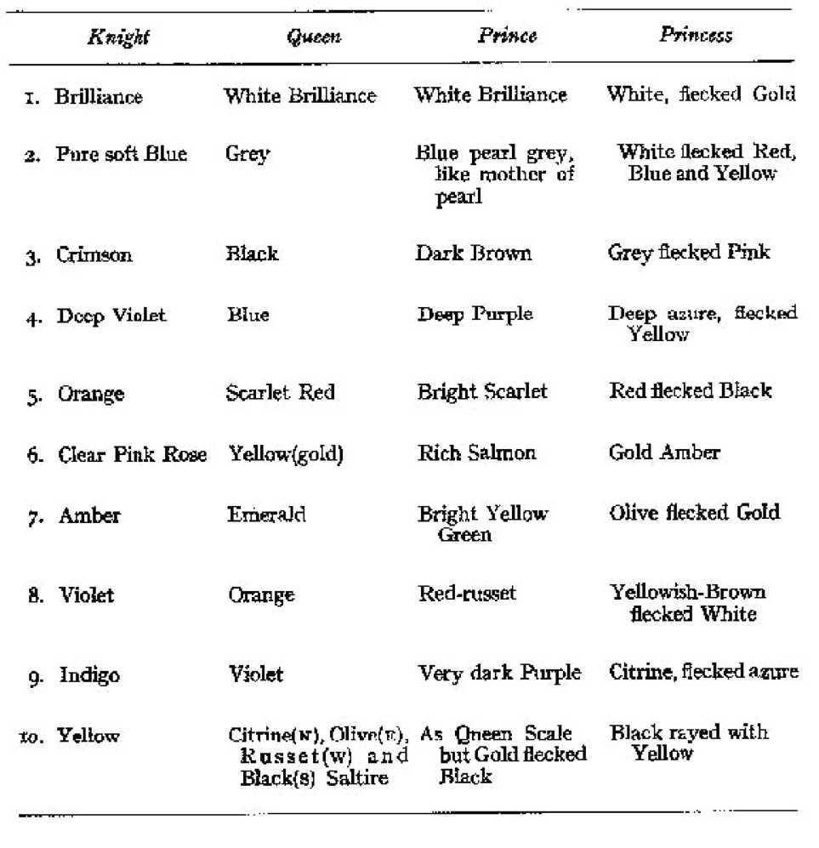

щ Court- Cards of the Tar of with Pie pheres Щ their Celestial Domimon — WANDS

**The Kmgbt of Wands, Rules zoc** 11\ to 20° $ -—including part of Hercules.

The £ueen WaTids. 20” x to to so* *r

The Prince of Wands, 20° 12s to и0 Я

The Pnncass of Wands, Rules one Quadrant of Heavens around blorth Tole. (See p. 177.J

k* Court Cards of the Tarot with the Spheres of tfcAf C&Usti&l Dominion *Swords.*

The Knight of Swords. Rules 20° У to 2t>° II

lie Queen of Swords, so° nj? to 20° ===

he Prmce of S words. 20° **Щ** to

30° 5K

he Princess oi Swords. Rules & thirl Quadrant.

The Coun Cards of the Tarat with the Spheres of tlmr Cdestial Dominion COPS

ТЬй Knight of Cups. Eiiies 20° to **2u* }{** including1 iuost of Pegasus.

Ihc Queen of Cups. зо° п to zo°

*SB*

The Prince of Cups* 20° ^ £0 20“

*4*

The Princess of Cups, Rules another Quadrant,

The Court Cards of the Tmot with ihm Spheres of their Celestial Domimofi — Disks.

The Knight of Disks. Elites зп° Л to aofl Щ

The £ueen of Disks, 20° £ to 2o0y5

TTie Prince of Disks. 306 *ip to 20° у

The Princess of Disks, Rule*, a fourth Quadrant of the Heavens about Kether.

|  |  |  |
| --- | --- | --- |
| 4tks and A Urihuliom of the Wand Suit (Clubs) | THU* avid A Uributmis of the Cup Smt iRmris) |  |
| The Root of the Powers af lTire , | , le Koot ol the Powers of Water | с  i |
| o' in ^ Dominion | S in ® Love | 3 |
| О iii Vutuje | §ji: iii, ps Abundance | 1 |
| $ in т Completion | in 23 Luxury | A |
| Fj m Я Strife | in ТЦ Disappointment | t; |
| ?4 in .fl Victory | О in Щ Pleasure | £ |
| <? in ft Valour | 9 in П] Debauch | 7 |
| Щ in £ Swiftness | Тэ iii и Indolence | c |
| ^ iii Jj Strength | 2[ in X Happiness | с  -* |
| Yi in t Oppression | in к Satiety | zc |

TitUs and Attribution of the Titles and Attribution of the

. iPGYtl Suit {Spadzs) Coin, Disk, ut Suit

|  |  |  |
| --- | --- | --- |
| ■ b + p * i.  The Root of the Powers oi Ait | + f + 1 ■  . The Root of th e PoWei’s 0 i Ear tii | 0  1 |
| w m — Peace | Щ in ^ Change | 2 |
| h in =£S Sorrow | $ in y*) Work | 3 |
| % in л Truce | 0 in Power | 4 |
| ^ in cii Defeat | $ in У Worry | 5 |
| И in 5s Science | ^ m й Success | 6 |
| ^ in ess Futility | Fb in b Failuie | 7 |
| 2i щ it Interference | О m TTp Pmdence | S |
| in n Cruelty | hi Щ Gai n | 9 |
| G Щ ci Ruin | £ in 1$ Wealth | ro |

THE TRIPLE TRINITY OF THE PLANETS

|  |  |  |
| --- | --- | --- |
| ¥ | The Spiritual 4 |  |
| 0 | The Human (Intellectual)* | Self- jj {ego; Я |
|  | The Sensory (Bodily) |  |
|  | The Spiritual " | mi |
| b | The Human (Intellectual)* | oi the 4* |
|  | he Sensory (BodUy; j | Sell |
| Щ | The Spmti^al " | Relation |
| $ | The Human (Intellectual)* | г with the © |
| ? | he Sensory (Bodily) | non-ego. |
|  | ill Pillar |  |
|  | The Spiritual |  |
| о | The Human | Consciouanfis^ |
| w | The Automatic j |  |

Pillar of Mercy

|  |  |  |
| --- | --- | --- |
| Ш | The Creative | Mntlfi of |
| % | The Paternal | action on th* |
| p | The Passionate j Pi&iy of Severity | non-ego. |
| h | The Intuitive |  |
| £ | The Volitional | Mode of Sdf-  expfesgiiori. |
| a  ■r | The Intellectual |  |

•For one **m** sght say “consdouft"*

THE TRIPLICITIES OF THE ZODIAC



Fire of Fire Air of Fire Water of Fire

Lightning—swift violence of onset.

Fire

Sun—steady force of energy.

Rainbow—fading spiritualized reflection of the Image.



Fire of Water Air of Water Water of Water

Water

Rain, Springs, etc.—swift passionate attack.

Sea—steady force of putrefaction.

Pool—stagnant spiritualized reflection of Images.



Fire of Air Wind—swift onset (note idea of balance as in

Air

trade winds.)

Air of Air Clouds—steady conveyors of water.

Water of Air Vibrations—bulk unmoved, spiritualized to reflect

Ruach (mind).



Fire of Earth Air of Earth Water of Earth

Mountains—violent pressure (due to gravitation).

Earth

Plains—steady bearing of life.

Fields—quiet, spiritualized to bear vegetable and animal life.

In each case the Cardinal sign represents the Birth of the Element, the Kerubic sign its Life, and the Mutable sign its Passing Over towards the ideal form proper to it; i.e. to Spirit. So also the Princesses in the Tarot are the Thrones of Spirit.

THE ***VITAL штт***

1

The Tliree Gods I A 0

The Three Goddesses

The Three Dr-tnuirges

if, Chi id ten Horns and Hoor-Pa- \ Kxaat i

The Yoni **ganders** (Ths Worn не justified

The Slain Gcds

The Lingam The Ynm The &Шс (Priest, Plieste&j, Ceremony)

O* 'Cbt; Holy Ghost.

I. The Messenger.

XX. The Secret Seed.

IL The Virgin.

Ill* The Wife*

1Ш The Mother.

X. The AH Father 3 in i.

IV. The Ruler.

V, The Son (Priest)*

VI. The Twins Emerging

XIX* llie Sim (Playmg)

XVL The Crowned and Conquering Child emerging' fr om Womb as in A L P.

VII. The Grata!; Chariot oi Life.

XIV. The Tregtianl Womb preserving life*

VIII. The Sexually joined.

XT. 156 & 666.

XU. The Redeemer in the waters.

ХПТ. The Redeeming Belly which kills XV.

XV. Erect & Glad*

XVIII. The Witch: Yoni.stagnant and waiting,

XX. God iiiul Man as Lwins fi'<?m **Nuit and Hadit.**

XXL The System,

The Paniacle of the WhoJe

S. H. Soror I.W.E. 8°=3° A.-. A.-.

3. The Tarot and the Hermetic Order of the Golden Dawn.

One must now digress into the history of the Hermetic Order of the Golden Dawn, the society reconstituted by Dr. Westcott and his colleagues, in order to show further evidence as to the authenticity of the claim of the promulgators of the cipher manuscript.

Among these papers, besides the attribution of the Tarot, were certain skeleton rituals, which purported to contain the secrets of initiation; the name (with an address in Germany) of a Fraulein Sprengel was mentioned as the issuing authority. Dr. Westcott wrote to her; and, with her permission, the Order of the Golden Dawn was founded in 1886.

(The G.‘. Da is merely a name for the Outer or Preliminary Order of the R.R. et A.C., which is in its turn an external manifestation of the A.‘. A.‘. which is the true Order of Mas­ters1—See Magick, pp. 229-244.) The genius who made this possible was a man named Sam­uel Liddell Mathers. After a time, Frl. Sprengel died; a letter written to her, asking for more ad­vanced knowledge, elicited a reply from one of her colleagues. This letter informed Dr. West­cott of her death, adding that the writer and his associates had never approved of Frl. Sprengel’s action in authorising any form of group working, but, in view of the great reverence and esteem in which she was held, had refrained from open opposition. He went on to say that

3. Early astronomers calculated that the Sun took 360 days to go round the Zodiac. This was a closely guarded secret of the learned; so they concealed it in the divine name Mithras, which adds up, according to the Greek Convention (M 40—I 10—Th. 9—R 100—A 1—S 200) to 360. Better observation showed 365 days to be more accurate; so they decided to call it “Abraxas” (A 1—B 2—R 100—A 1—X 6o—A 1—S 200). When the others found this out they put themselves right by altering the spelling of Mithras to Meithras, which adds (like Abraxas) to 365. In this there is still an error of not quite six hours; so that, in the course of centuries, the Calendar kept slipping. It did not assume its present form until the time of Pope Gregory.

The Point of all this, that they divided the Circle of the Zodiac into 360 degrees, is that this is a convenient basis for calculation.

Each angular measure of 10 degrees was called a Decanate. Of these there are thus thirty-six, dividing each Sign of the Zodiac into three sections. It was supposed that the influ­ence of the Sign was very swift and fierce in the first Decan, powerful and balanced in the sec­ond, spiritualised and deciduous in the third.

5. It is confusing at first, but most instructive and illuminating when the principle is thoroughly assimilated, to note how all these Elements subdivide and coalesce. One can only reach the comprehension of any one of these Symbols by making a composite picture of it, one composed of all the others in varying proportion. Thus each of the planets gives a certain por­tion of its influence to any object. This habit of thought leads to an understanding of the Unity of Nature (with its proper and spiritual exaltation) which could hardly be attained in any other way; it produces an internal harmony which ends in an acceptance of Life and of Nature.

It is now almost time to analyse and define the traditional characteristics of these symbols; but perhaps it would be better, first of all, to build on a sure foundation by consid­eration of the number Two, which hitherto has not been taken into account.

There are only two operations possible in the Universe, Analysis and Synthesis. To di­vide, and to unite. Solve et coagula: said the Alchemists.

If anything is to be changed, either one must divide one object into two parts, or add another unit to it. This principle lies at the basis of all scientific thought and work.

The first thought of the man of science is Classification, Measurement. He says, “This oak-leaf is like that oak-leaf; this oak-leaf is unlike this beech-leaf”. Until one has grasped this fact, one has not begun to understand Scientific Method.

The Ancients were fully cognisant of this idea; The Chinese, in particular, based their whole philosophy on this primary division of the original Nothing. One must begin with Noth­ing; otherwise the question would arise, Whence came this postulated Something? So they wrote the equation—Zero equals plus one plus minus one 0=(+1)+(-1).

“Plus One” they called the Yang, or Male Principle; “Minus One”, the Yin or Female Prin­ciple. These then combine in varying proportion, giving the idea of Heaven and Earth in per-

* * *

1. It seems probable that the Qabalists who invented the Tree of Life were inspired by Pythagoras, or that both he and they derived their knowledge from a common source in higher antiquity. In any case, both schools agree upon one fundamental postulate, which is as follows: Ultimate Reality is best described by Numbers and their interplay. It is interesting to note that modern Mathematical Physics has been finally driven to some similar assumption.
2. to XXI. The Juggler; The High Priestess; The Empress; The Em­peror; The Hierophant; The Lovers (or, The Brothers); The Char­iot; Adjustment; The Hermit; Fortune; Lust; The Hanged Man; Death; Art; The Devil; The Tower (or, War); The Star; The Moon; The Sun; The Aeon; The Universe.